**Part 1**

**Deployment of the application in various cloud platforms**

**P1.1 Google Cloud Platform**

**P1.1.1 Introduction to Google Cloud Platform**

With Google Cloud Platform (GCP), you can build, test, and deploy applications on Google's highly-scalable and reliable infrastructure for your web, mobile, and backend solutions.

# **Overview**

This overview is designed to help you understand the overall landscape of Google Cloud Platform (GCP). Here, you'll take a brief look at some of the commonly used features and get pointers to documentation that can help you go deeper. Knowing what's available and how the parts work together can help you make decisions about how to proceed. You'll also get pointers to some tutorials that you can use to try out GCP in various scenarios. And GCE allows administrators to select the region and zone where certain data resources will be stored and used. Currently, GCE has three regions: United States, Europe and Asia. Each region has two availability zones and each zone supports either Ivy Bridge or Sandy Bridge processors. GCE also offers a suite of tools for administrators to create advanced networks on the regional level.

**GCP resources**

GCP consists of a set of physical assets, such as computers and hard disk drives, and virtual resources, such as virtual machines (VMs), that are contained in [Google's data centers](https://www.google.com/about/datacenters/) around the globe. Each data center location is in a global region. Regions include Central US, Western Europe, and East Asia. Each region is a collection of zones, which are isolated from each other within the region. Each zone is identified by a name that combines a letter identifier with the name of the region. For example, zone an in the East Asia region is named Asia-east1-a

**Accessing resources through services**

In cloud computing, what you might be used to thinking of as software and hardware products, become services. These services provide access to the underlying resources. The [list of available GCP services](https://cloud.google.com/products/) is long, and it keeps growing. When you develop your website or application on GCP, you mix and match these services into combinations that provide the infrastructure you need, and then add your code to enable the scenarios you want to build.

**Global, regional, and zonal resources**

Some resources can be accessed by any other resource, across regions and zones. These global resources include preconfigured disk images, disk snapshots, and networks. Some resources can be accessed only by resources that are located in the same region.

**Persistent disk**

Every Google Compute Engine instance starts with a disk resource called persistent disk. Persistent disk provides the disk space for instances and contains the root [filesystem](https://en.wikipedia.org/wiki/Filesystem) from which the instance boots. Persistent disks can be used as raw [block devices](https://en.wikipedia.org/wiki/Block_devices). By default, Google Compute Engine uses [SCSI](https://en.wikipedia.org/wiki/SCSI) for attaching persistent disks. Persistent Disks provide straightforward, consistent and reliable storage at a consistent and reliable price, removing the need for a separate local ephemeral disk. Persistent disks need to be created before launching an instance.

**Projects**

Any GCP resources that you allocate and use must belong to a project. You can think of a project as the organizing entity for what you're building. A project is made up of the settings, permissions, and other metadata that describe your applications. Resources within a single project can work together easily, for example by communicating through an internal network, subject to the regions-and-zones rules. The resources that each project contains remain separate across project boundaries; you can only interconnect them through an external network connection.

Each GCP project has:

* A project name, which you provide.
* A project ID, which you can provide or GCP can provide for you.
* A project number, which GCP provides.

**P1.1.2 Compute Engine for the implementation of Application**

Part 1

* Login to Google Cloud Platform
* Select or Create a Project by selecting GCP Project

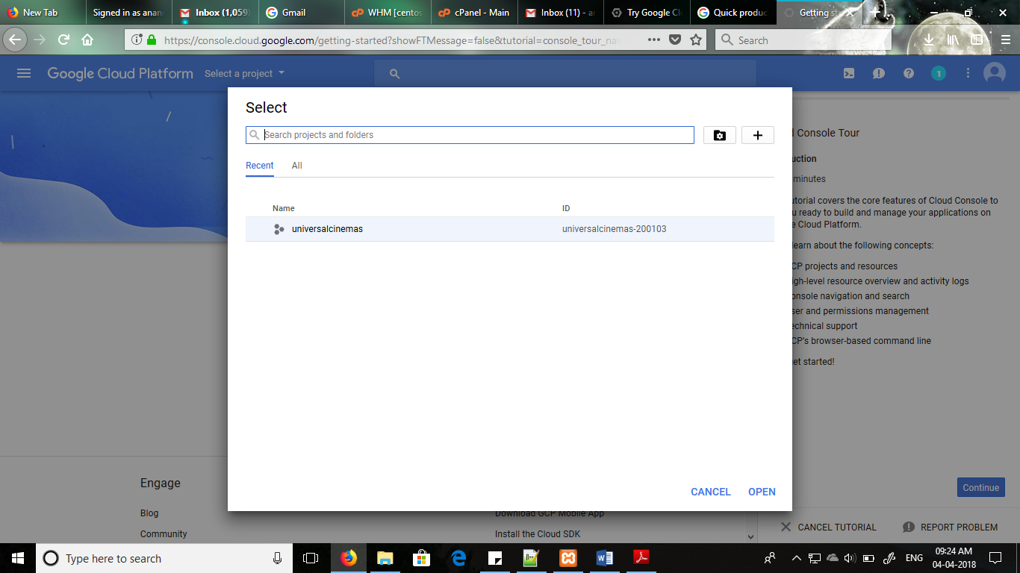

* 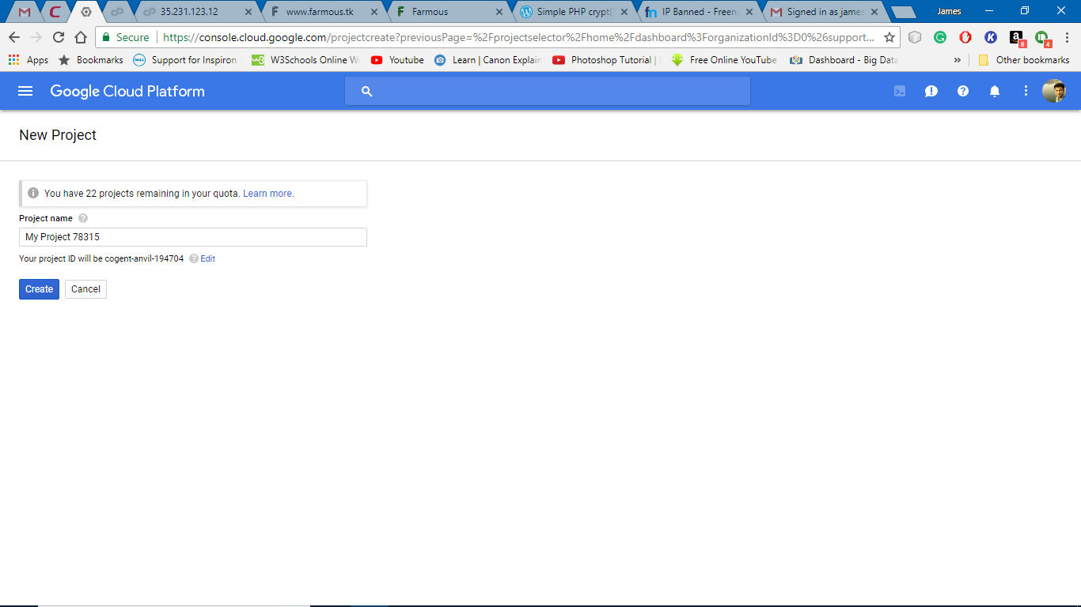Go to Products & Services > Compute > Compute Engine
* Create Virtual Machine Instance
* Choose a name for Instance and select zone
* Select Machine type, CPU, RAM as required or it can be customizable
* Select Boot Disk Image (Recommended to CentOS 7)
* Allow full access to all cloud APIs in Identity and API access
* Allow both HTTP & HTTPS access to the firewall

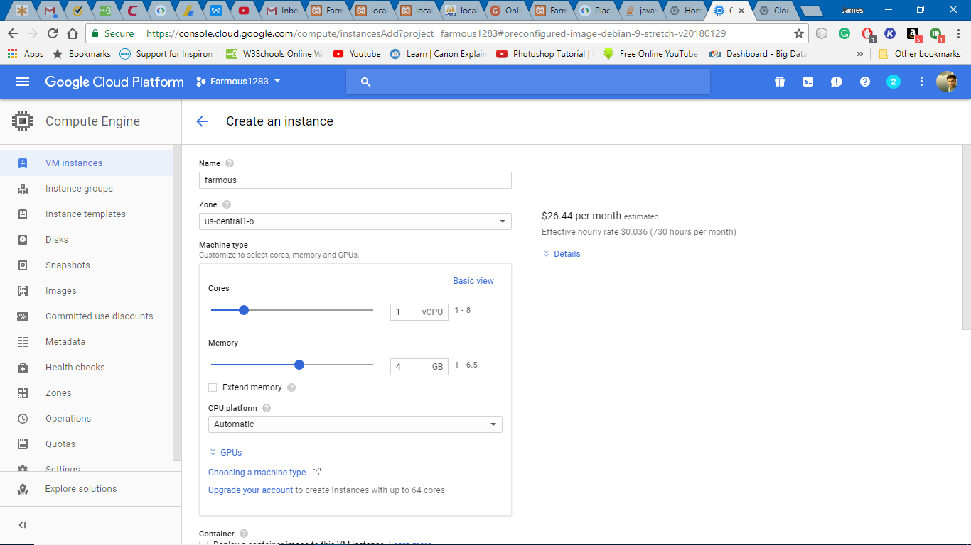

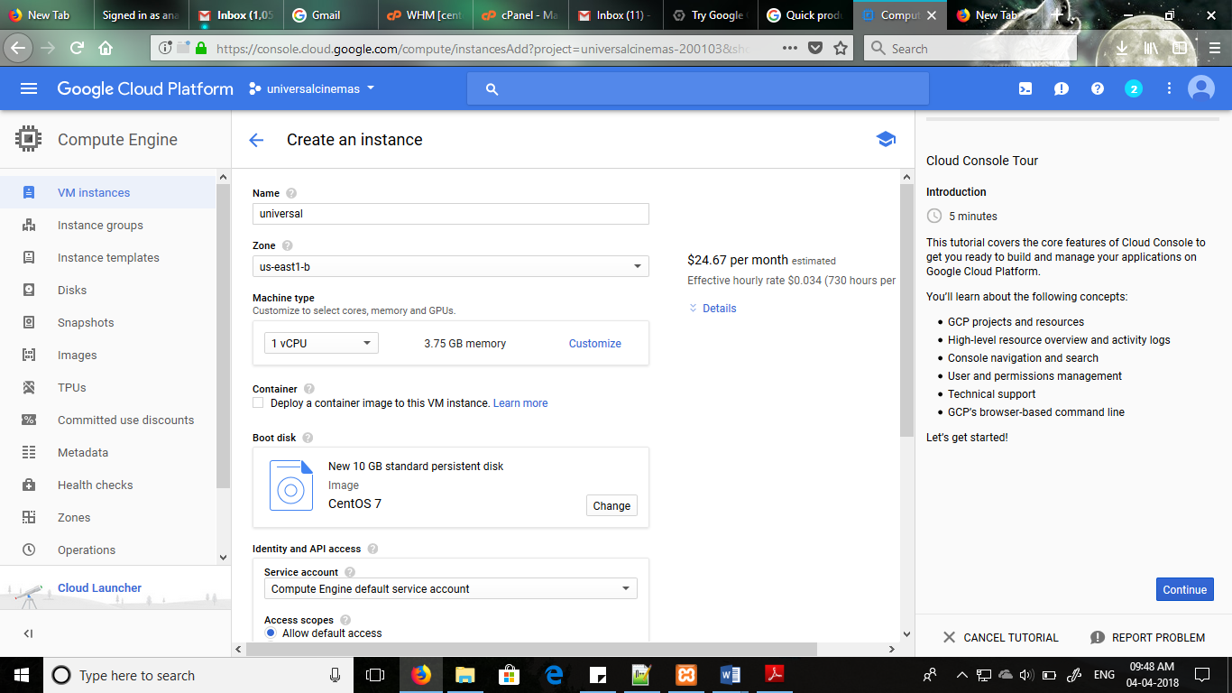

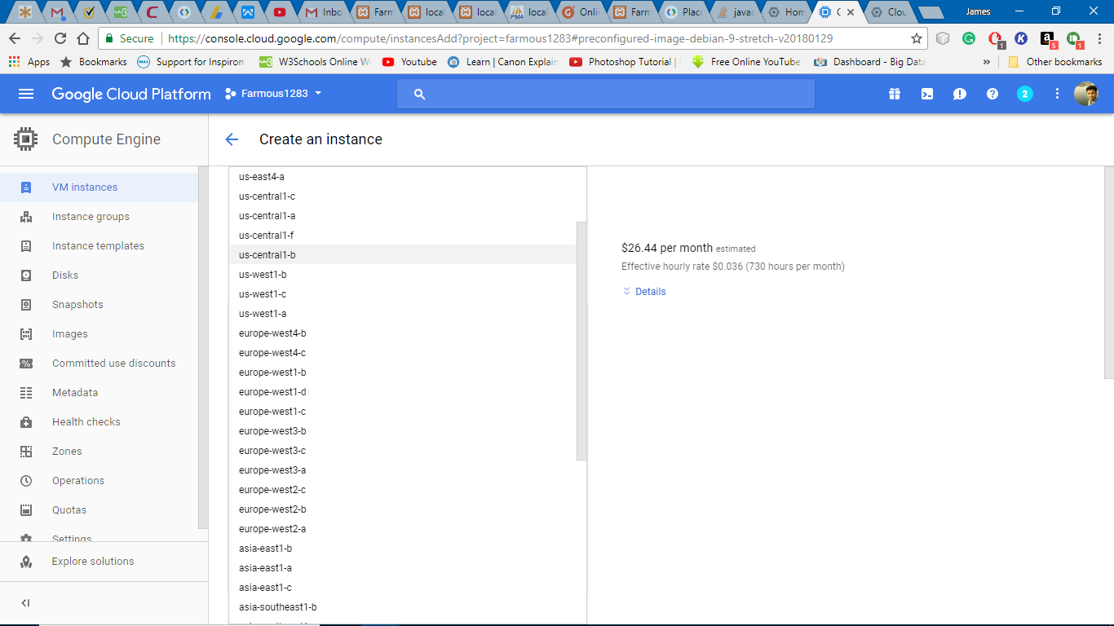

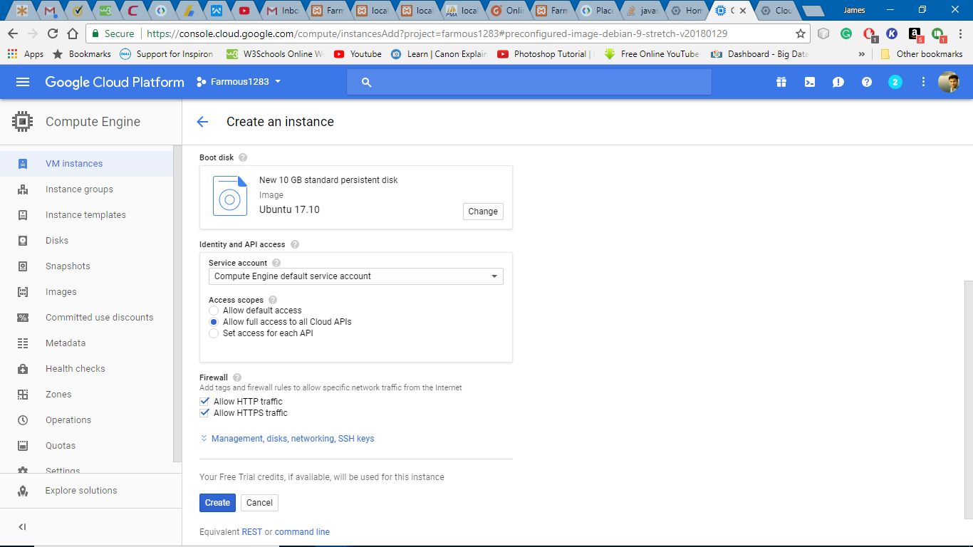

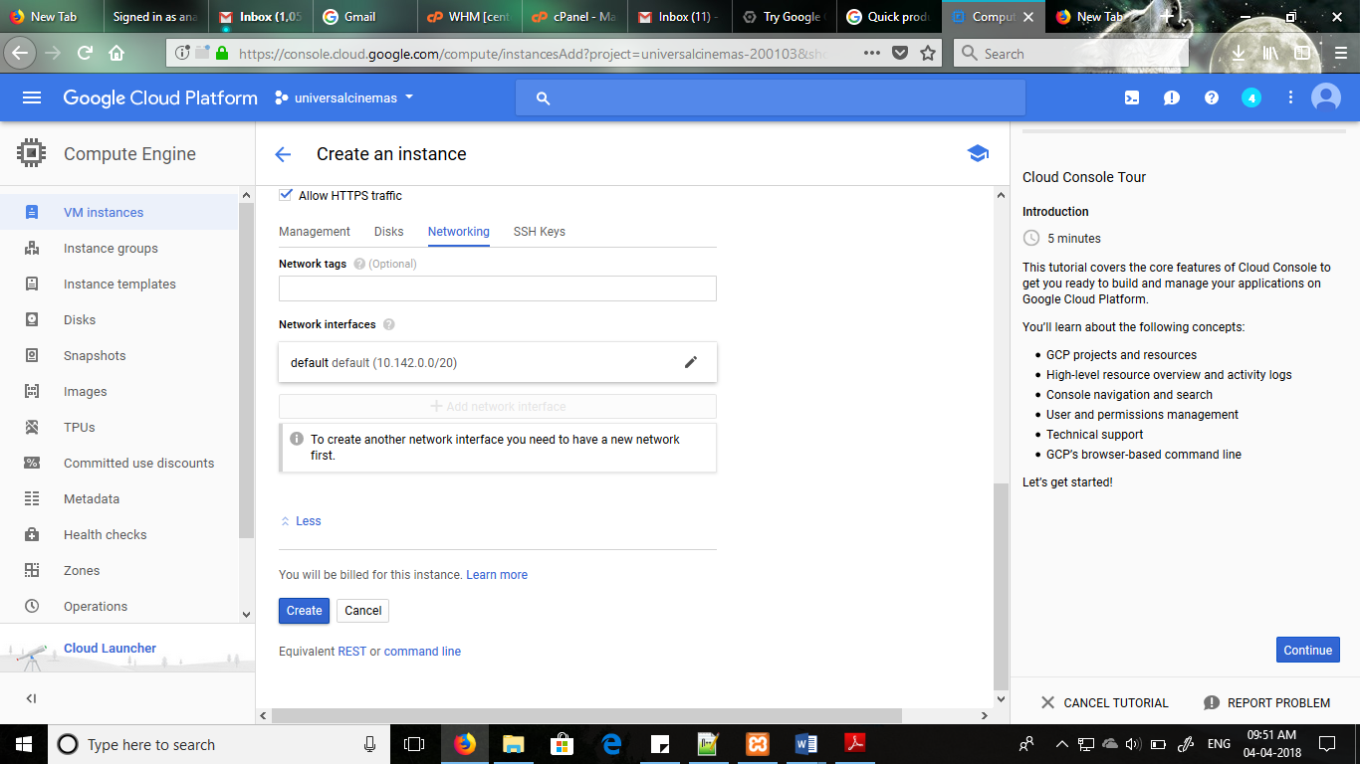

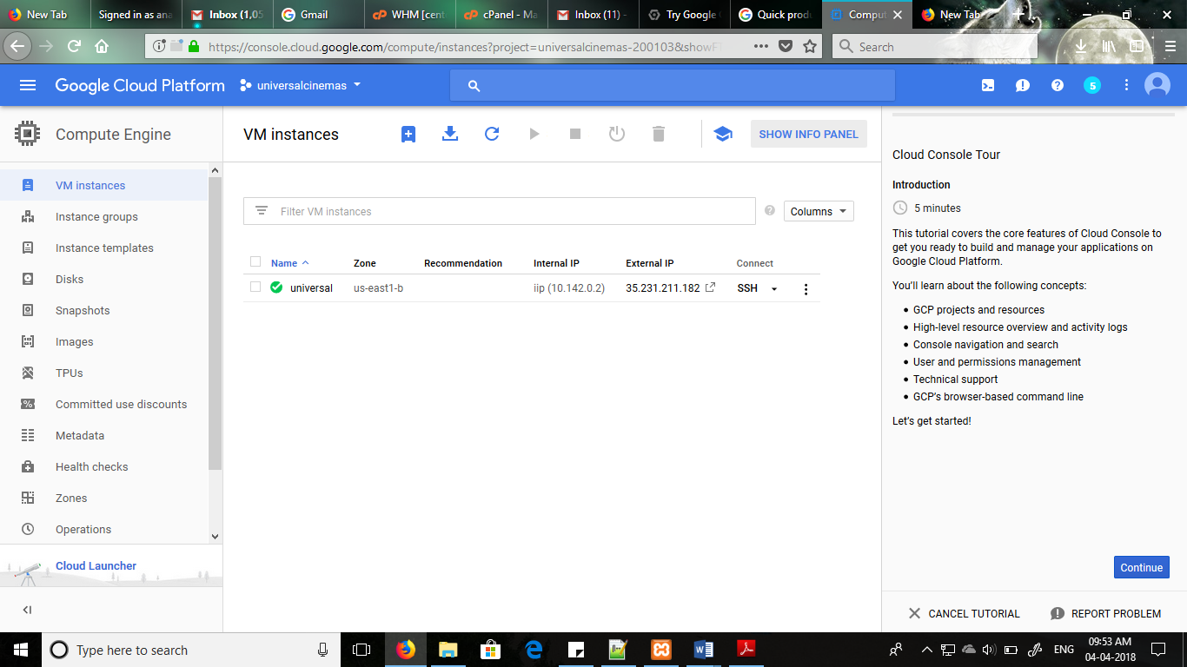

* Configure VM Instance using SSH (Secure Shell)

sudo -s

yum update -y

yum install -y perl

yum install -y wget

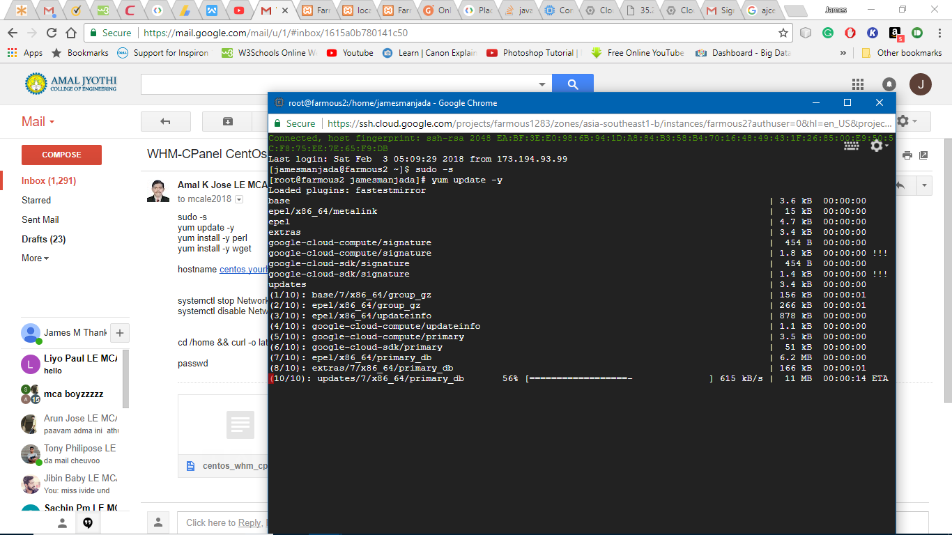

hostname centos.yourhostname.com

systemctl stop NetworkManager.service

systemctl disable NetworkManager.service

cd /home && curl -o latest -L https://securedownloads.cPanel.net/latest && sh latest

passwd

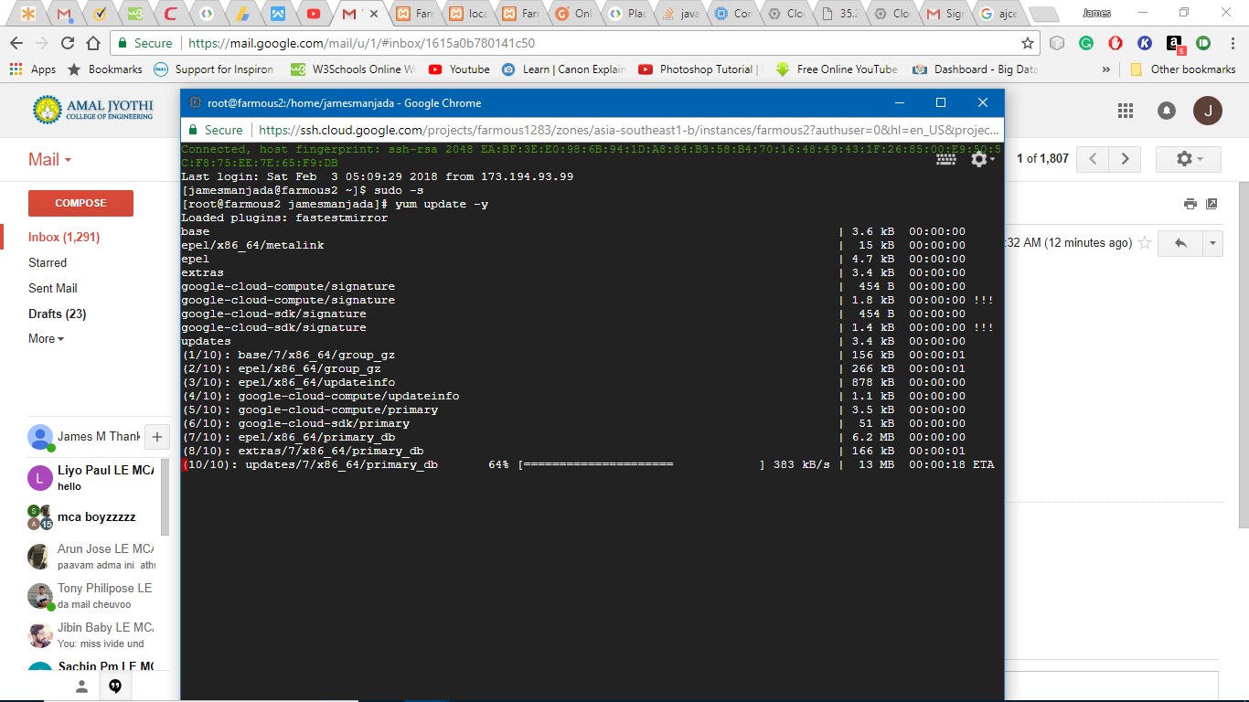

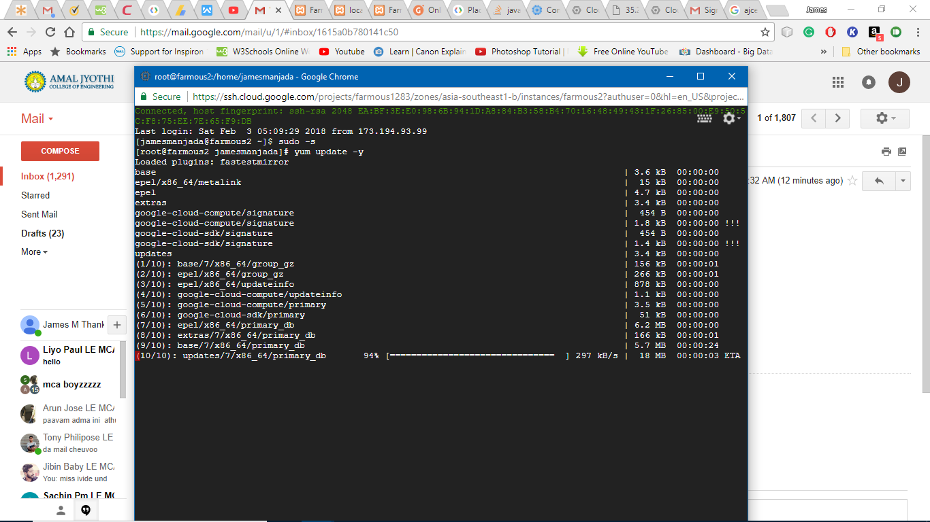

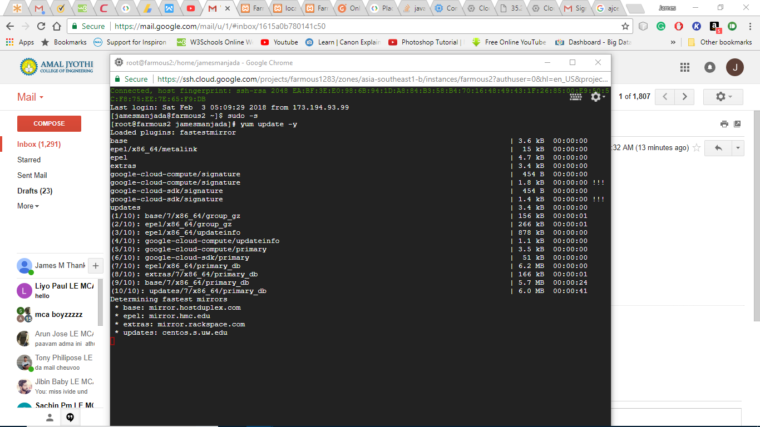

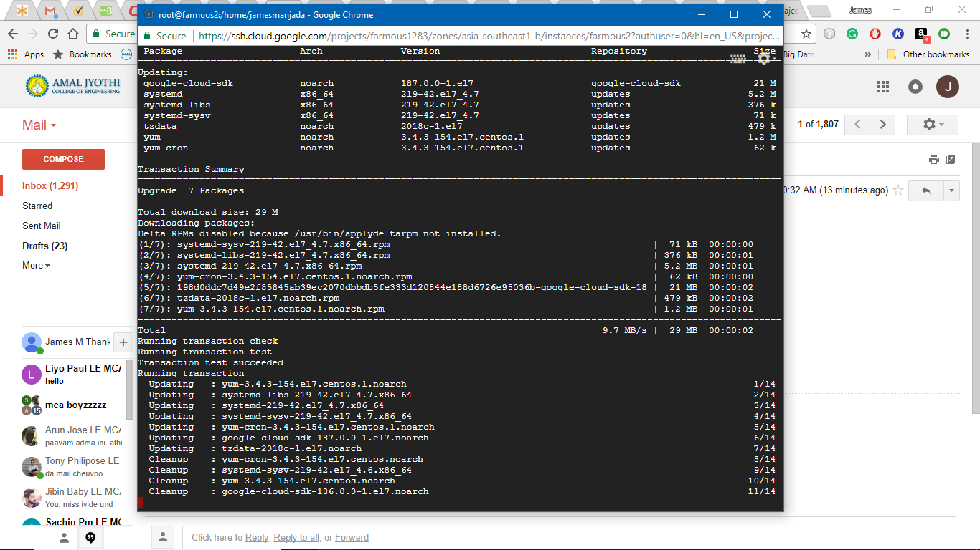

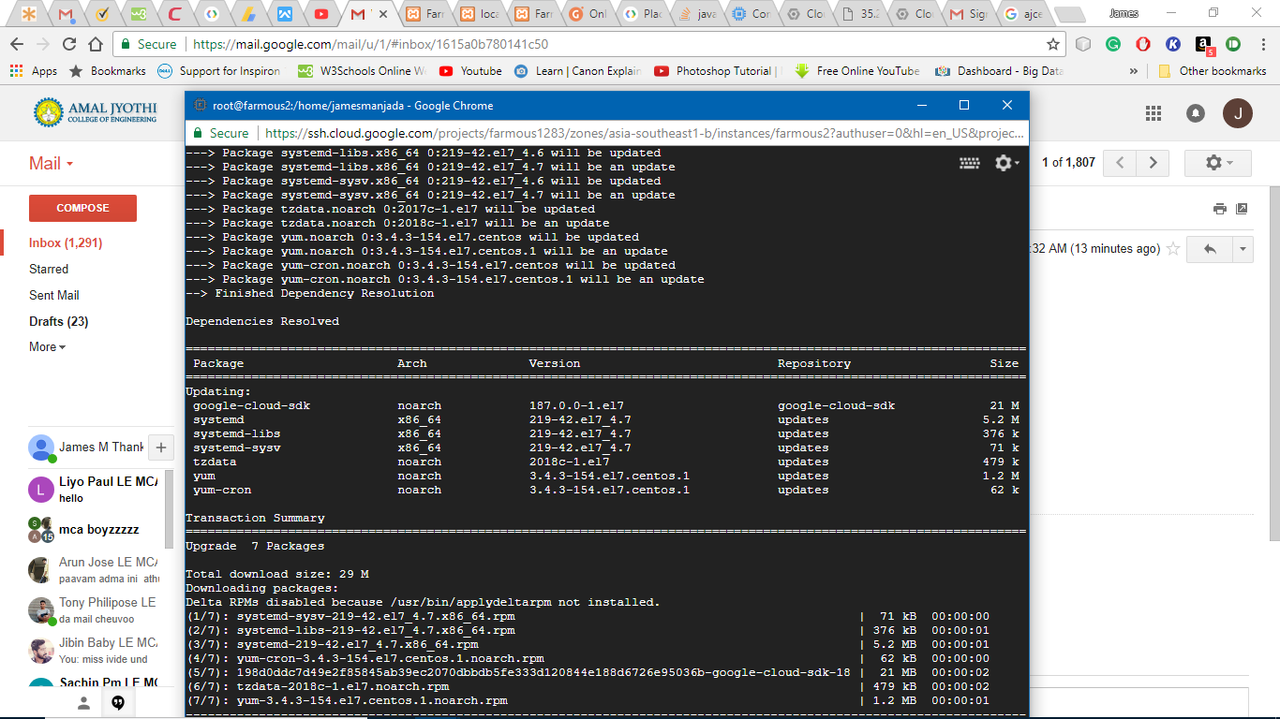

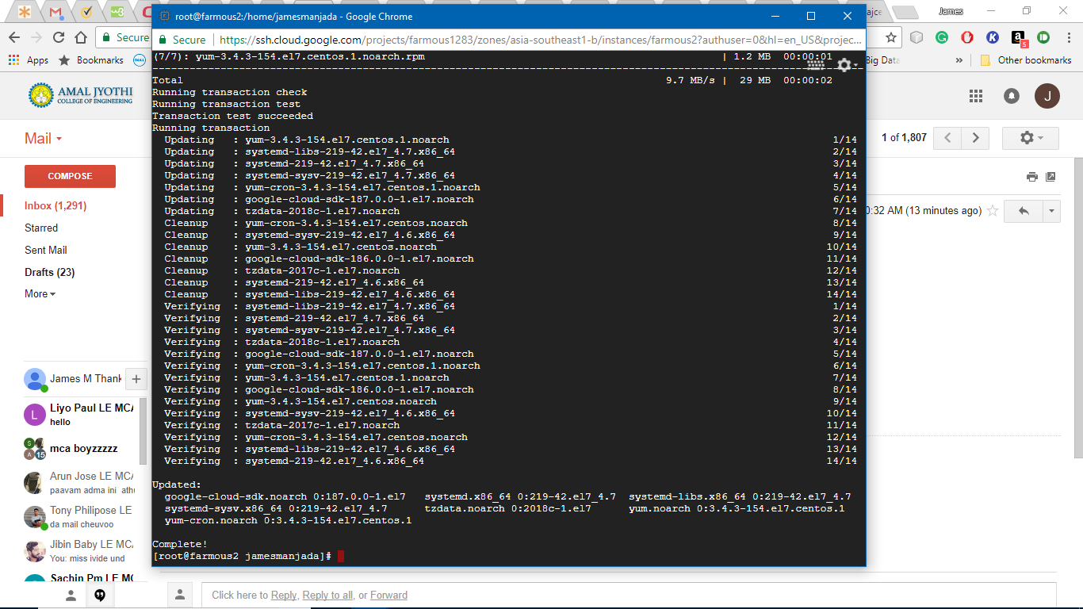

* Configure Cloud Zone (Cloud DNS

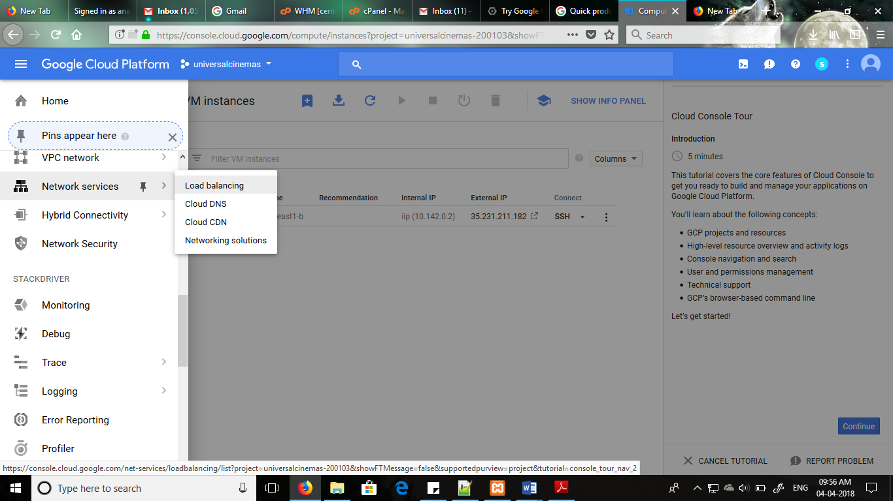

* Create a DNS Zone

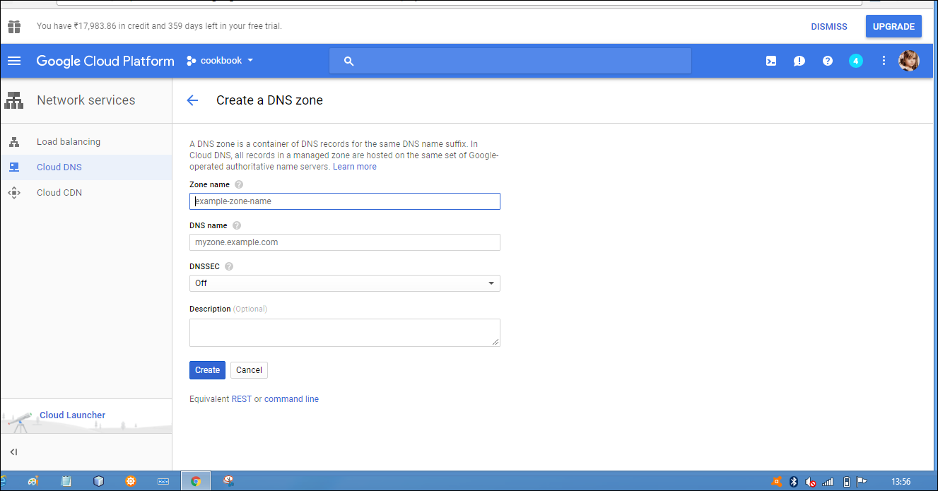

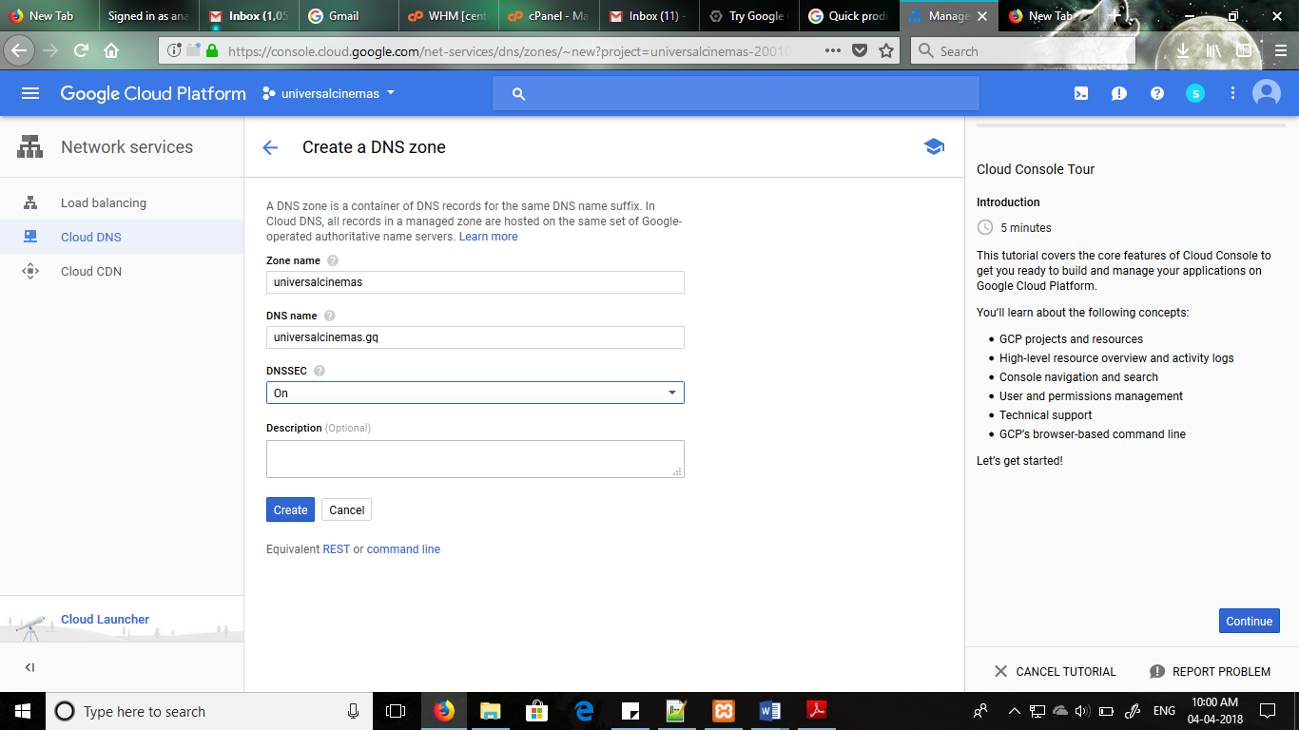

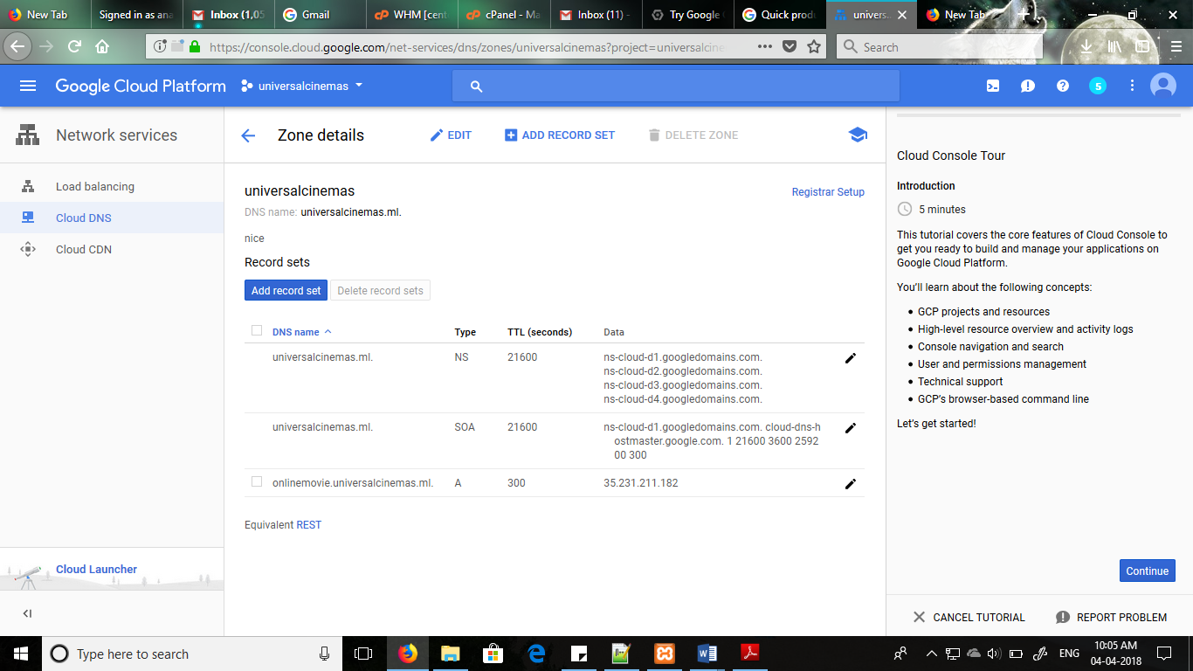

* Nameserver as Data of DNS type NS

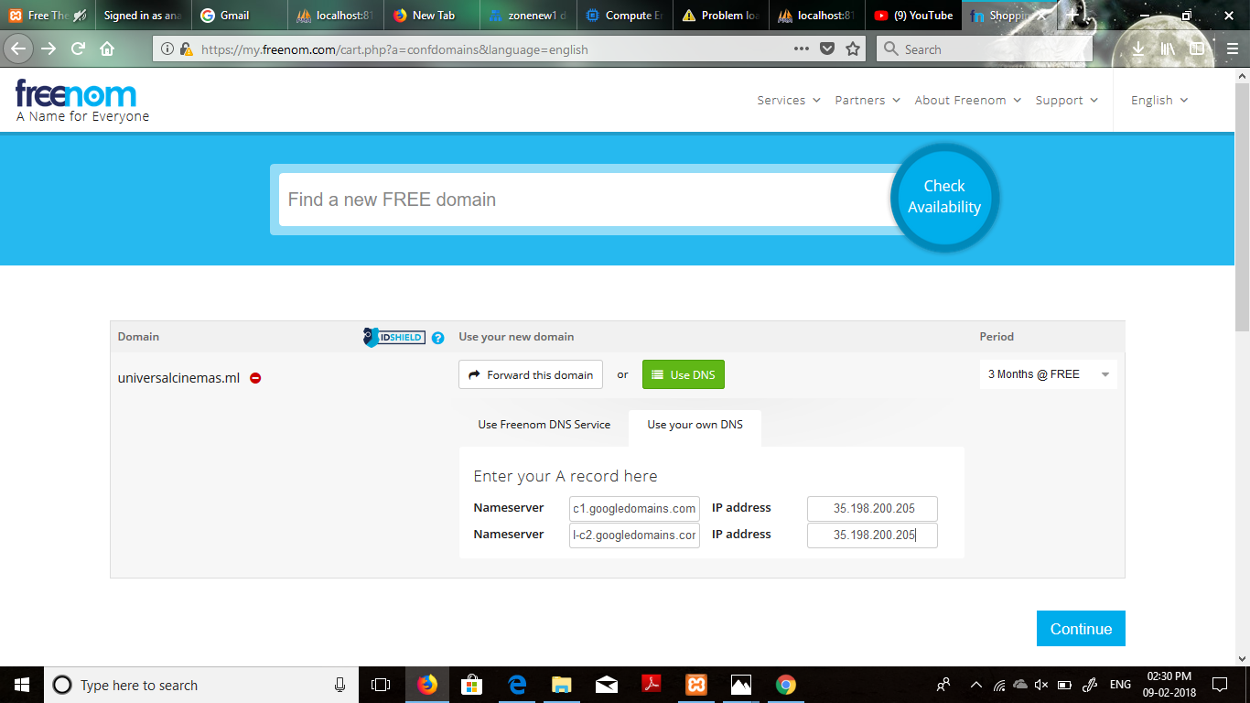

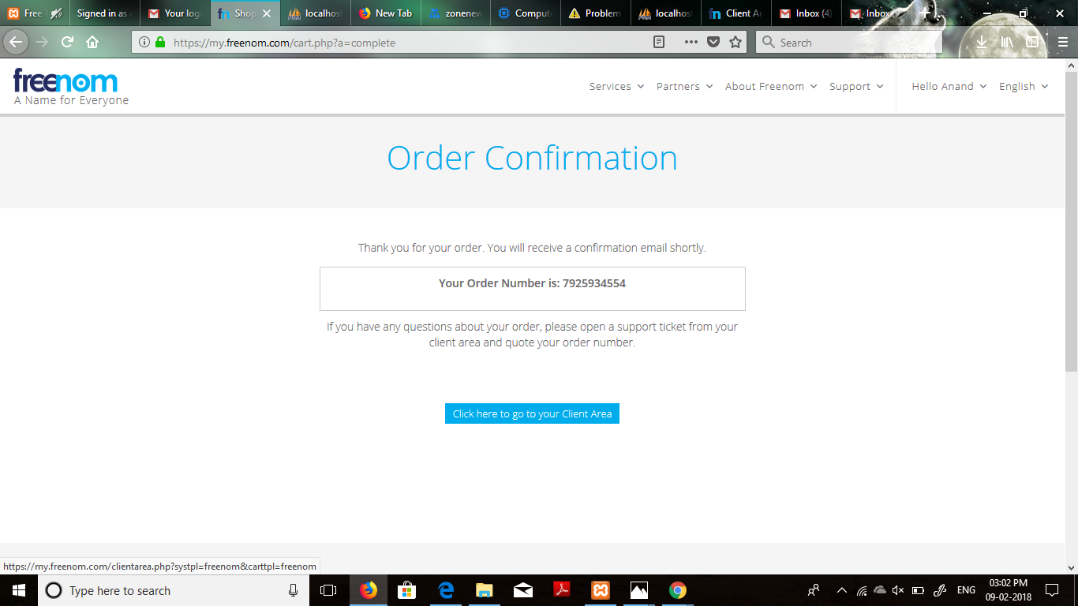

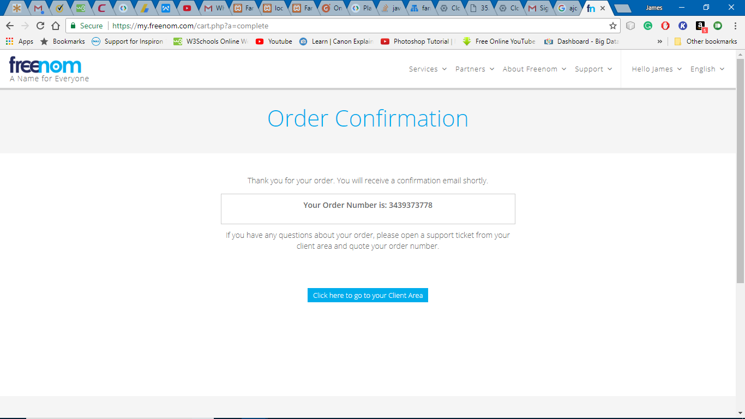

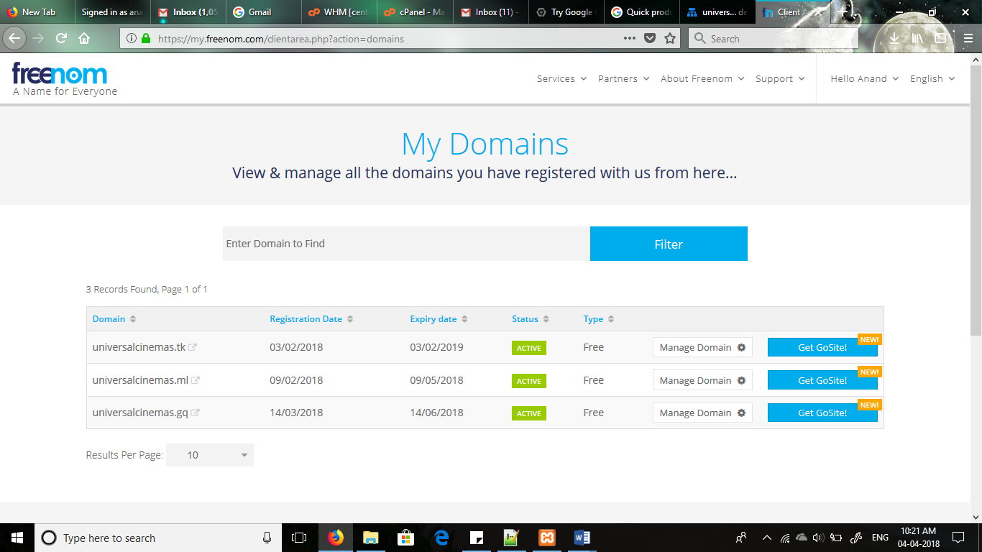

* Creating Firewall Rule (WHM tcp:2087 cPanel tcp:2083)

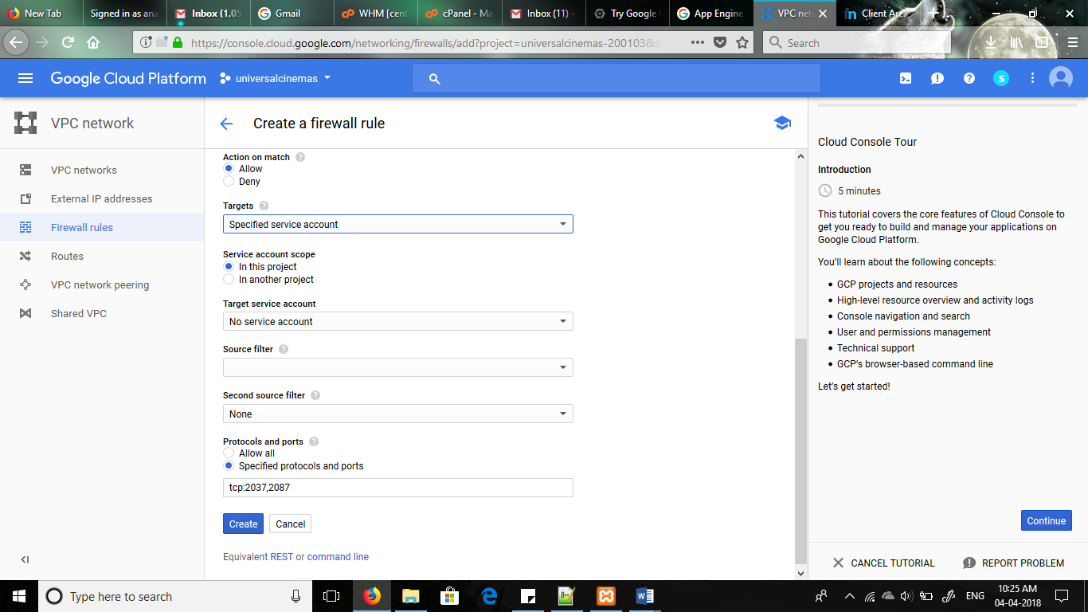

* Login to WHM using Instance Ext.IP:2087
* Configuring Network Environment in WHM account

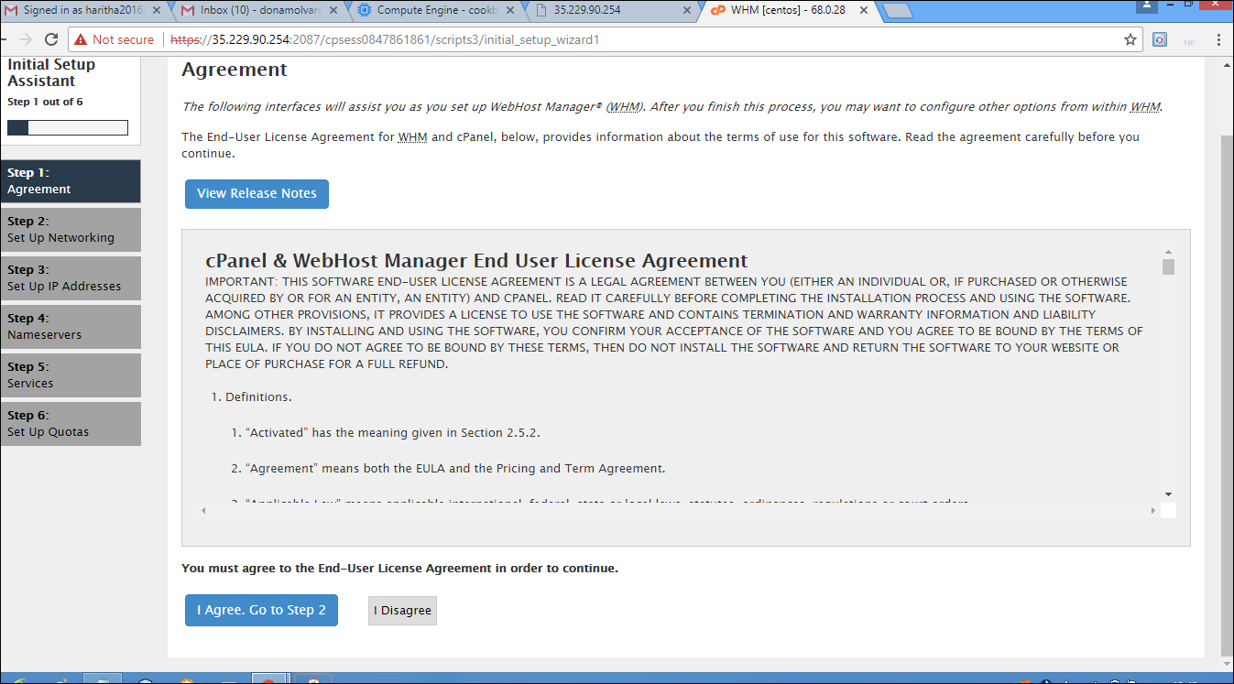

* Go to step 2

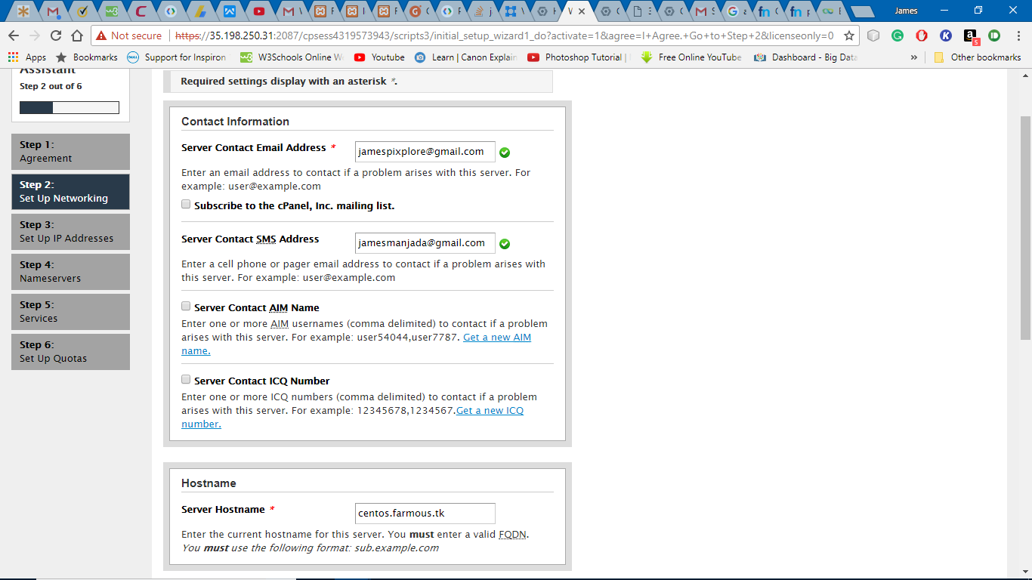

* Go to step 3

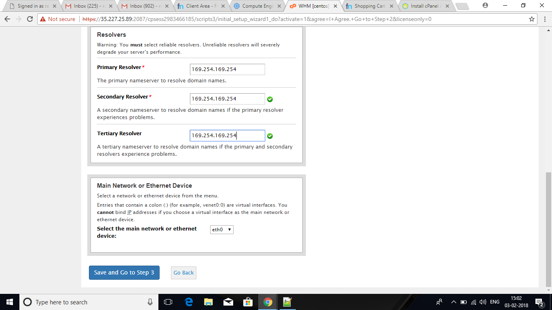

* Configuring IP address in WHM account

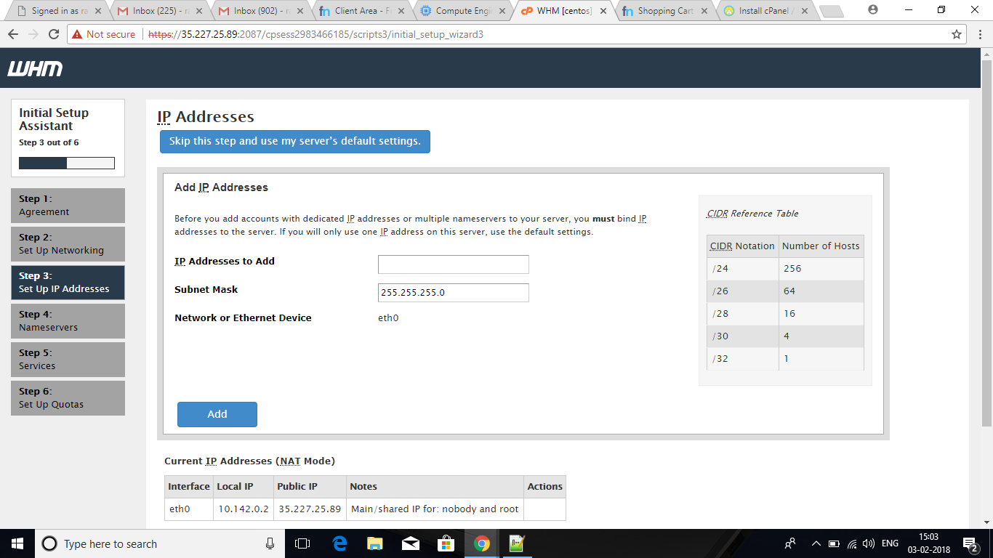

* Go to Step 4

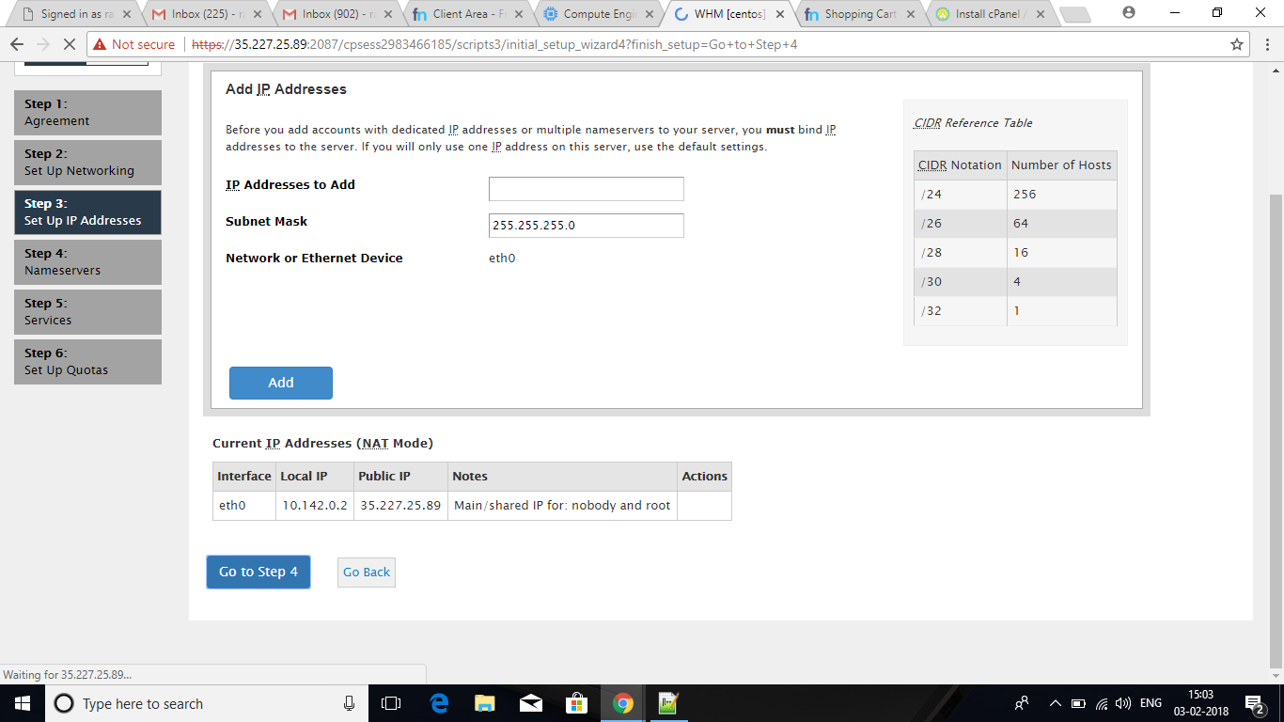

* Configuring Nameserver and Hostname

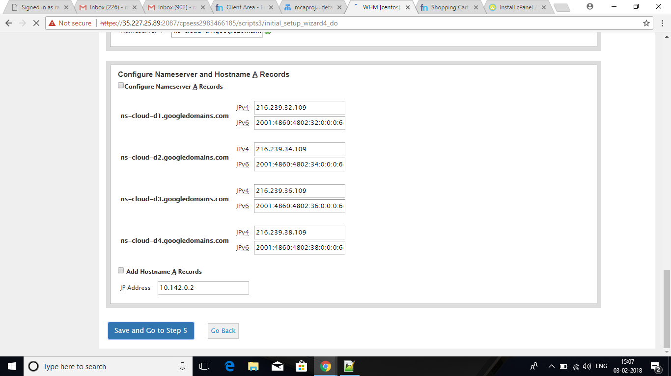

* Configuring FTP services

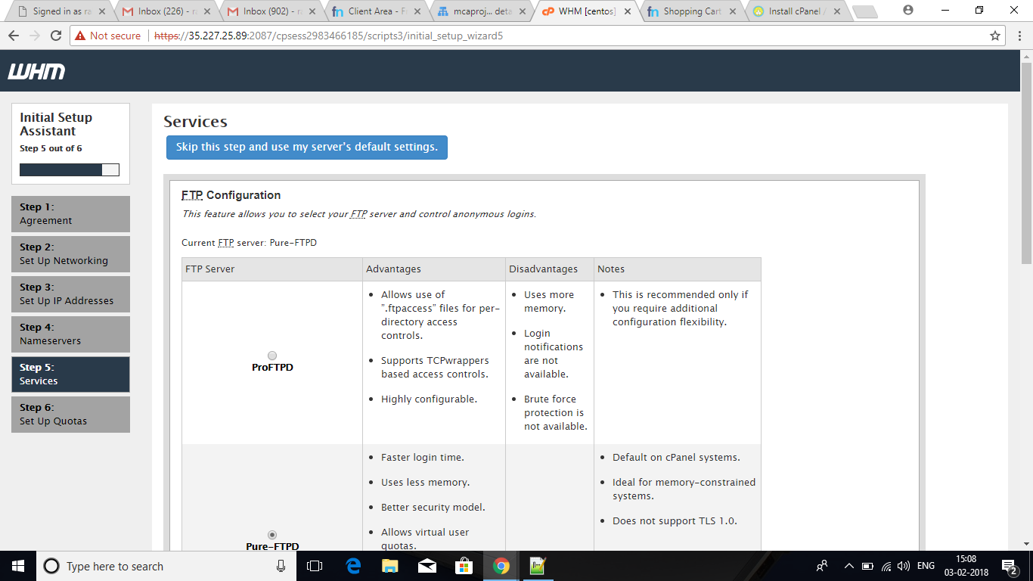

* 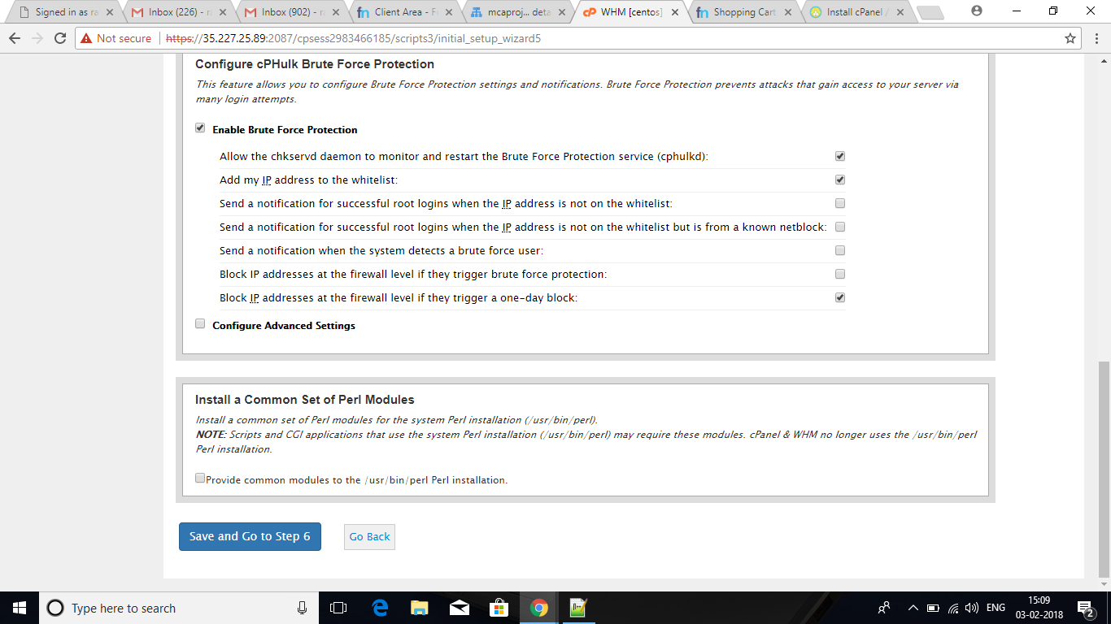Save and Go To step 6
* 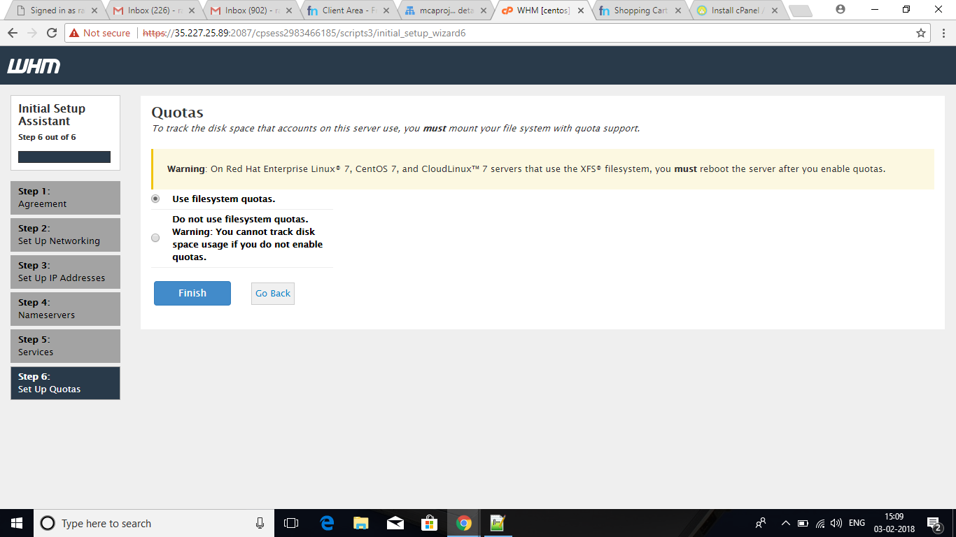Finish the Initial Setup
* Once completed the above step, select Go to WHM

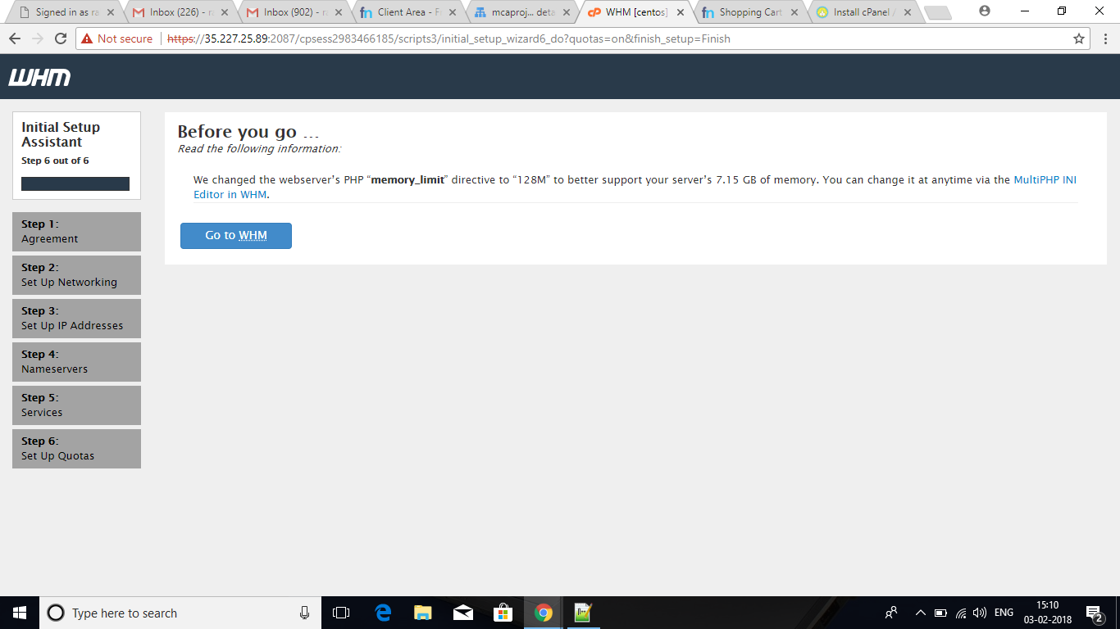

* Feature Showcase of WHM panel

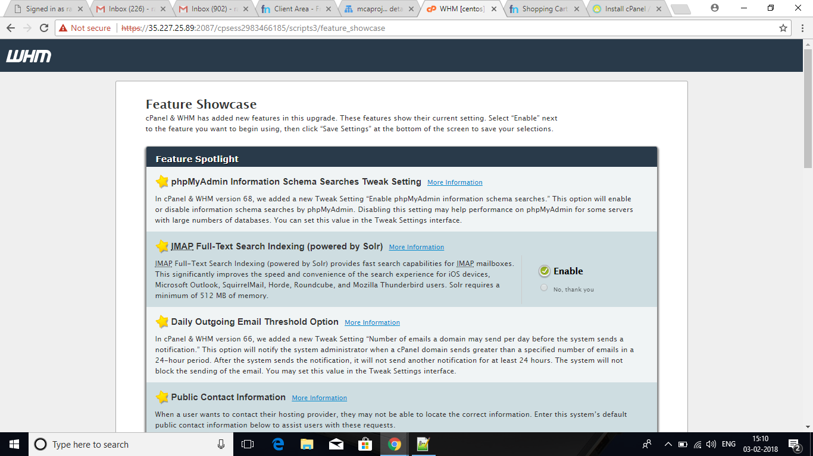

* Save your Settings

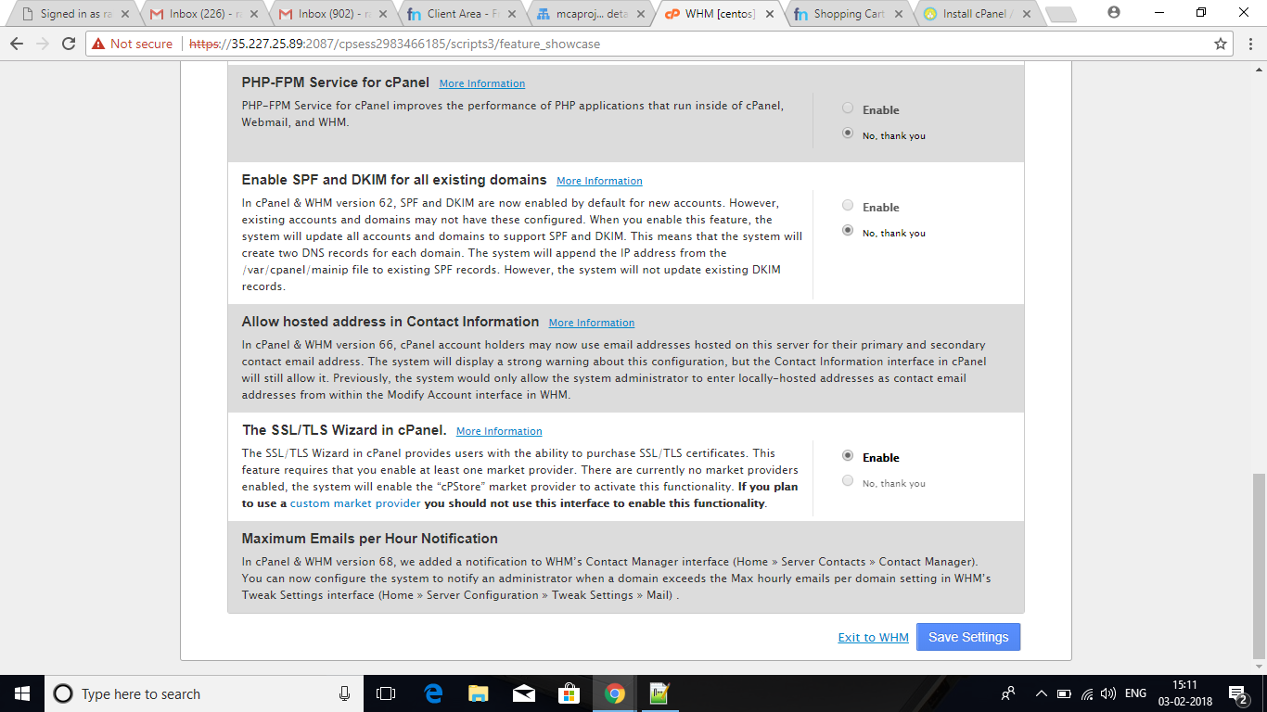

* Enabling all the settings

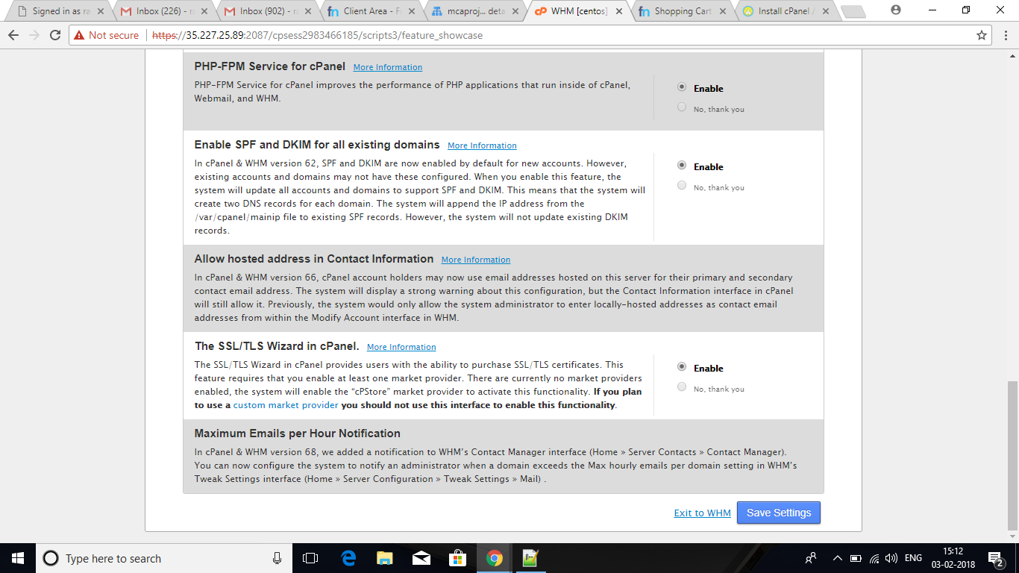

* Settings Enabled

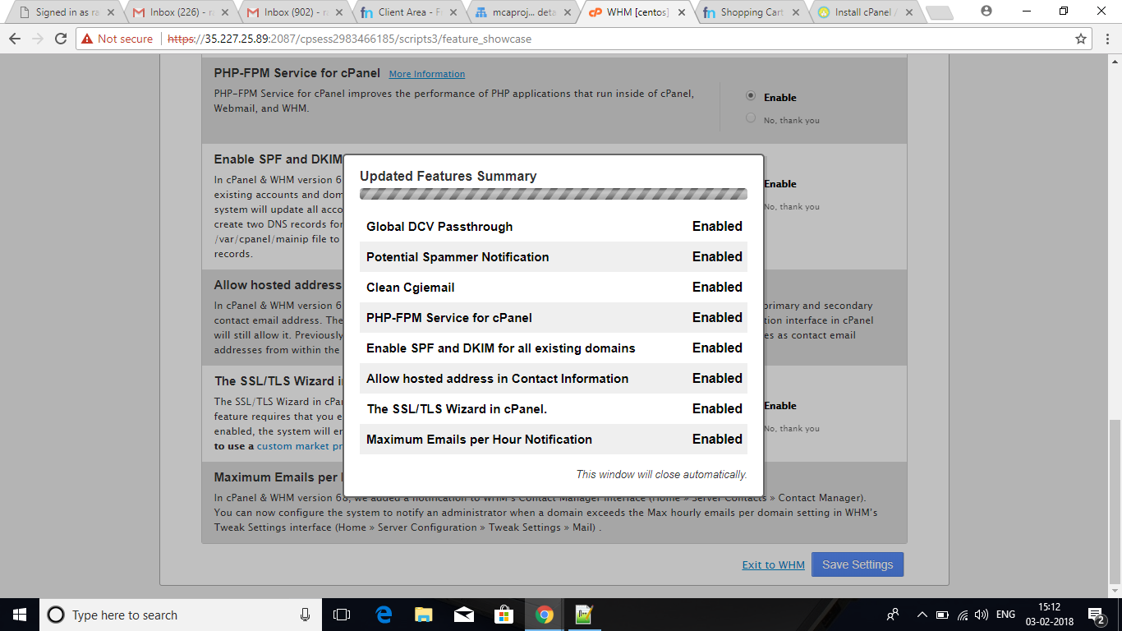

* Successfully redirected to WHM Account

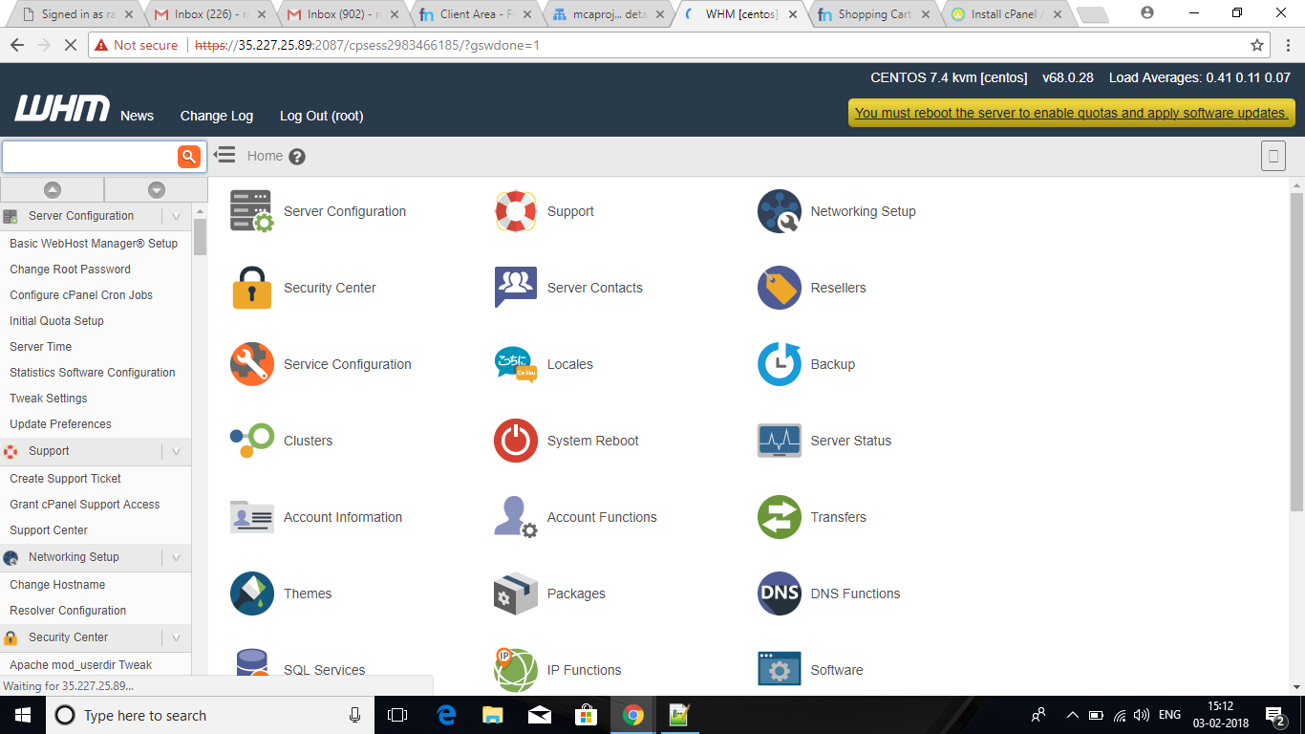

* Once you access the WHM panel, you can Create a new cPanel Account

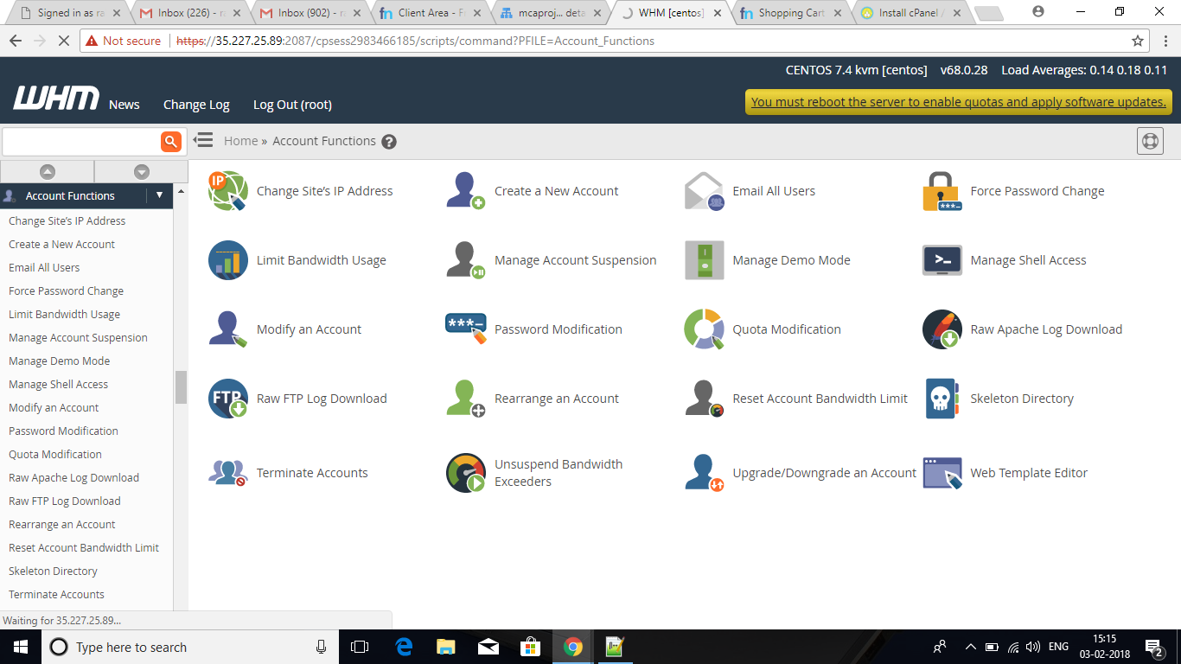

* cPanel Account creation with your registered domain name

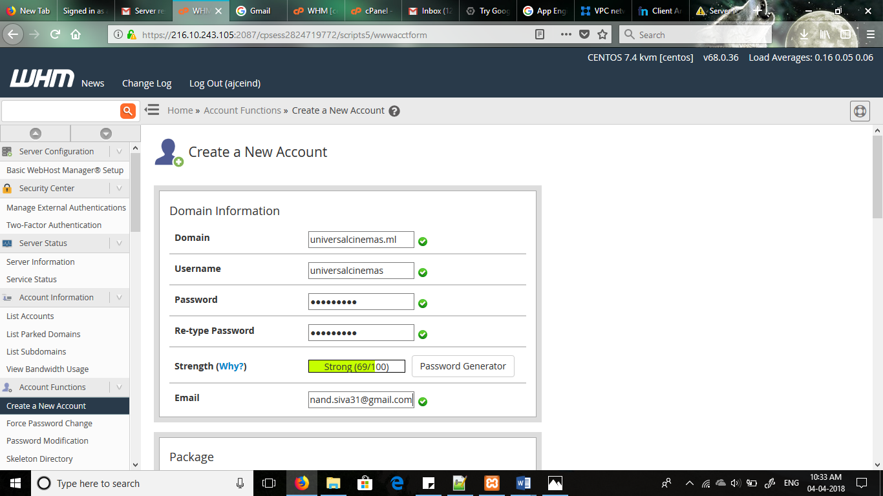

* Configuring Mail Routing settings

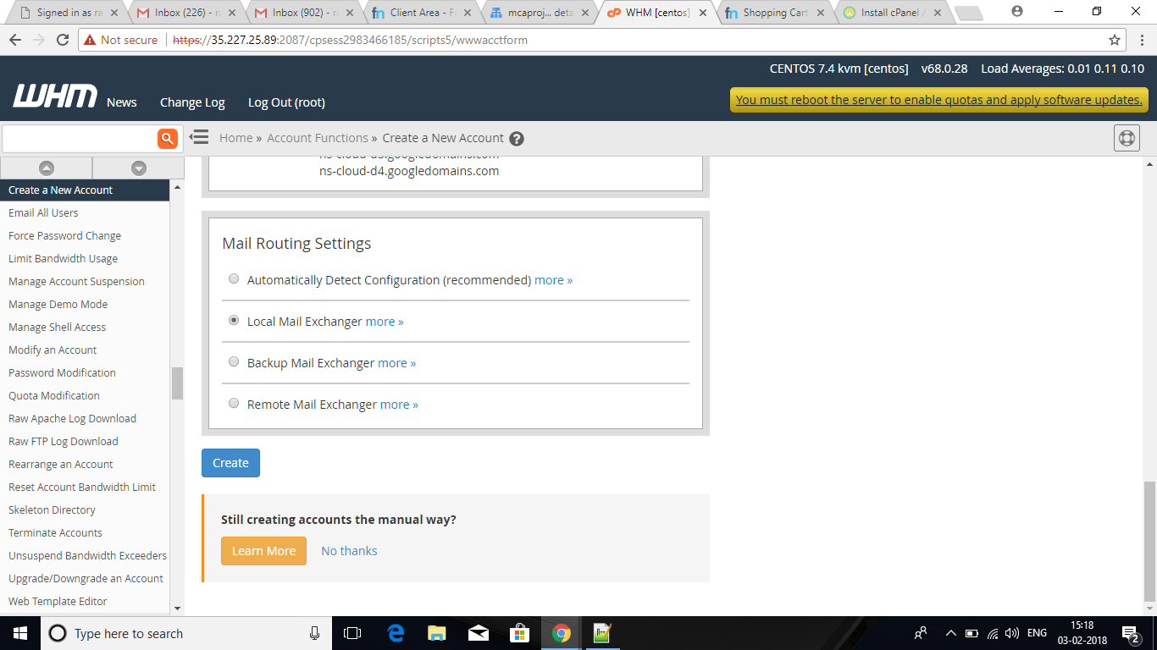

* Creating the cPanel account

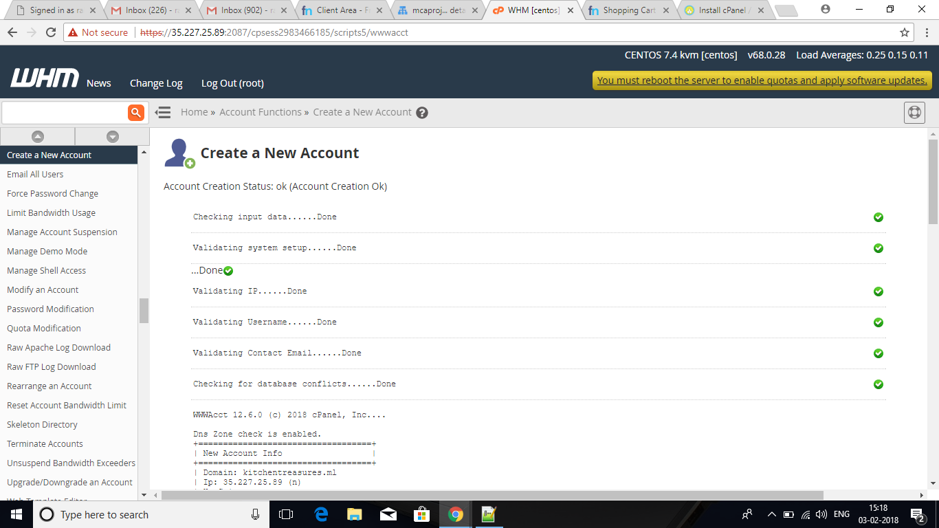

* Finding Account Information

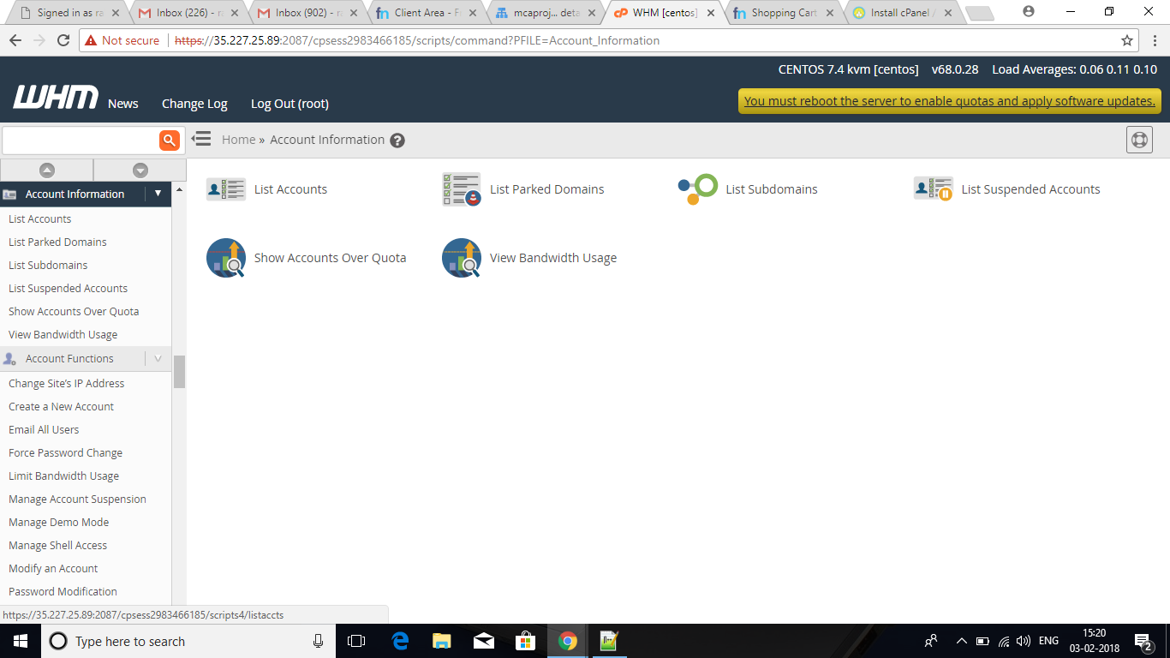

* Checking the Firewall Rules

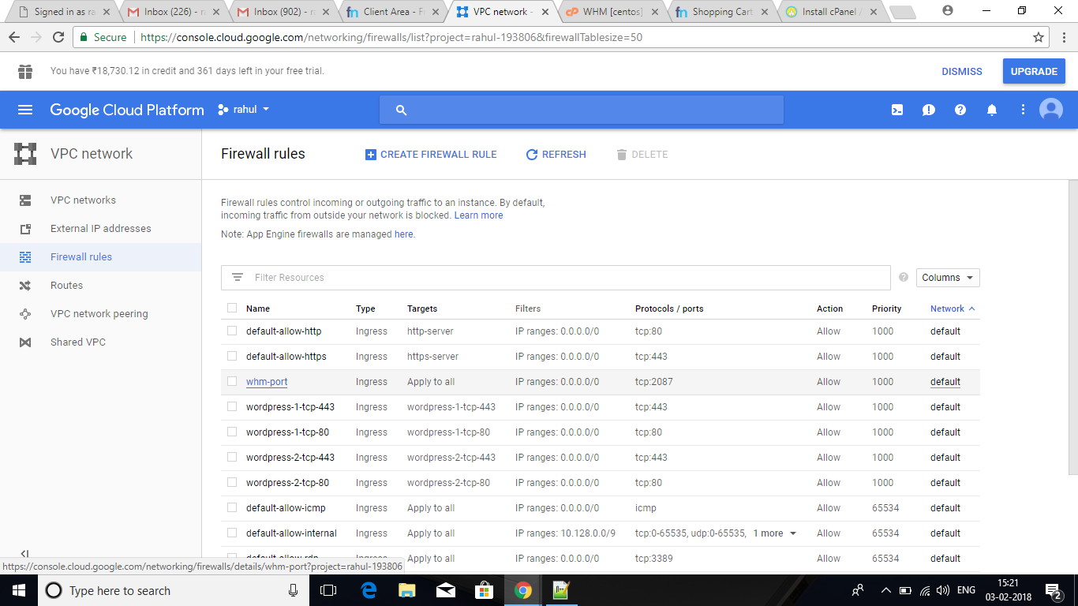

* Creating a Firewall rule for cPanel

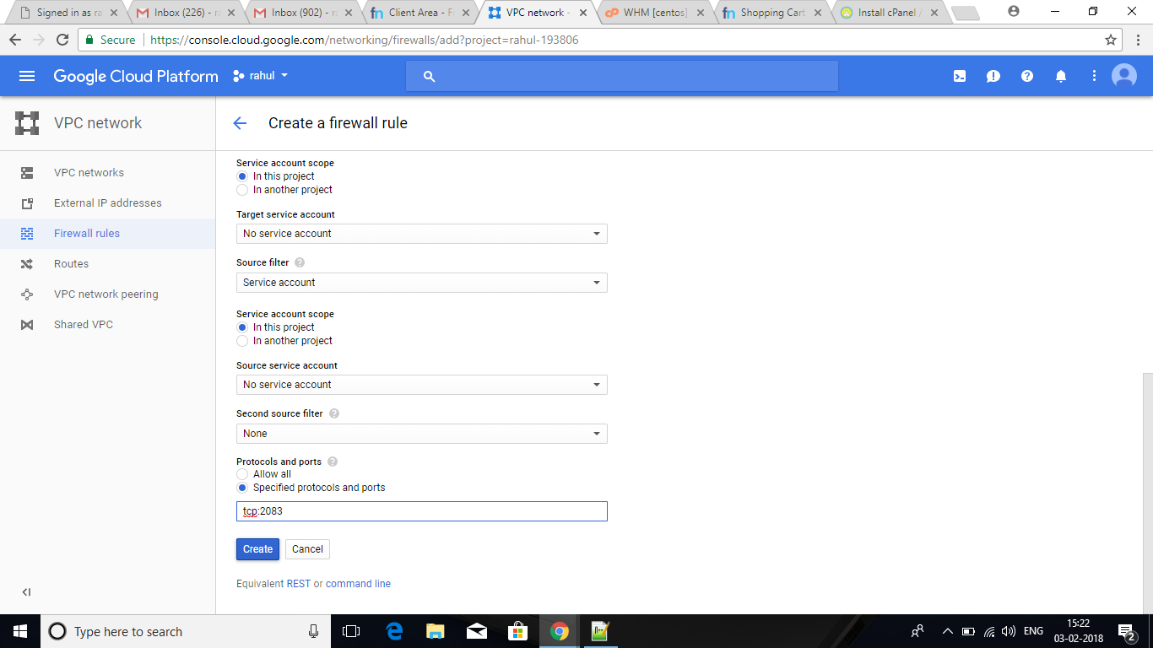

* Once all the above process is completed, you will be able to access the cPanel File Manager

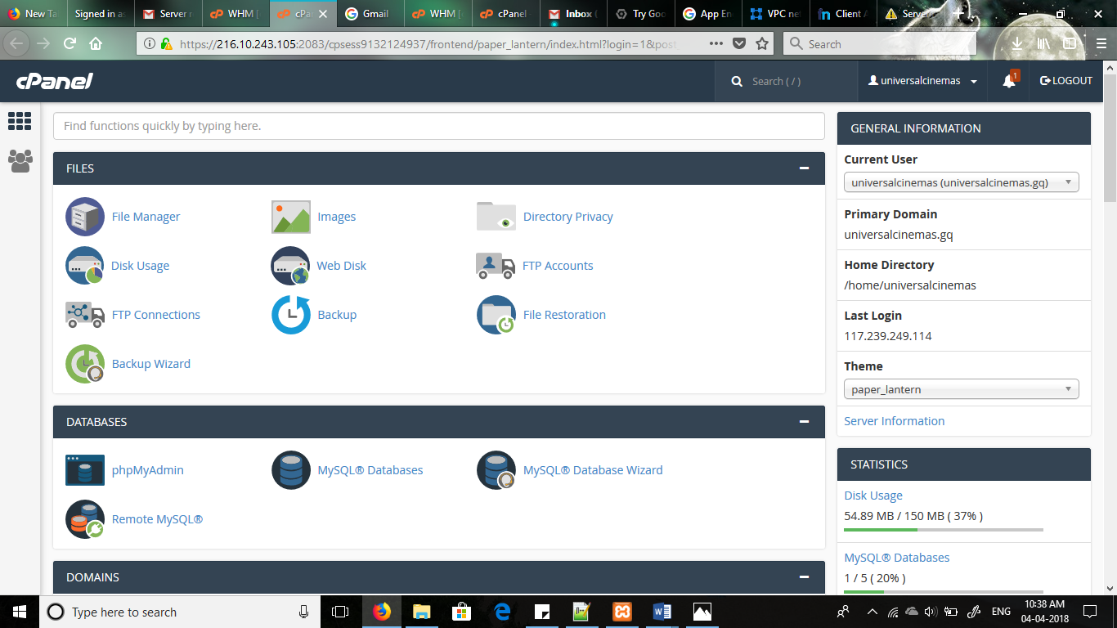

* Open Public_html folder to store your project files.

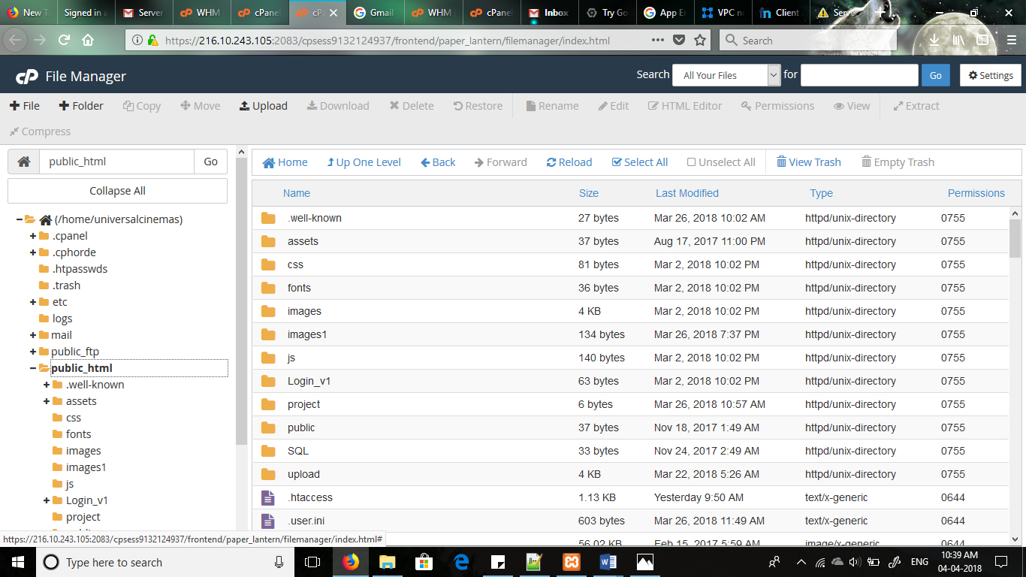

* Zip the project source and upload, extract the contents to here



* Go to MySQL Database and create new user and set all privileges to user.
* Create new Database and go to phpMyAdmin to import database.
* Once successfully imported, Edit your connection string of Database file with created username and password.

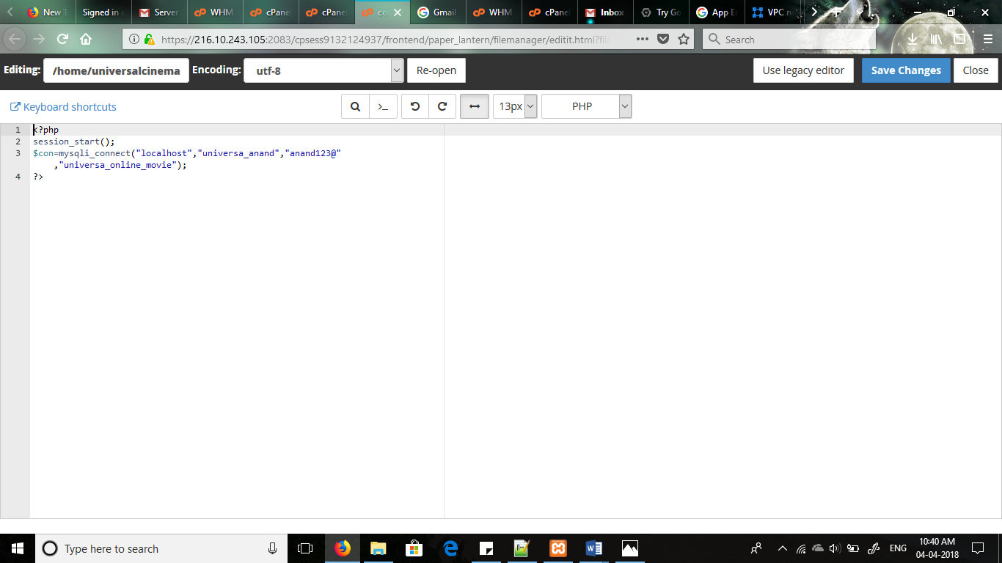

* Creating SQL Instance

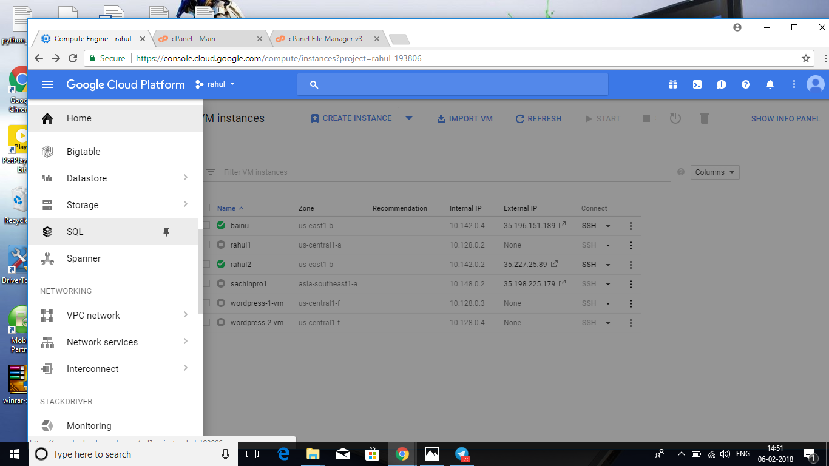

* Choose an SQL instance type

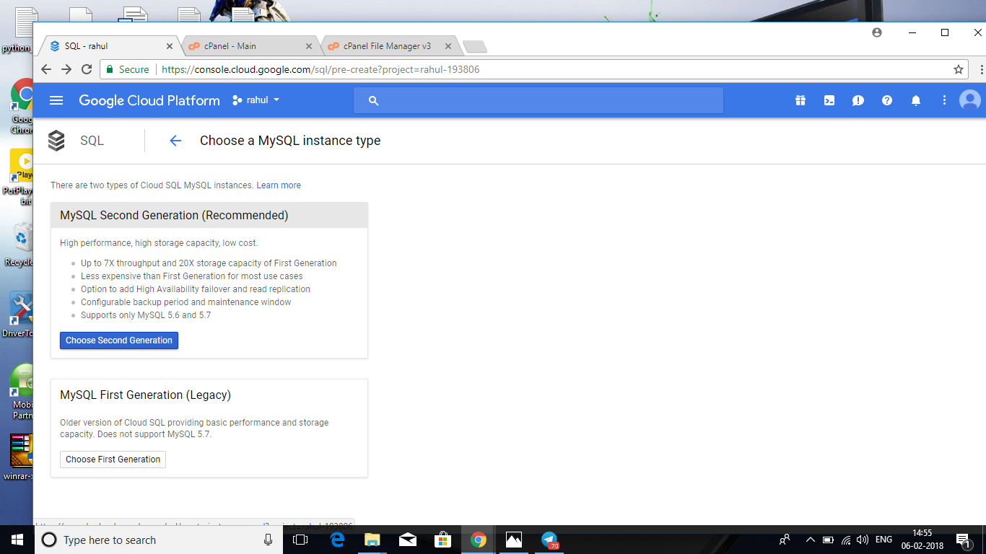

* Create MySQL Second Generation Instance

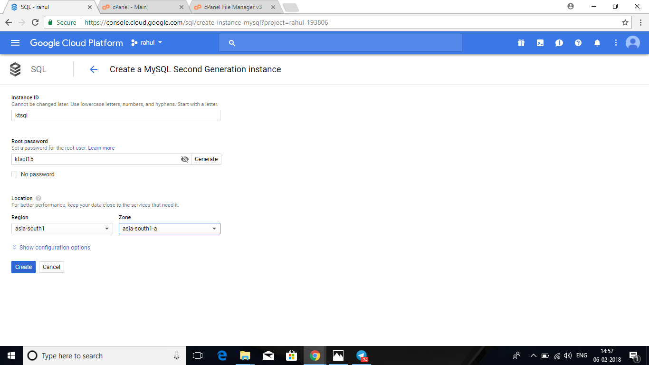

* Create an Instance of the second generation

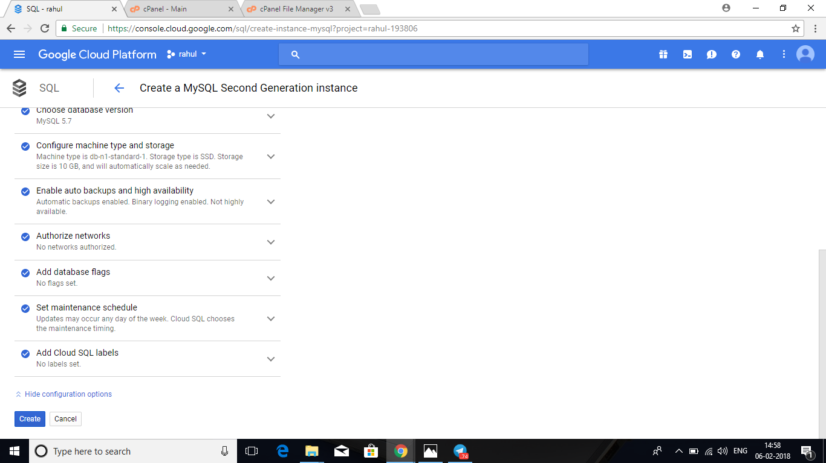

* Instance Created with a Failover

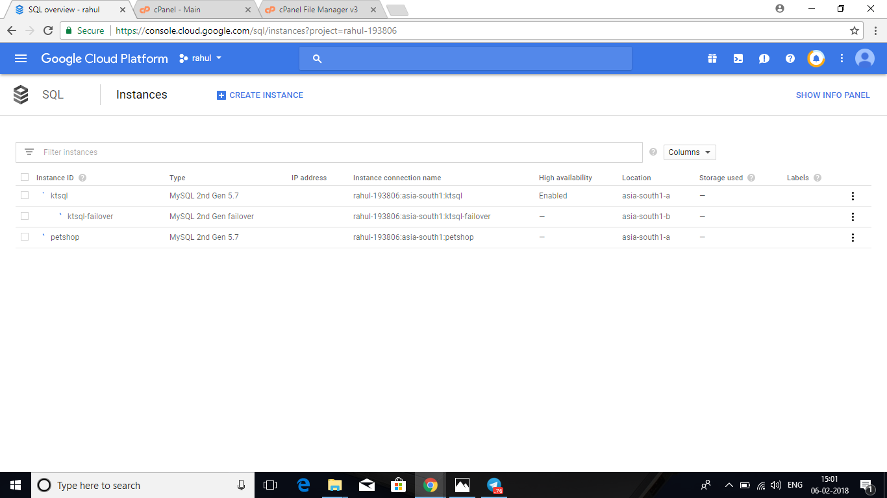

* SQL Instance is activated

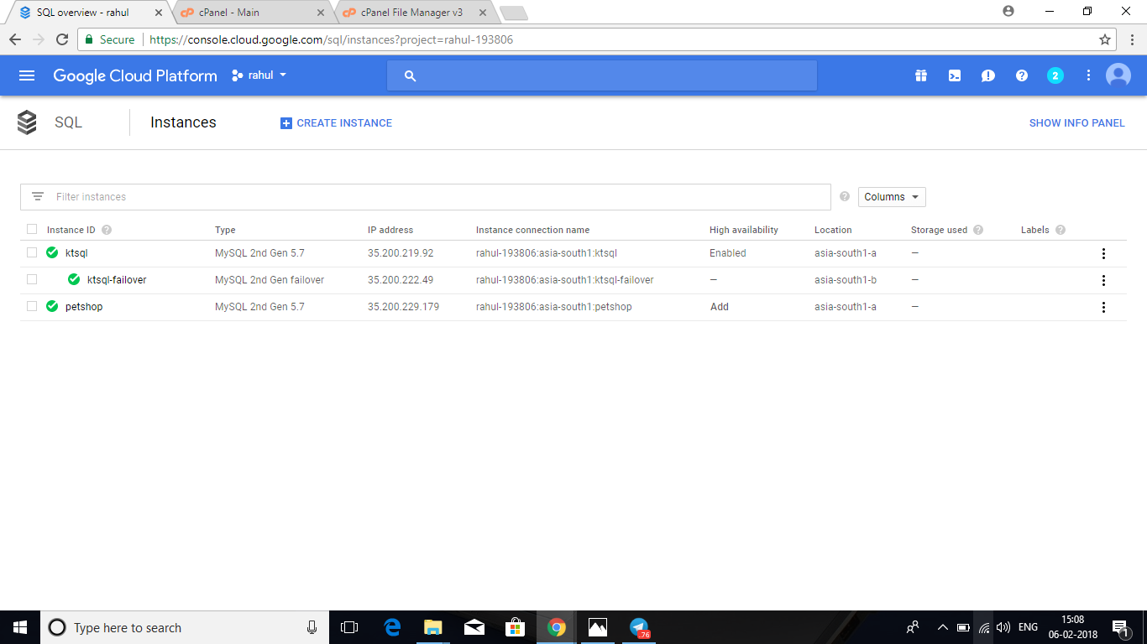

* Transfer the SQL file to an instance

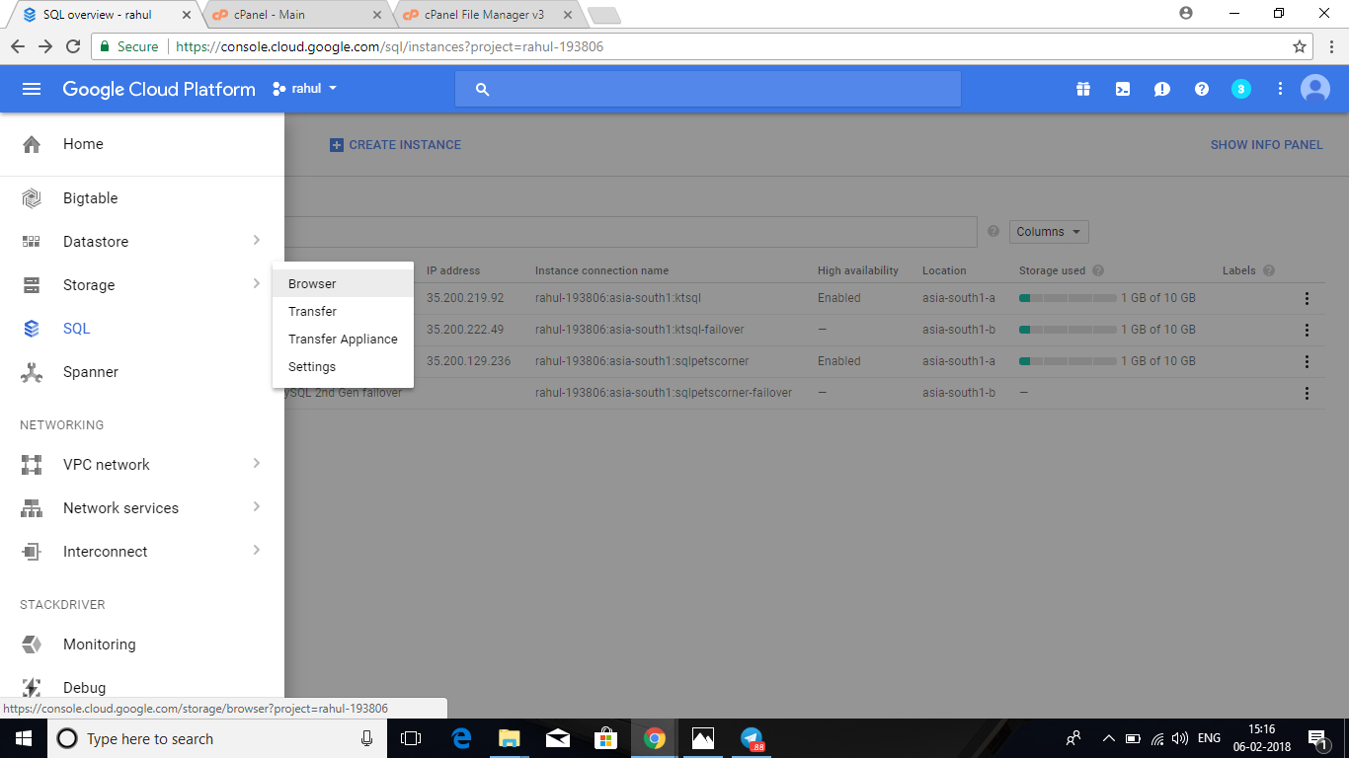

* Creating Buckets to store the files

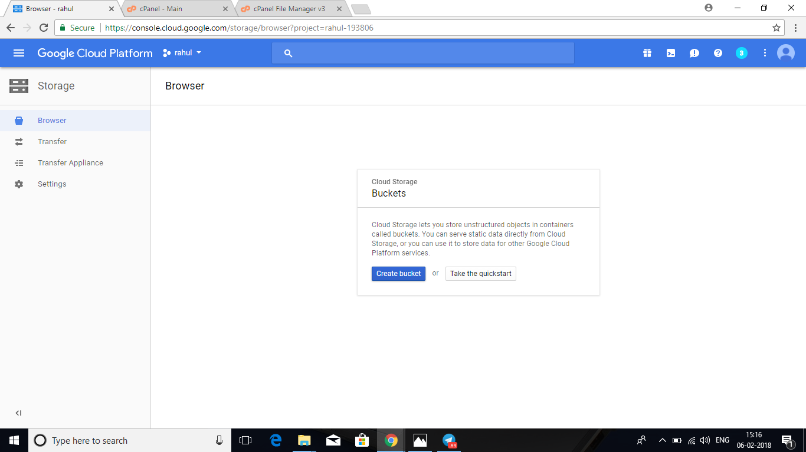

* Bucket Creation steps

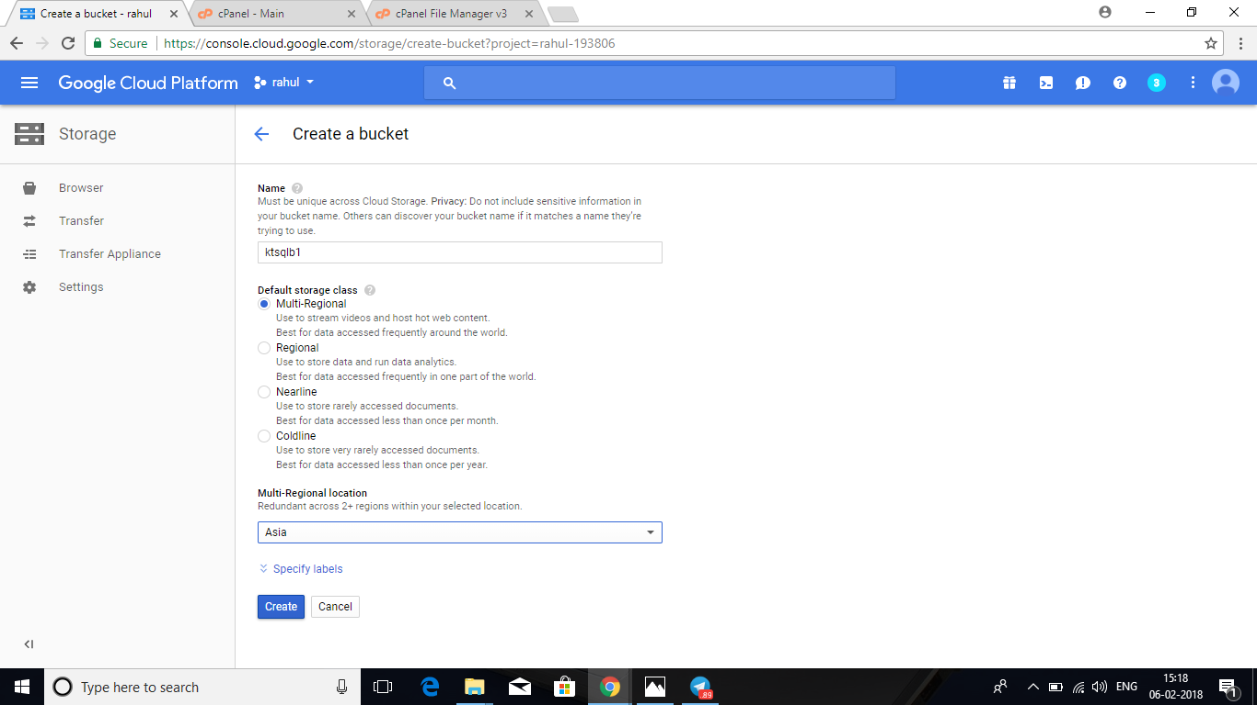

* Uploading files to buckets

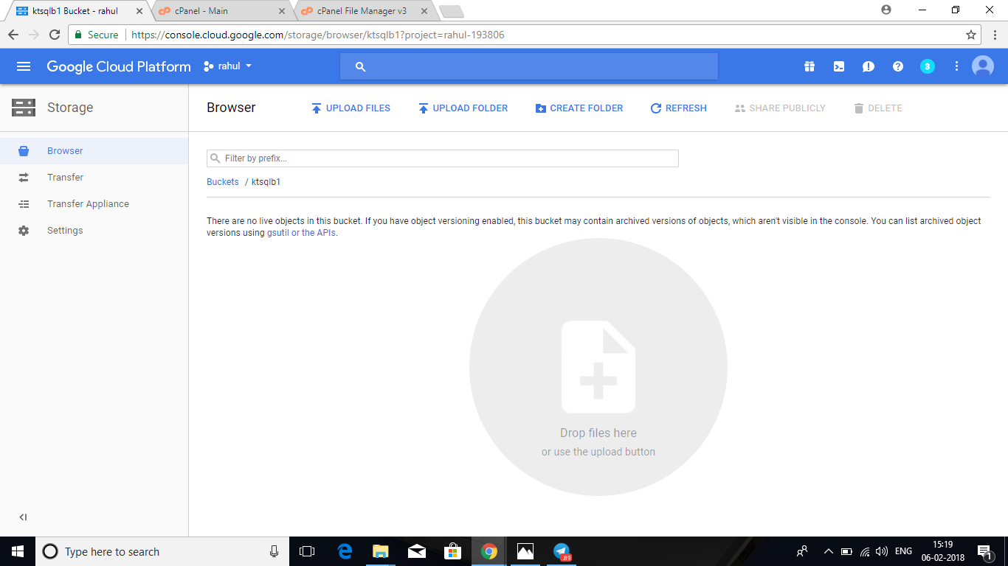

* Upload files

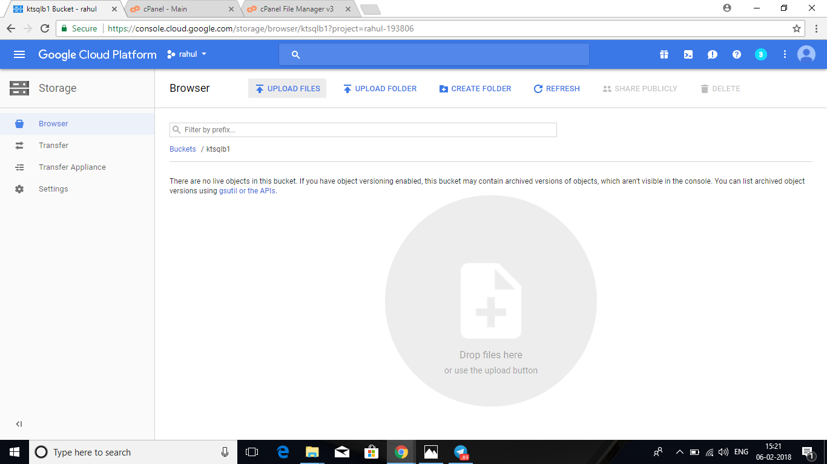

* File Uploaded

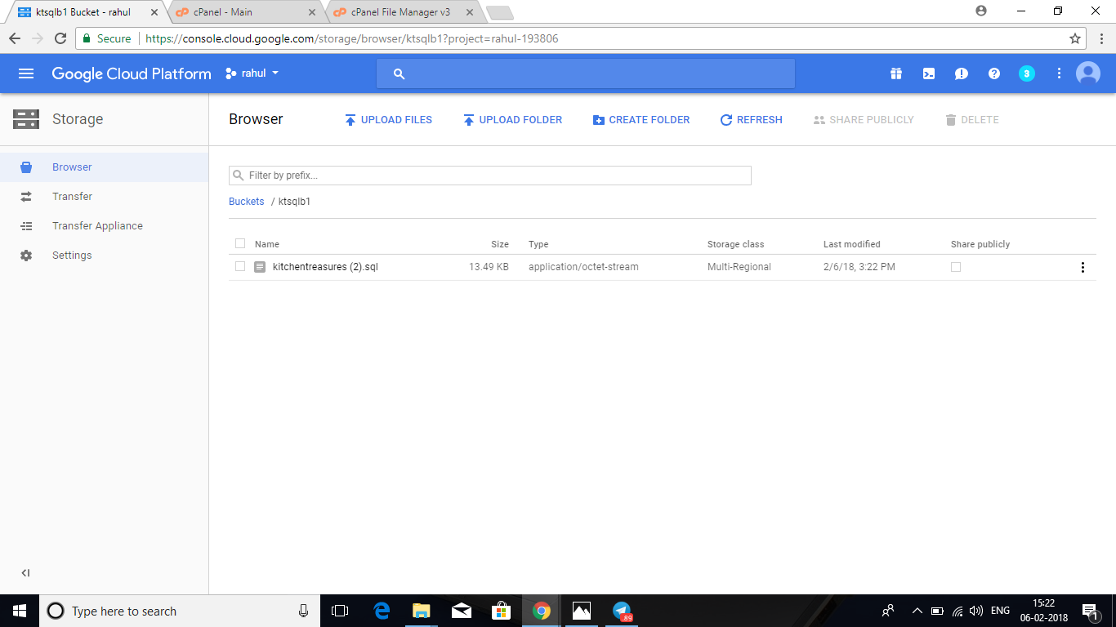

* Instance Details

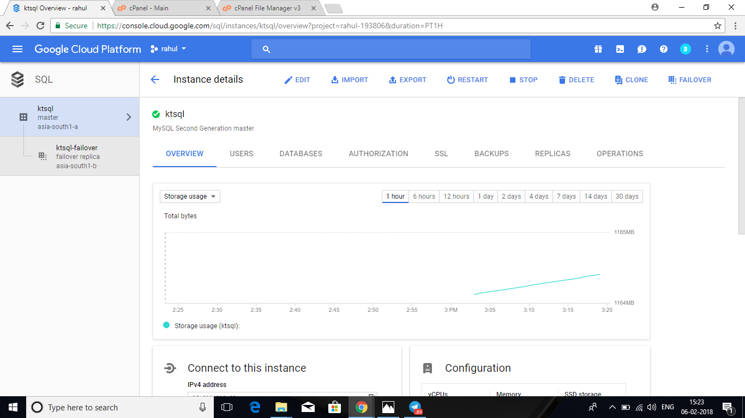

* Create a User Account

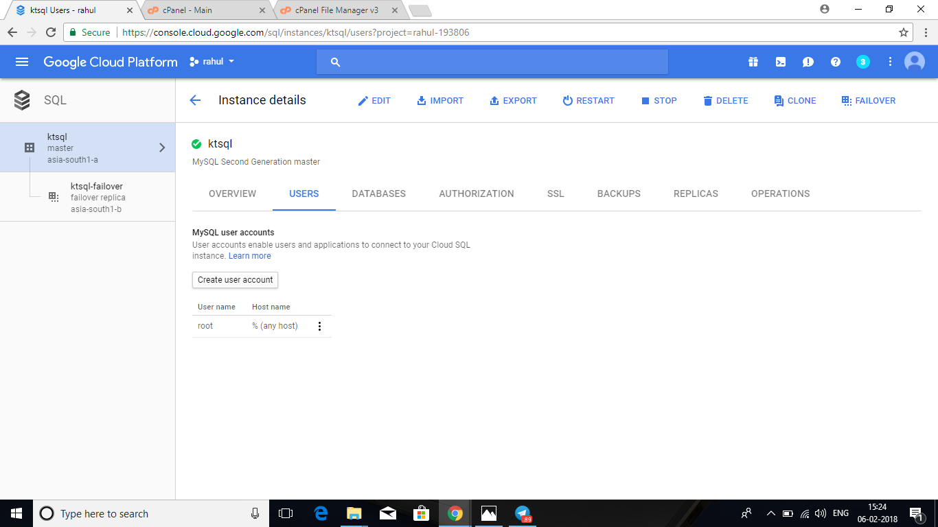

* Providing a name for the user account

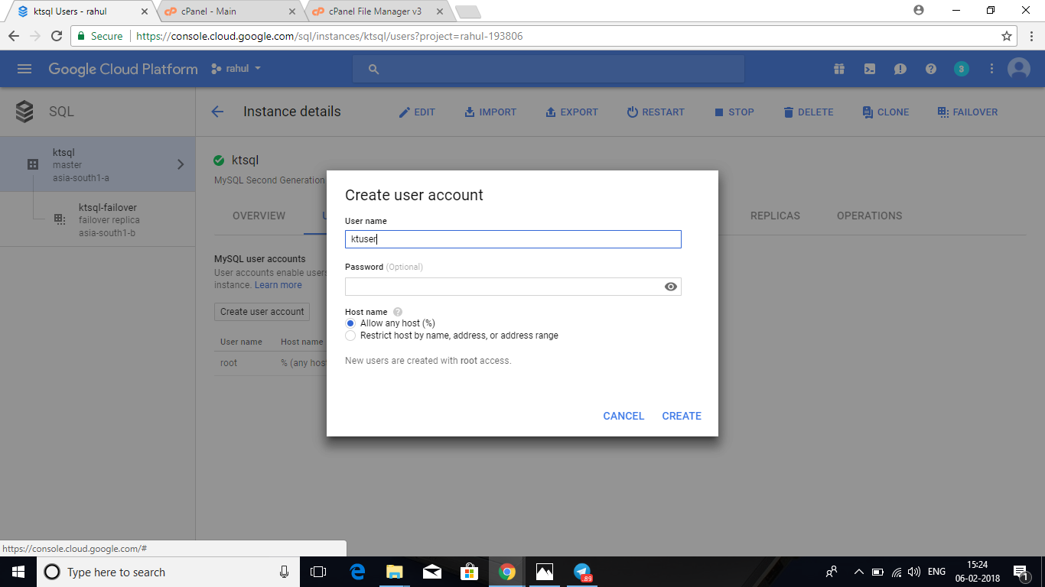

* Authorization of Instance

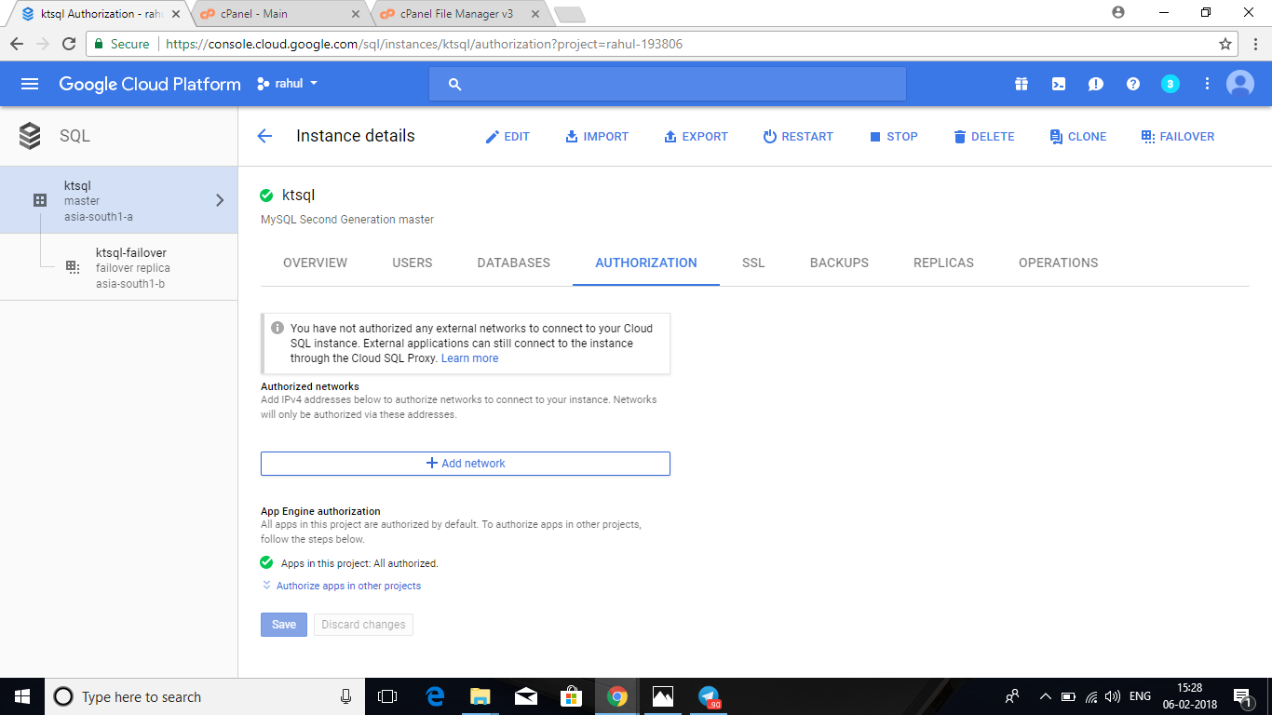

* Network Configuration of Instances

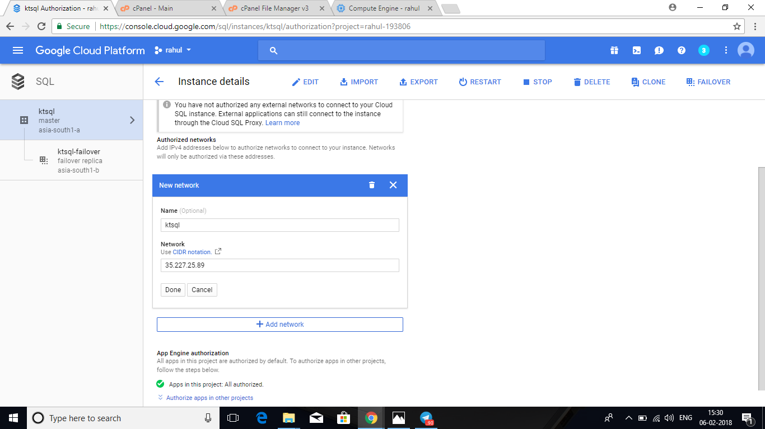

* Overview of the Instance

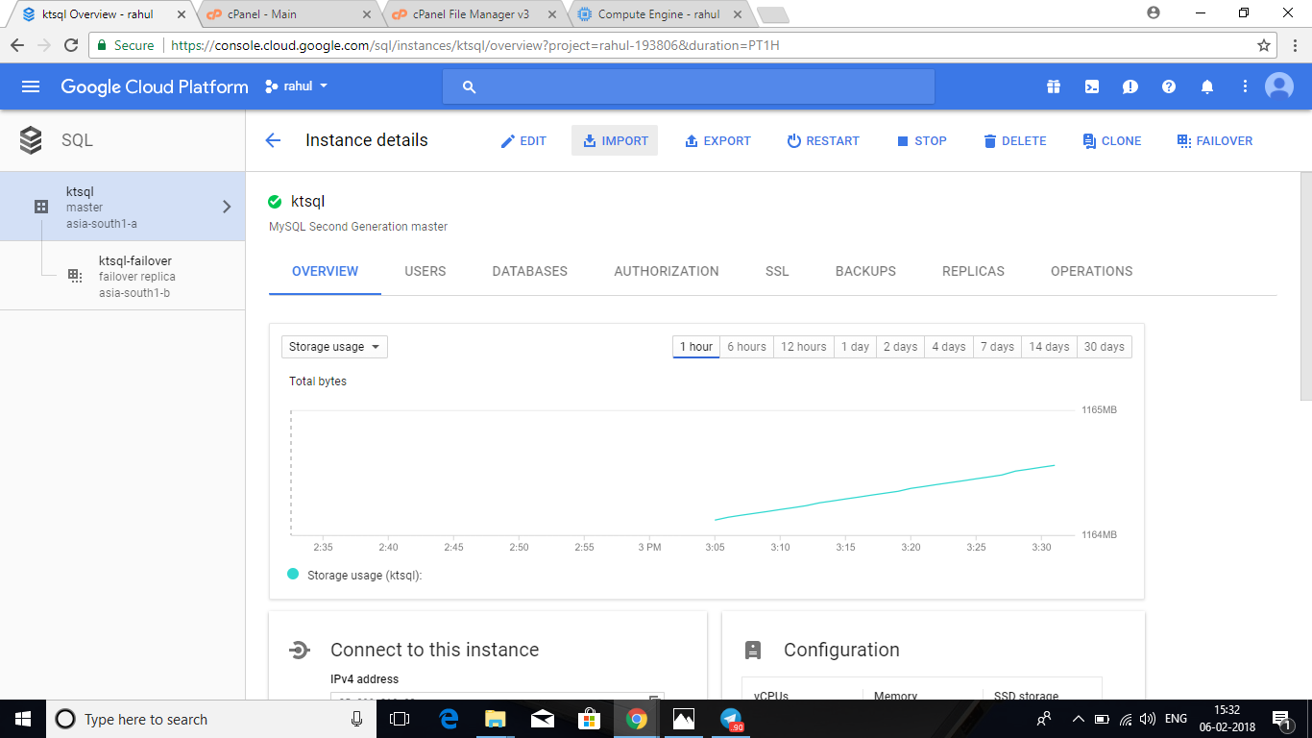

* Change the import settings of cloud storage

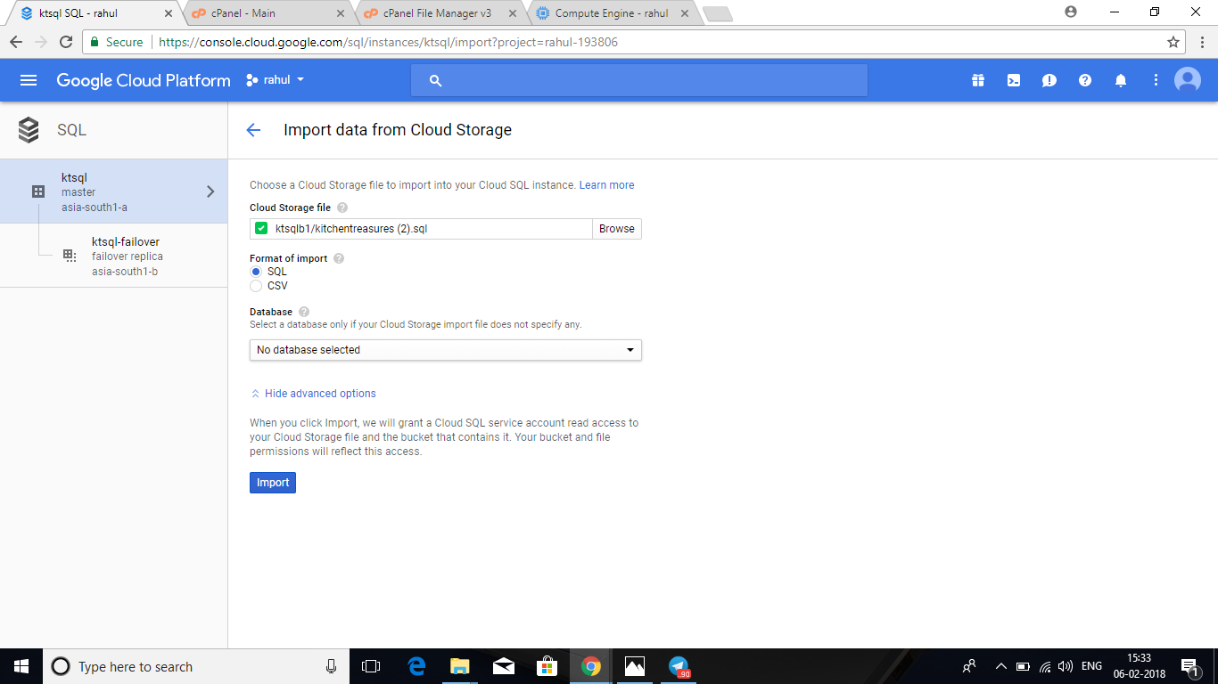

* Change the connection string of Database. Php

**P1.1.3 Google AppEngine**

Google App Engine is a Platform as a Service ([PaaS](http://searchcloudcomputing.techtarget.com/definition/Platform-as-a-Service-PaaS)) product that provides [Web app developers](http://searchcloudapplications.techtarget.com/definition/Web-app-development) and enterprises with access to Google's [scalable](http://searchdatacenter.techtarget.com/definition/scalability) hosting and tier 1 Internet service.

Google App Engine is Google's platform as a service offering that allows developers and businesses to build and run applications using Google's advanced infrastructure. These applications are required to be written in one of a few supported languages, namely: Java, Python, PHP and Go. It also requires the use of Google query language and that the database used is Google Big Table. Applications must abide by these standards, so applications either must be developed with GAE in mind or else modified to meet the requirements.

GAE is a platform, so it provides all of the required elements to run and host Web applications, be it on mobile or Web. Without this all-in feature, developers would have to source their own servers, database software and the APIs that would make all of them work properly together, not to mention the entire configuration that must be done. GAE takes this burden off the developers so they can concentrate on the app front end and functionality, driving better user experience.

Advantages of GAE include:

* Readily available servers with no configuration requirement
* Power scaling function all the way down to "free" when resource usage is minimal
* Automated cloud computing tools

Step 1- Starting App Engine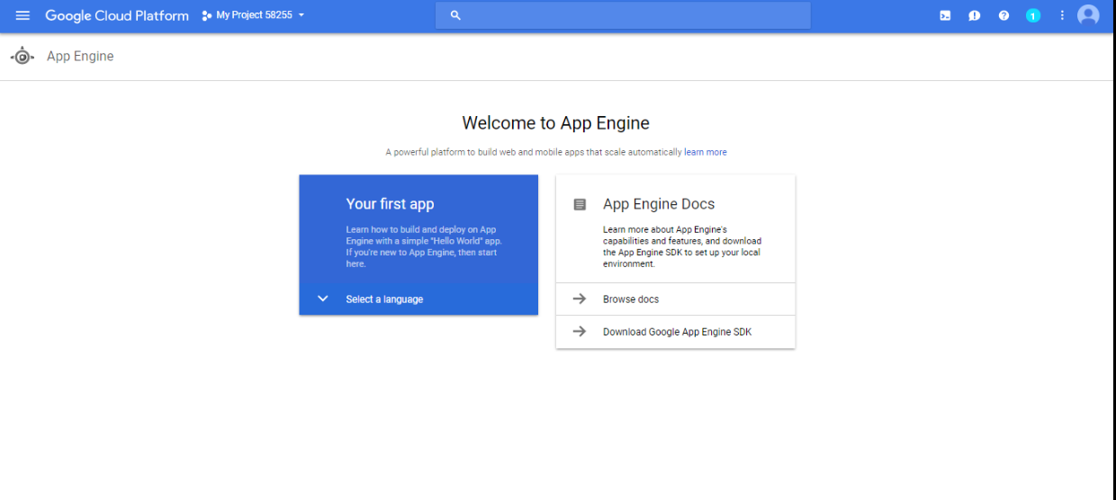

Step 2- Choosing language(Php)

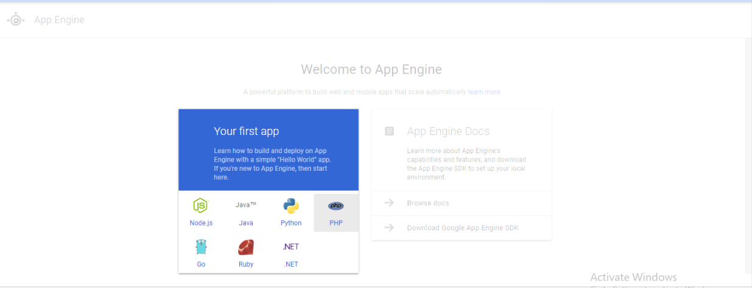

Step 3- Choosing the region

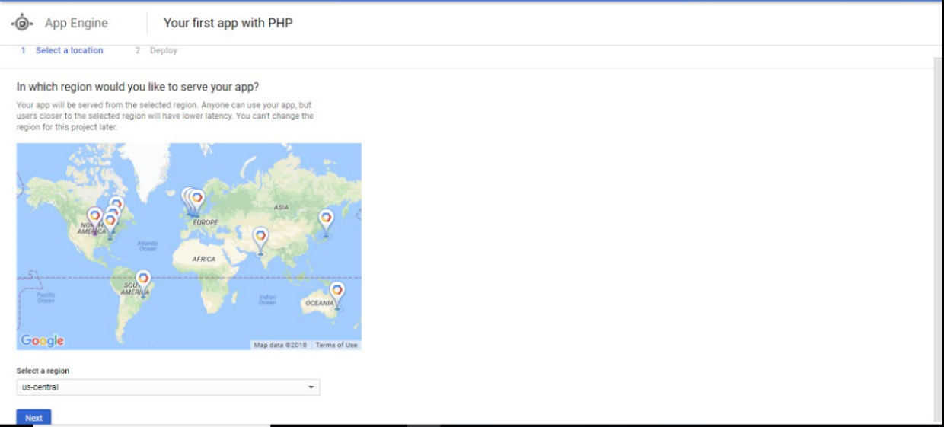

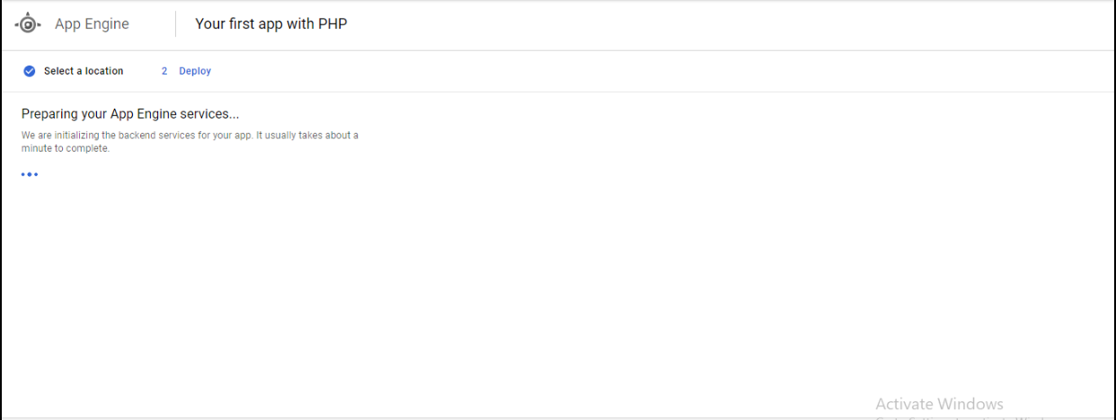

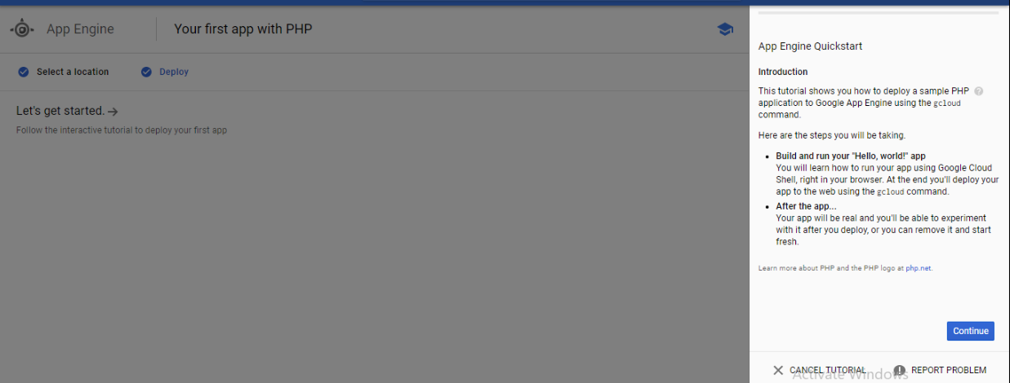

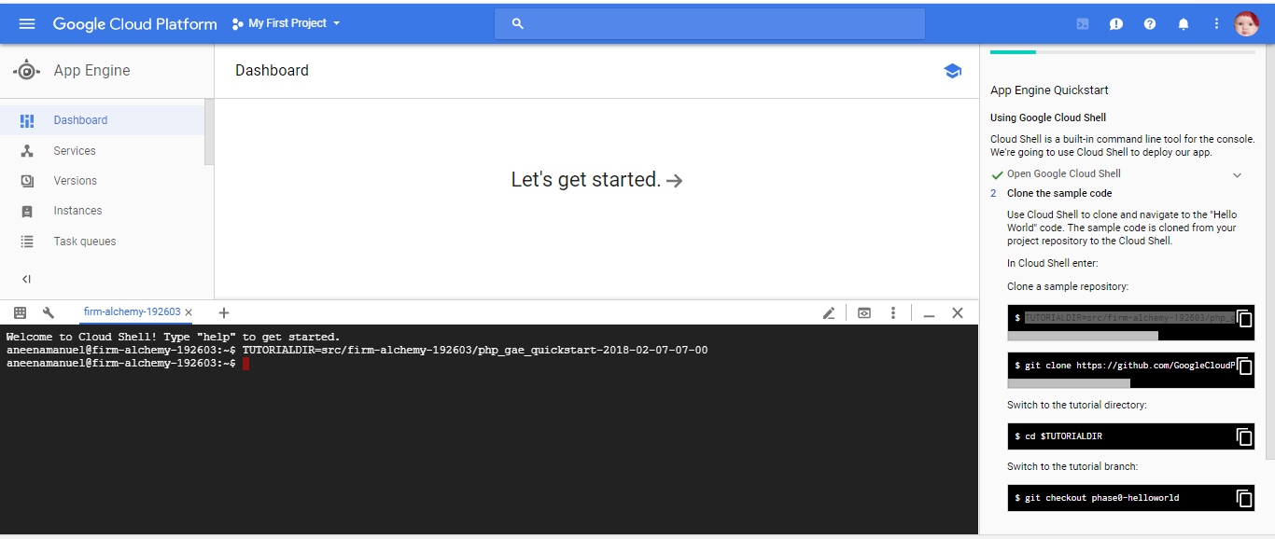

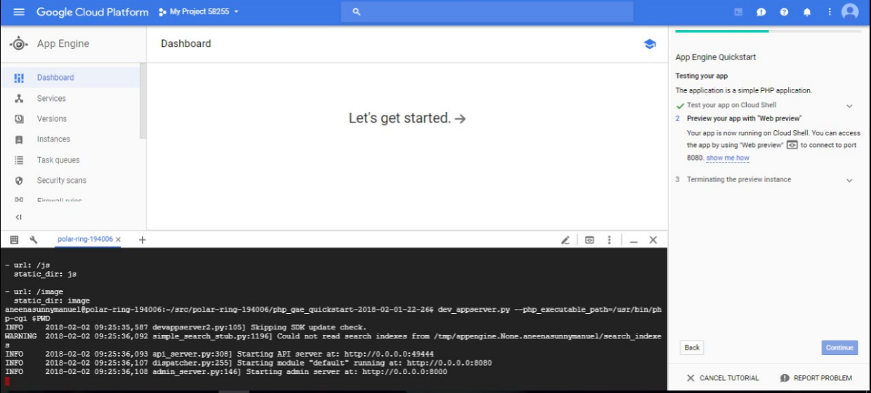

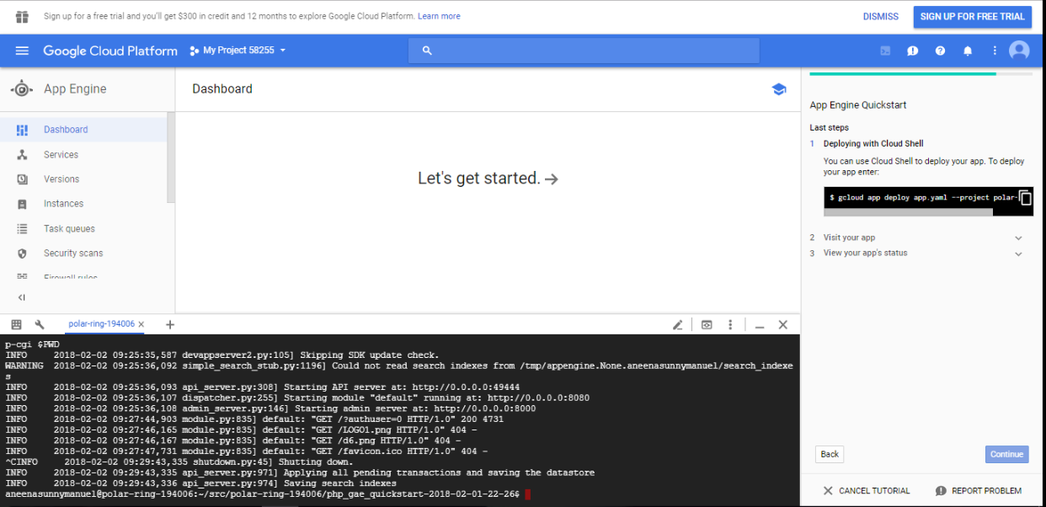

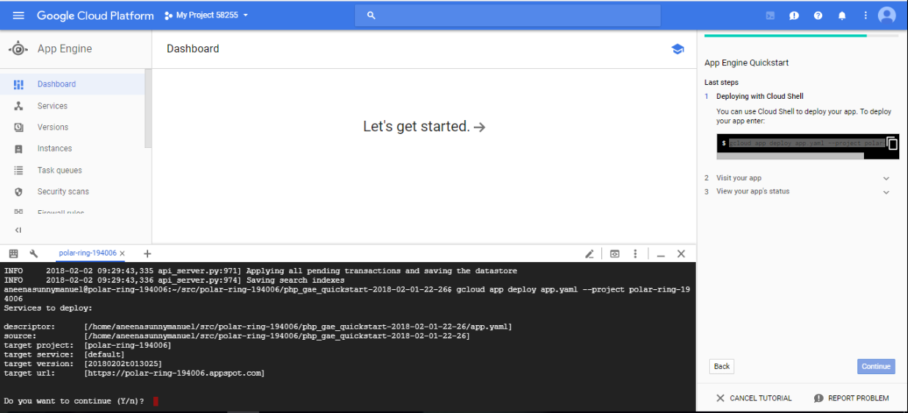

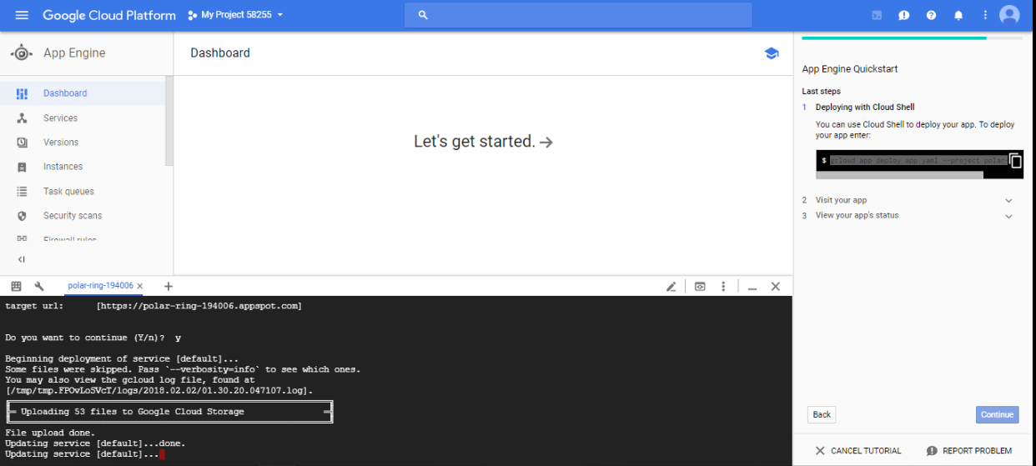

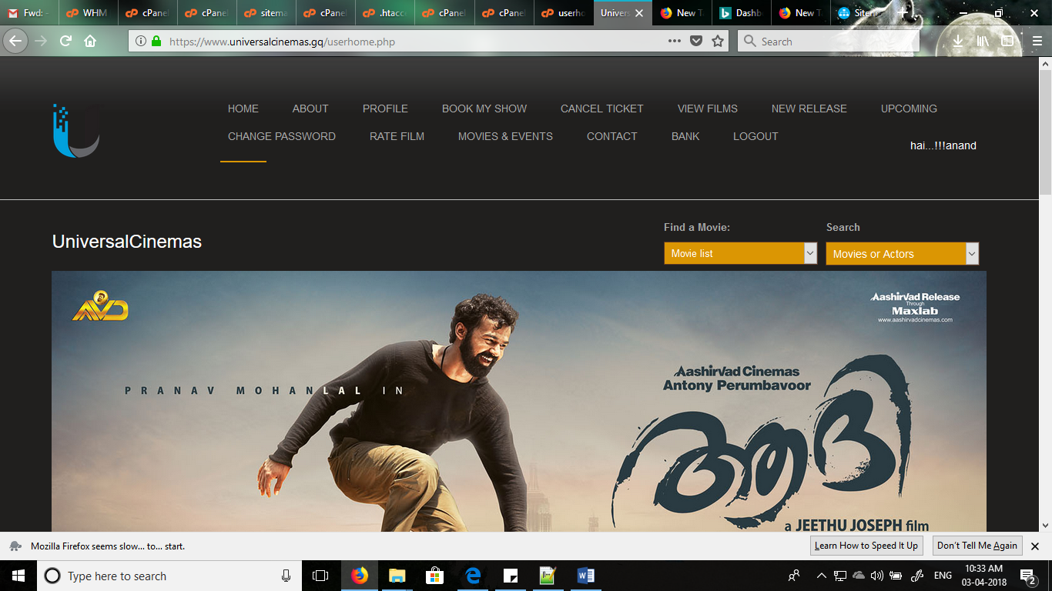

**P1.1.4 Cloud Launcher**

Google Cloud Launcher lets you quickly deploy functional software packages that run on Google Cloud Platform. Even if you are unfamiliar with services like [Compute Engine](https://cloud.google.com/compute/docs/) or [Cloud Storage](https://cloud.google.com/storage/docs/), you can easily start up a familiar software package without having to manually configure the software, virtual machine instances, storage, or network settings. Deploy a software package now, and scale that deployment later when your applications require additional capacity. Google Cloud Platform updates the images for these software packages to fix critical issues and vulnerabilities but doesn't update software that you have already deployed.

Step 1- Move to Cloud Launcher and select wordpress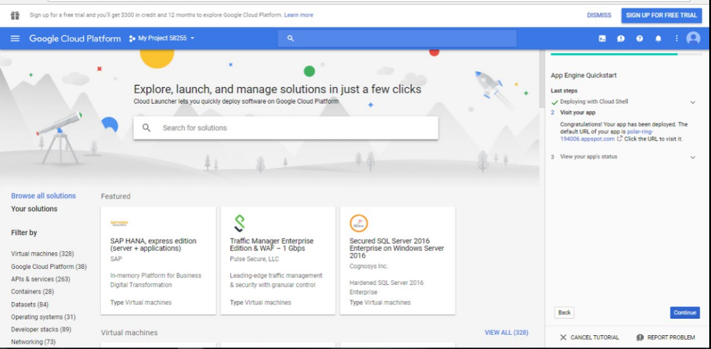

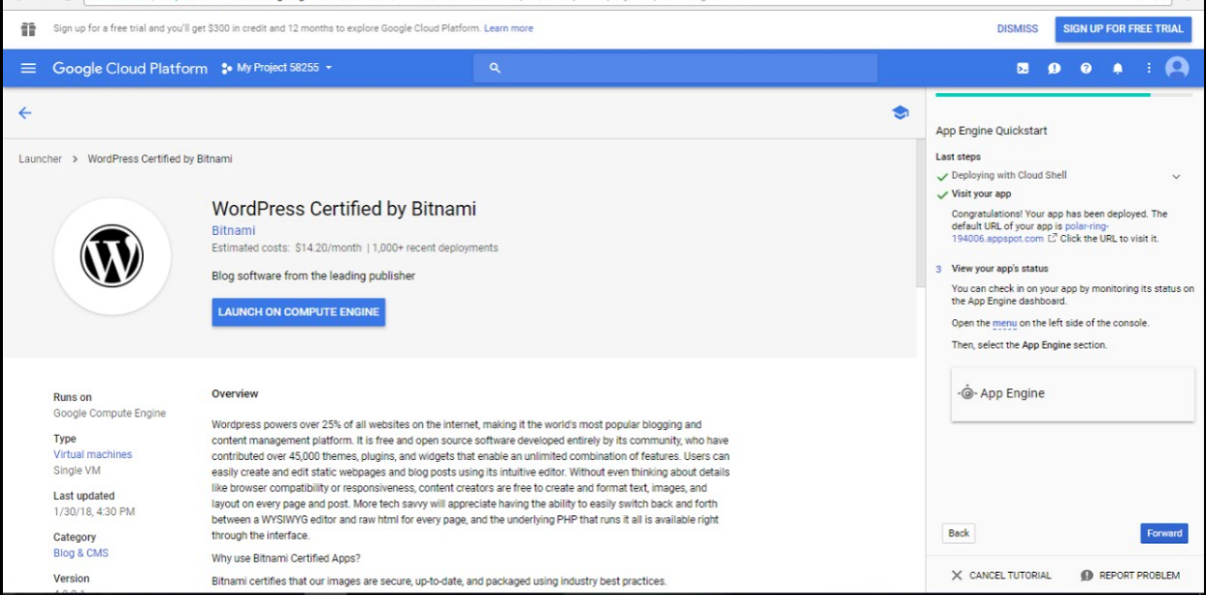

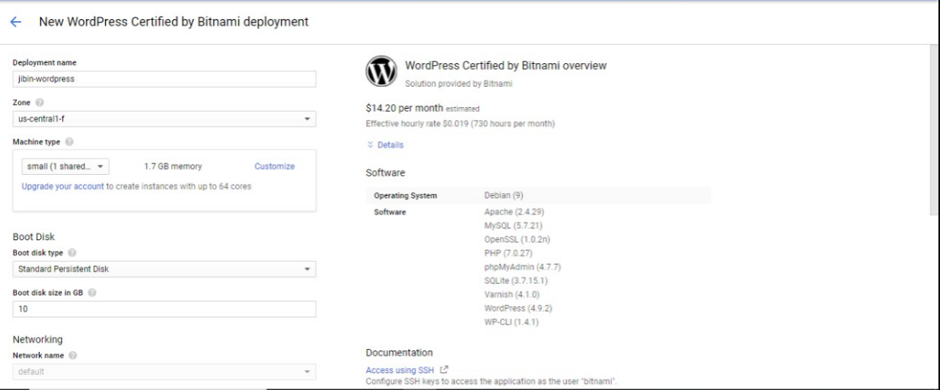

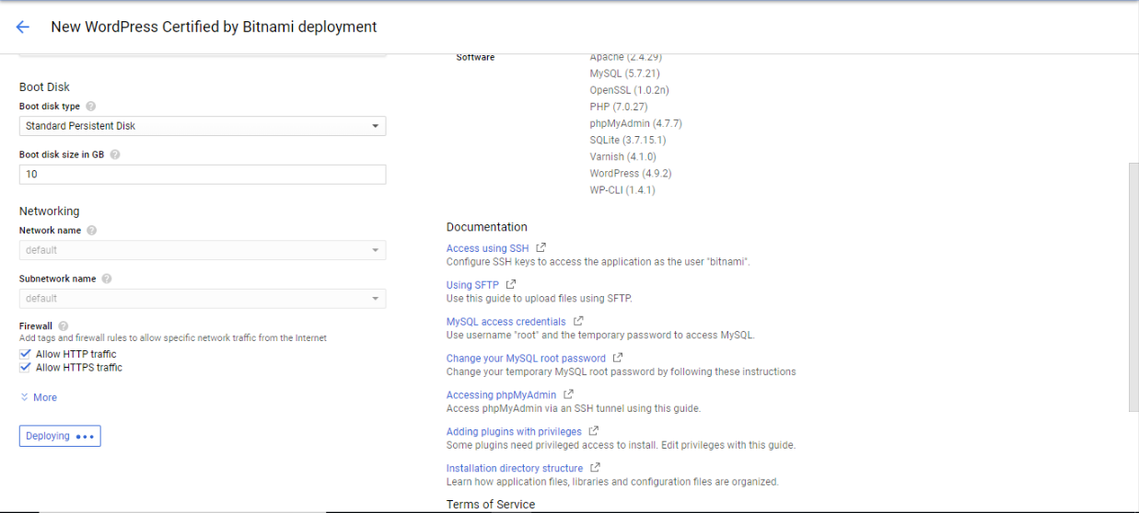

Step 2- Deploying Wordpress

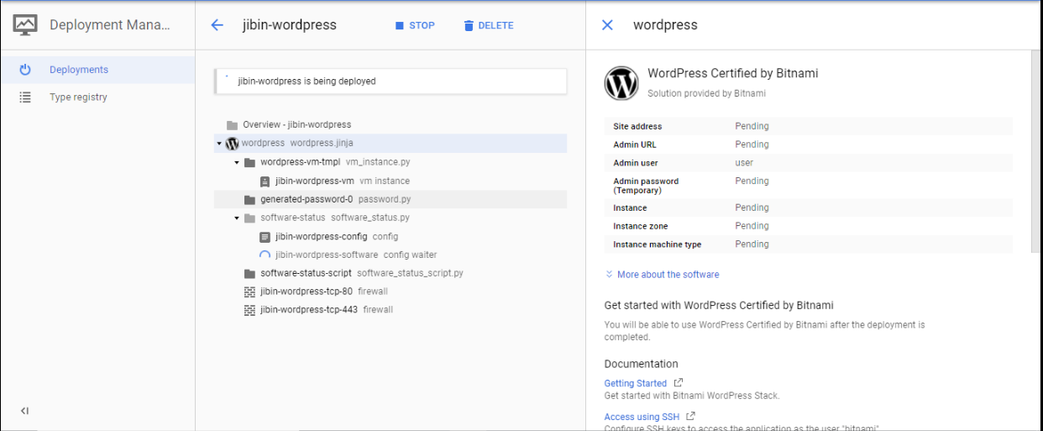

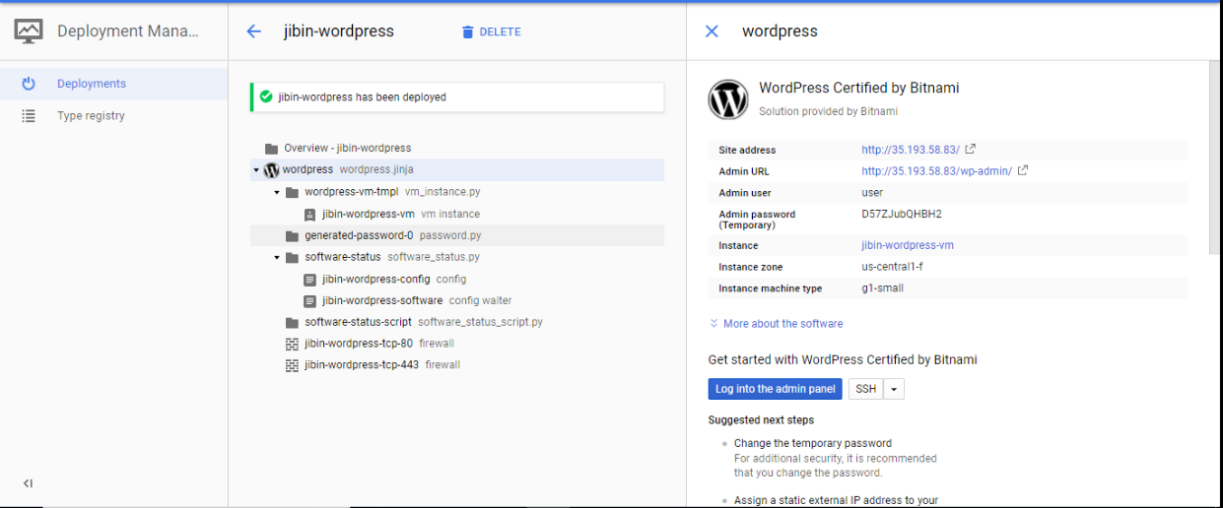

Step 3- Setting username and password

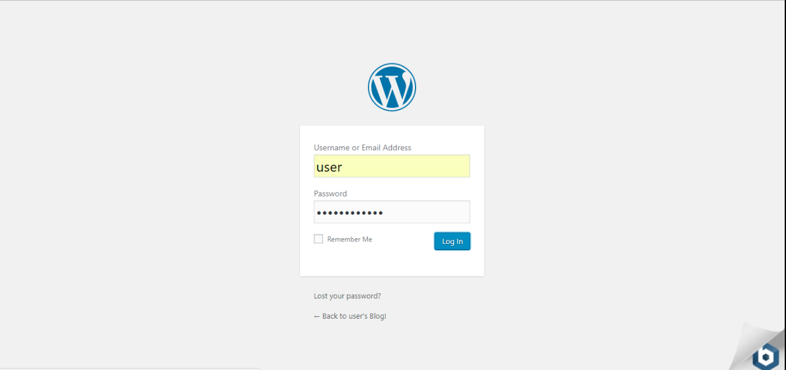

Step 4- Logging to wordpress

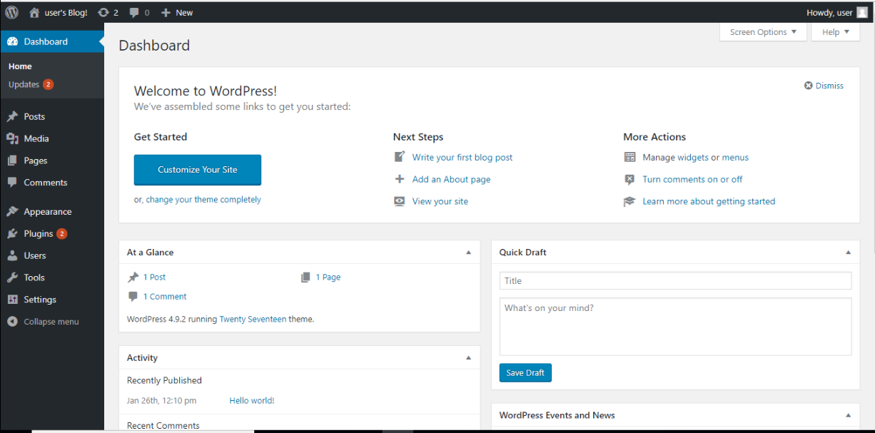

Step 5- Customizing websites



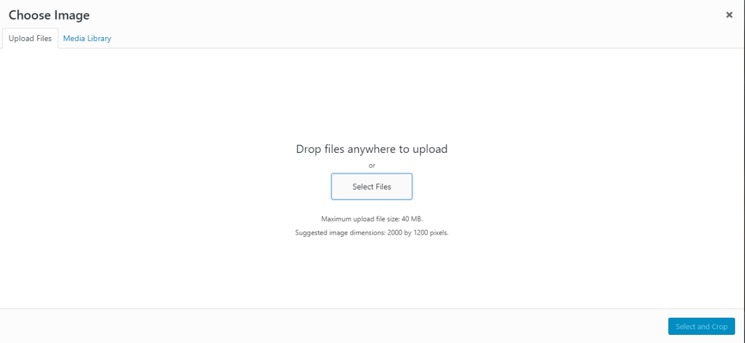

**P1.1.5** **Web Host Management Tools**

**P1.1.5.1 Web Host Manager(WHM)**

Web Host Manager, or WHM, is a powerful program that allows administrative access to the back end of cPanel. There are two versions that Host Gator uses. Reseller accounts get basic WHM. Dedicated Servers and VPS accounts get root WHM (also called rWHM), which has features that require root access to the server enabled. Resellers cannot have rWHM. WHM gives you a lot more control and flexibility when managing either a few very popular and resource intensive sites, or large number of sites. On top of giving you the ability to sell hosting services to other people, WHM also gives you the option to create and manage multiple cPanels. There are lots of really good reasons, if you have business oriented or popular sites, to place them on separate cPanels. Here are a few of the more common reasons we see:

* If one of your sites is hacked or attacked, the odds that the hacker can get into your other sites is dramatically reduced, which increases your security.
* There is no way for someone to tell if accounts on different cPanels are attached to the same WHM account, which increases your privacy.
* If you have multiple sites that need to take credit cards, using WHM saves you a lot of time, stress, and money. To be able to process credit cards you need an SSL certificate.
* You have the ability to monitor and adjust your bandwidth and disk space, which can be key to keeping a quickly growing or popular site from being suspended or going down due to bandwidth overages.
* Managing a large number of domains in one cPanel can be frustrating, especially if you update the files regularly. While we allow unlimited domains on a shared cPanel account, that does not mean it is always pleasant to work on that many domains in one cPanel.
* You need to have several web sites that take credit cards, and each one needs its own cPanel for its own dedicated IP address.

WHM gives you a suite of tools to easily do the following things:

* Create, delete, and suspend your cPanel accounts.
* Manage and monitor your sites (password resets).
* Access to check and change all of your domains' DNS zones.
* The ability to configure your own customers' support requests through cPanel.
* Permission to check the server information and status.
* Ability to create your own default page when you create a new account.
* Access to customize your hosting and control panel with extensive branding.
* Ability to change your client domain names and user names.
* Hop between every cPanel on your account and access/change anything that does not require SQL access.

**P1.1.5.2 Control Panel (cPanel)**

cPanel is an online Linux-based [web hosting control panel](https://en.wikipedia.org/wiki/Web_hosting_control_panel) that provides a graphical interface and automation tools designed to simplify the process of hosting a web site. cPanel utilizes a 3-tier structure that provides capabilities for administrators, resellers, and end-user website owners to control the various aspects of website and server administration through a standard web browser. In addition to the GUI, cPanel also has command line and API-based access that allows third party software vendors, [web hosting](https://en.wikipedia.org/wiki/Web_hosting) organizations, and developers to automate standard system administration processes.

cPanel is designed to function either as a [dedicated server](https://en.wikipedia.org/wiki/Dedicated_hosting_service) or [virtual private server](https://en.wikipedia.org/wiki/Virtual_private_server). The latest cPanel version supports installation on [CentOS](https://en.wikipedia.org/wiki/CentOS), [Red Hat Enterprise Linux](https://en.wikipedia.org/wiki/Red_Hat_Enterprise_Linux) (RHEL), and [CloudLinux OS](https://en.wikipedia.org/wiki/CloudLinux_OS). cPanel 11.30 is the last major version to support [FreeBSD](https://en.wikipedia.org/wiki/FreeBSD). Application-based support includes [Apache](https://en.wikipedia.org/wiki/Apache_HTTP_Server), [PHP](https://en.wikipedia.org/wiki/PHP), [MySQL](https://en.wikipedia.org/wiki/MySQL), [PostgreSQL](https://en.wikipedia.org/wiki/PostgreSQL), [Perl](https://en.wikipedia.org/wiki/Perl), and [BIND](https://en.wikipedia.org/wiki/BIND) (DNS). Email based support includes [POP3](https://en.wikipedia.org/wiki/Post_Office_Protocol), [IMAP](https://en.wikipedia.org/wiki/Internet_Message_Access_Protocol), and [SMTP](https://en.wikipedia.org/wiki/Simple_Mail_Transfer_Protocol) services. cPanel is accessed via https on [port](https://en.wikipedia.org/wiki/Port_(computer_networking)) 2083.

Once installed, cPanel cannot be easily removed. cPanel's FAQ states that the best way to uninstall cPanel is by reformatting the server. However, uninstall guides are available online for expert server administrators who do not wish to reformat their server. Similarly, it should only be installed on a freshly installed operating system with minimal prior configuration.

The tools provided are designed to simplify running and controlling a website. It uses a tiered structure that allows different levels of access. Administrators and end users can control the different aspects of the server and the website directly through their browser. cPanel is generally accessed using https on port 2083 or simply by adding “/cpanel” to the end of the host name. Depending on the hosting provider the cPanel will generally have some sort of auto installer or package dedicated to content management systems like WordPress.

**Some of the great features that cPanel includes are:**

* **Email: Within cPanel you can create new email accounts, view/modify your existing accounts, modify your MX records, change email passwords, set up mail box quotas and much more.**
* **Domains: Under the domains section of cPanel, you can configure new domains to your account, set up parked domains, create subdomains, setup redirects, and much more.**
* **File Management: In the files section of cPanel, you can back up your cpanel account, access/ modify files stored in your account, review your disk usage, and create/manage FTP accounts**
* **Databases: Here you can create new databases, set up remote access to MySQL, access the databases using phpMyAdmin, and much more**

**cPanel is very user friendly and is quite robust. There's numerous tools within cPanel to handle a wide variety of tasks. It contains a full help menu that is easy to use.**

**P1.1.5.3** Plesk Panel

Plesk is the leading WebOps hosting platform to run, automate and grow applications, websites and hosting businesses. Being the only OS-agnostic platform, Plesk is running on more than 380,000 servers, automating 11M+ websites and 19M mailboxes. Available in more than 32 languages across 140 countries, 50% of the top 100 service providers worldwide are partnering with Plesk today. Plesk has simplified the life of SysAdmins and SMBs since the early 2000’s and continues to add value across multiple cloud services. The Plesk hosting platform effectively enables application developers by providing access to a simple and more secure web infrastructure managed by web pros and hosting companies.

The worldwide developer market consists of over 20M cloud developers who are looking for access to faster, more secure and efficient infrastructures. The Plesk vision is to constantly elevate customer and partner profitability by providing them with a cloud platform that grants application developers a ready-to-code environment. Besides simplifying complexity, Plesk increases its efforts to enable customers and partners alike to extend and customize Plesk as an open hosting platform. The rich ecosystem of Plesk extensions not only provides access to even more relevant features targeted at specific audiences but also allows service providers of any size to generate unique upsell opportunities.

Plesk culture

As a team, we thrive on excellence, innovation, collaboration, and efficiency. We enjoy what we do, understand our customers and build a hosting platform that clients love and need. The relentless commitment of our team to accept new business challenges guarantees that we are creative and respectful of time and resources as well as the environment. We keep our actions and goals transparent, cultivate a culture of leadership, inclusion, execution, and respect. As a former member of the Parallels group of companies, our background is global, innovative and diverse. January 2016 was the right time for Plesk to become a separate business, enabling us to accelerate development cycles, drive innovation and focus on the needs of our partners, customers and employees.

Implementation

Part 1

* Go to Google Cloud Launcher
* Search for Plesk or choose Plesk Onyx on Windows 2012 R2 Webhost Edition from the solutions
* Go to Plesk Onyx on Windows 2012 R2 Webhost Edition by clicking on it.

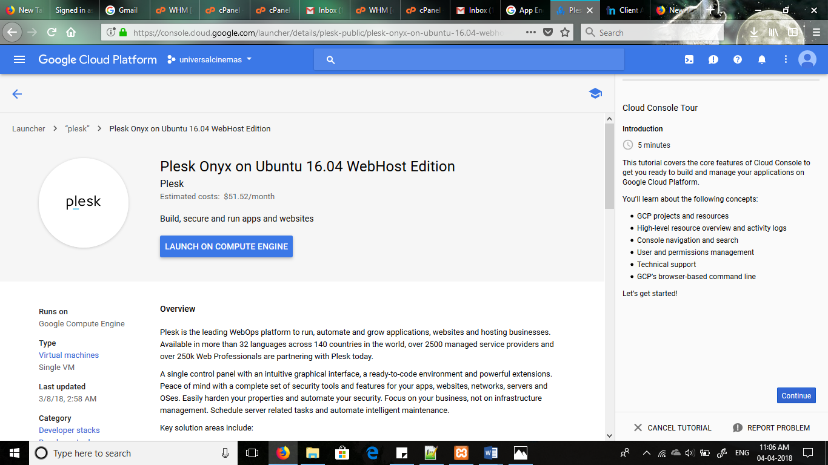

* As a new user goes to ‘Launch on Compute Engine’ or if you have past deployment, those can appear in the window.

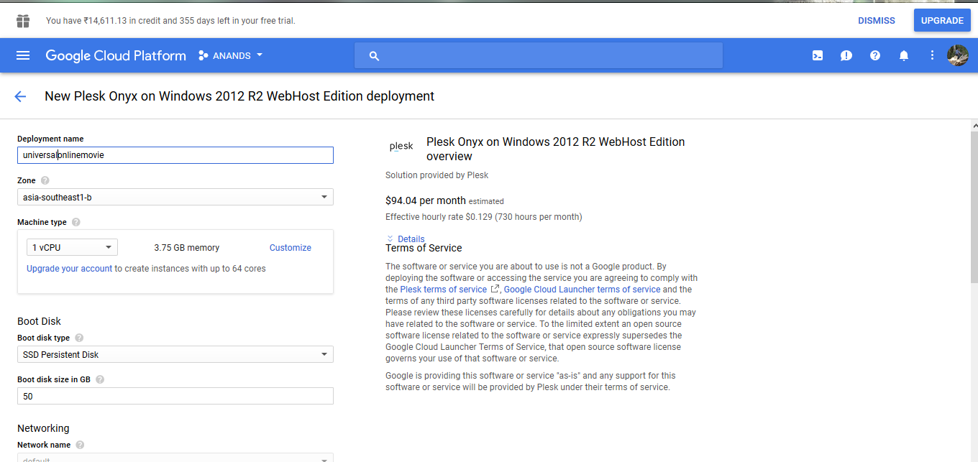

* On the window, choose a valid Deployment name, zone, Machine type, Boot disk type and allow HTTP Traffic rules. Then Deploy the instance

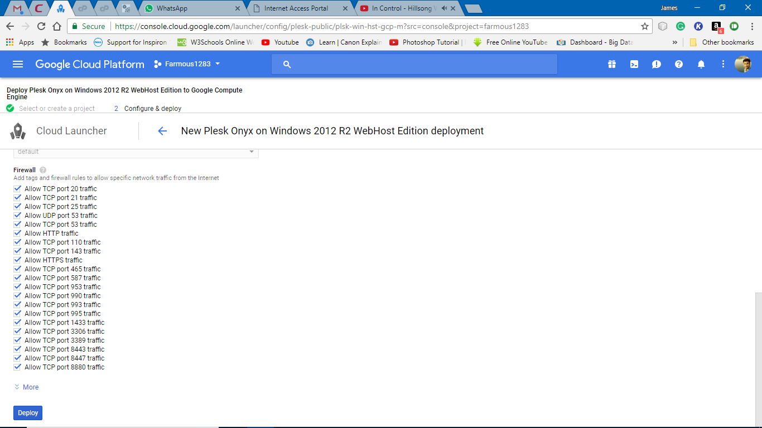

* Once successfully deployed, you will be redirected to Deployment Manager window

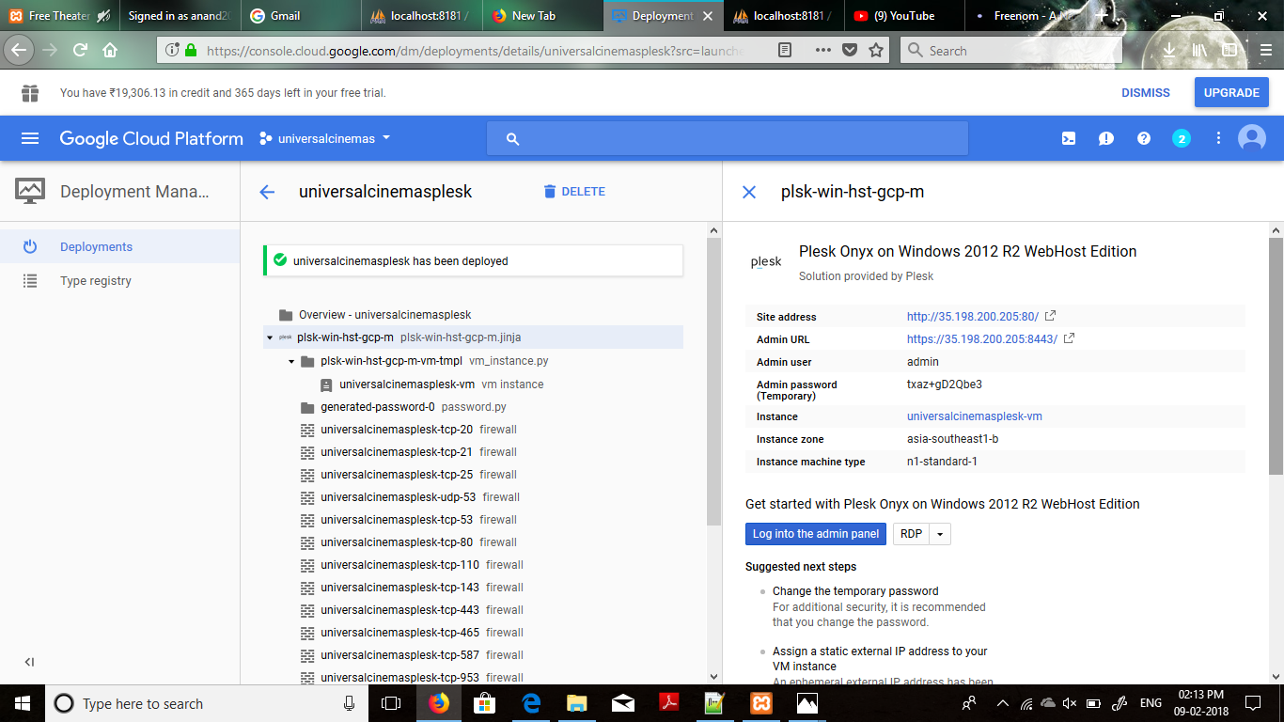

* Use the Login credentials provided by the Deployment Manager to access the Admin panel. Use the Admin URL to log in, with Admin user and Admin password(temporary)

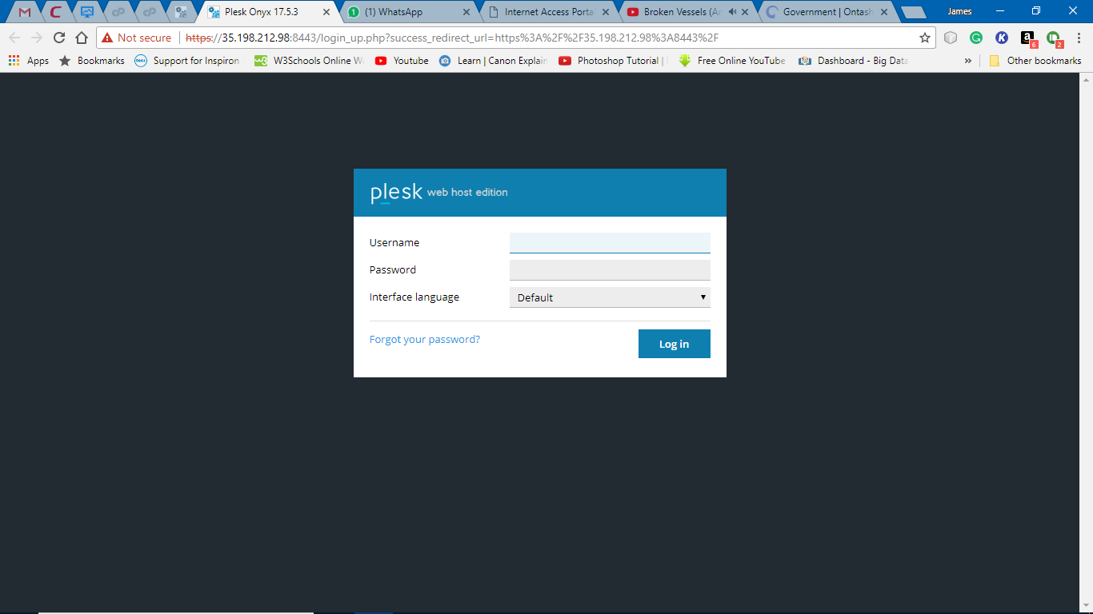

* Once you successfully logged in, you have to configure the web host, such as how you will use the product, user interface and etc.
* Choose Education/Academic

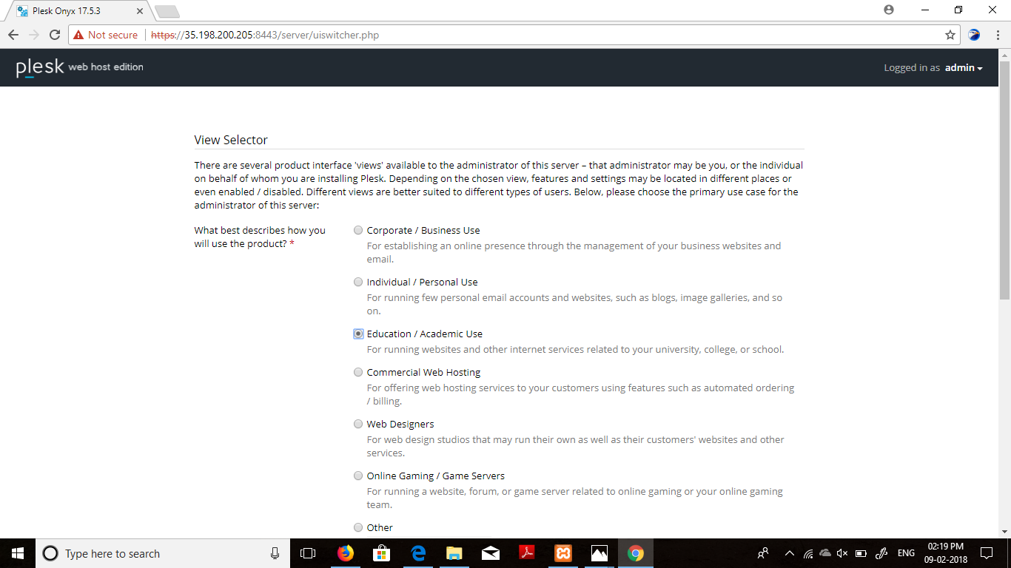

* Default UI (Power User View)

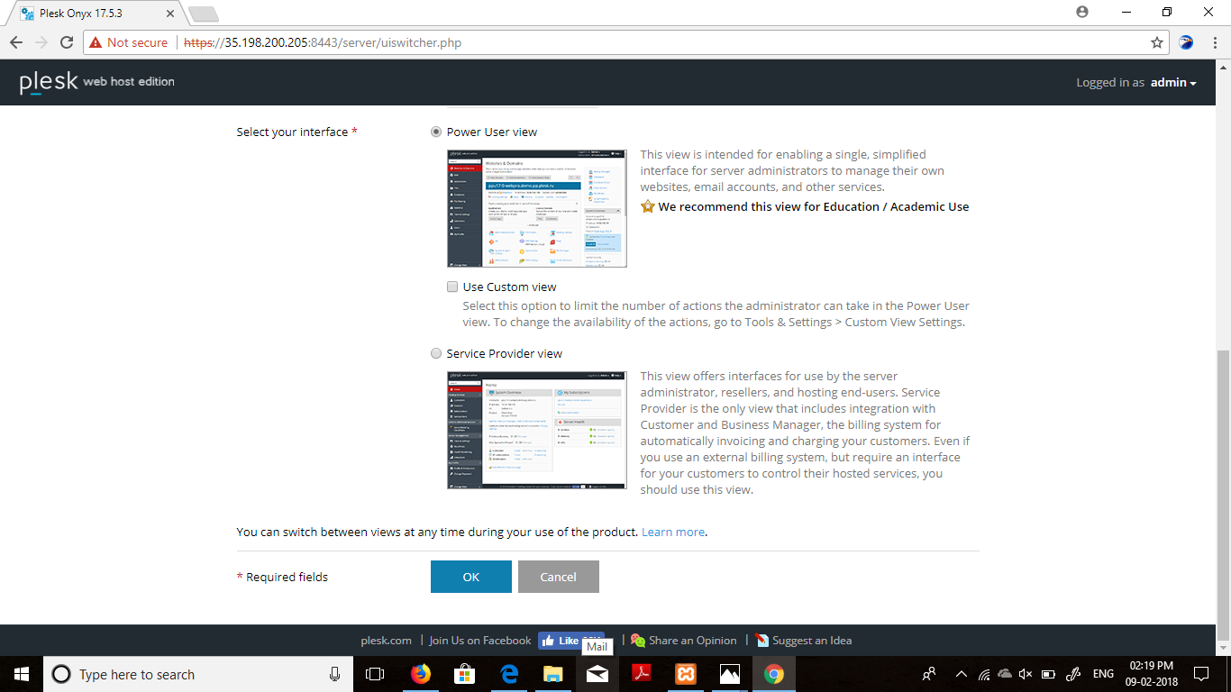

* On the next step, you have to enter the hostname, if you already have a hostname use that one or create a new domain

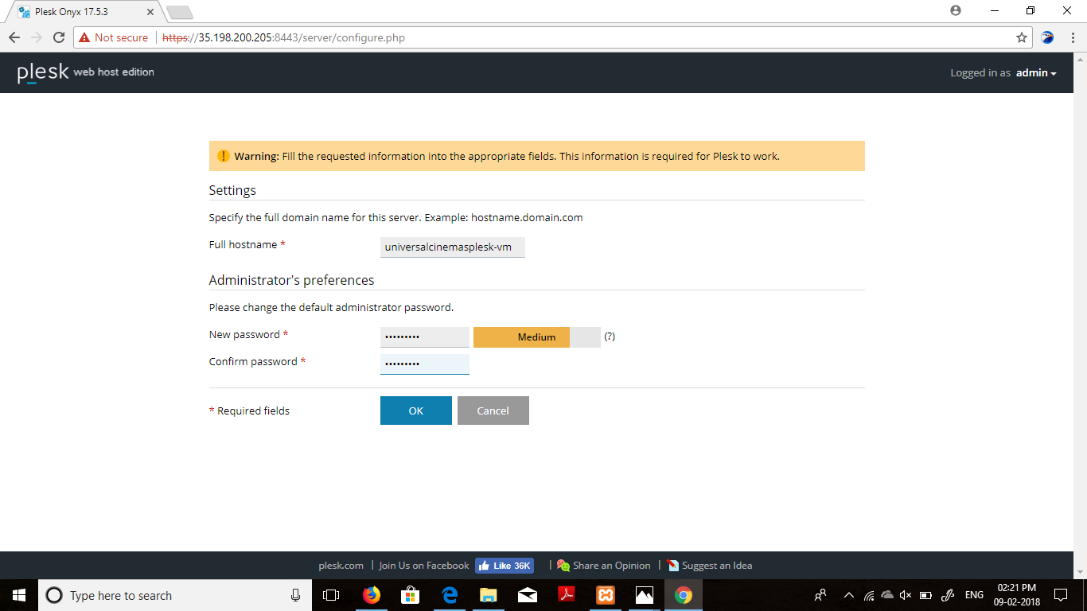

Part 2 - Creating Domain to use on Plesk

* Use a valid domain provider to register a domain
* Here we are using ‘Freenom’to register
* universalcinemas.gqis the available domain
* Before completing the order, Configure the records by creating DNS Zone and Recordset
* Configure Cloud Zone (Cloud DNS) (Menu>Network services>Cloud DNS)

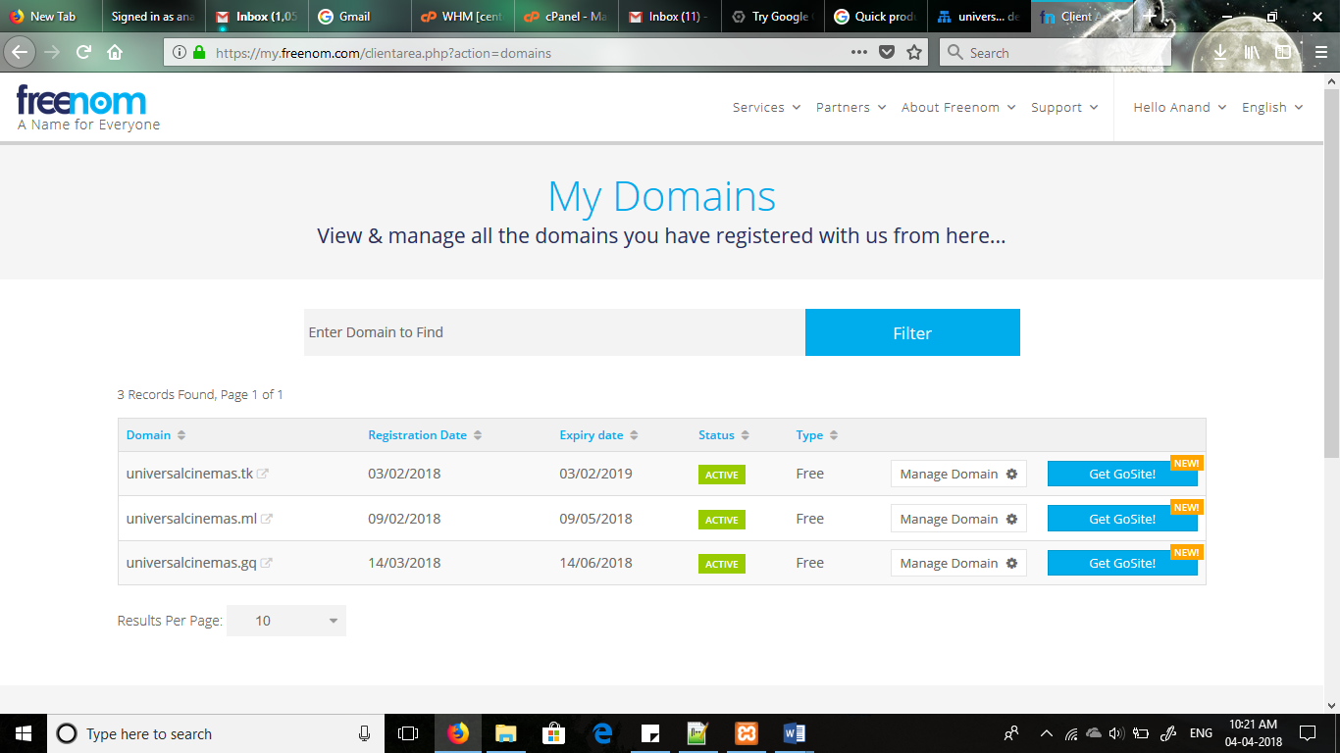

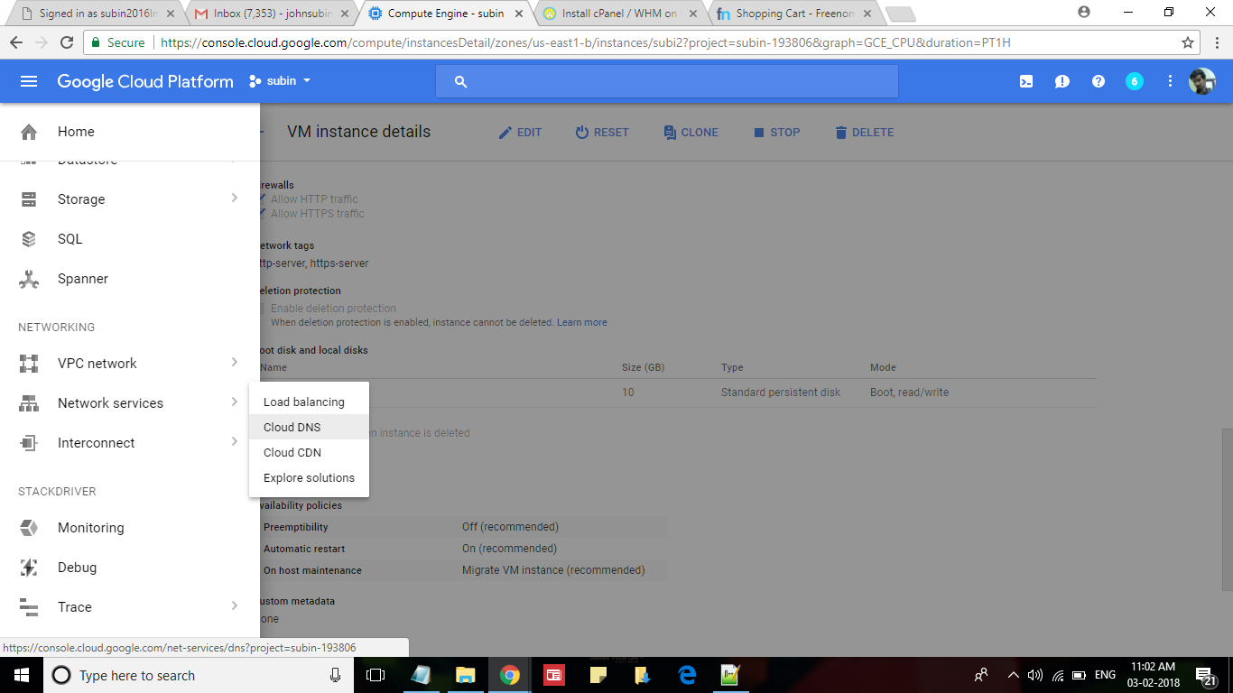

* Create a DNS Zone

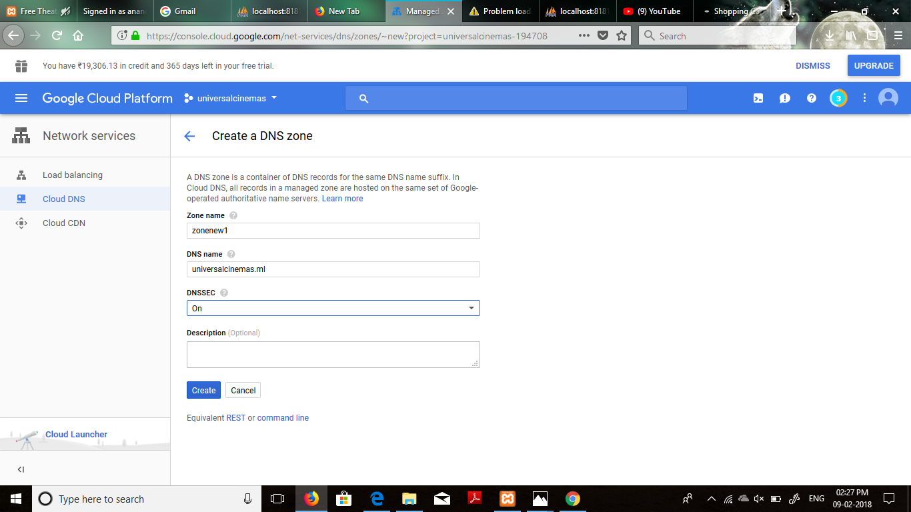

* Once you created the DNS Zone, Add Record set in that DNS Zone. Create a recordset as Type A and CNAME

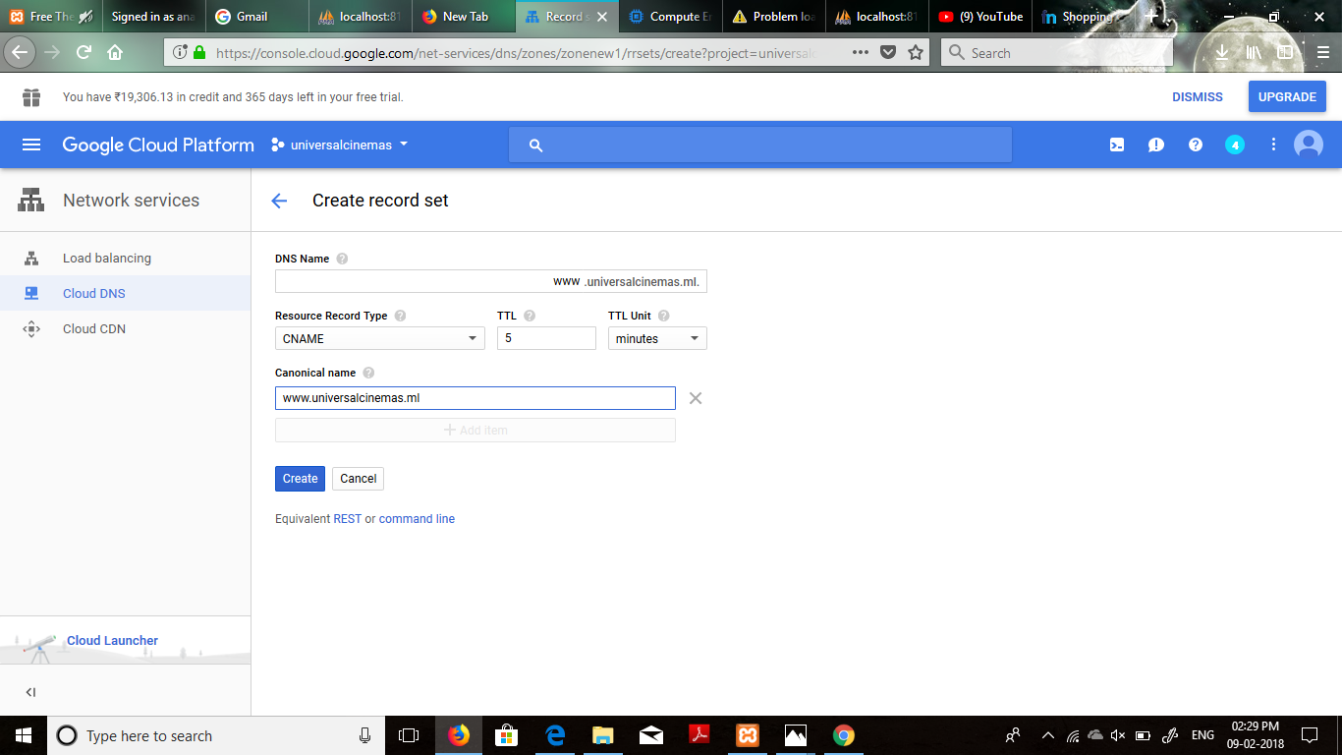

* Use Instance Ext.IP address as IP address and Data of Record Type NS as Nameserver on Domain registration page (at Use Freenom DNS Service and Use your own DNS)



* Then complete the order by filling up details.
* Once completed, go to My Domains and Management Tools to change nameserver.configure the nameserver as DNS Record Type NS
* Then go back to the Plesk panel,



* Put created domain name as Full Hostname and create a password for Administrator preferences, then proceed to next step
* Fill Administrator Information

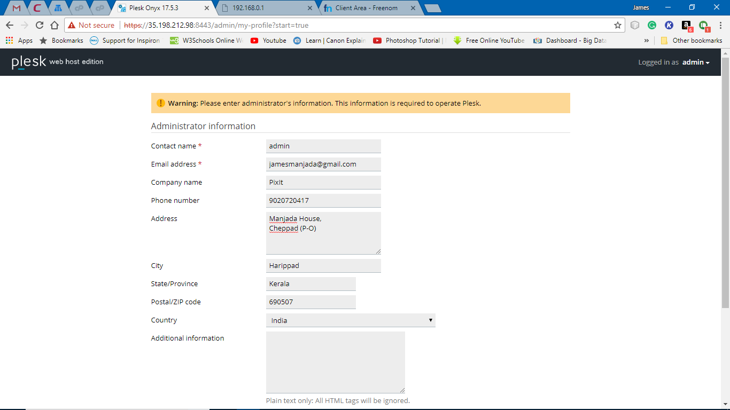

* Agree on End-User License Agreement Then Ok to continue

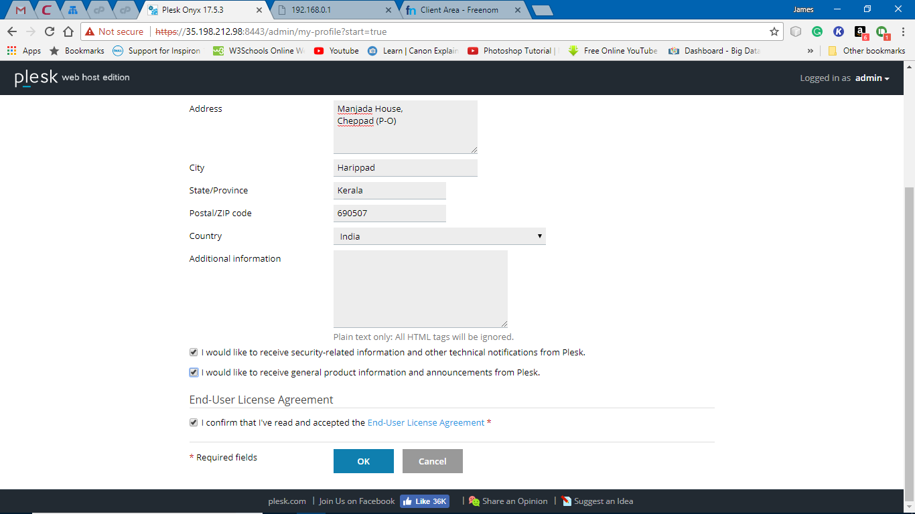

* Create your web space by providing hostname and password

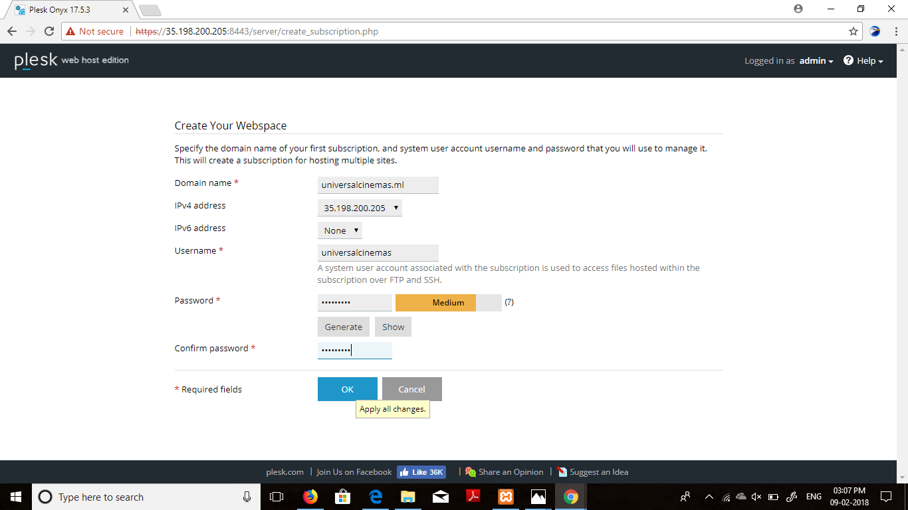

* By creating web space, you will be able to access Plesk panel. On the Plesk panel, you can upload files, add database etc.

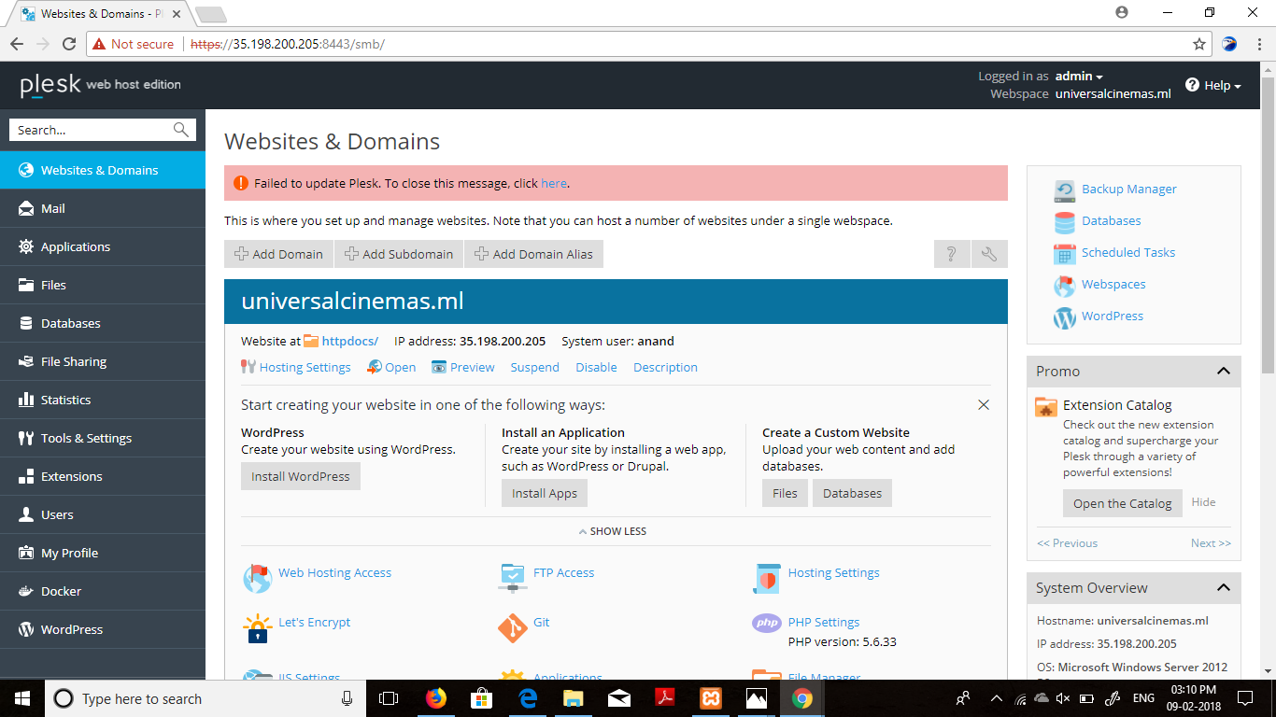

* Go to Files to upload your project

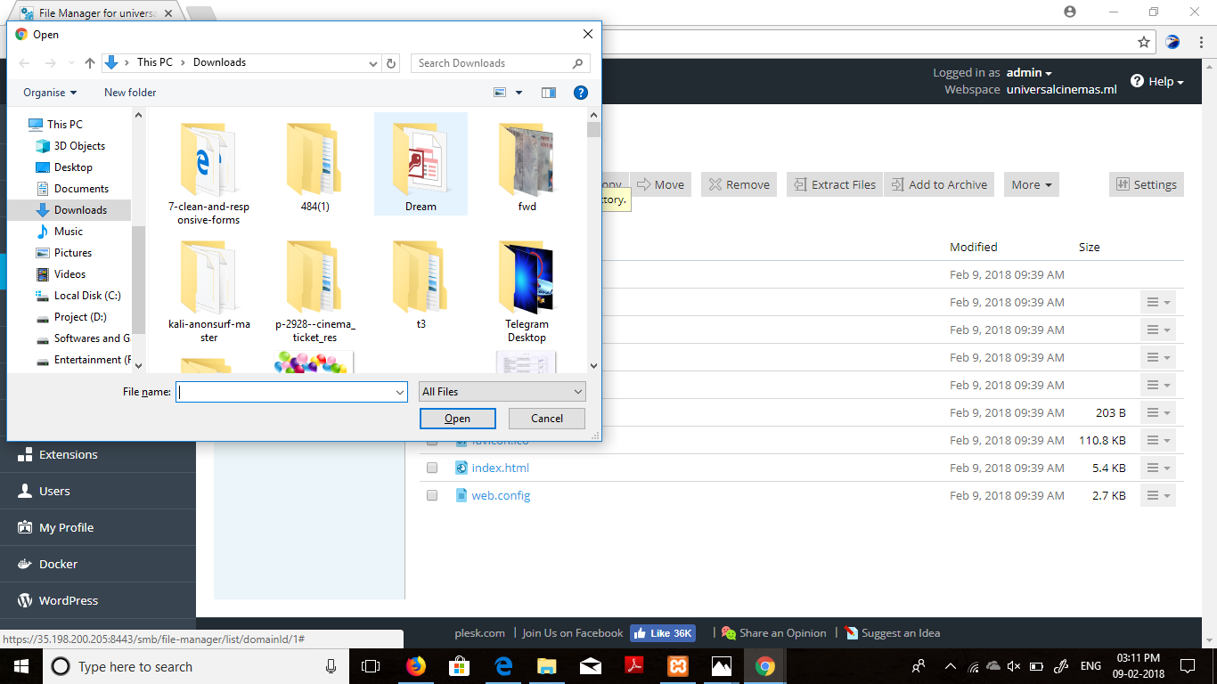

* Click on Upload button to upload files (Use ZIP file rather than a normal folder, it can be extracted)

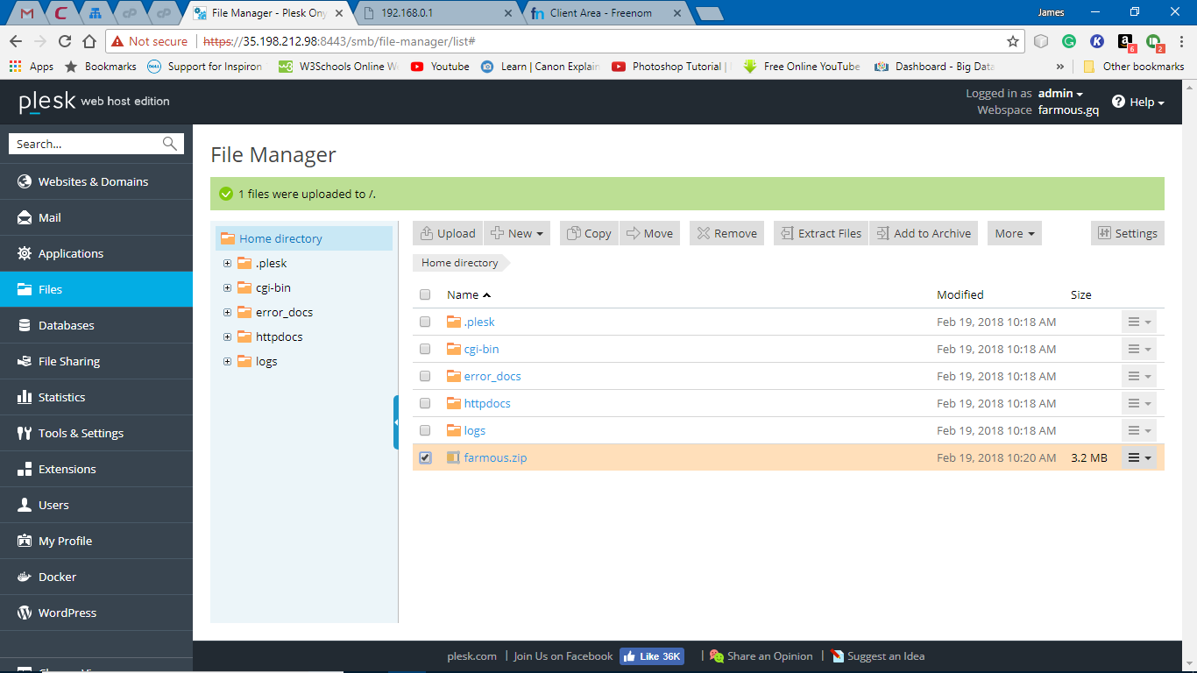

* Move to folder *httpdocs, create and extract your zip file inside the httpdocs*

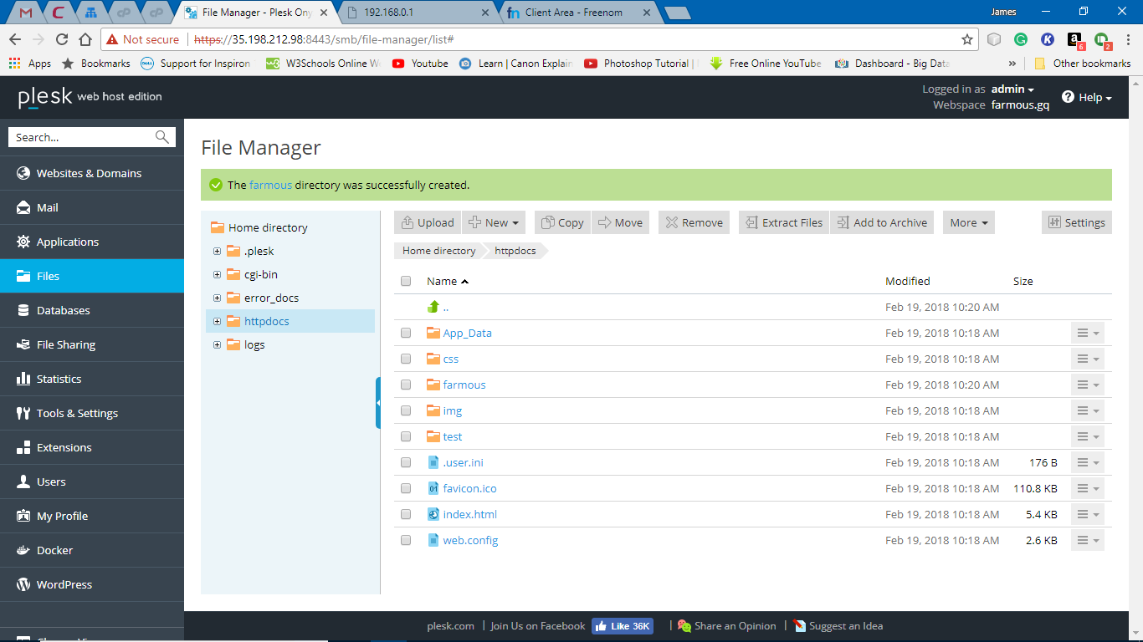

* Then go to your domain for checking the files is existing

Part 3 -Create Database and connect

* Go to Menu > Databases
* Choose database name, related site and create database user as well as password

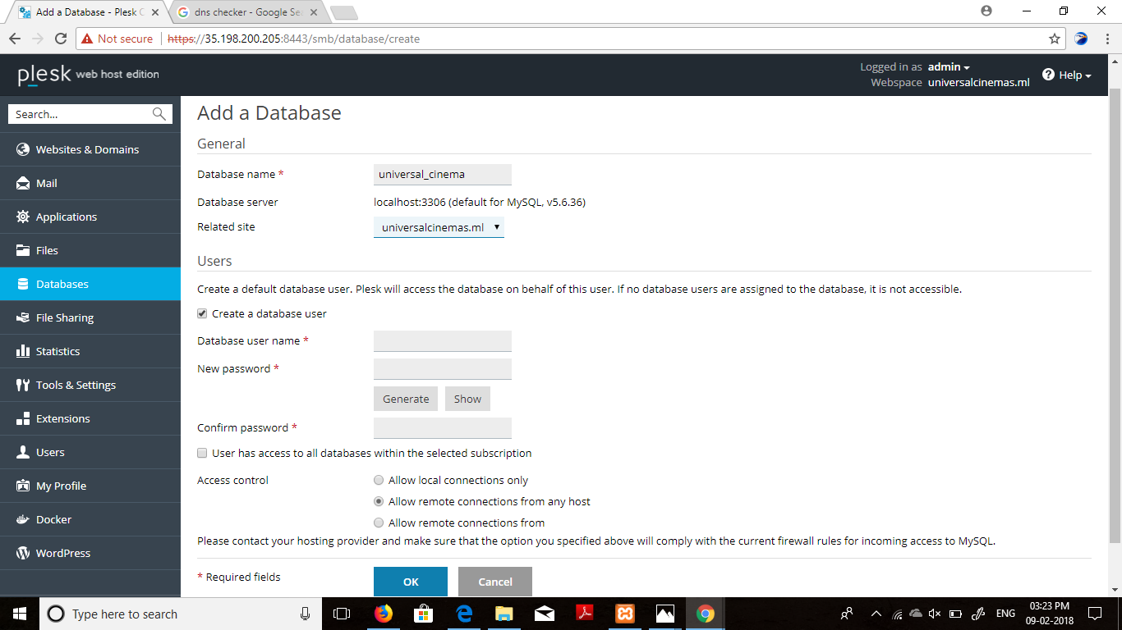

* All remote connection from any host under the Access control

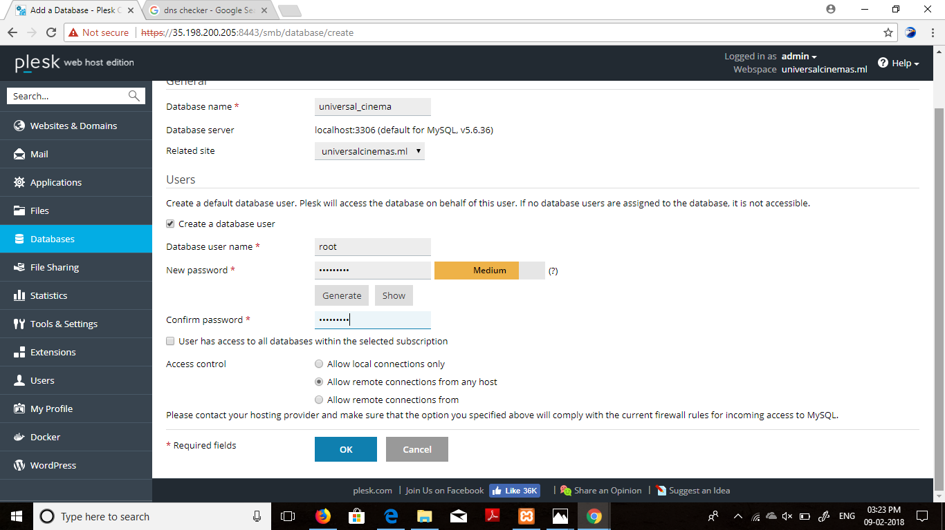

* Once completed, Import your database file(.sql) to database. Click on *Import Dump*

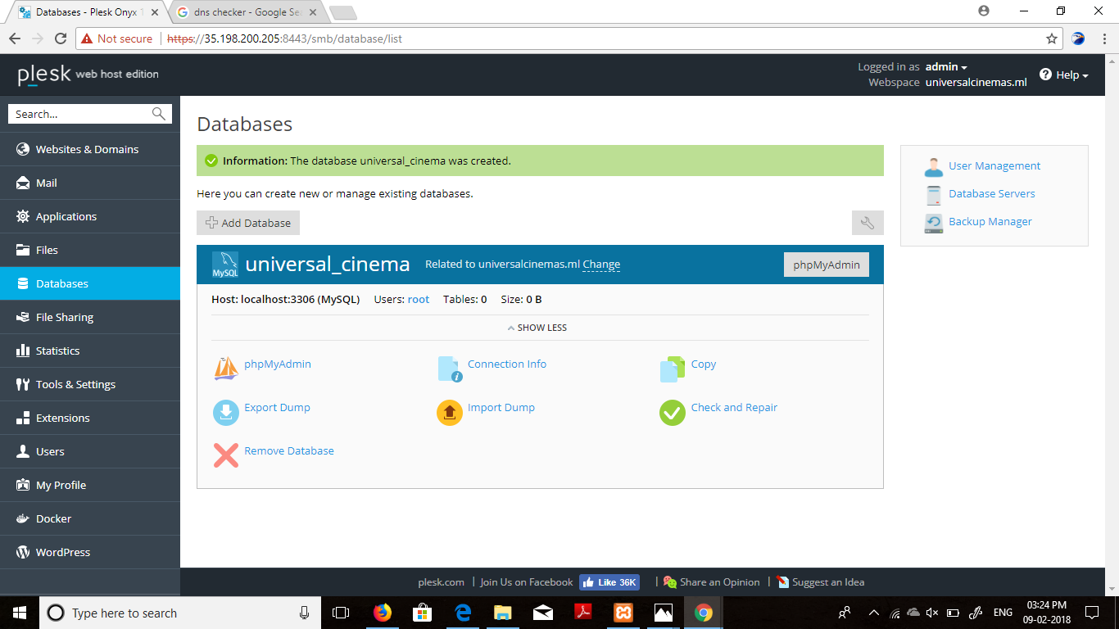

* Choose a .sql file from your system

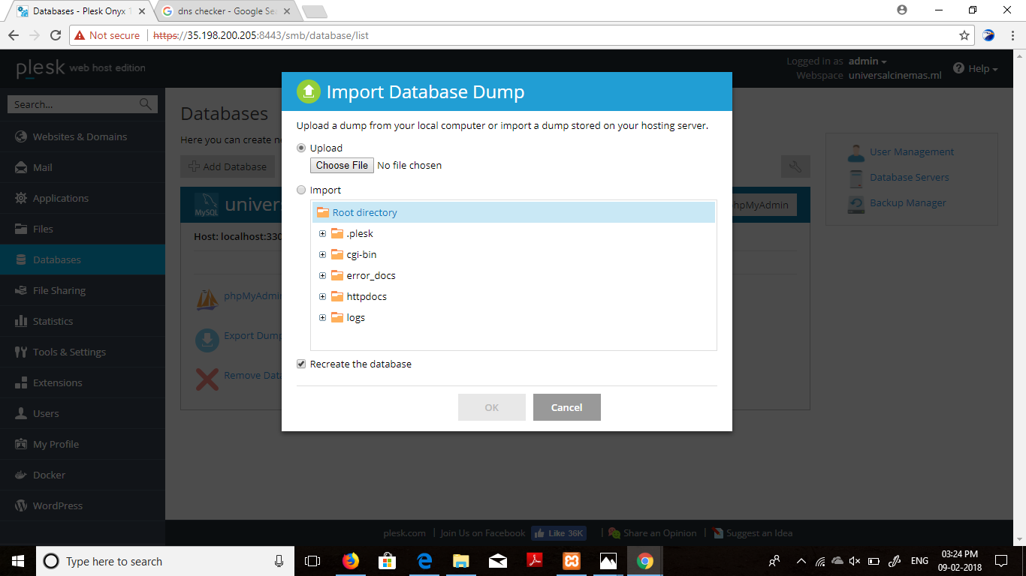

* Please verify your Database tables on phpMyAdmin, once it is verified edit your database connection string (Files > Connection File > Edit)

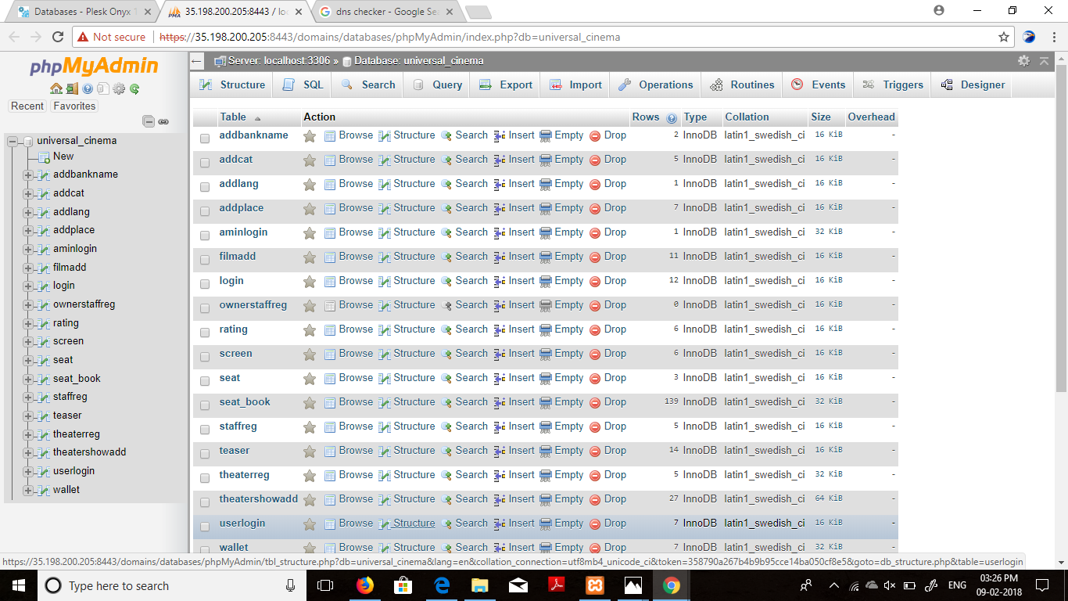

* Then save the file and go to your domain to verify that the connection is valid.

**P1.2 AWS (Amazon Web Services)**

**P1.2.1 Introduction Amazon Web Services Cloud**

In 2006, Amazon Web Services (AWS) began offering IT infrastructure services to businesses in the form of web services -- now commonly known as cloud computing. One of the key benefits of cloud computing is the opportunity to replace up-front capital infrastructure expenses with low variable costs that scale with your business. With the Cloud, businesses no longer need to plan for and procure servers and other IT infrastructure weeks or months in advance. Instead, they can instantly spin up hundreds or thousands of servers in minutes and deliver results faster.

Today, Amazon Web Services provides a highly reliable, scalable, low-cost infrastructure platform in the cloud that powers hundreds of thousands of businesses in 190 countries around the world. With data center locations in the U.S., Europe, Brazil, Singapore, Japan, and Australia, customers across all industries are taking advantage of the following benefits:

### Low Cost

AWS offers low, pay-as-you-go pricing with no up-front expenses or long-term commitments. We are able to build and manage a global infrastructure at scale and pass the cost saving benefits onto you in the form of lower prices. With the efficiencies of our scale and expertise, we have been able to lower our prices on 15 different occasions over the past four years. Visit the Economics Centre to learn more.

### Agility and Instant Elasticity

AWS provides a massive global cloud infrastructure that allows you to quickly innovate, experiment and iterate. Instead of waiting weeks or months for hardware, you can instantly deploy new applications, instantly scale up as your workload grows, and instantly scale down based on demand. Whether you need one virtual server or thousands, whether you need them for a few hours or 24/7, you still only pay for what you use. Visit the Architecture Centre to learn more.

### **Open and Flexible**

AWS is a language and operating system agnostic platform. You choose the development platform or programming model that makes the most sense for your business. You can choose which services you use, one or several, and choose how you use them. This flexibility allows you to focus on innovation, not infrastructure. Download the AWS Overview Whitepaper.

### **Secure**

AWS is a secure, durable technology platform with industry-recognized certifications and audits: PCI DSS Level 1, ISO 27001, FISMA Moderate, FedRAMP, HIPAA, and SOC 1 (formerly referred to as SAS 70 and/or SSAE 16) and SOC 2 audit reports. Our services and data centers have multiple layers of operational and physical security to ensure the integrity and safety of your data.  Visit the Security Centre to learn more.

## **Solutions**

The AWS cloud computing platform provides the flexibility to launch your application regardless of your use case or industry. Learn more about popular solutions customers are running on AWS.

### **[Application Hosting](https://aws.amazon.com/application-hosting/)**

Use reliable, on-demand infrastructure to power your applications, from hosted internal applications to SaaS offerings.

### **[Websites](https://aws.amazon.com/websites/)**

Satisfy your dynamic web hosting needs with AWS’s scalable infrastructure platform.

### **[Backup and Storage](https://aws.amazon.com/backup-recovery/)**

Store data and build dependable backup solutions using AWS’s inexpensive data storage services.

### **[Enterprise IT](https://aws.amazon.com/enterprise-it/)**

Host internal- or external-facing IT applications in AWS's secure environment.

### **[Content Delivery](https://aws.amazon.com/content-delivery/)**

Quickly and easily distribute content to end users worldwide, with low costs and high data transfer speeds.

### **[Databases](https://aws.amazon.com/running_databases/)**

Take advantage of a variety of scalable database solutions, from hosted enterprise database software or non-relational database solutions.

## Get Started

* Sign up for AWS, by signing up for AWS, you have access to Amazon’s cloud computing services.

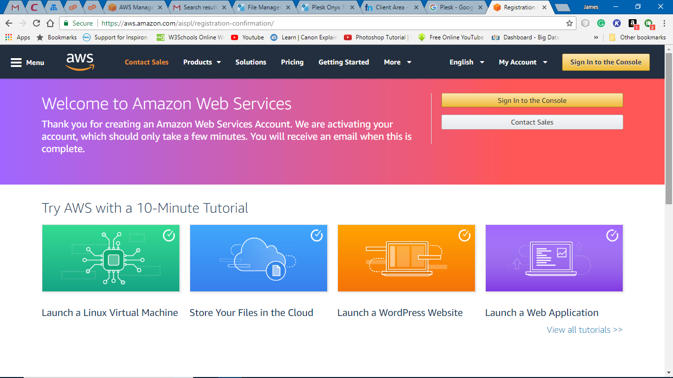

* Once you successfully logged in, you will be redirected to AWS Dashboard.

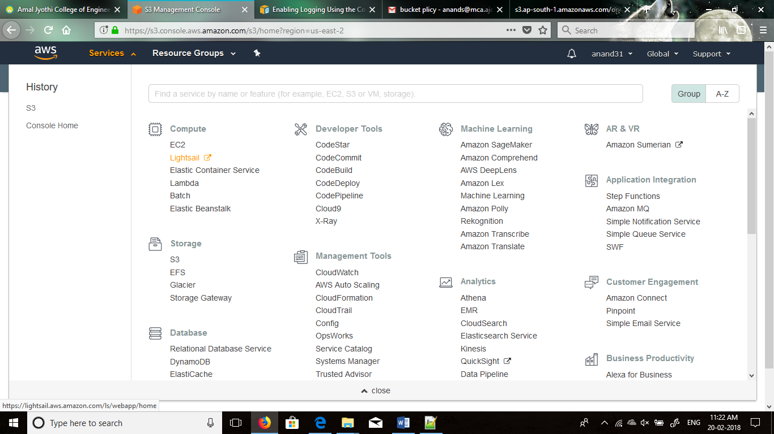

**P1.2.2** Amazon Elastic Compute Cloud (EC2)

Amazon Elastic Compute Cloud (Amazon EC2) is a web service that provides secure, resizable compute capacity in the cloud. It is designed to make web-scale cloud computing easier for developers.

Amazon EC2’s simple web service interface allows you to obtain and configure capacity with minimal friction. It provides you with complete control of your computing resources and lets you run on Amazon’s proven computing environment. Amazon EC2 reduces the time required to obtain and boot new server instances to minutes, allowing you to quickly scale capacity, both up and down, as your computing requirements change. Amazon EC2 changes the economics of computing by allowing you to pay only for capacity that you actually use. Amazon EC2 provides developers the tools to build failure resilient applications and isolate them from common failure scenarios.

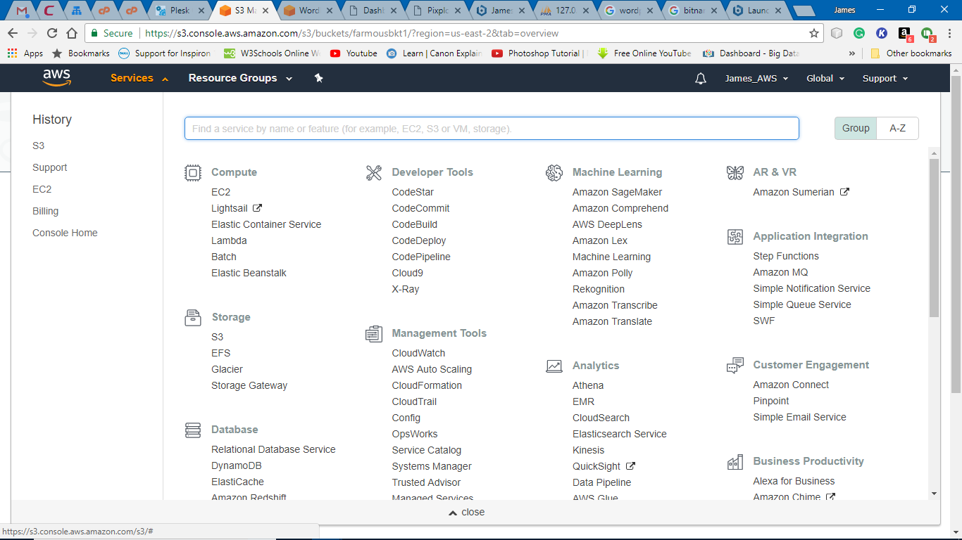

* Go to AWS Services>Computer>EC2

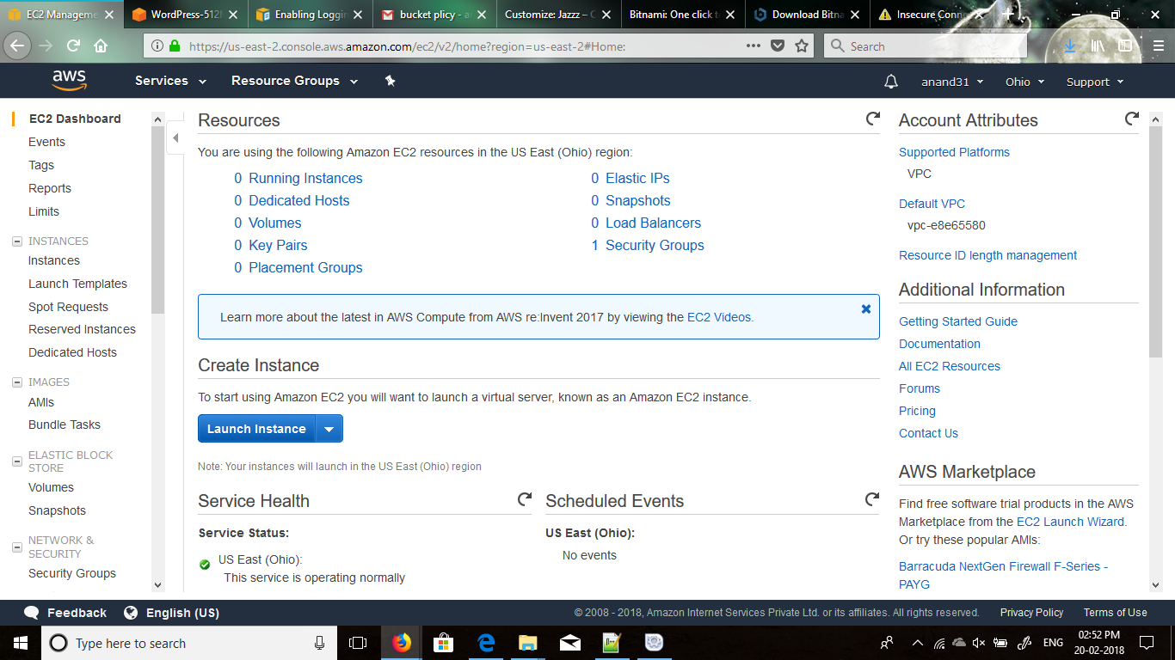

* Creating instance on AWS EC2, Step 1 required to select an Amazon Machine Image(AMI) and then proceed to next step.

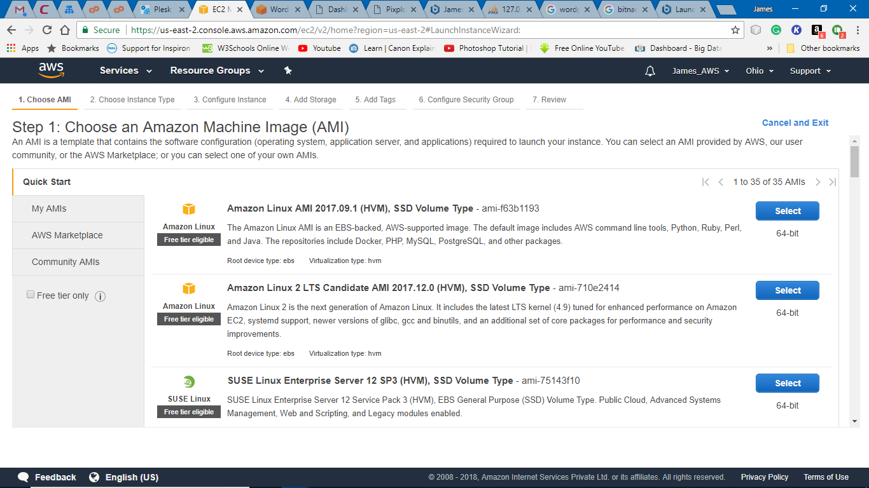

* The next step is to select an instance type

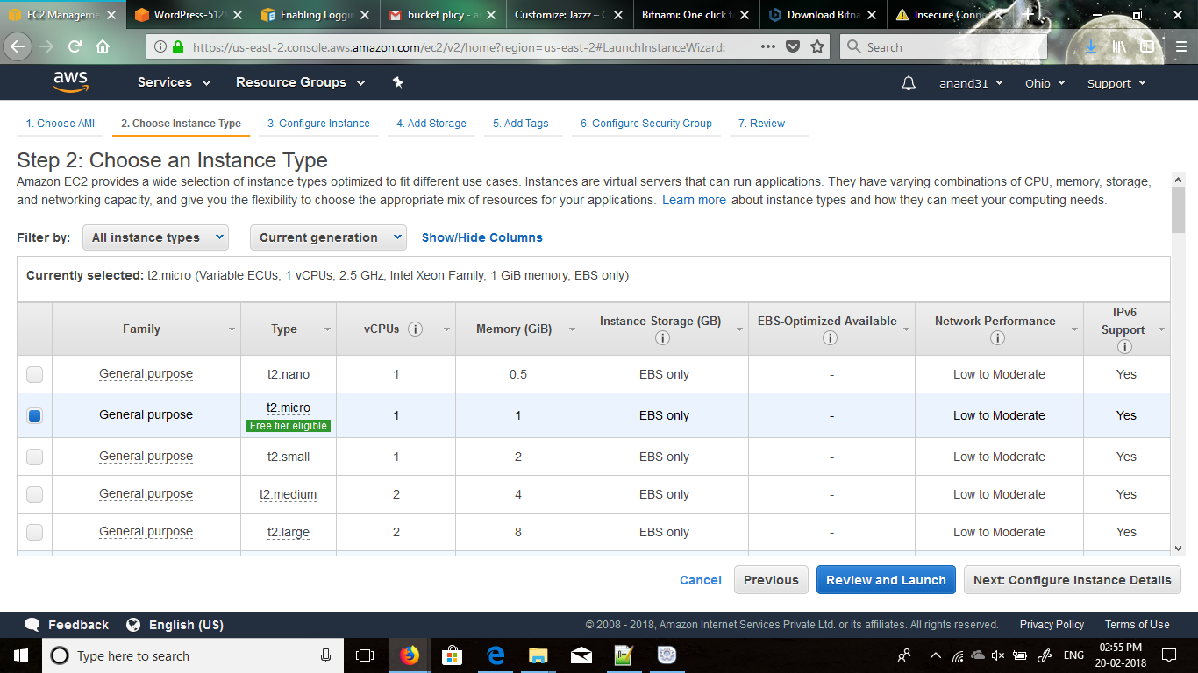

* Once instance type is selected go to step 3, where you have to configure instance details

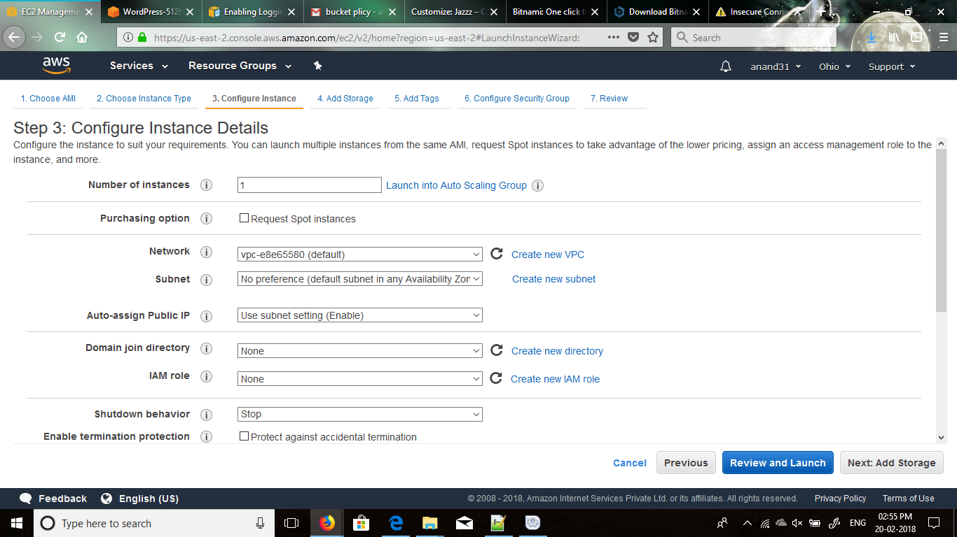

* The next step is to Add storage if storage is required add a new volume

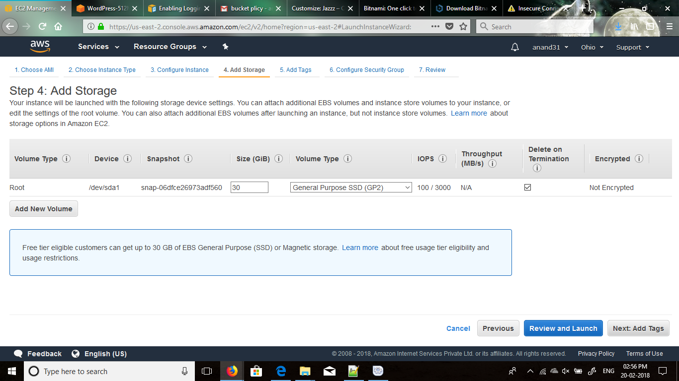

* The next Step is to Add Tags, which consist of a case-sensitive key-value pair

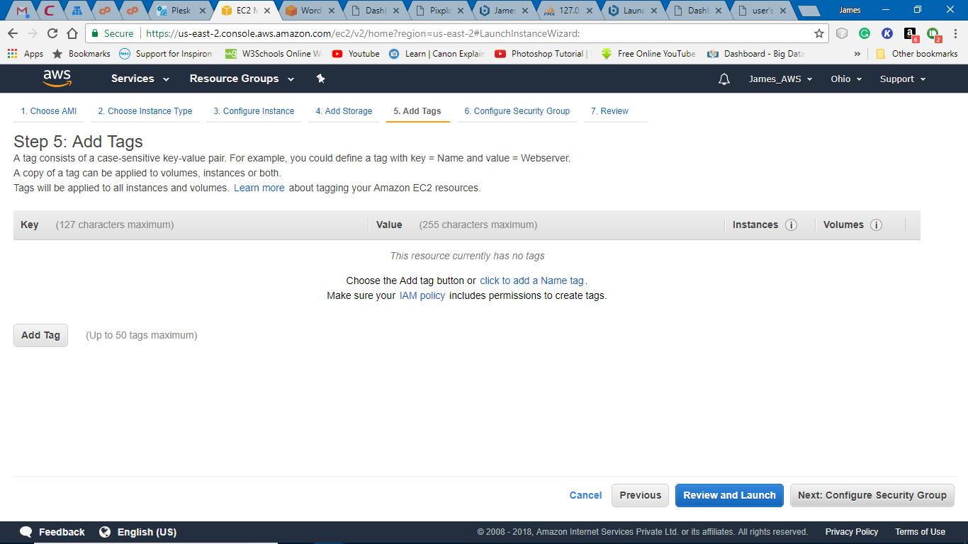

* The next step is to configure security group, you can assign security group as well as a name for the assigned group and description also.

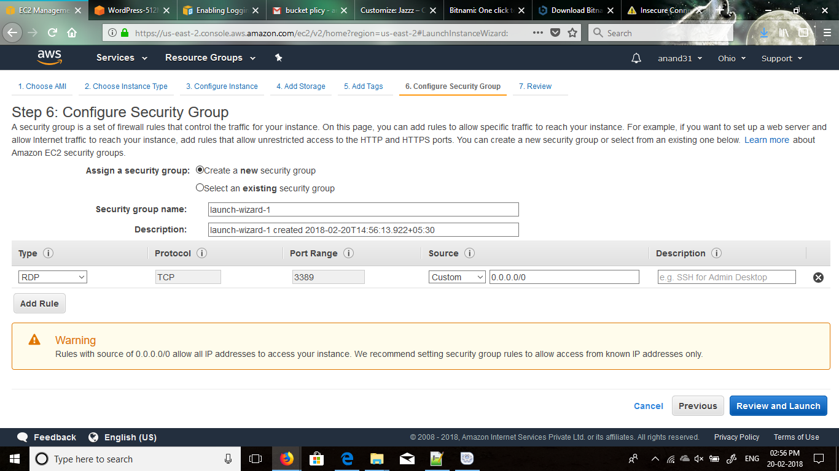

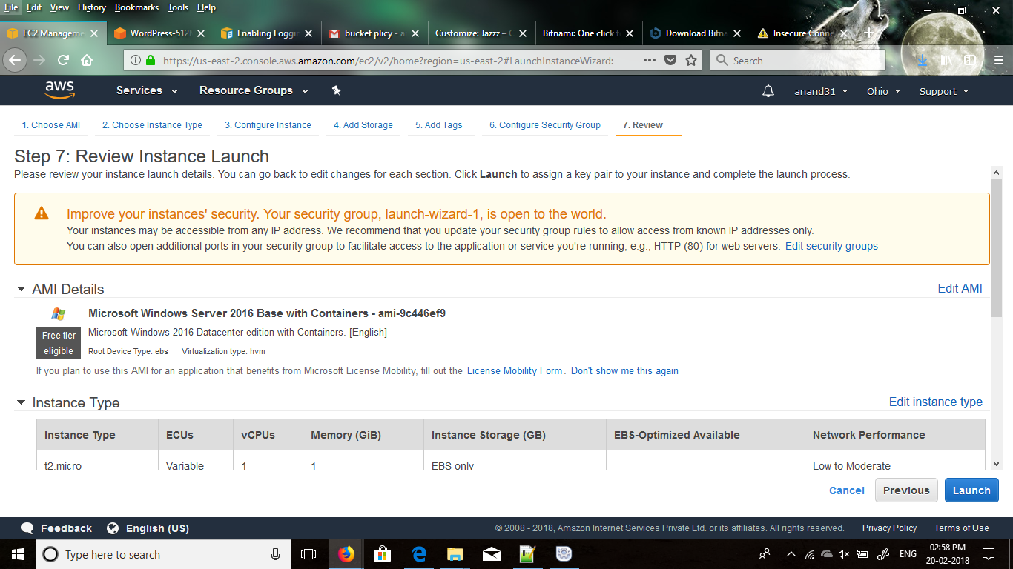

* This step is to review and launch your instance, here in this step you have to create or choose an existing key pair that AWS stores. If there is no existing key pair, create a new key pair by providing a name for the key pair and download the key pair for further process. And Launch your instance.

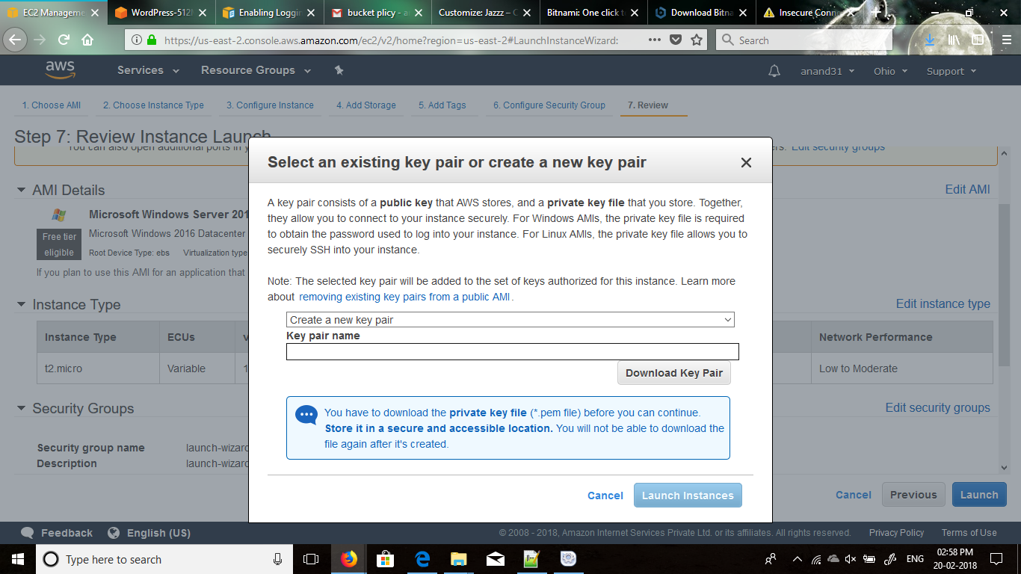

* Created instance is ready to launch.

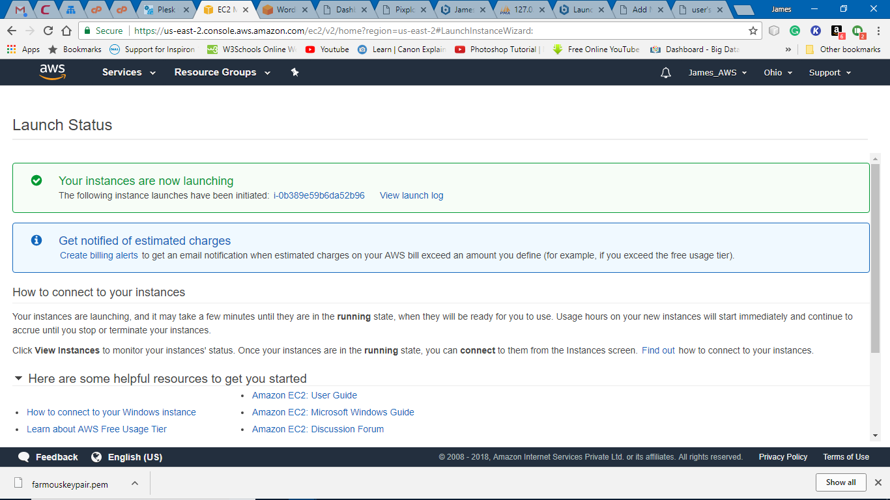

* To connect with your instance,You have to download remote desktop connector file and enable it with login credentials. Also, ensure that your system rules for remote connectivity are enabled.

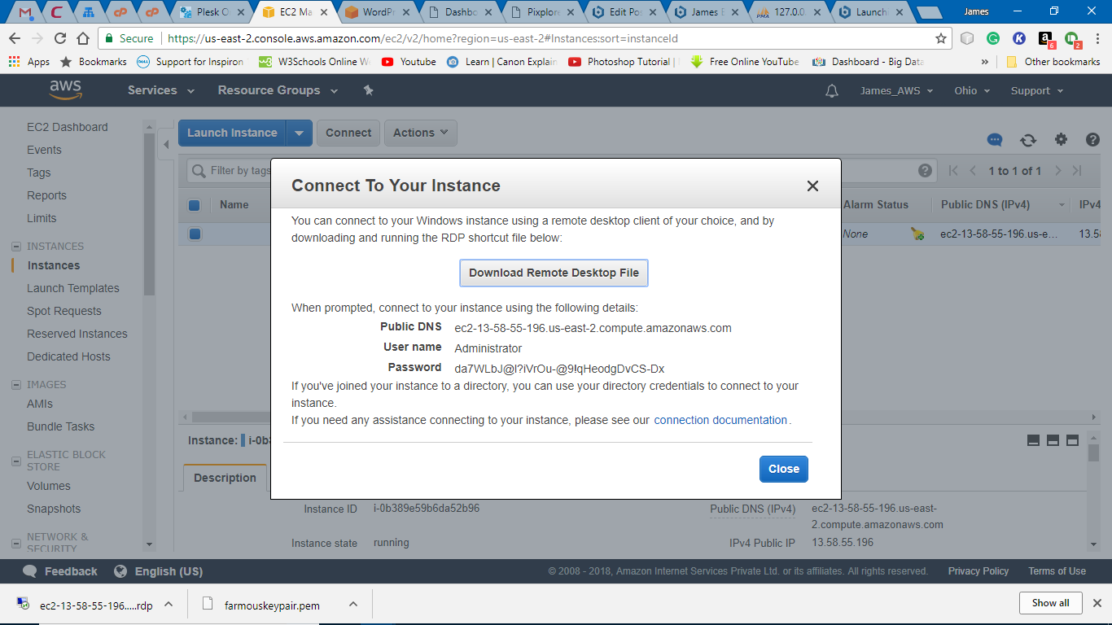

* Enter the Administrator password

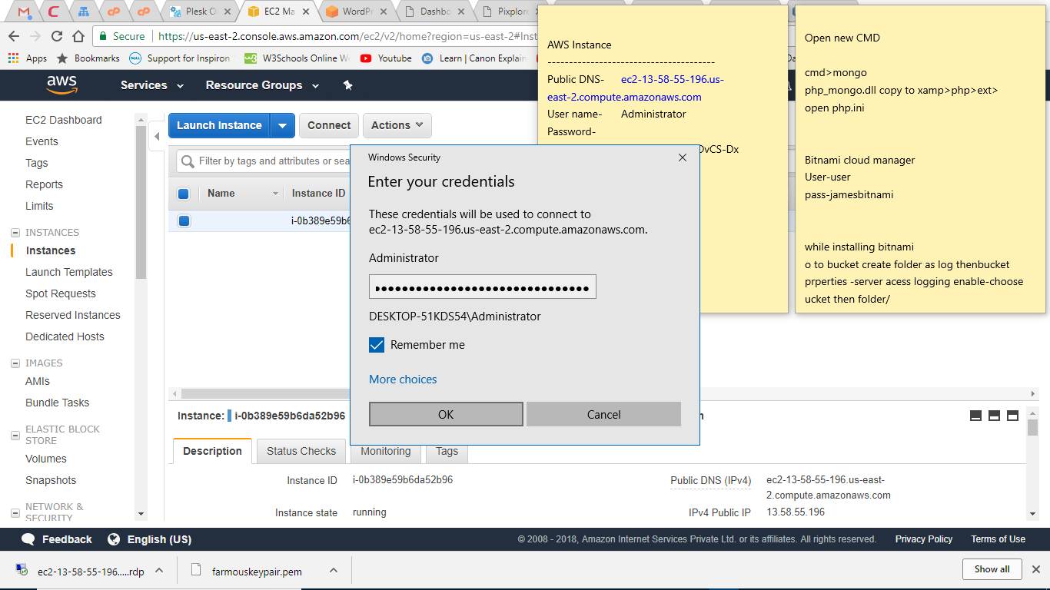

* Your instance is successfully connected remotely.

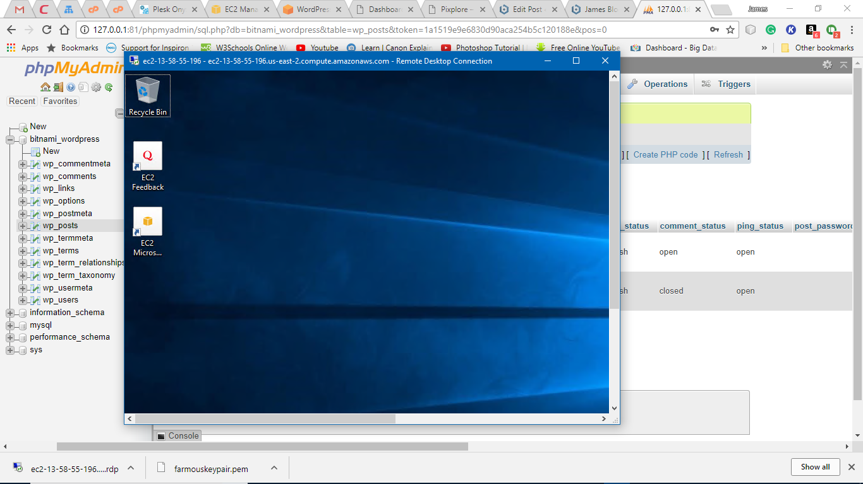

AWS Identity and Access Management(IAM)

AWS Identity and Access Management (IAM) is a web service that helps you securely control access to AWS resources. You use IAM to control who is authenticated (signed in) and authorized (has permissions) to use resources.

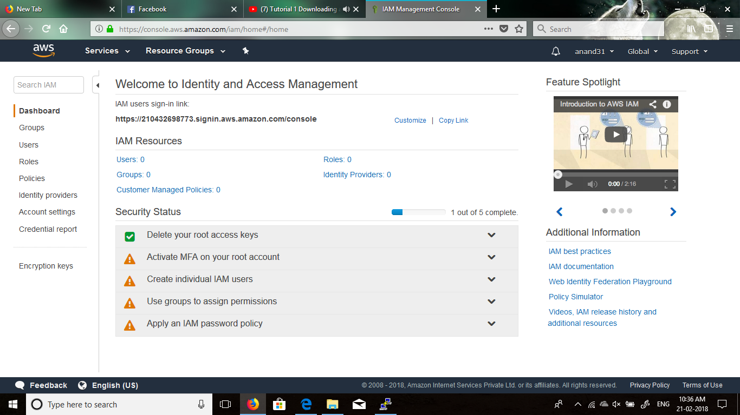

* Go to Dashboard>Users to add a new user

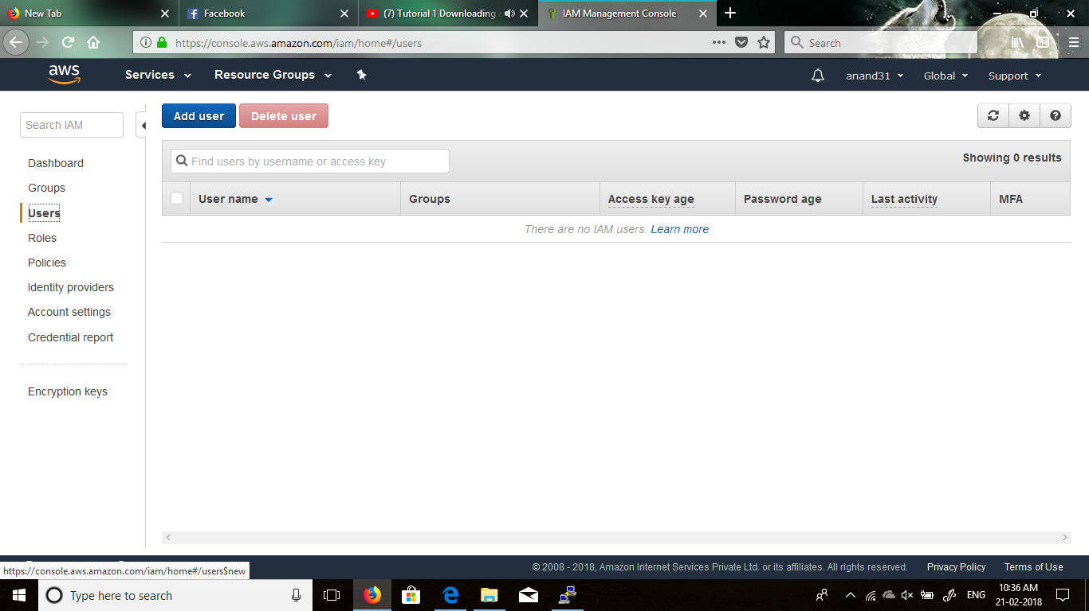

* In the first step, you have to provide details such as name and access type of the user

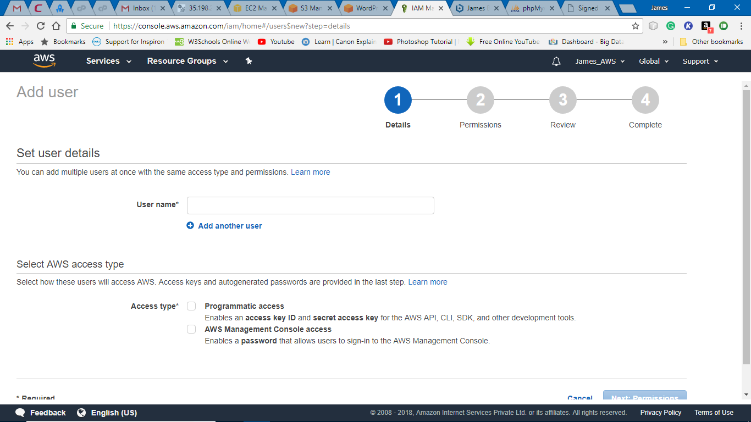

* And provide a password for the console

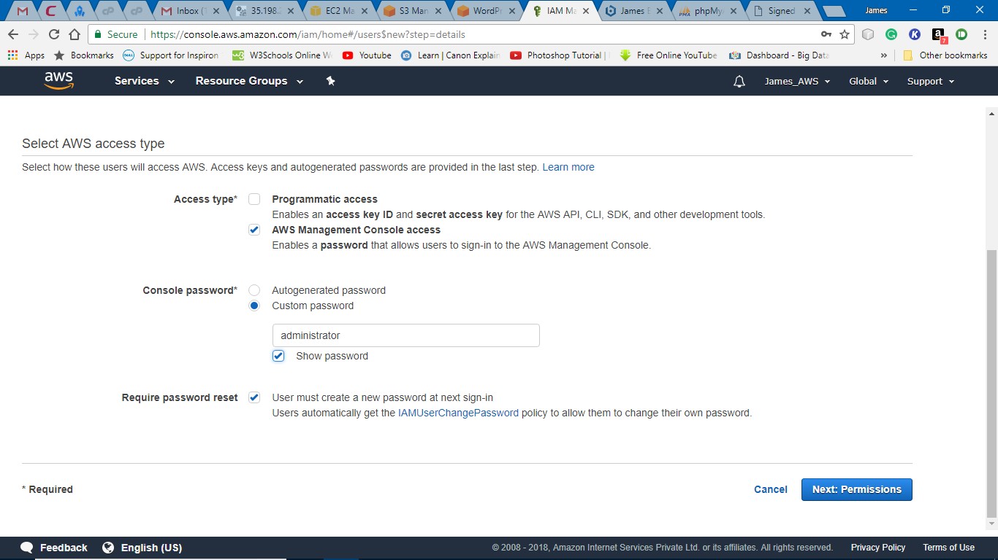

* Once completed the first step, go to the Second step which is to configure permission for the created user. Therefore create a group

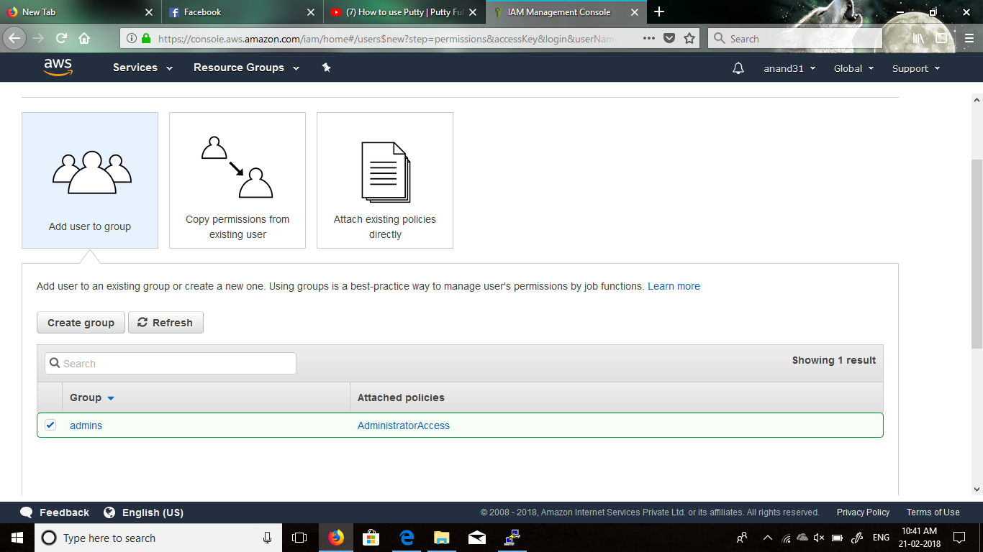

* Assign a name for the group and set policy type as Administrator Access

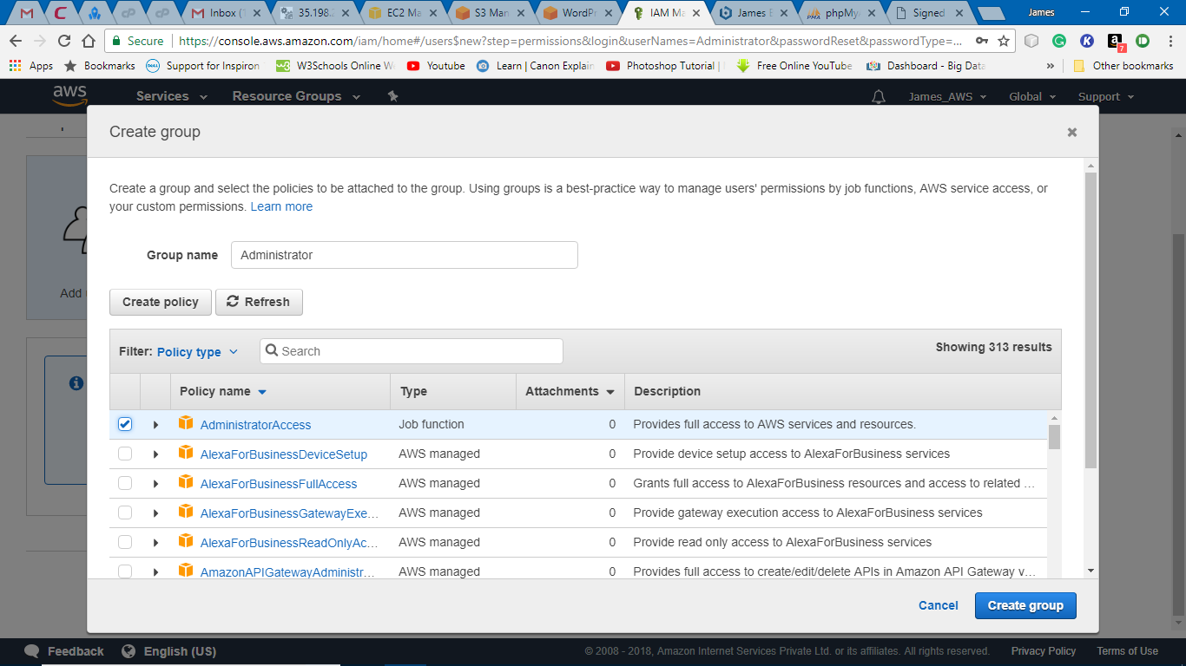

* Once completed, the group which was created will available

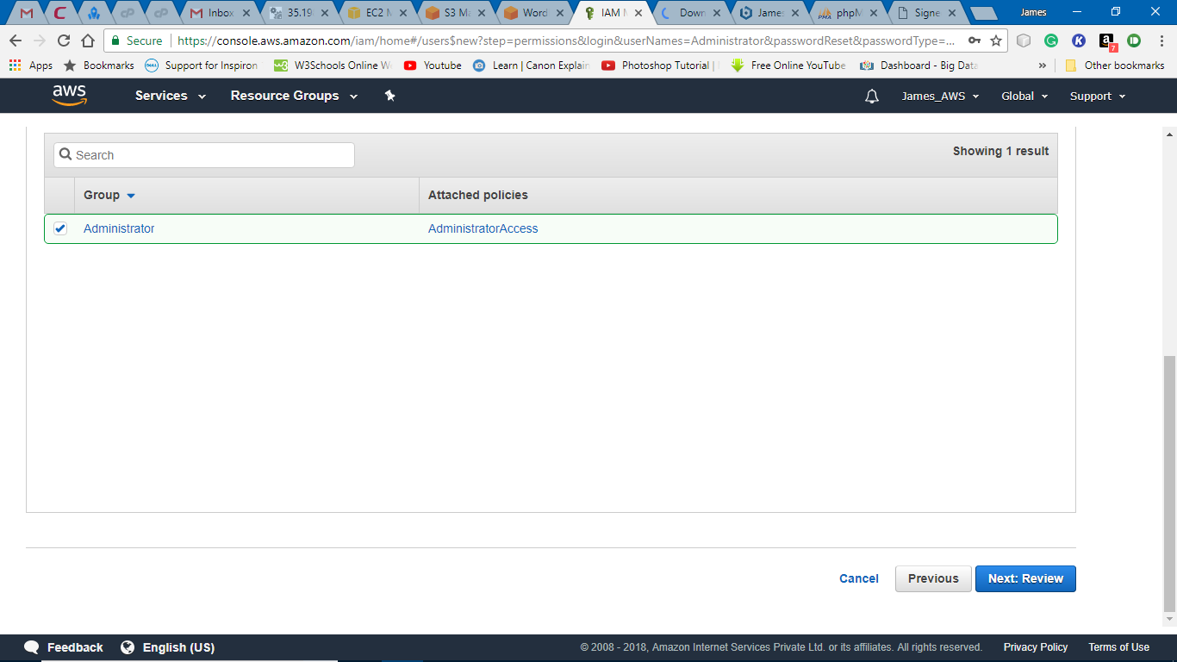

* The next step is to review your user

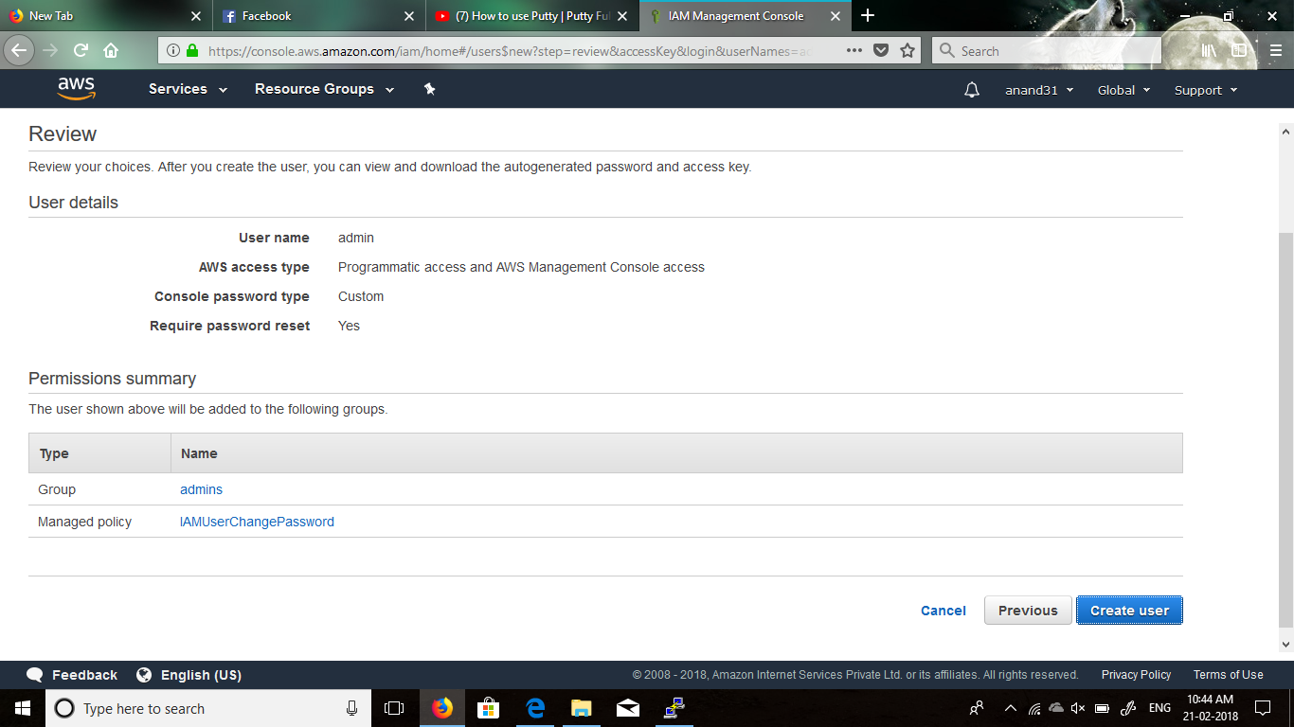

* Once all the above steps are worked fine, the final step will show user confirmation

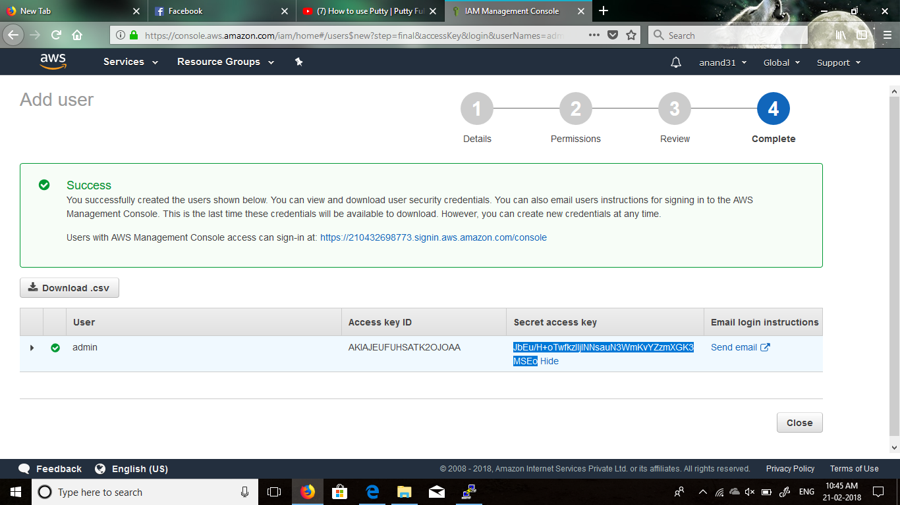

* Login to AWS again with previously created user credentials. Account-ID will appear automatically.

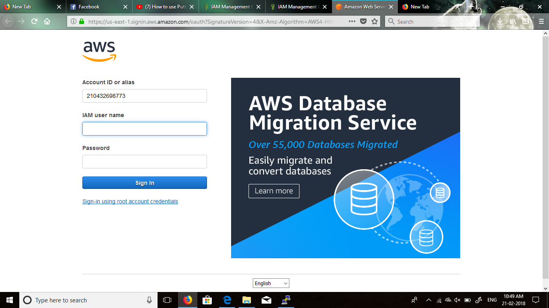

* Once successfully logged in, you will be redirected to AWS home page

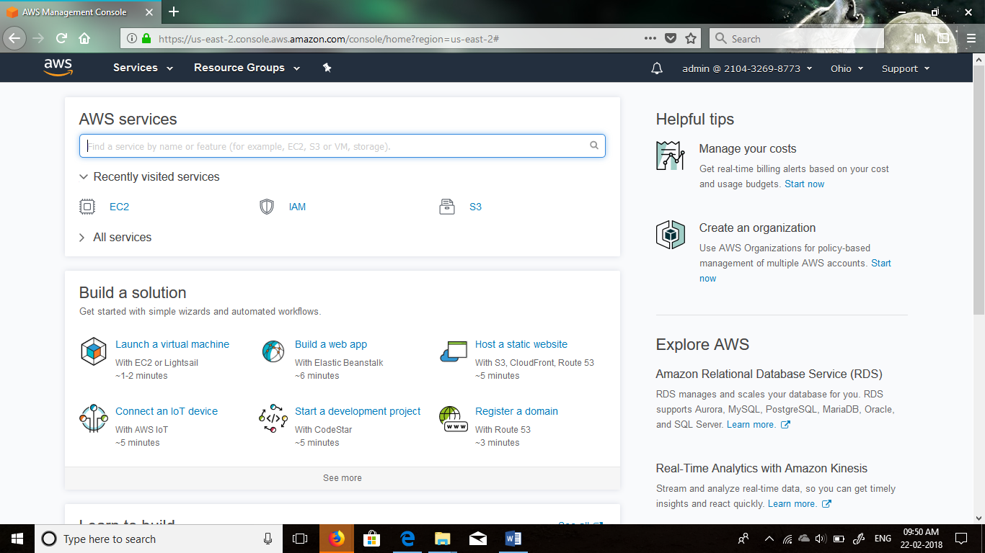

* Go to EC2 Dashboard and select keypairs

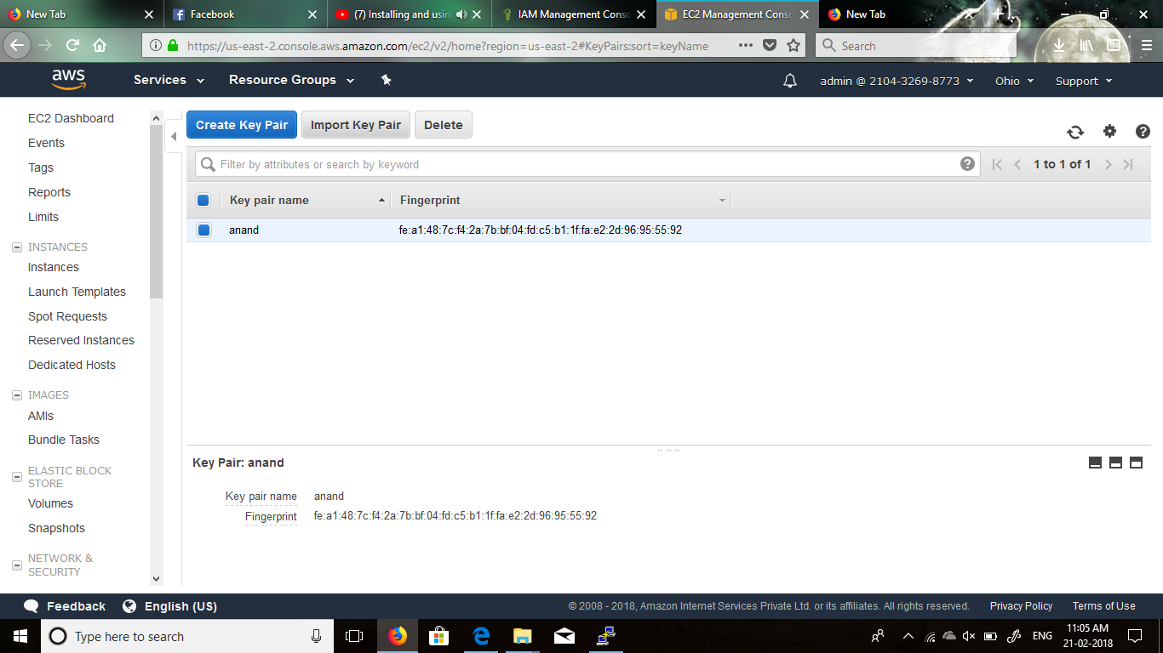

* Here you have to create a pair of the key. So, assign a name for the key

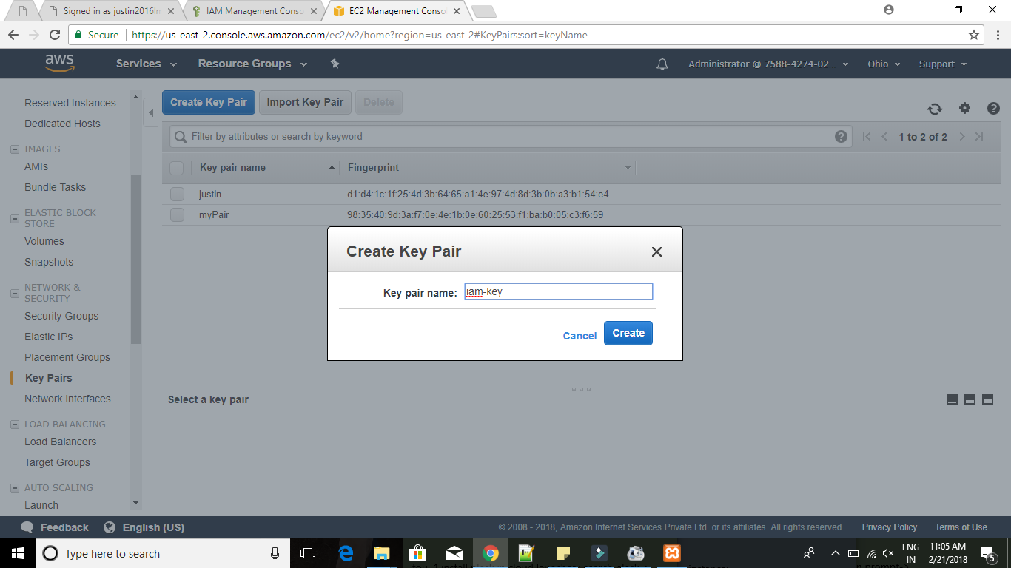

**Creating another Instance on EC2**

* Creating instance on AWS EC2, Step 1 required to select an Amazon Machine Image(AMI) and then proceed to next step.

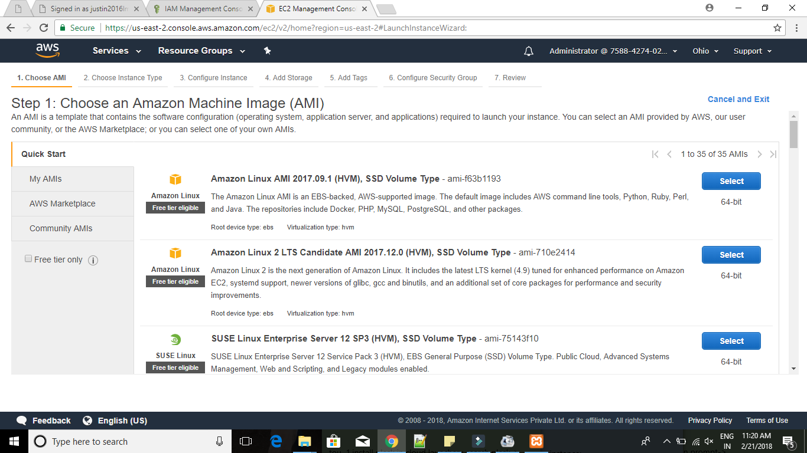

* The next step is to select an instance type

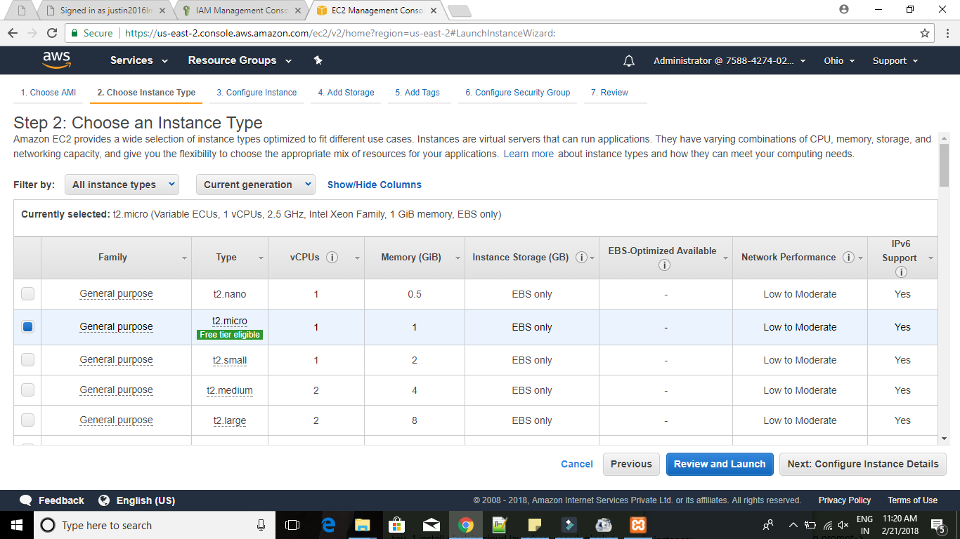

* Once instance type is selected go to step 3, where you have to configure instance details

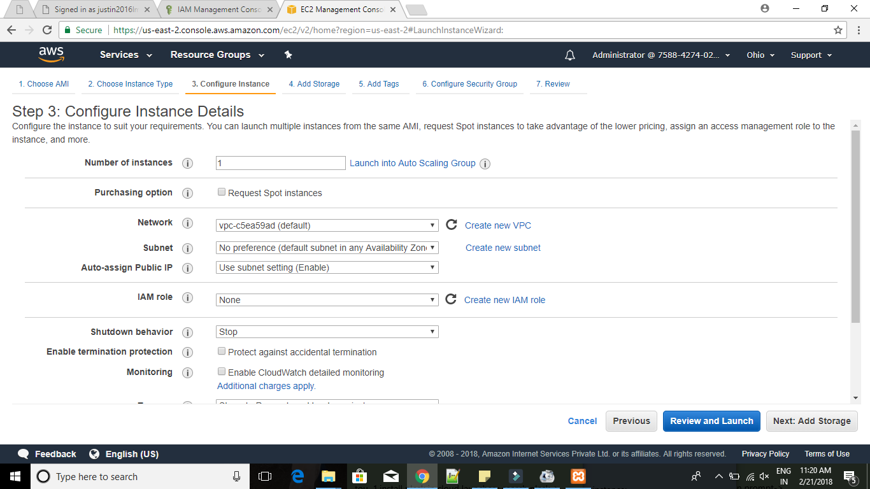

* The next step is to Add storage if storage is required add a new volume

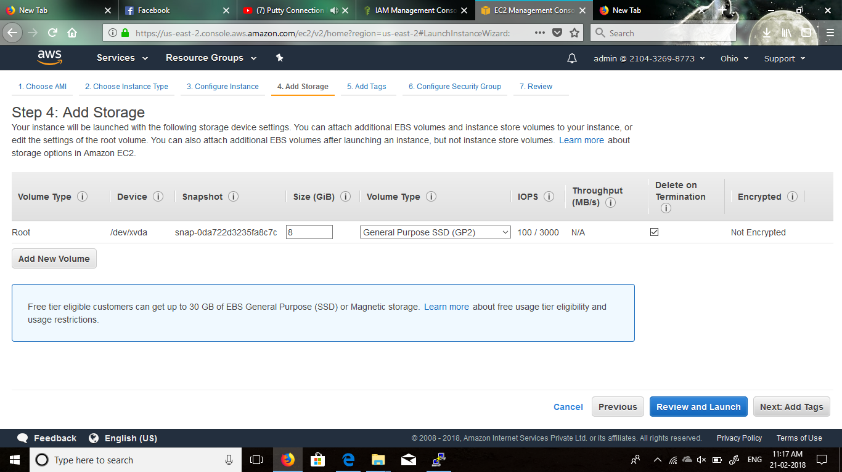

* The next Step is to Add Tags, which consist of a case-sensitive key-value pair

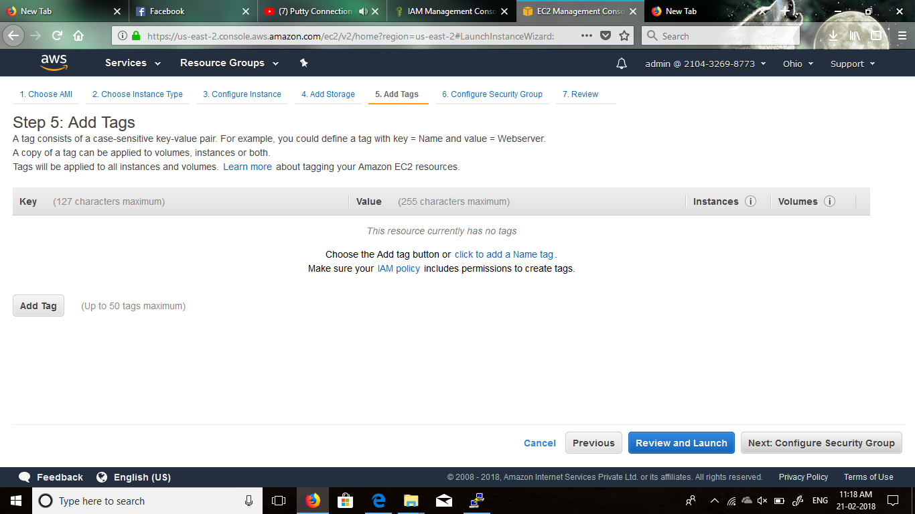

* The next step is to configure security group, you can assign security group as well as a name for the assigned group and description also.

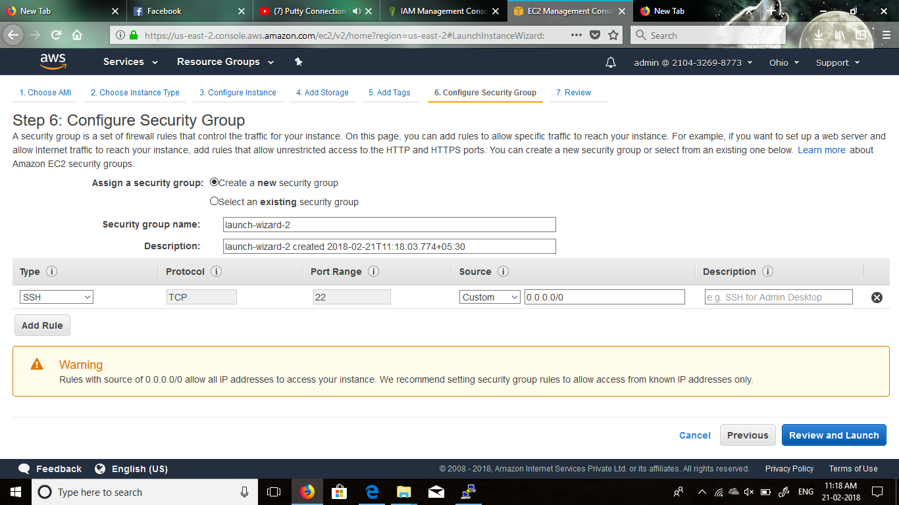

* This step is to review and launch your instance, here in this step you have to create or choose an existing key pair that AWS stores. If there is no existing key pair, create a new key pair by providing a name for the key pair and download the key pair for further process. And Launch your instance.

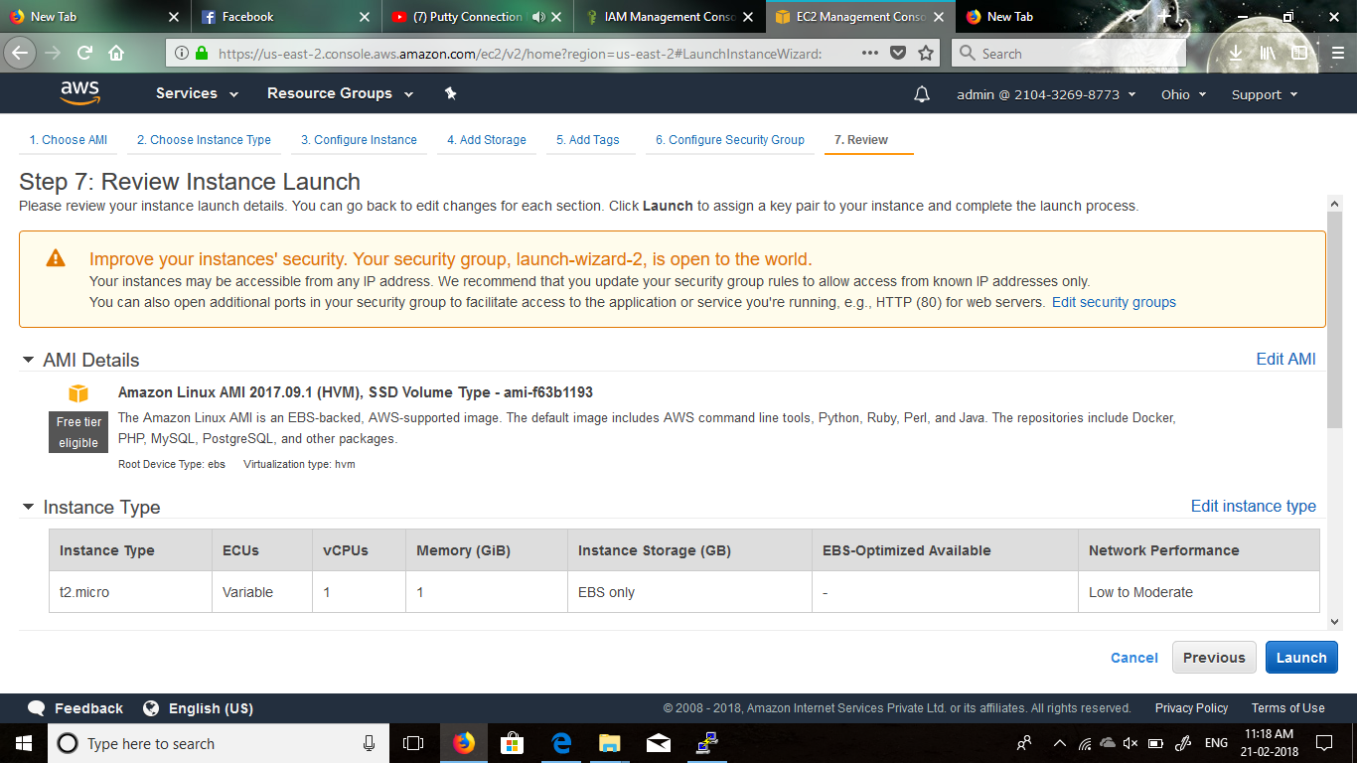

* Created instance is ready to launch.

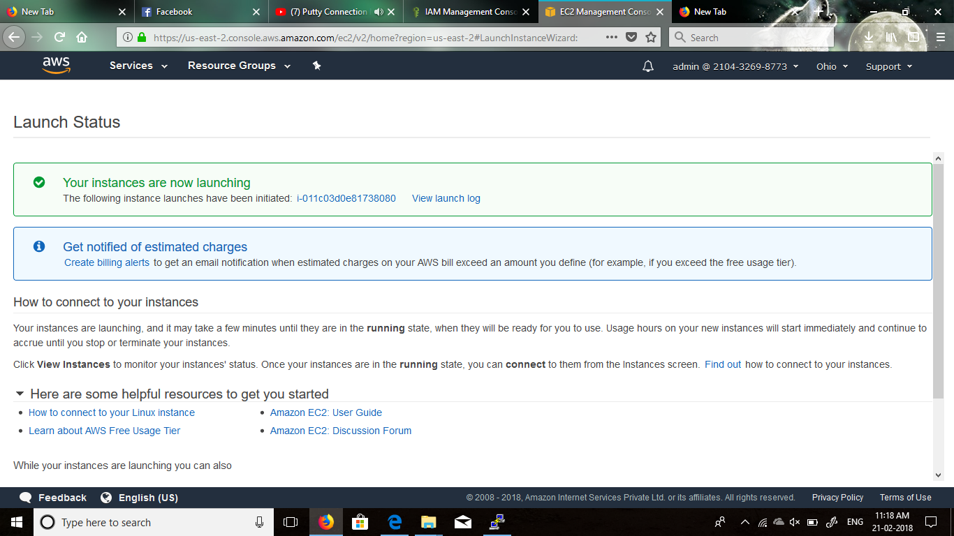

* Created Instance is running actively

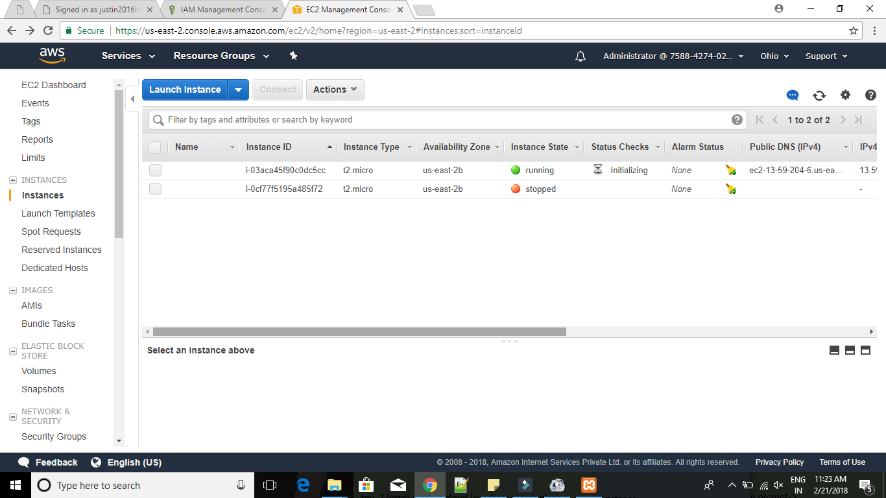

**PuTTY Application**

PuTTY is an SSH and telnet client, developed originally by Simon Tatham for the Windows platform. PuTTY is open source software that is available with source code and is developed and supported by a group of volunteers.

* PuTTY Key Generator is an executable file contained in the PuTTY package. And used to generate a key pair

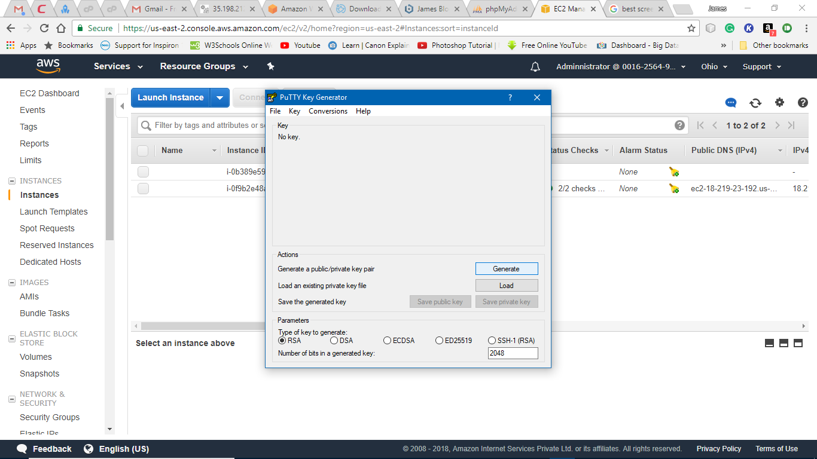

* Click *Generate* button to create public or private key pair.

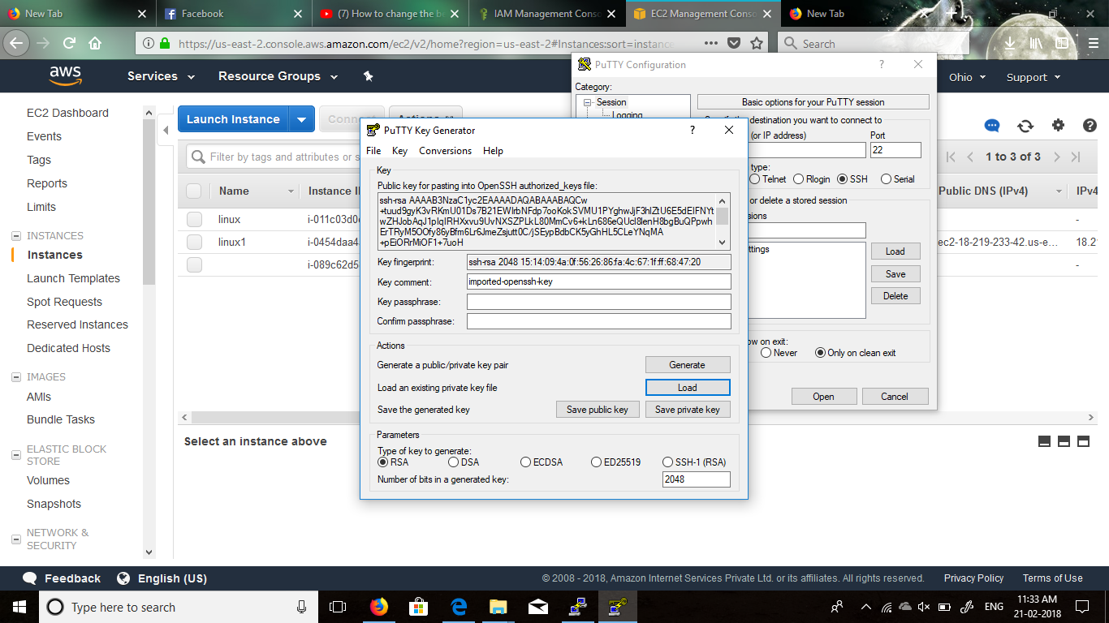

* Connect to your Instance, Go to EC2 Dashboard and select your instance which was created earlier and click on *connect.* A window will appear for instance information. Copy and keep Public DNS

For eg: ec2-18-219-23-192.us-east-2.compute.amazonaws.com

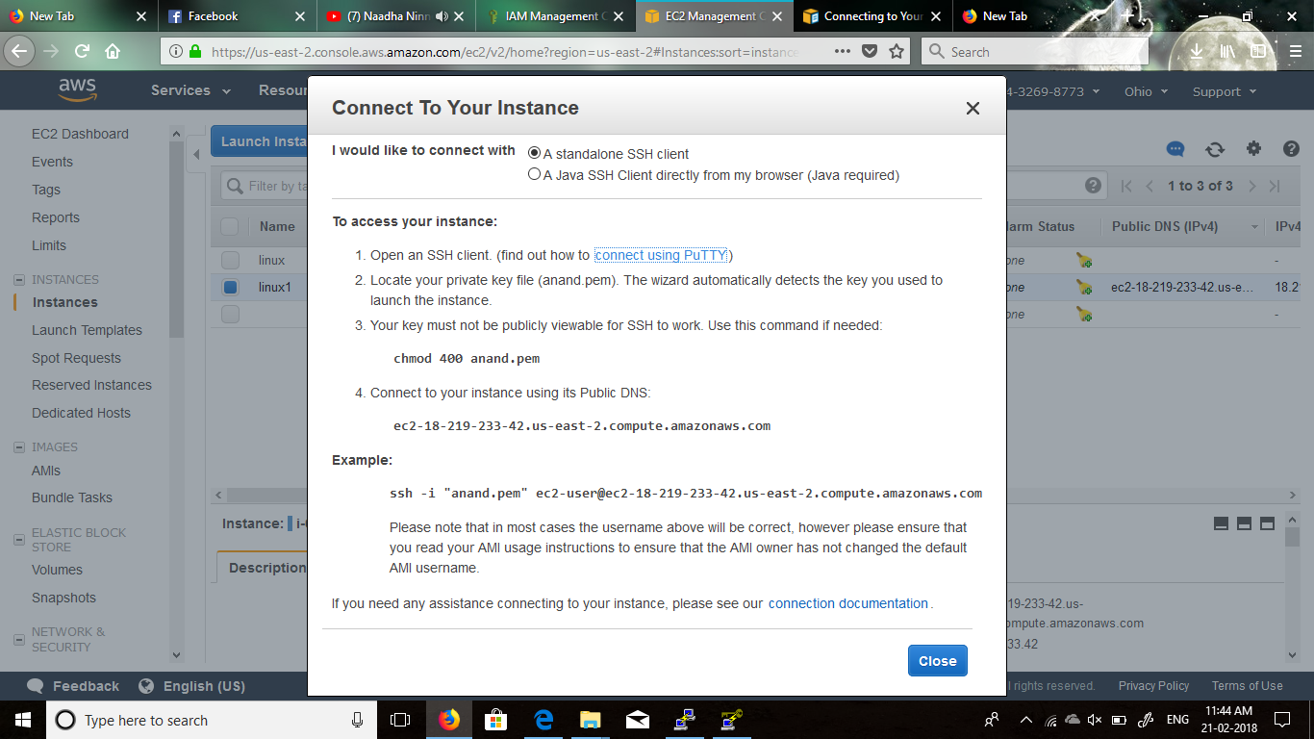

* Open the PuTTY Application and configure it. Use Public DNS as Hostname with prefix ec2-user@.

For eg: [ec2-user@ec2-18-219-23-192.us-east-2.compute.amazonaws.com](mailto:ec2-user@ec2-18-219-23-192.us-east-2.compute.amazonaws.com)

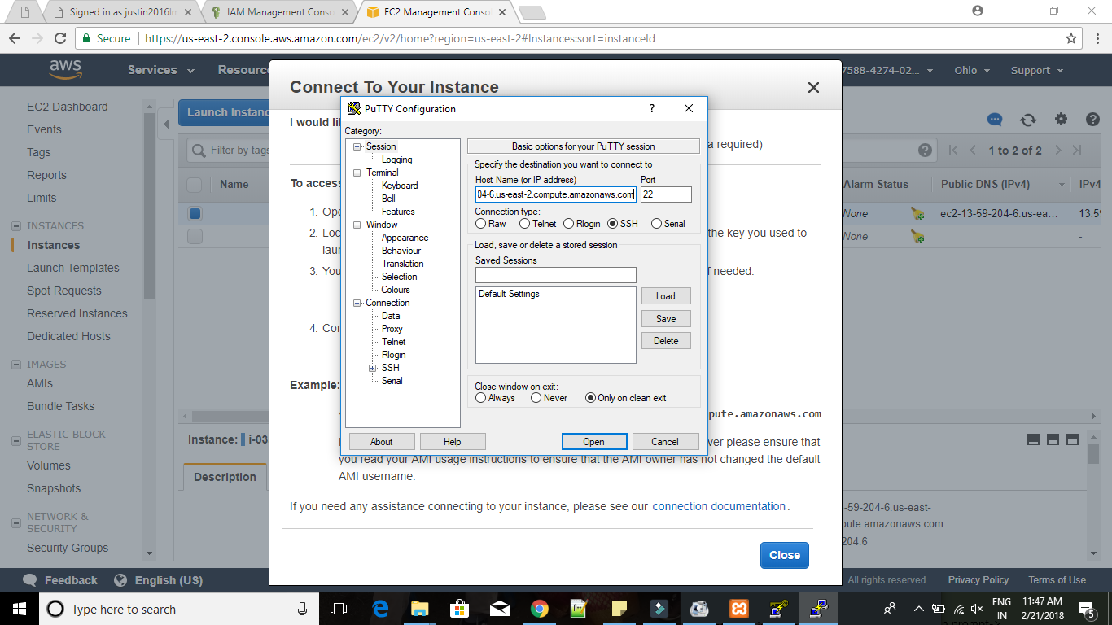

* Go to Connection > SSH > Auth, and browse private key file, which was generated when the instance key pair is created. Then Open the connection.

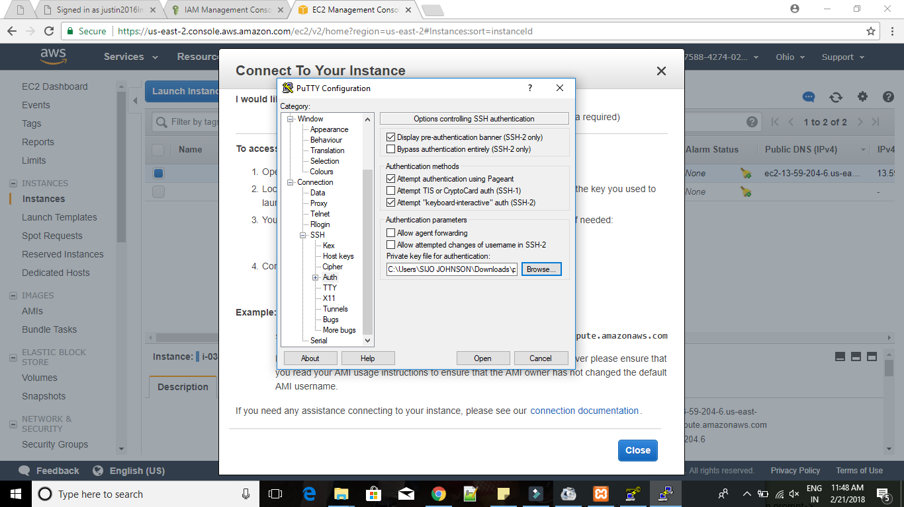

* Once the connection is established you will get a prompt like following.

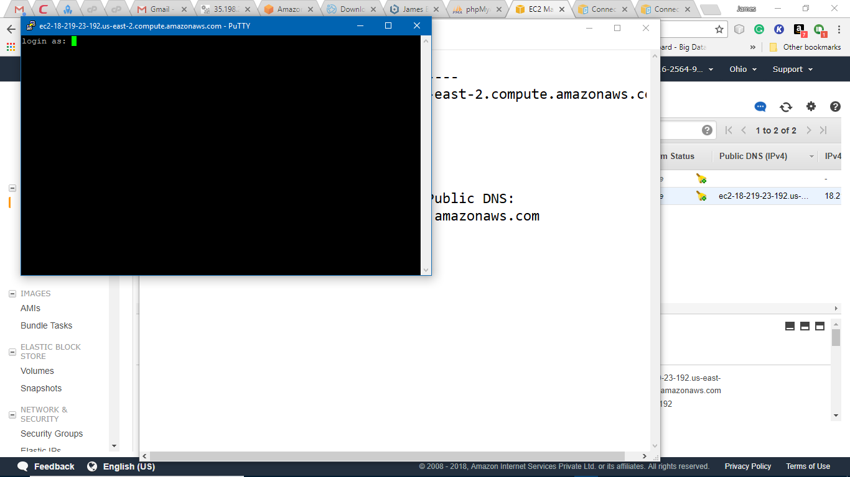

**Install and start the LAMP Web server with the Amazon Linux AMI**

We have to configure LAMP web server by using commands. Prefer to use AWS Docs to complete the process

(Visit https://docs.aws.amazon.com/AWSEC2/latest/UserGuide/install-LAMP.html)

* $ **sudo yum update –y**

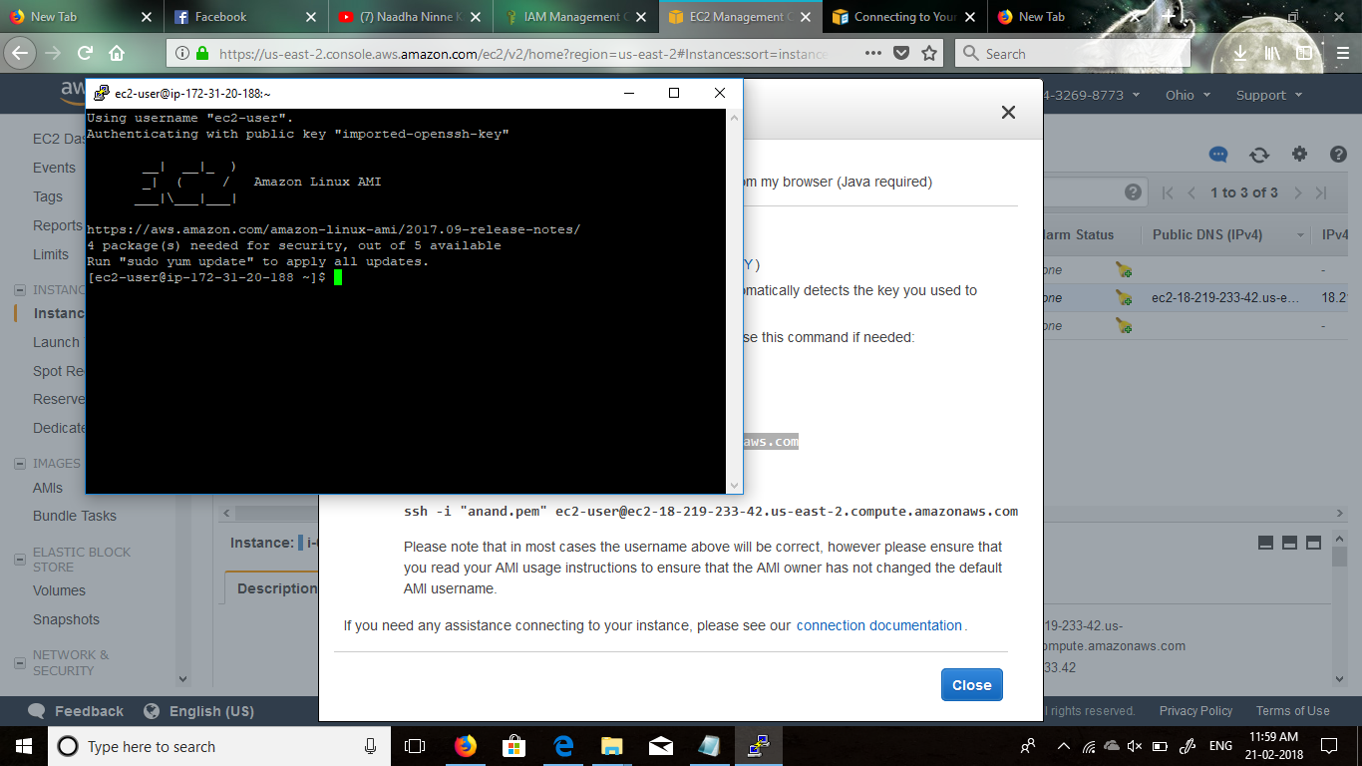

* $ **sudo yum install -y httpd24 php70 mysql56-server php70-mysqlnd**

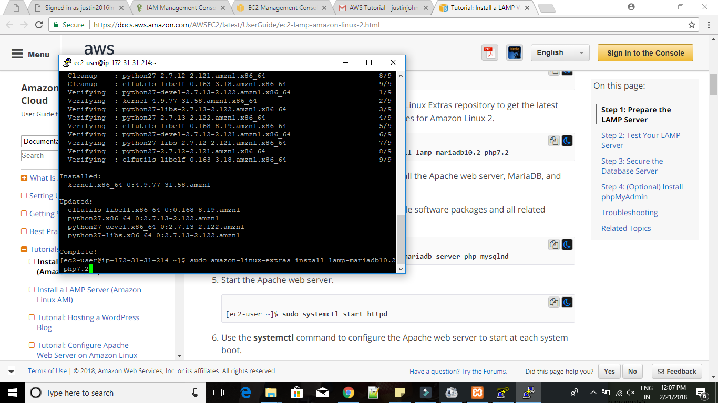

* Starting the Apache web server.
* $ **sudo service httpd start**

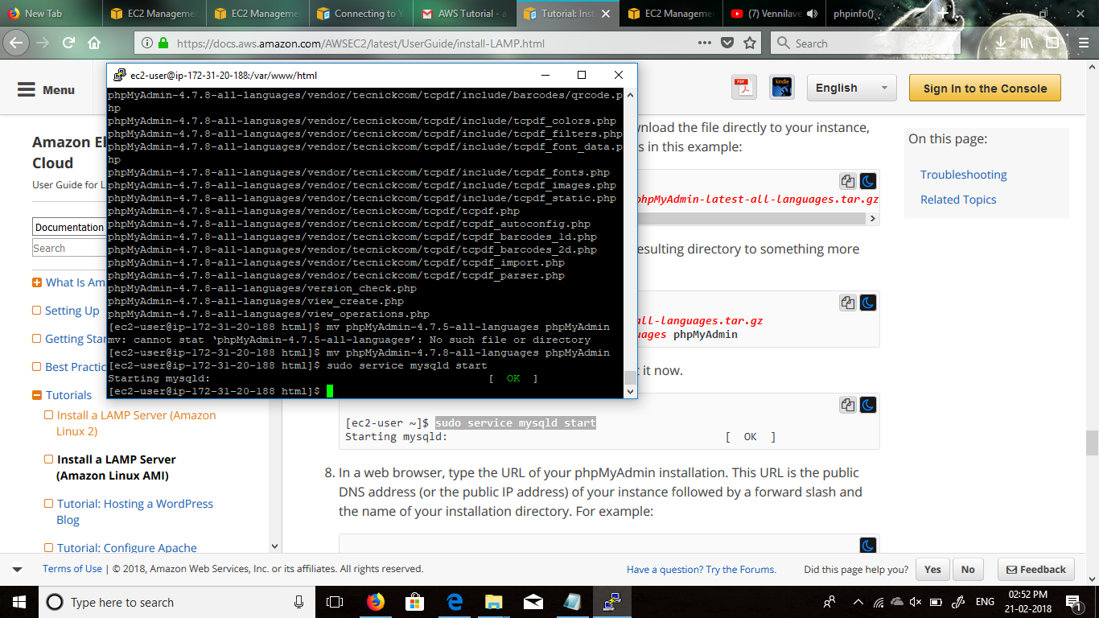

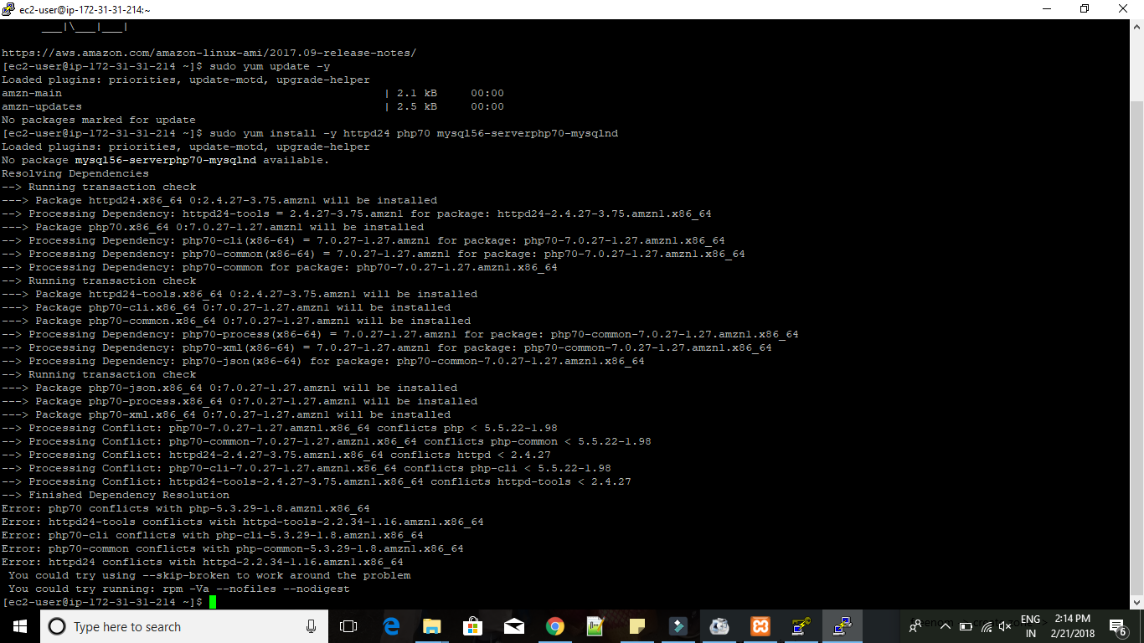

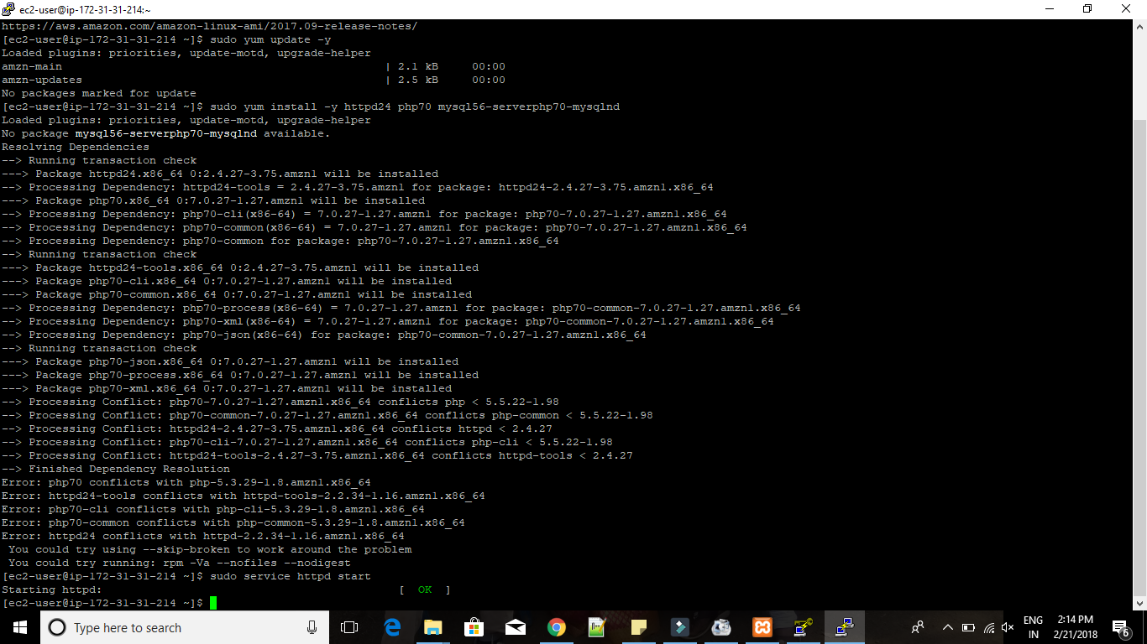

* Use the chkconfig command to configure the Apache web server to start at each system boot.
* $ **sudo chkconfig httpd on**

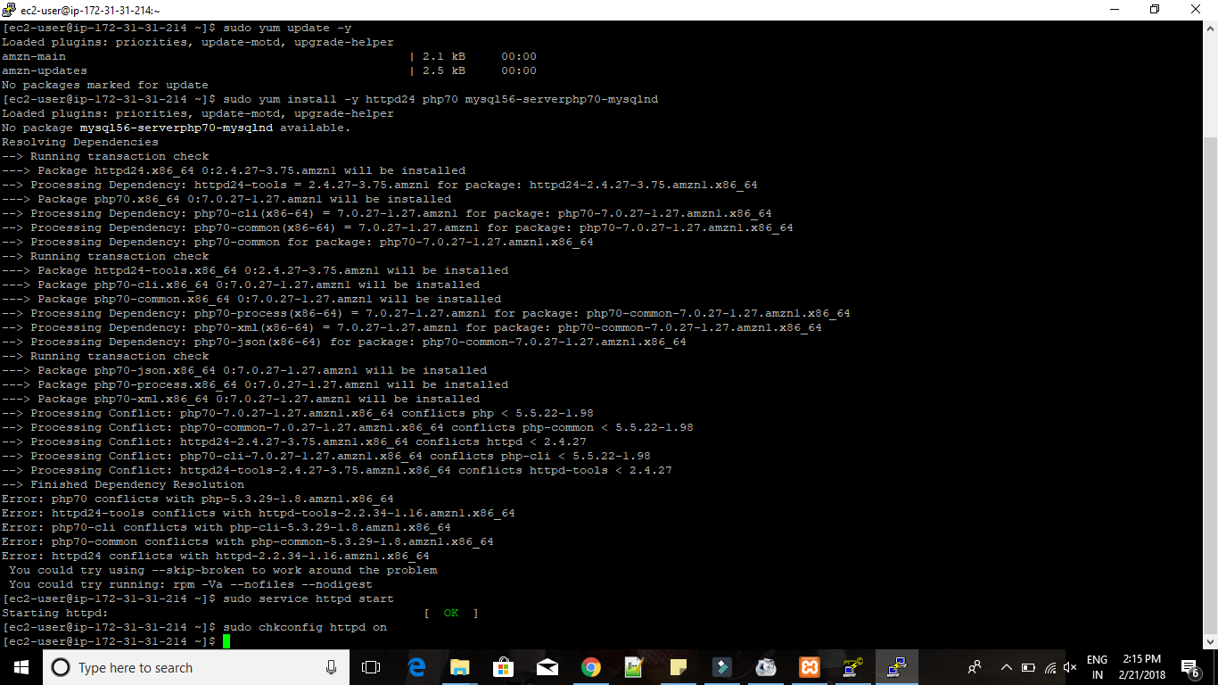

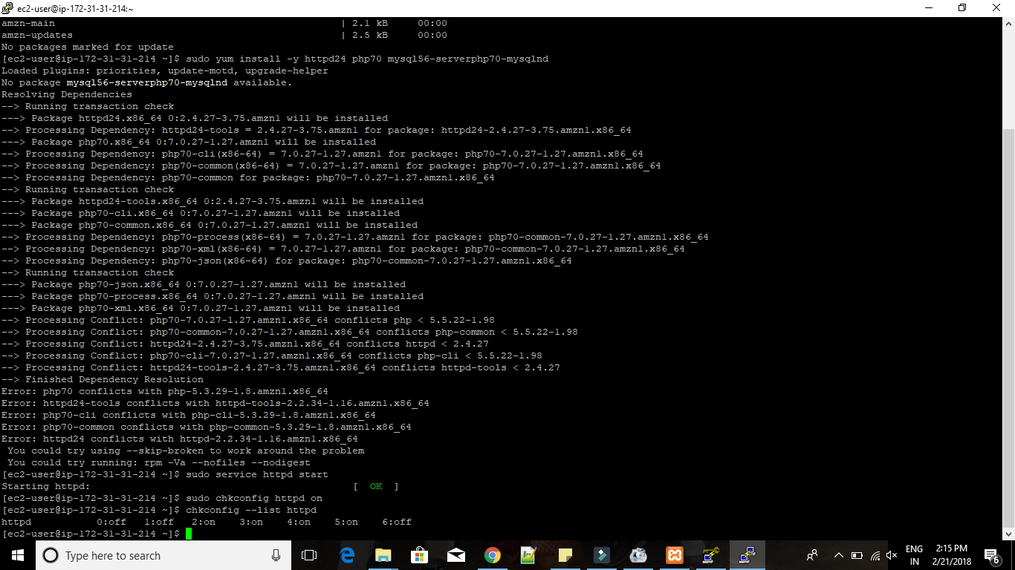

* **Add a security rule to allow inbound HTTP (port 80) connections to your instance**
* Open the Amazon EC2 console at https://console.aws.amazon.com/ec2/.
* Choose **Instances** and select your instance.
* Under **Security groups**, choose **view inbound rules**

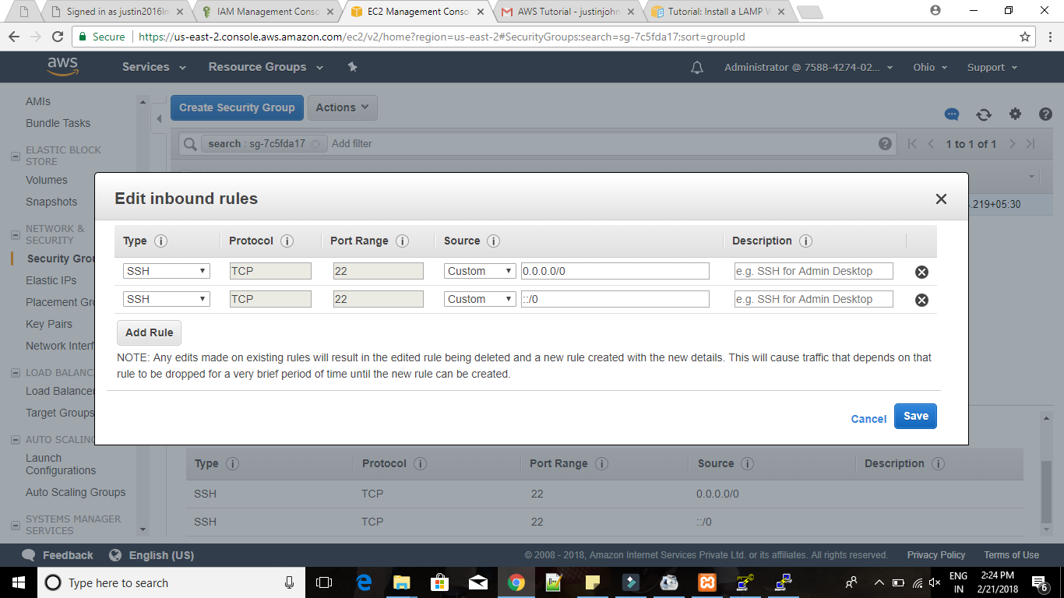

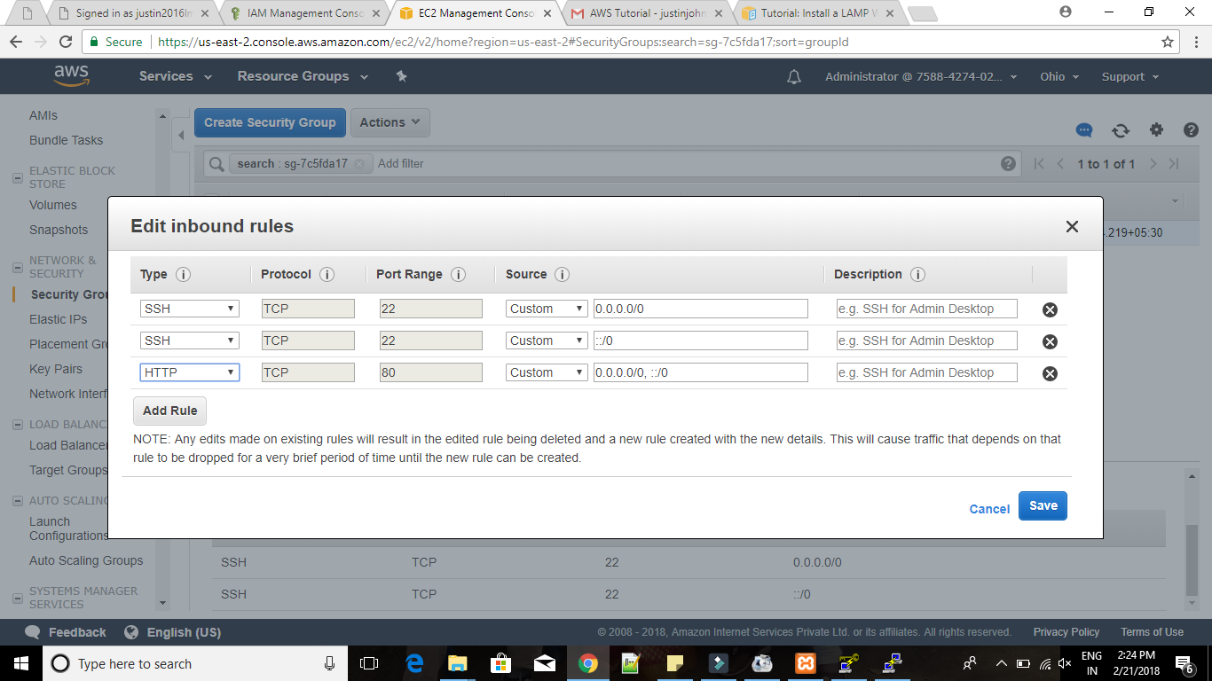

* Amazon Linux AMI Test Page

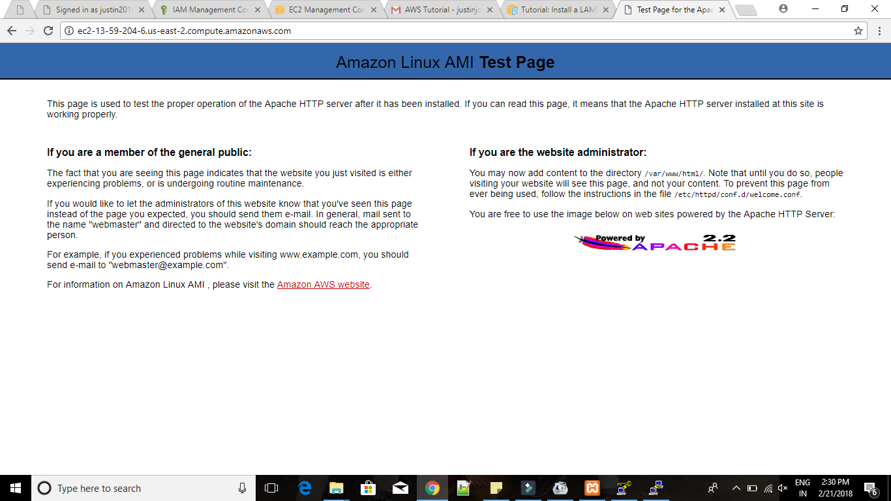

* To List Apache Document Root Directory

$ **ls -l /var/www**

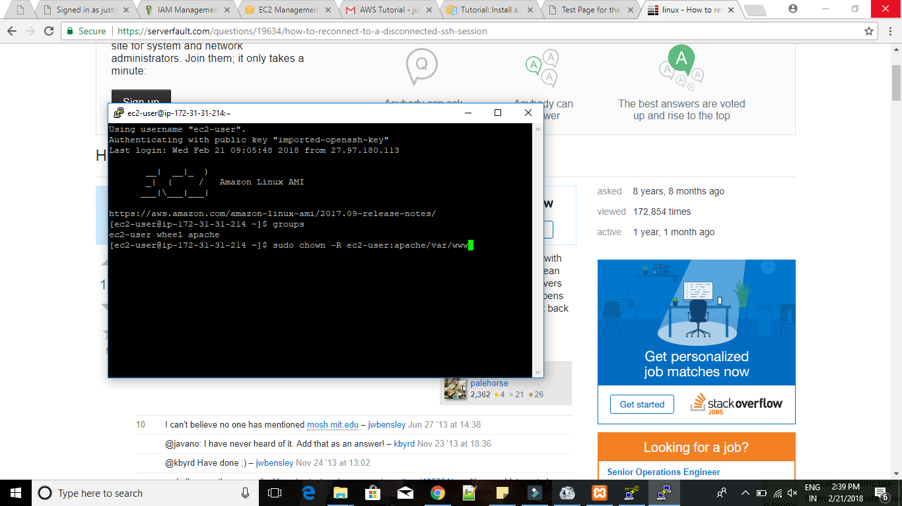

* Add your user to the apache group.

$ **sudo usermod -a -G apache *ec2-user***

* Log out (use the **exit** command or close the terminal window).

$ **exit**

* To verify your membership in the apache group, reconnect to your instance, and then run the following command.

[ec2-user ~]$ **groups**

ec2-user wheel apache

* Change the group ownership of /var/www and its contents to the apache group.

$ **sudo chown -R ec2-user:apache /var/www**

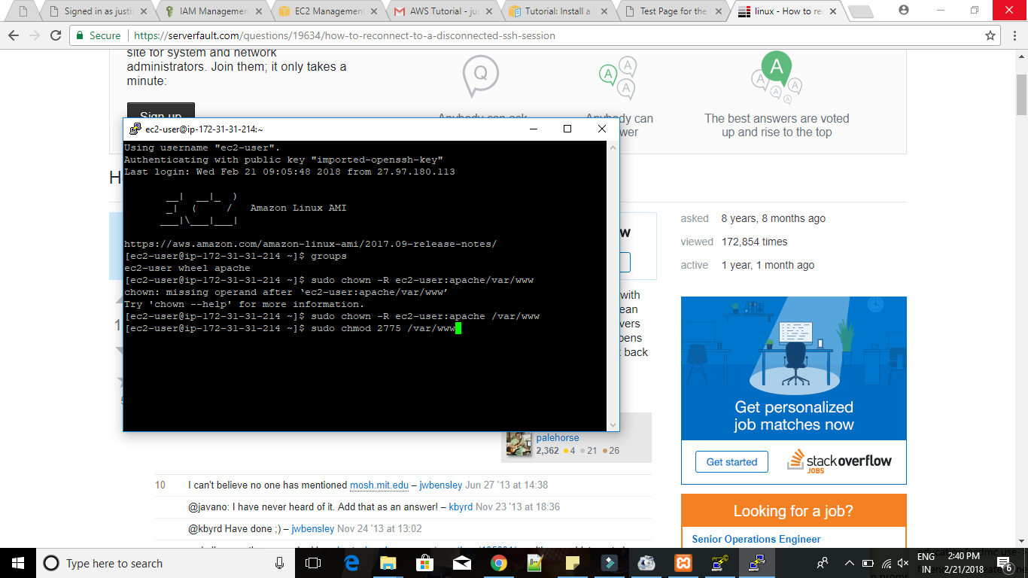

* change the directory permissions of /var/www and its subdirectories.

$ **sudo chmod 2775 /var/www**

$ **find /var/www -type d -exec sudo chmod 2775 {} \;**

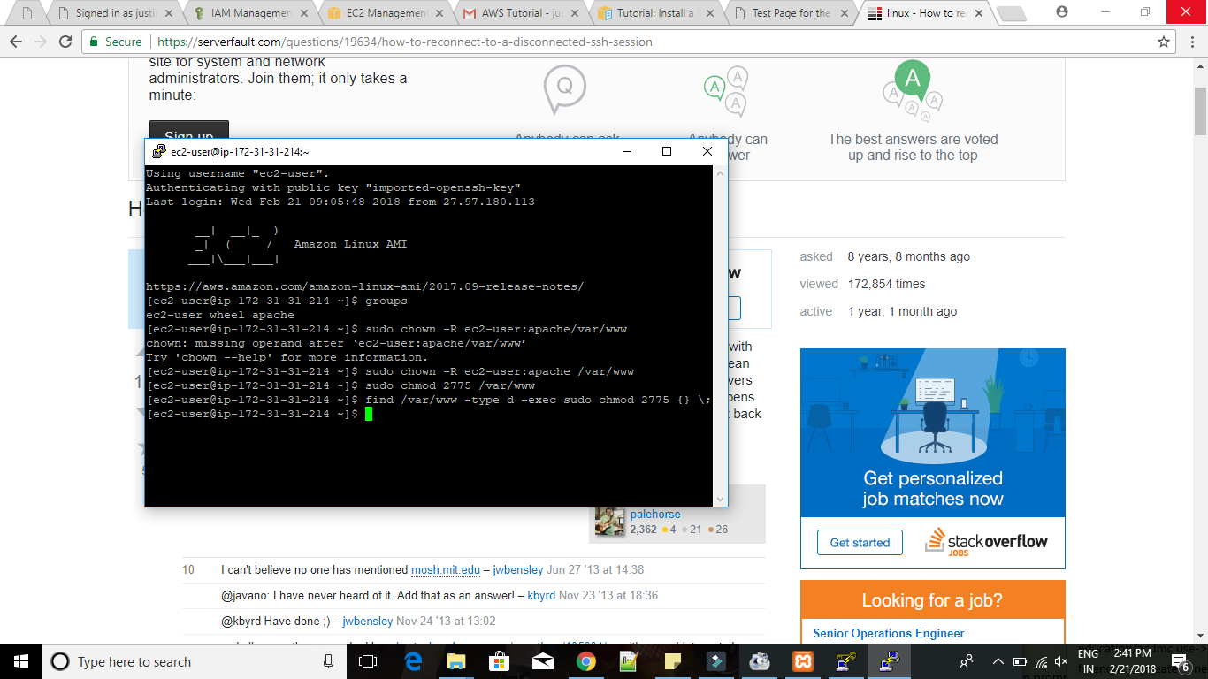

* To recursively change the file permissions of /var/www and its subdirectories.

$ **find /var/www -type f -exec sudo chmod 0664 {} \;**

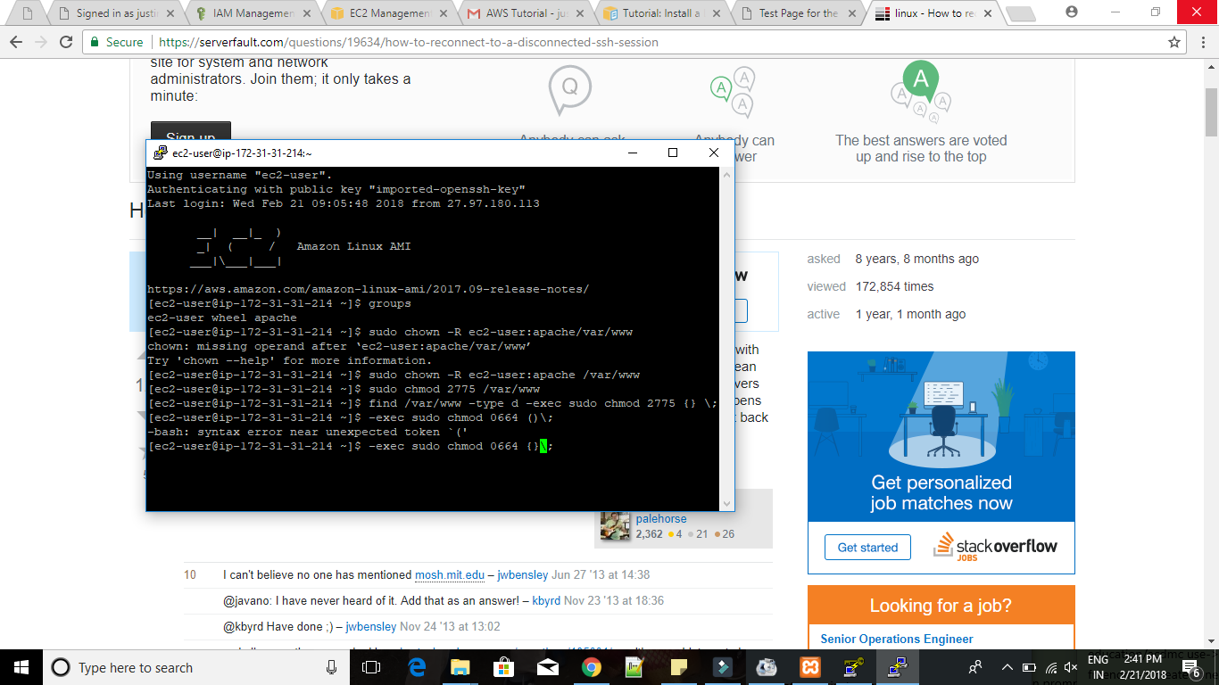

**To test your LAMP web server**

* Create a PHP file in the Apache document root.
* $ **echo "<?php phpinfo(); ?>" > /var/www/html/phpinfo.php**
* Type the URL of the file that you just created. This URL is the public DNS address of your instance followed by a forward slash and the file name.
* For eg: *http://my.public.dns.amazonaws.com/phpinfo.php*
* PHP Information page

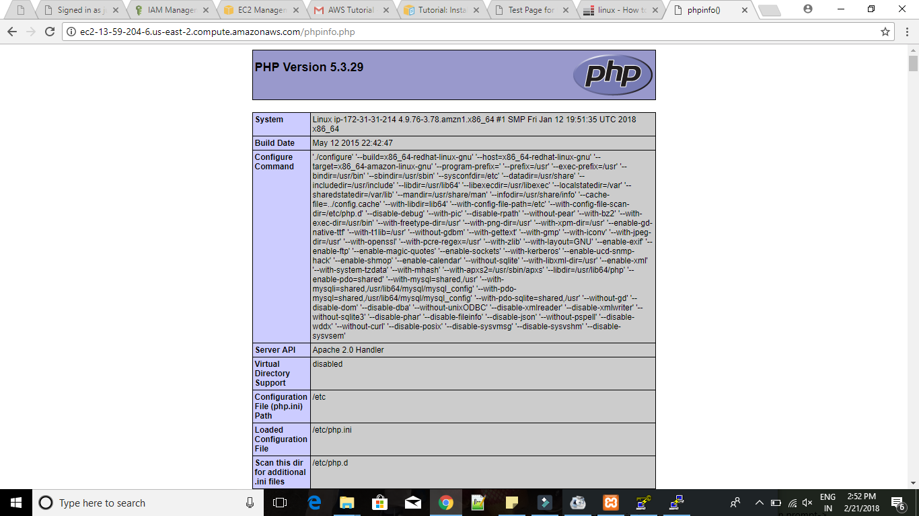

* Verify that the /var/www/html/phpinfo.php file was created properly in the previous step.
* $ **sudo yum list installed httpd24 php70 mysql56-server php70-mysqlnd**

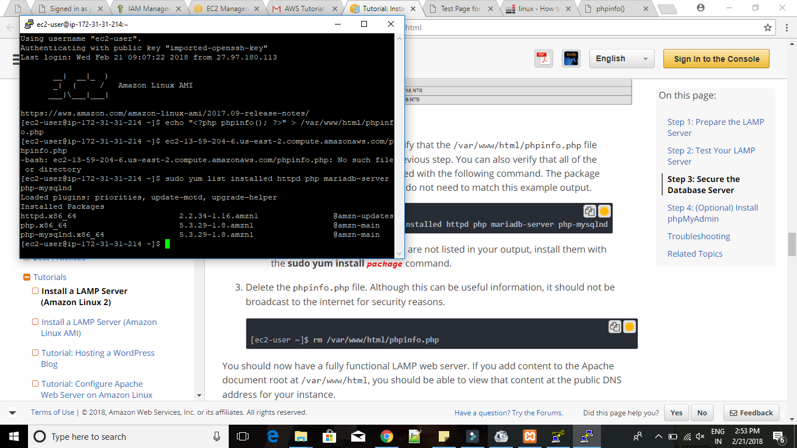

**To secure the database server**

* Start the MySQL server

$ **sudo service mysqld start**

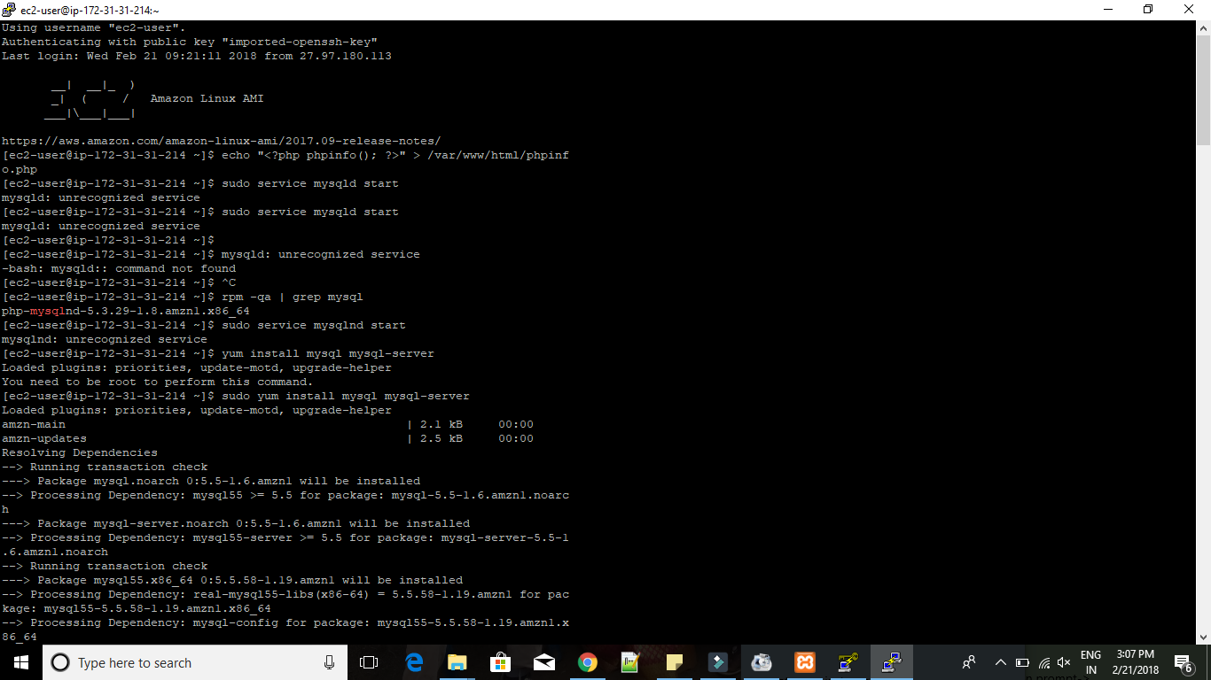

* Run mysql_secure_installation.

$ **sudo mysql_secure_installation**

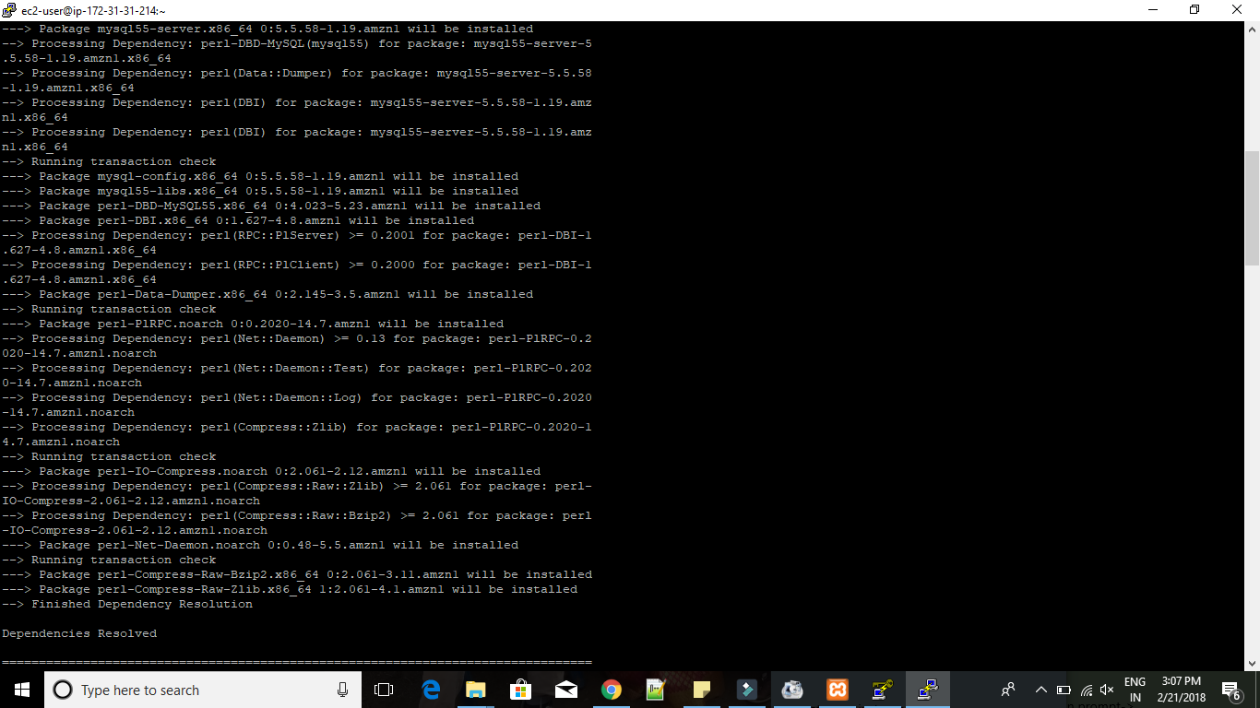

Install phpMyAdmin

* Log in to your EC2 instance using SSH.
* Install the required dependencies.

$ **sudo yum install php70-mbstring.x86_64 php70-zip.x86_64 -y**

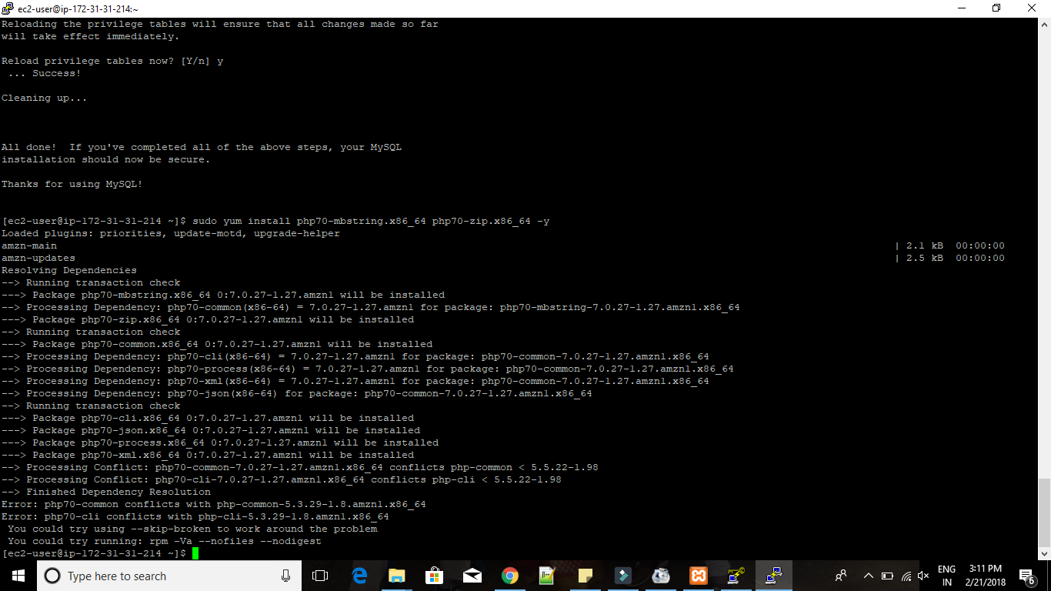

* Restart Apache

$ **sudo service httpd restart**

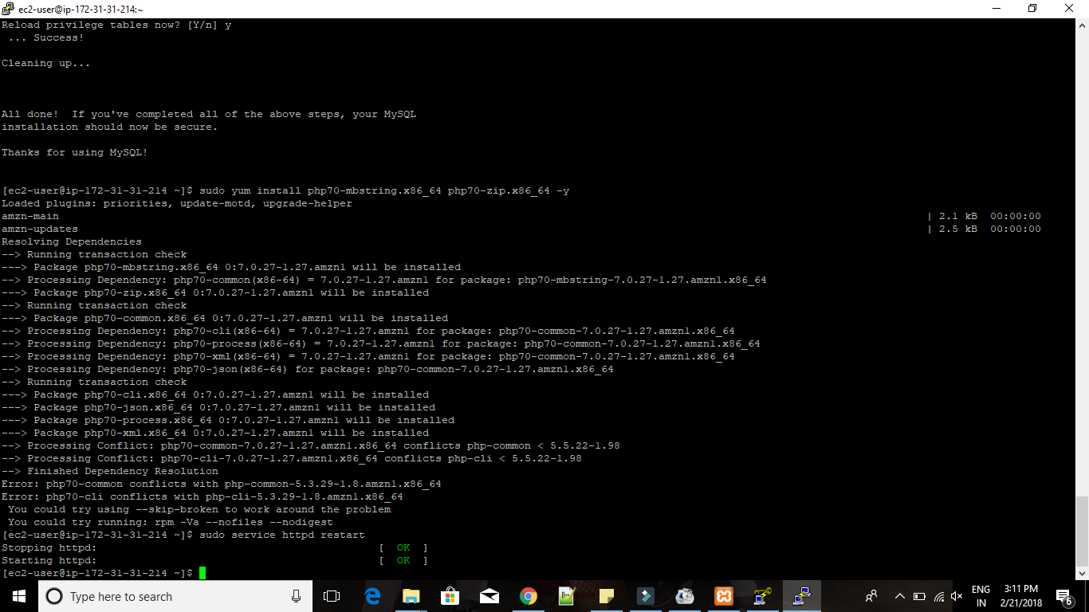

* Navigate to the Apache document root at /var/www/html

$ **cd /var/www/html**

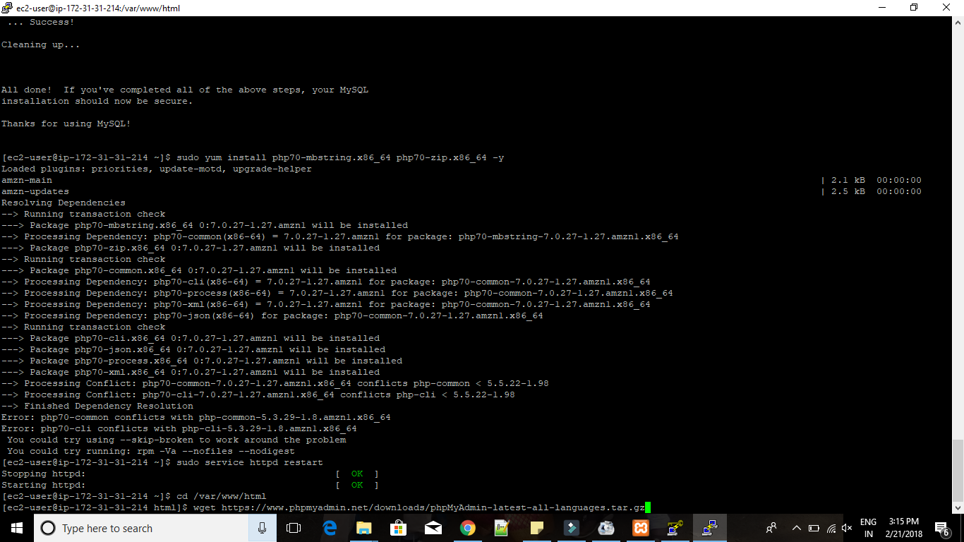

* Select a source package for the latest phpMyAdmin release.

$ **wget *https://www.phpmyadmin.net/downloads/phpMyAdmin-latest-all-languages.tar.gz***

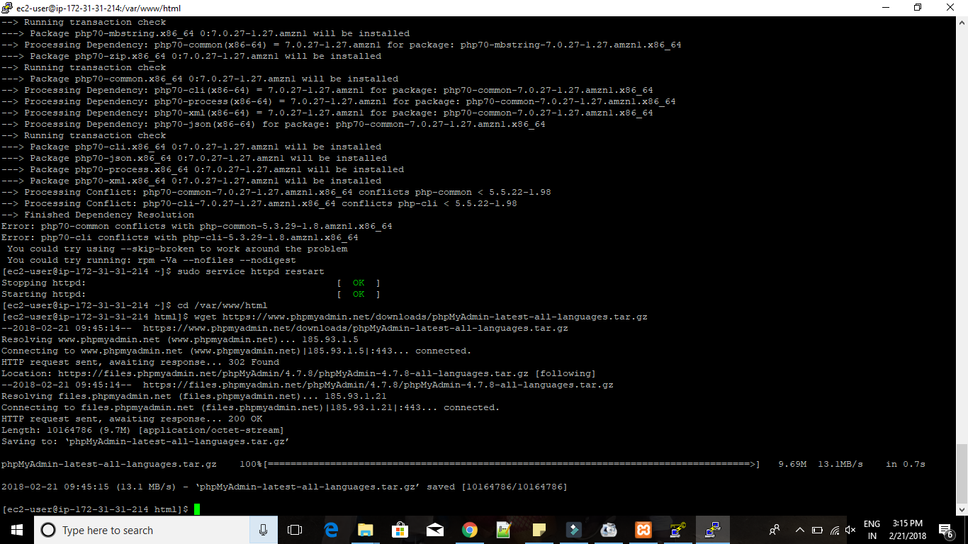

* Extract the package and change the name of the resulting directory to something more manageable.

$ **tar -xvzf *phpMyAdmin-latest-all-languages.tar.gz***

$ **mv *phpMyAdmin-4.7.5-all-languages* phpMyAdmin**

* Start MySQL server

$ **sudo service mysqld start**

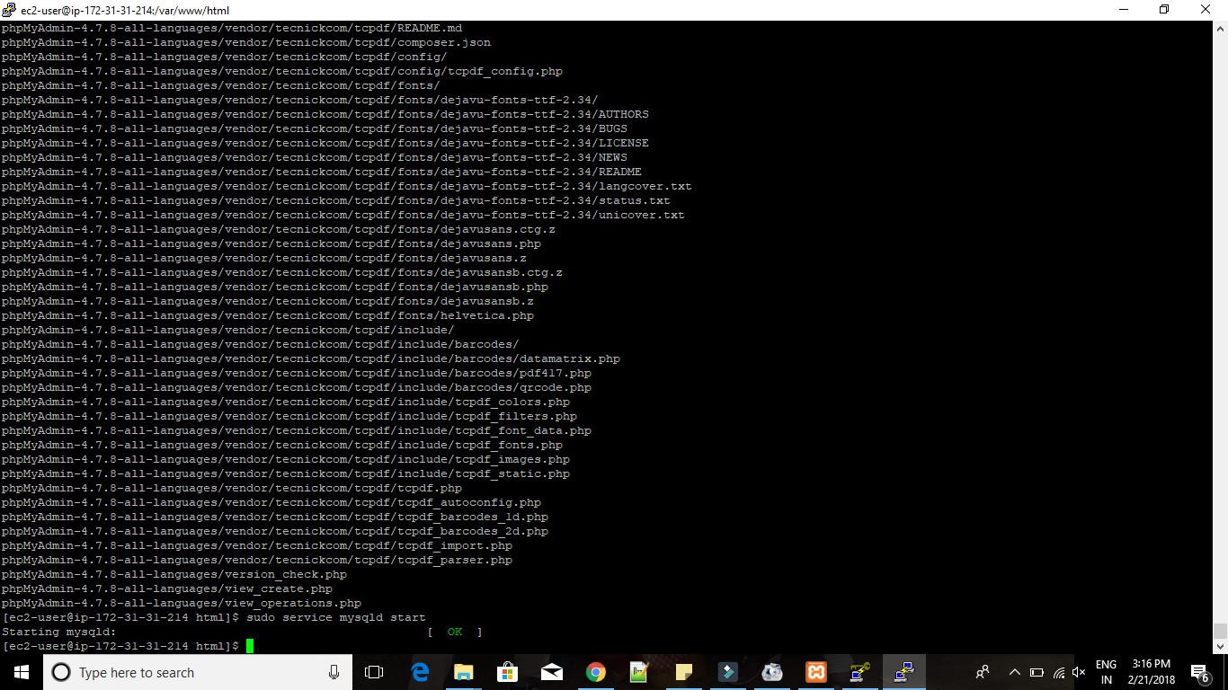

* In a web browser, type the URL of your phpMyAdmin installation. This URL is the public DNS address (or the public IP address) of your instance followed by a forward slash and the name of your installation directory. For example:

*http://my.public.dns.amazonaws.com/phpMyAdmin/*

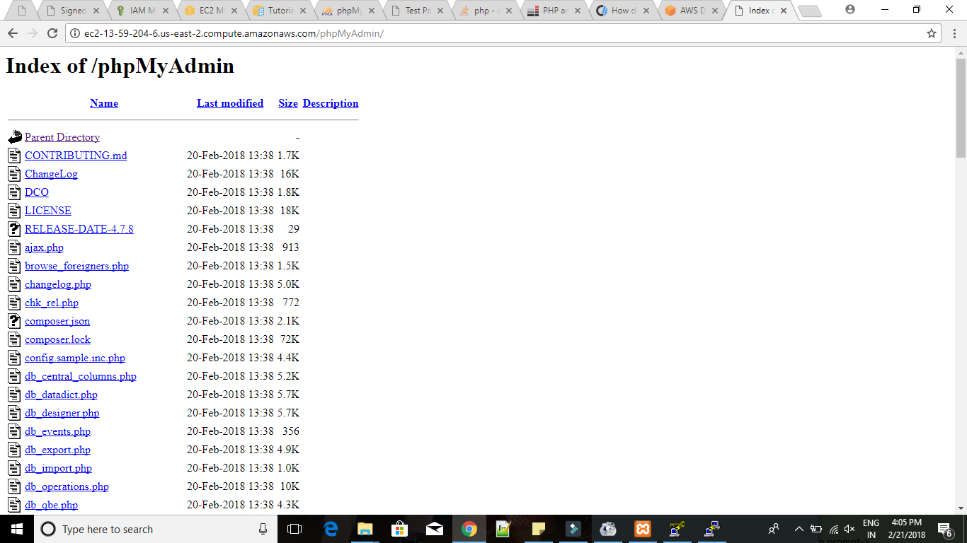

**P1.2.3** Amazon Simple Storage Service (S3)

Amazon S3 is a web service offered by Amazon Web Services. Amazon S3 provides storage through web services interfaces. S3 is a scalable, high-speed, low-cost, web-based cloud storage service designed for online [backup](http://searchdatabackup.techtarget.com/definition/backup) and [archiving](http://searchstorage.techtarget.com/definition/archive) of data and [application programs](http://searchsoftwarequality.techtarget.com/definition/application-program). S3 was designed with a minimal feature set and created to make web-scale computing easier for developers. Amazon S3 is an object storage service, which differs from block and file cloud storage. Each object is stored as a file with its metadata included and given an ID number. Applications use this ID number to access an object. Unlike file and block cloud storage, a developer can access an object via a rest API.

The S3 cloud storage service gives a subscriber access to the same systems that Amazon uses to run its own websites. S3 enables a customer to upload, store and download practically any file or object that is up to five [gigabytes](http://searchstorage.techtarget.com/definition/gigabyte) (5 GB) in size. Amazon S3 comes in two storage classes: S3 Standard and S3 Infrequent Access. S3 Standard is suitable for frequently accessed data that needs to be delivered with low latency and high throughput. S3 Standard targets applications, dynamic websites, content distribution and big data workloads. S3 Infrequent Access offers a lower storage price for backups and long-term data storage.

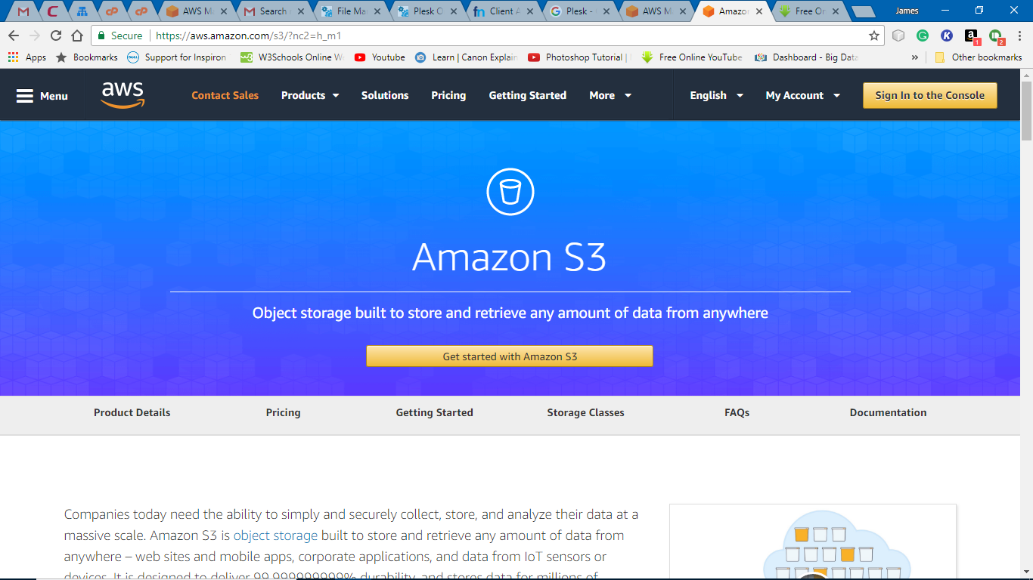

* Get started with Amazon S3

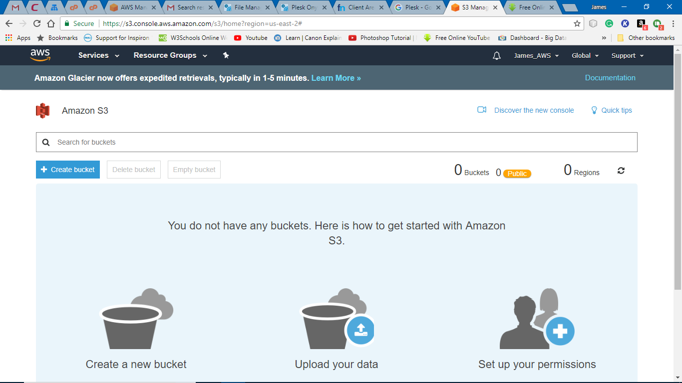

* Bucket allows to store data as an object, choose bucket name and bucket region to create a bucket in S3

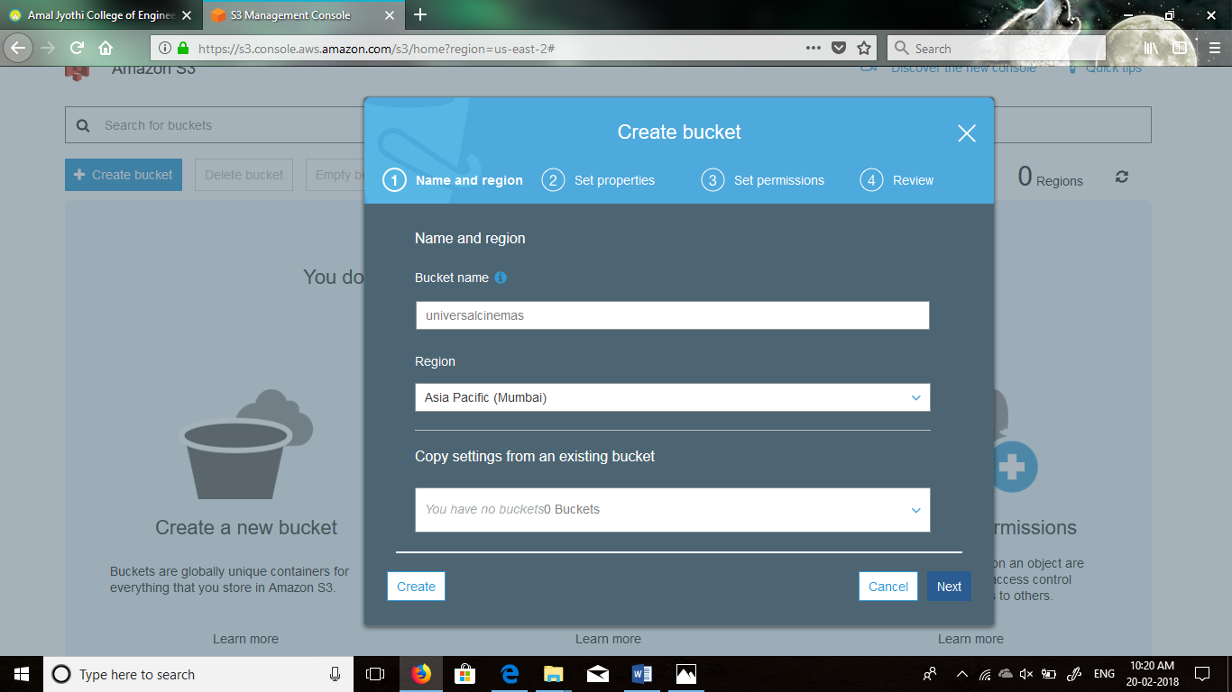

* Set properties for the bucket such as versioning, server access logging, tags, object level logging.

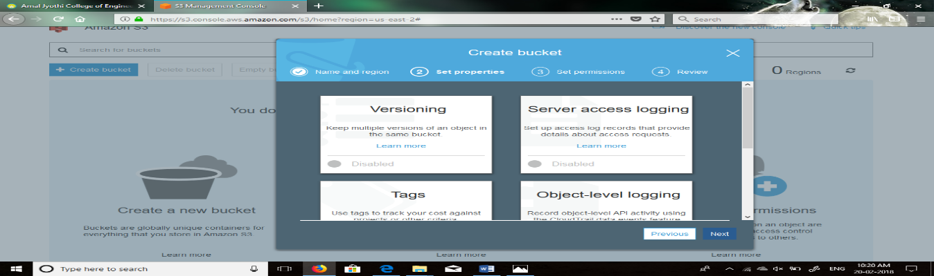

* Set permission for the bucket.

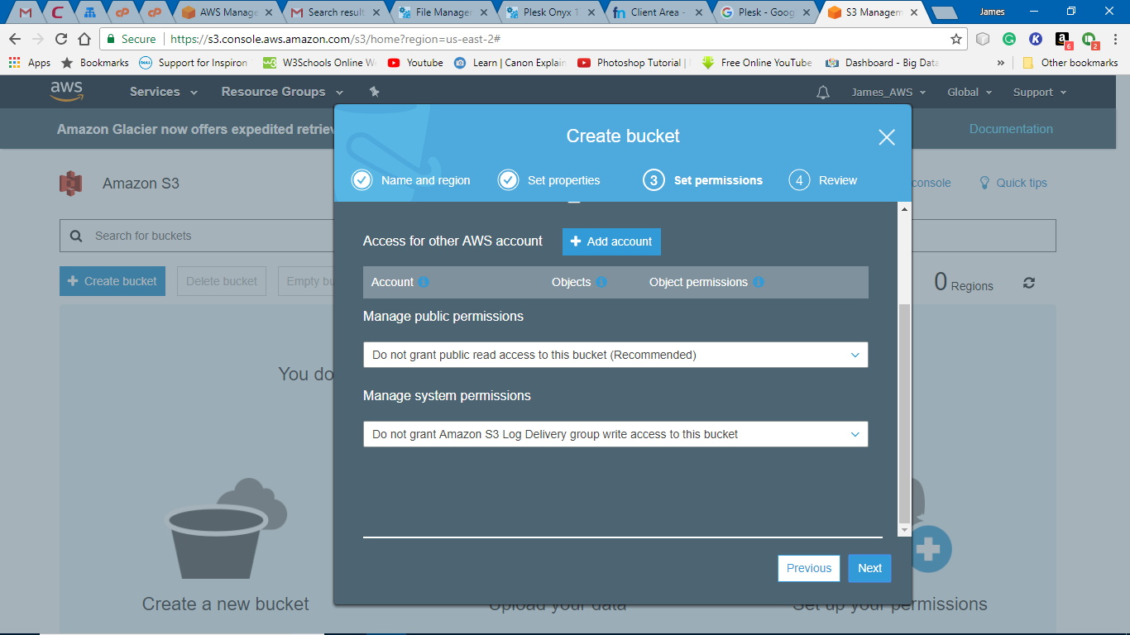

* Verify the bucket with Review.

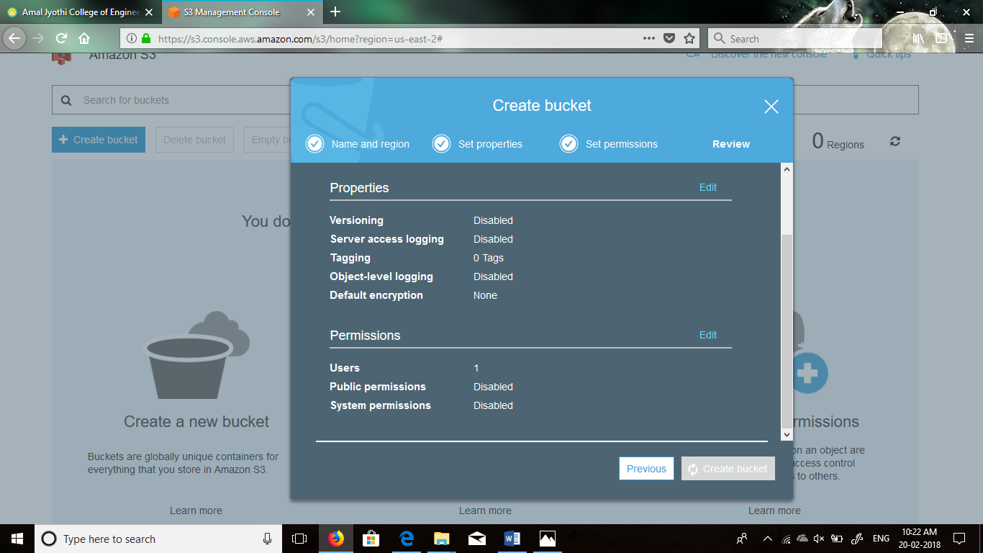

* S3 Bucket successfully created.

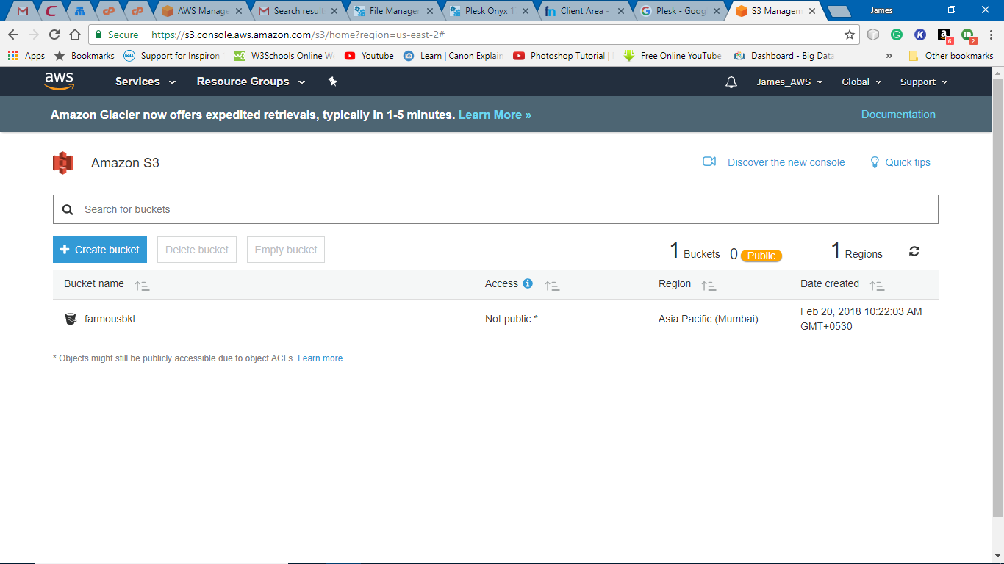

* We have created a bucket, so files can be uploaded to this bucket and those files stored as an object under the bucket.

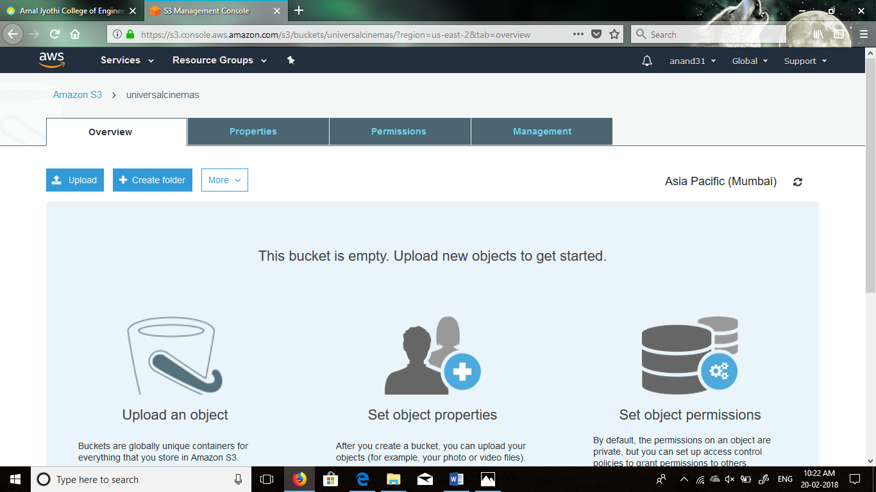

* Choose *upload* to insert files into the bucket.

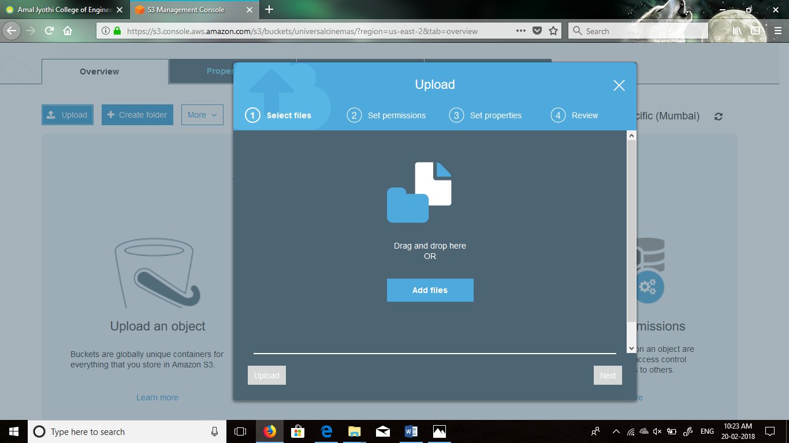

* File uploaded to the bucket successfully.

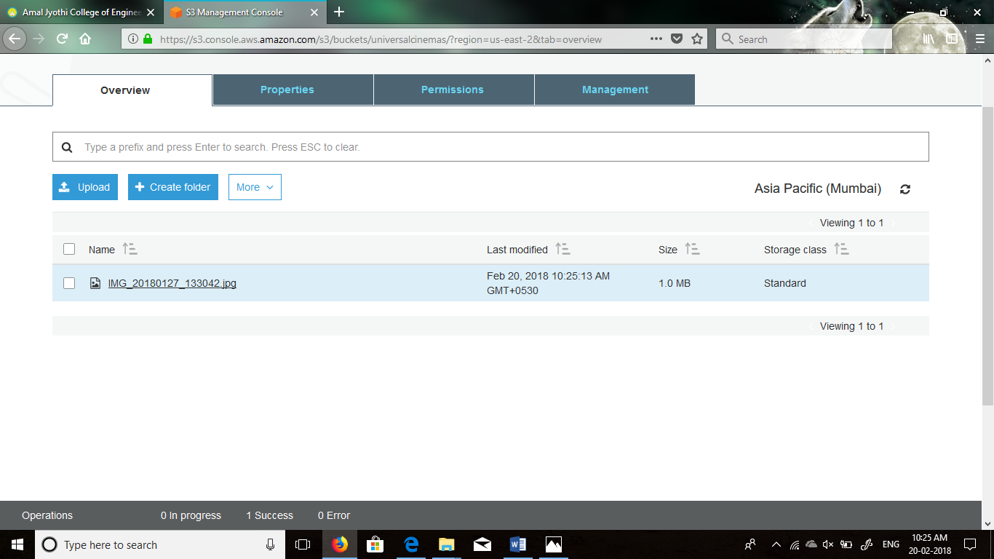

* To view the file, we need to configure the public access as enabled.

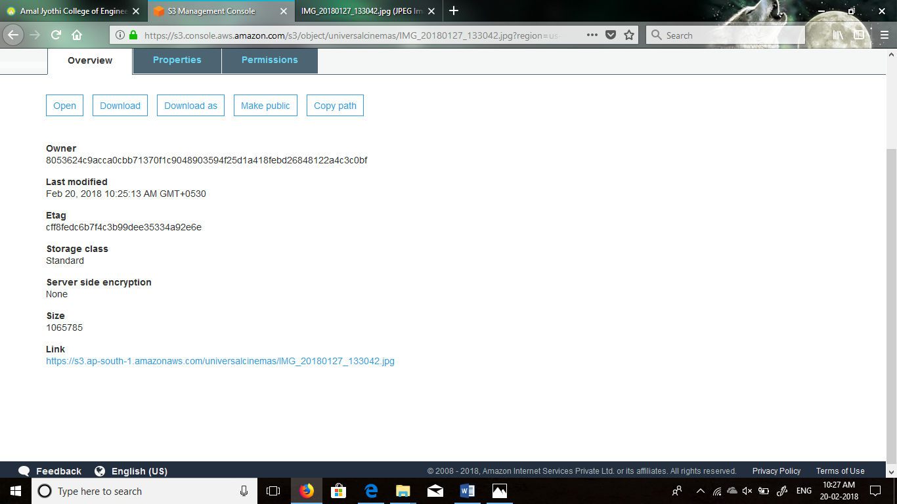

* After setting the public access properties, just go the URL provided in the page to view the image or such files.



Static Website hosting using AWS S3 Bucket

* Create a folder in the bucket
* Upload *.html* files to the folder on the bucket as mentioned in the above steps.
* Enable public access permission to the folder by configuring Bucket policy.

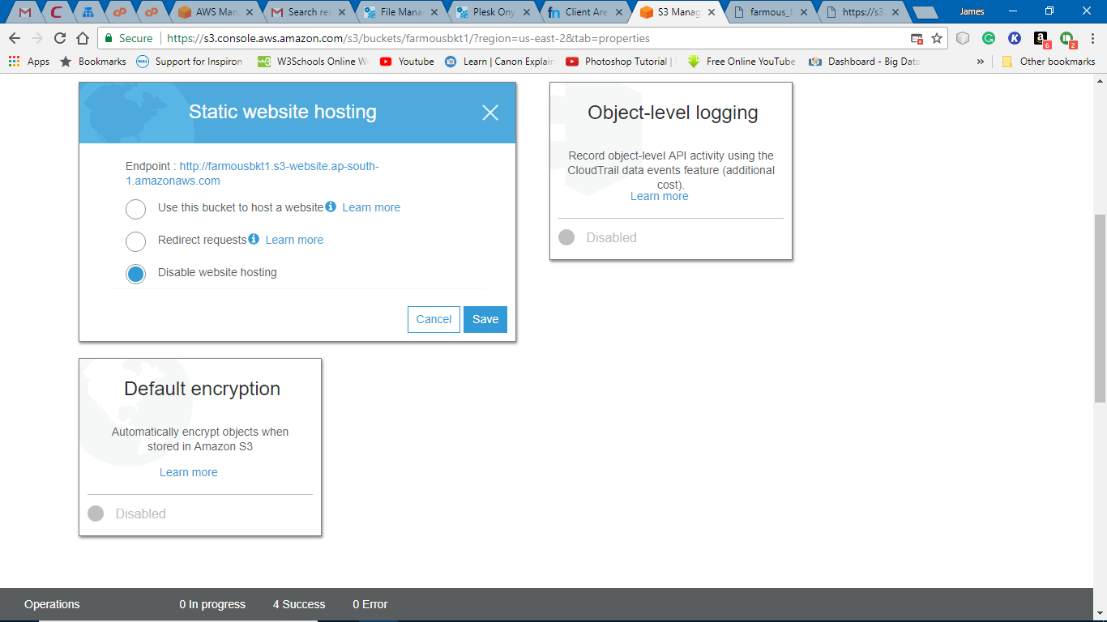

* Add File name and save.

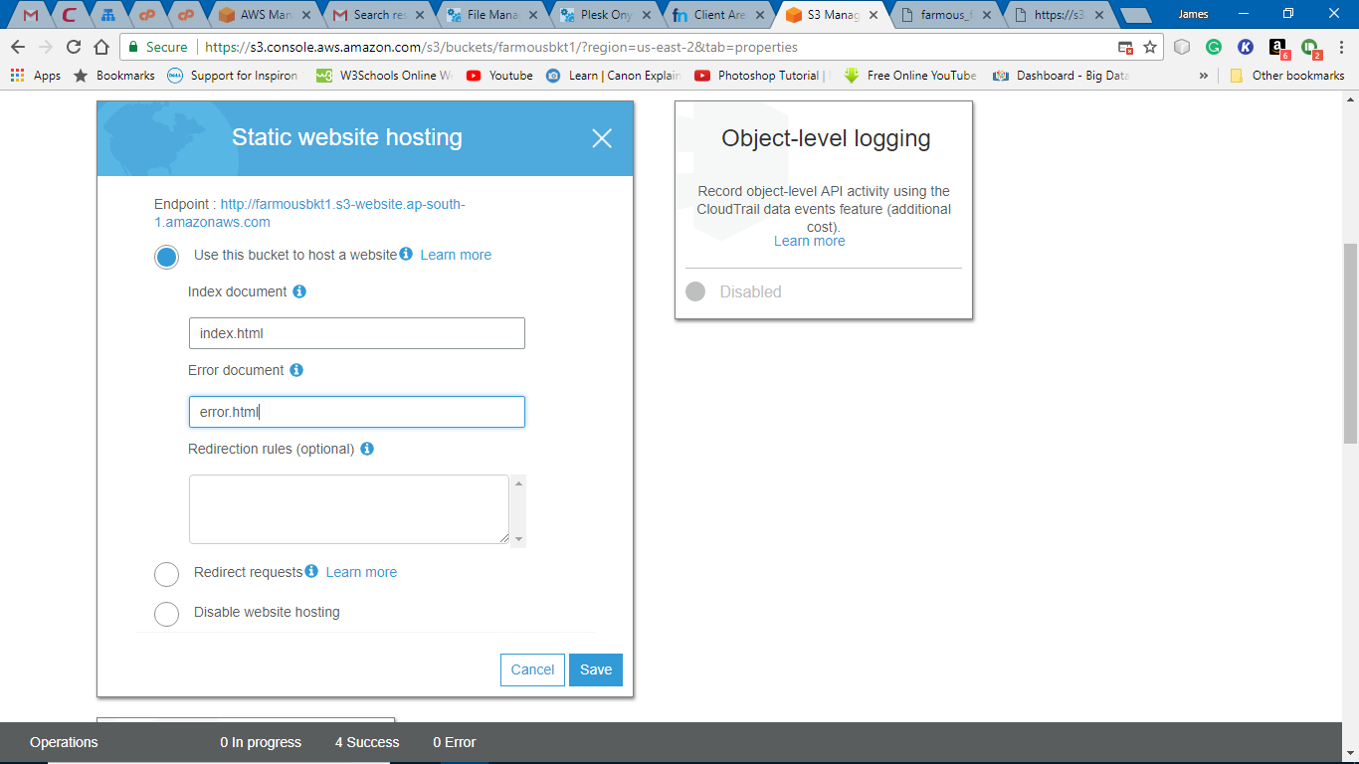

* Go to Bucket policy editor and set a new policy to the bucket

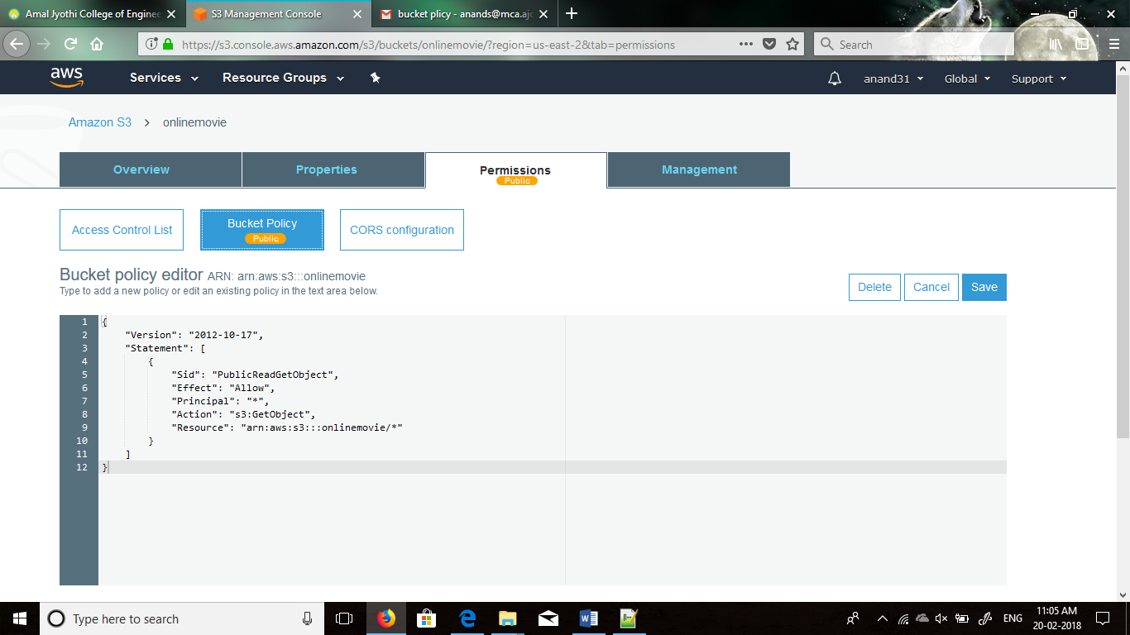

Amazon Lightsail

Amazon Lightsail is an Amazon cloud service that offers bundles of cloud computing power and memory for new or less experienced cloud users.

* To create an instance, we have to select an instance location, availability zone, platforms such as Linux/Unix or Windows and blueprint

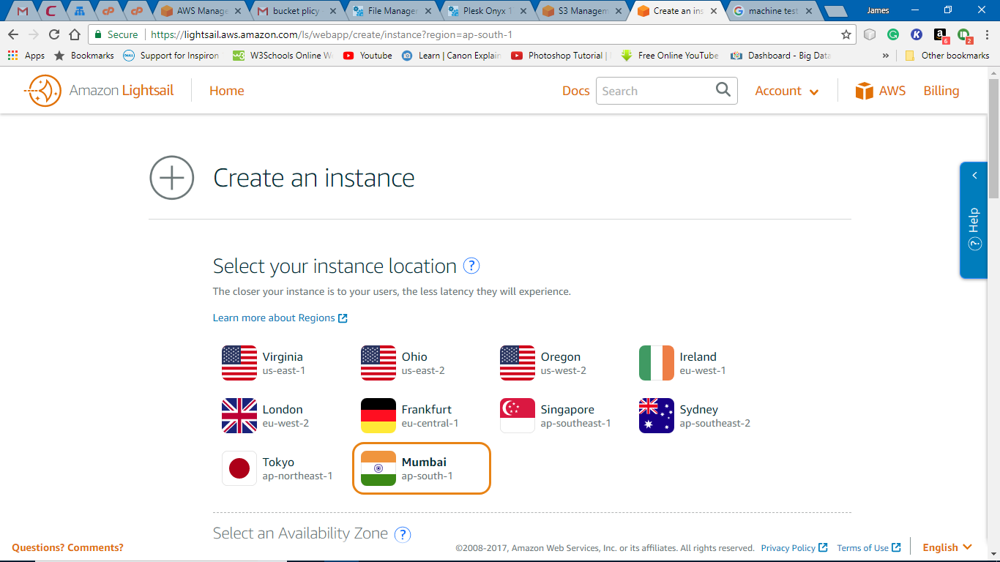

* Instance Location

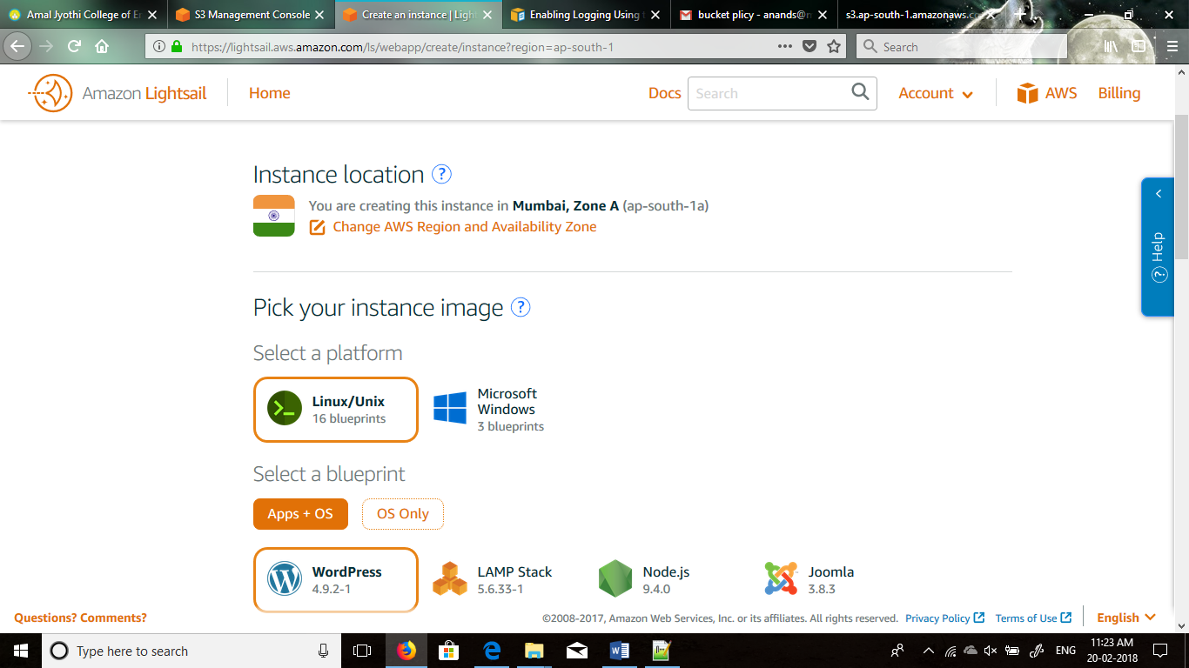

* Availability zone, instance image, and blueprint

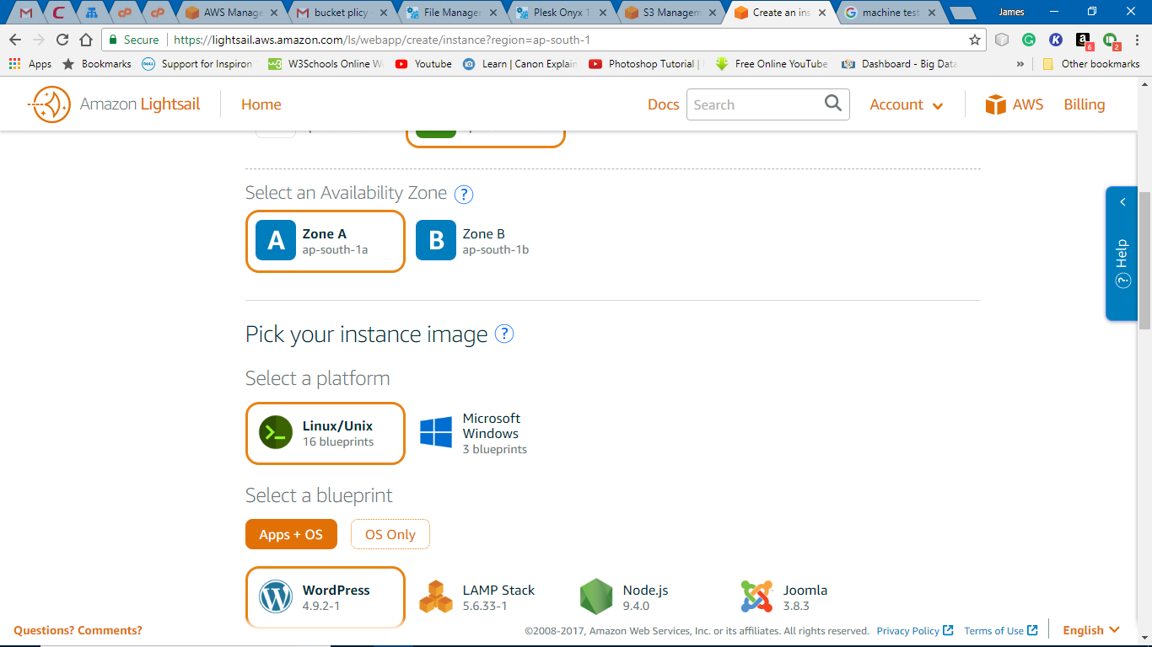

* Name your instance

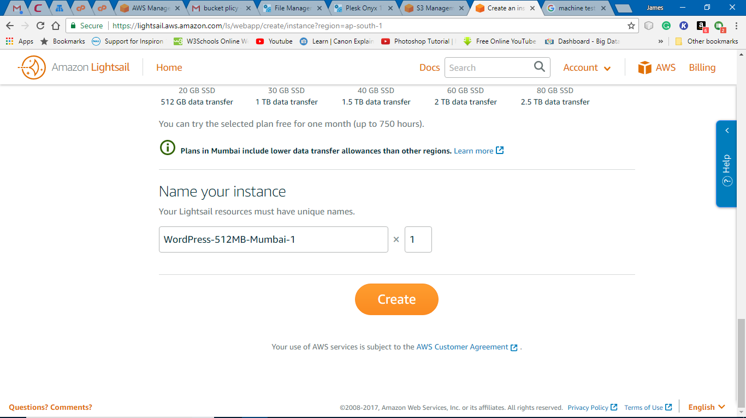

* Instance under processing

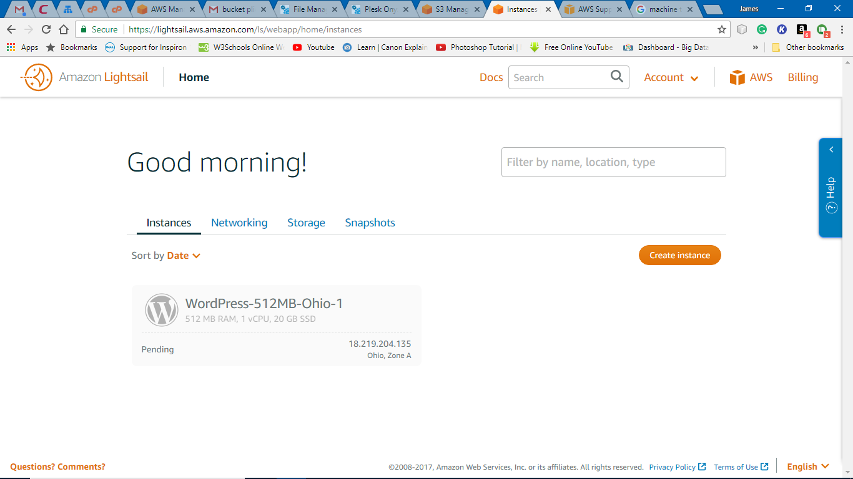

* WordPress instance is ready to use.

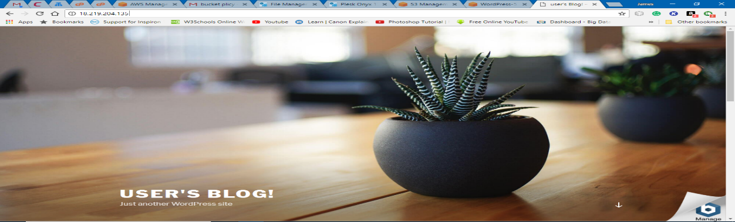

* To customize WordPress Blog, Login to the admin panel. To know the admin password just go to SSH and type *cat bitnami_application_password*

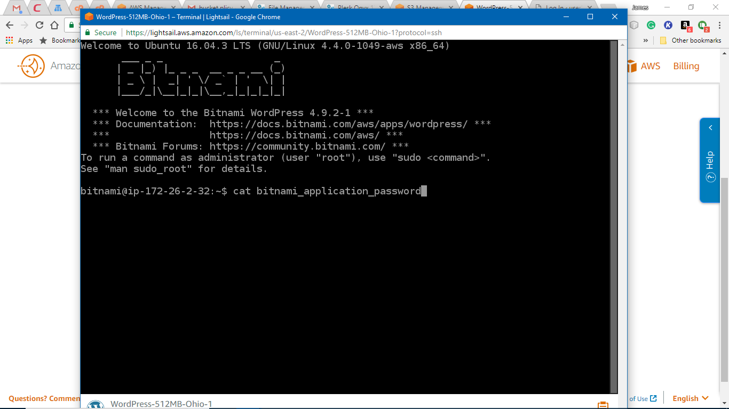

* Use Username(user) and above password to login to admin panel.

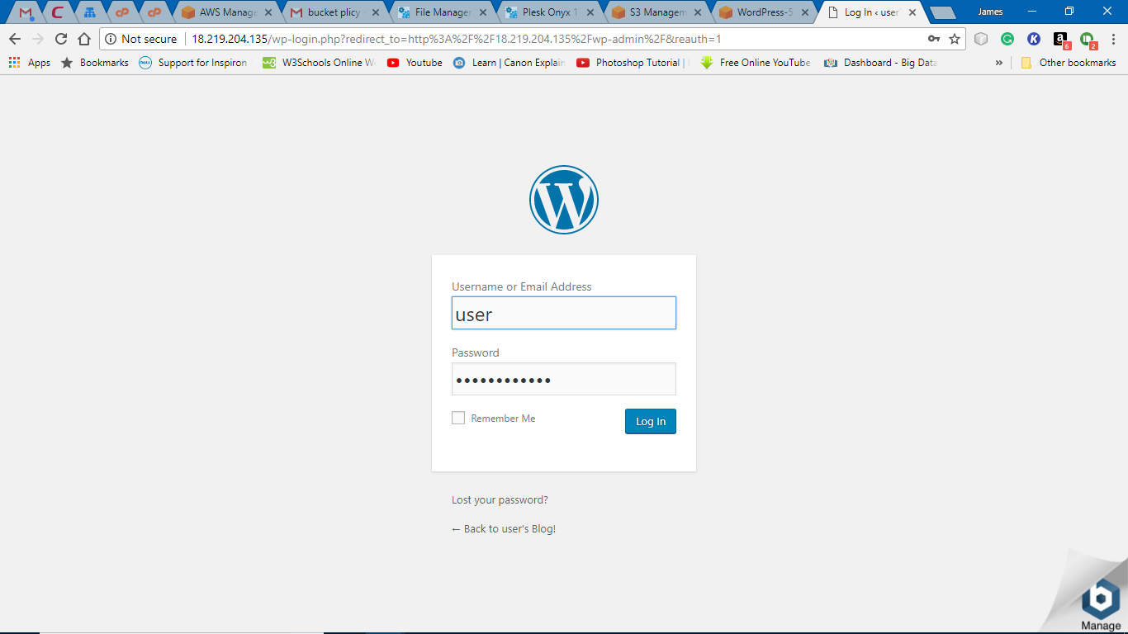

* To Manage your WordPress remotely, Download Bitnami WordPress Stack and install.

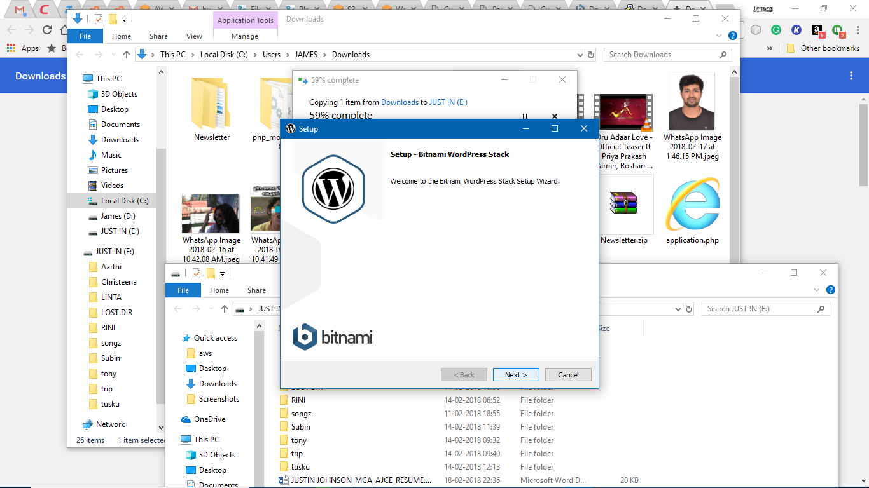

* Configure your Gmail

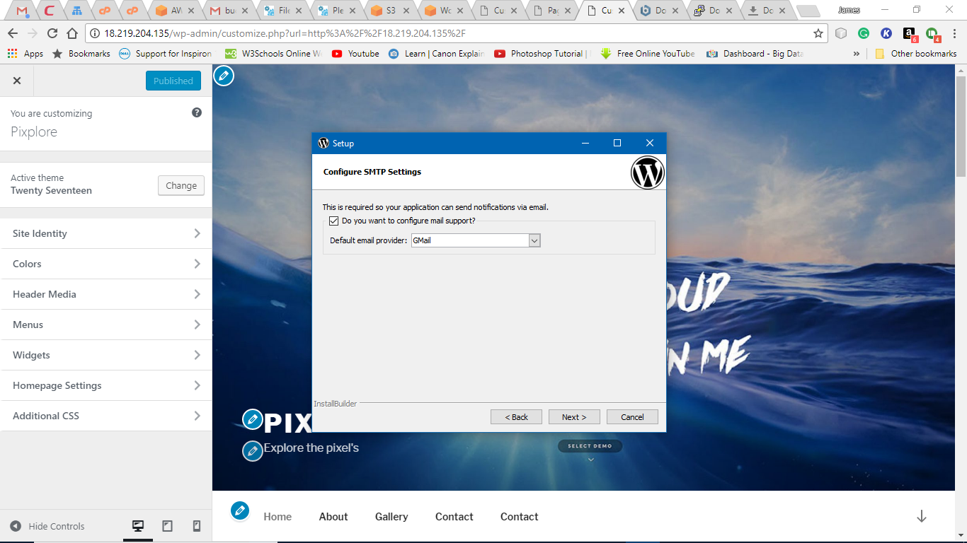

* The set name for your Blog

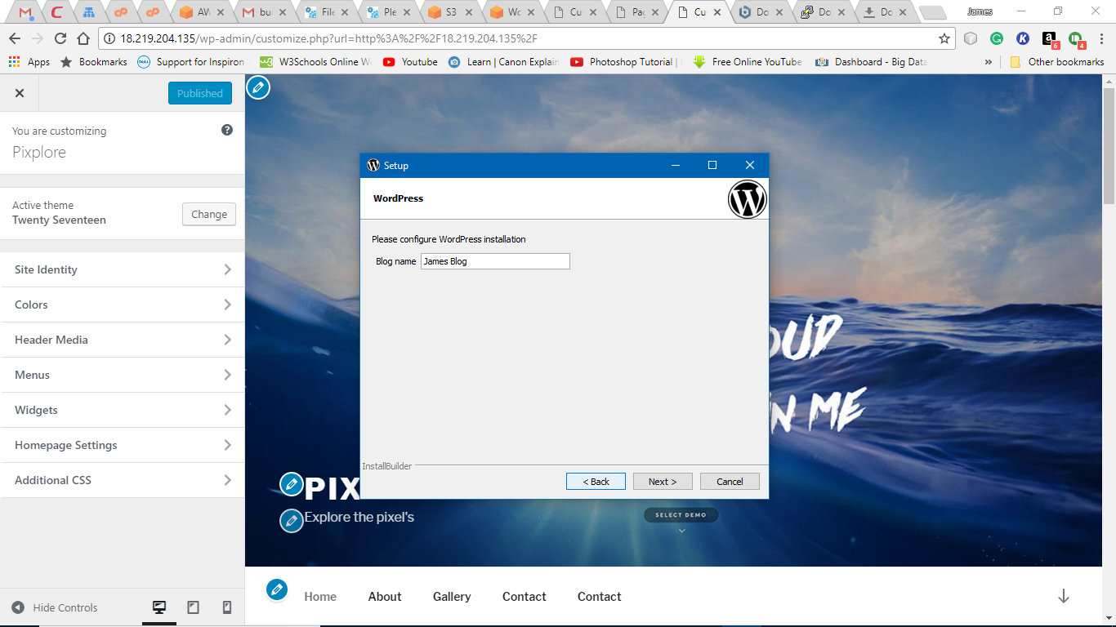

* Continue to complete installation

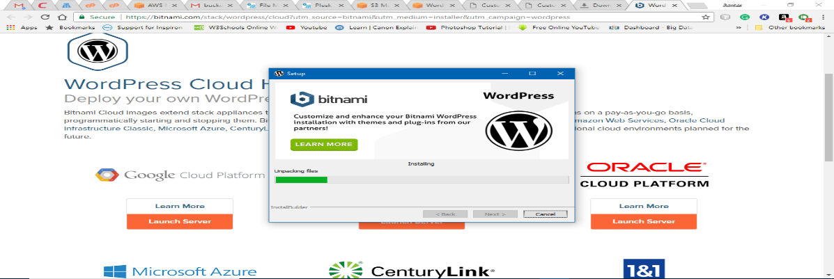

* Once Bitnami WordPress stack successfully installed, you can access its control panel. Go to your application as well as phpMyAdmin to manage your application

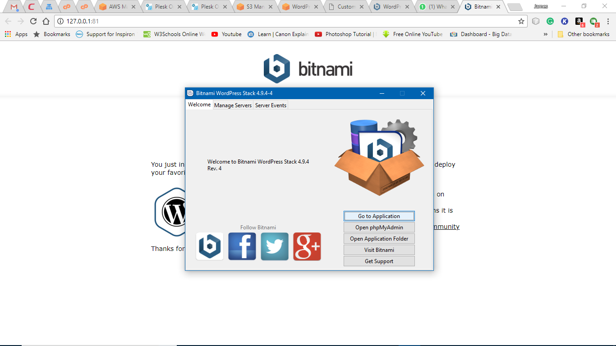

* phpMyAdmin

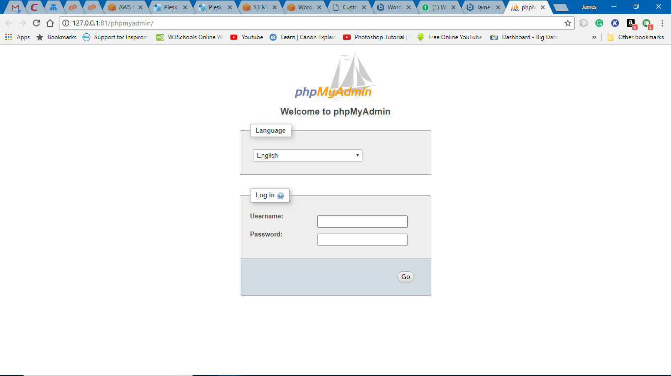

**P1.2.4 AWS DB Products**

### **P1.2.4.1** Amazon Relational Database Service (RDS)

Amazon Relational Database Service (Amazon RDS) is a web service that makes it easy to set up, operate, and scale a relational database in the cloud. It provides cost-efficient and resizable capacity while managing time-consuming database administration tasks, freeing you up to focus on developing your applications.

Amazon RDS gives you access to the capabilities of a familiar MySQL, PostgreSQL, Oracle or Microsoft SQL Server database engine. This means that the code, applications, and tools you already use today with your existing databases can be used with Amazon RDS. Amazon RDS automatically patches the database software and backs up your database, storing the backups for a user-defined retention period and enabling point-in-time recovery. You benefit from the flexibility of being able to scale the compute resources or storage capacity associated with your Database Instance (DB Instance) via a single API call.

### **P1.2.4.2** Amazon DynamoDB

DynamoDB is a fast, fully managed NoSQL database service that makes it simple and cost-effective to store and retrieve any amount of data and serve any level of request traffic. All data items are stored on Solid State Drives (SSDs) for high availability and durability.

### **P1.2.4.2** Amazon ElastiCache

ElastiCache is a web service that makes it easy to deploy, operate, and scale an in-memory cache in the cloud. The service improves the performance of web applications by allowing you to retrieve information from fast, managed, in-memory caches, instead of relying entirely on slower disk-based databases. ElastiCache supports two widely adopted open-source engines – Memcached and Redis. The service is protocol compliant with both engines, so popular tools that you use today with existing Memcached and Redis environments will work seamlessly with ElastiCache.

**P1.2.5 DevOps in AWS**

AWS provides a set of flexible services designed to enable companies to more rapidly and reliably build and deliver products using AWS and DevOps practices. These services simplify provisioning and managing infrastructure, deploying application code, automating software release processes, and monitoring your application and infrastructure performance. And it is the combination of cultural philosophies, practices, and tools that increase an organization’s ability to deliver applications and services at high velocity: evolving and improving products at a faster pace than organizations using traditional software development and infrastructure management processes. This speed enables organizations to better serve their customers and compete more effectively in the market.

Under a DevOps model, development and operations teams are no longer “siloed.” Sometimes, these two teams are merged into a single team where the engineers work across the entire application lifecycle, from development and test to deployment to operations, and develop a range of skills not limited to a single function. Quality assurance and security teams may also become more tightly integrated with development and operations and throughout the application lifecycle. These teams use practices to automate processes that historically have been manual and slow. They use a technology stack and tooling which help them operate and evolve applications quickly and reliably. These tools also help engineers independently accomplish tasks (for example, deploying code or provisioning infrastructure) that normally would have required help from other teams, and this further increases a team’s velocity.

**P1.3 Microsoft Azure Cloud**

**P1.3.1 Introduction to Microsoft Azure Cloud**

Microsoft Azure (formerly Windows Azure is a [cloud computing](https://en.wikipedia.org/wiki/Cloud_computing) service created by [Microsoft](https://en.wikipedia.org/wiki/Microsoft) for building, testing, deploying, and managing applications and services through a global network of Microsoft-managed [data centers](https://en.wikipedia.org/wiki/Data_center). It provides [software as a service (SaaS)](https://en.wikipedia.org/wiki/Software_as_a_service), [platform as a service (PaaS)](https://en.wikipedia.org/wiki/Platform_as_a_service) and [infrastructure as a service (IaaS)](https://en.wikipedia.org/wiki/Infrastructure_as_a_service) and supports many different [programming languages](https://en.wikipedia.org/wiki/Programming_language), tools, and frameworks, including both Microsoft-specific and third-party software and systems. Windows Azure is designed to make IT management easier. The main purpose of developing Windows Azure was to minimize the overhead and personnel expenses associated with the creation, distribution, and upgrade of the Web applications.

The Windows Azure platform is considered a platform as a service, which is an imperative component of a cloud computing platform. It consists of various on-demand services hosted in Microsoft's data centers and is commoditized through three product brands. The services and applications developed using the Azure platform run on the Windows Azure operating system, which provides a runtime environment for Web applications along with an extensive set of services that facilitate the building, hosting and management of applications without requiring maintenance too expensive onsite resources. Windows Azure is designed to support both Microsoft and non-Microsoft platforms. The three main components that constitute Windows Azure are:

* Compute layer
* Storage layer
* Fabric layer

Windows Azure also includes an automated service management feature that allows the upgrading of applications without affecting their performance. Windows Azure is designed to support a number of platforms and programming languages. Some of the languages supported are extensible markup language (XML), representational state transfer (REST), Simple Object Access Protocol (SOAP), Ruby, Eclipse, Python, and PHP.

**Implementation**

* Go to Microsoft Azure and sign into Microsoft Azure for Student starter

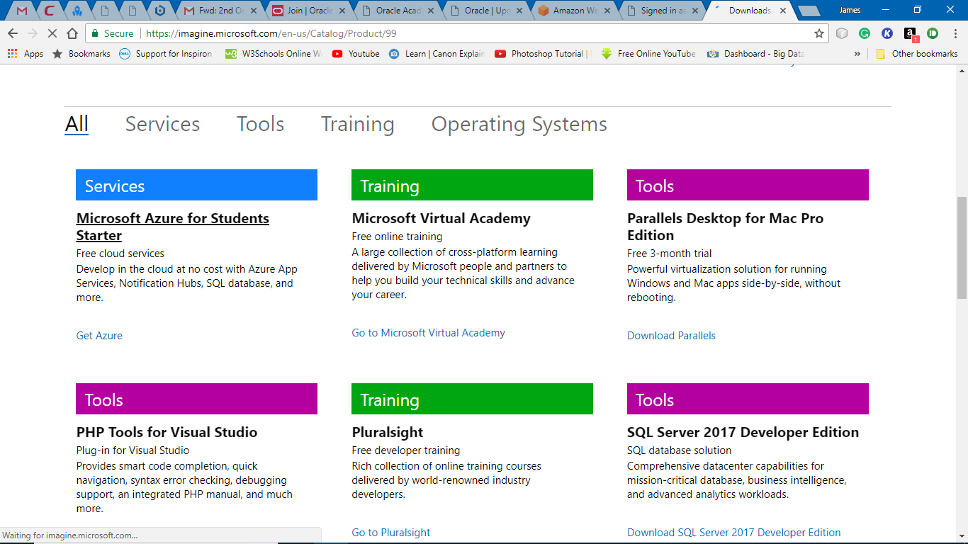

* Once you get the verification link to your Mail, Activate your Account

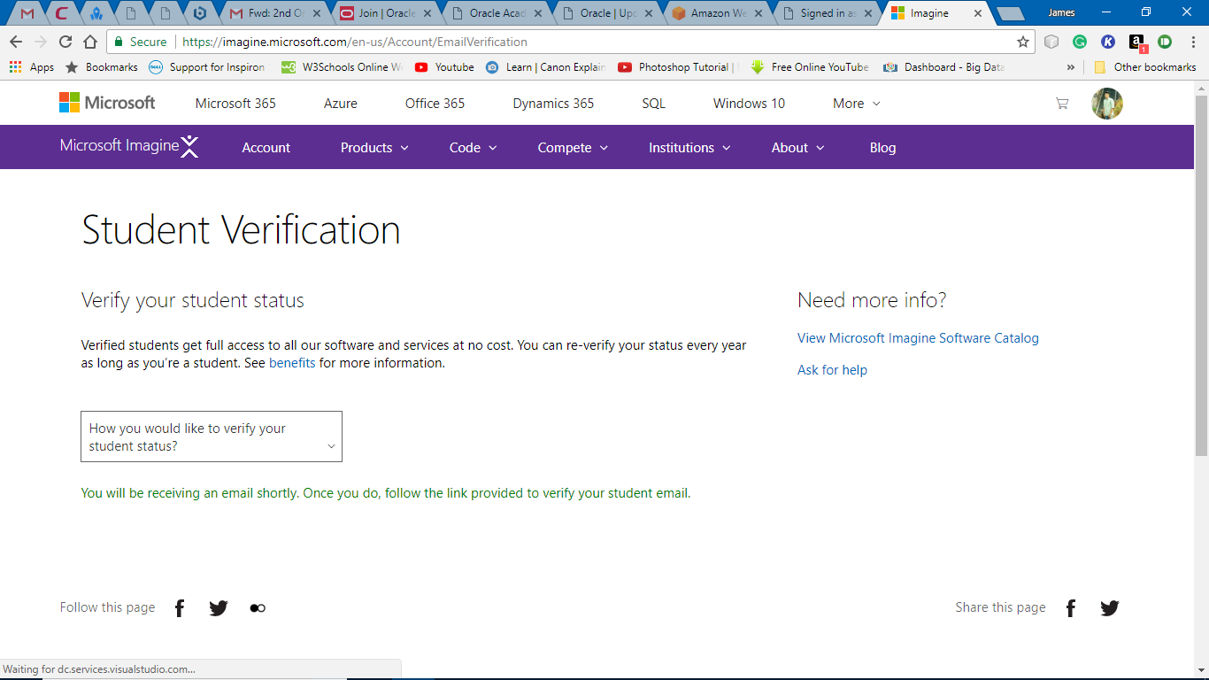

* Once completed you can access Azure Dashboard. Whichh allows you to configure

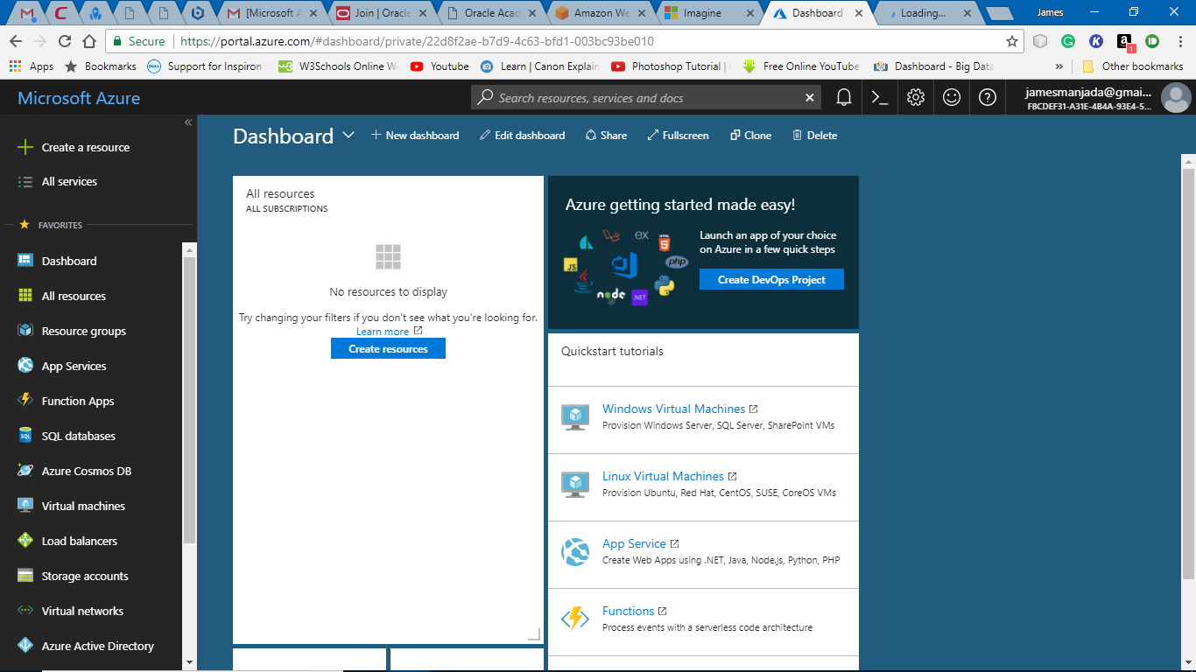

* Go to Dashboard and create Resource group. Allocate Resource group name, subscription and resource group location.

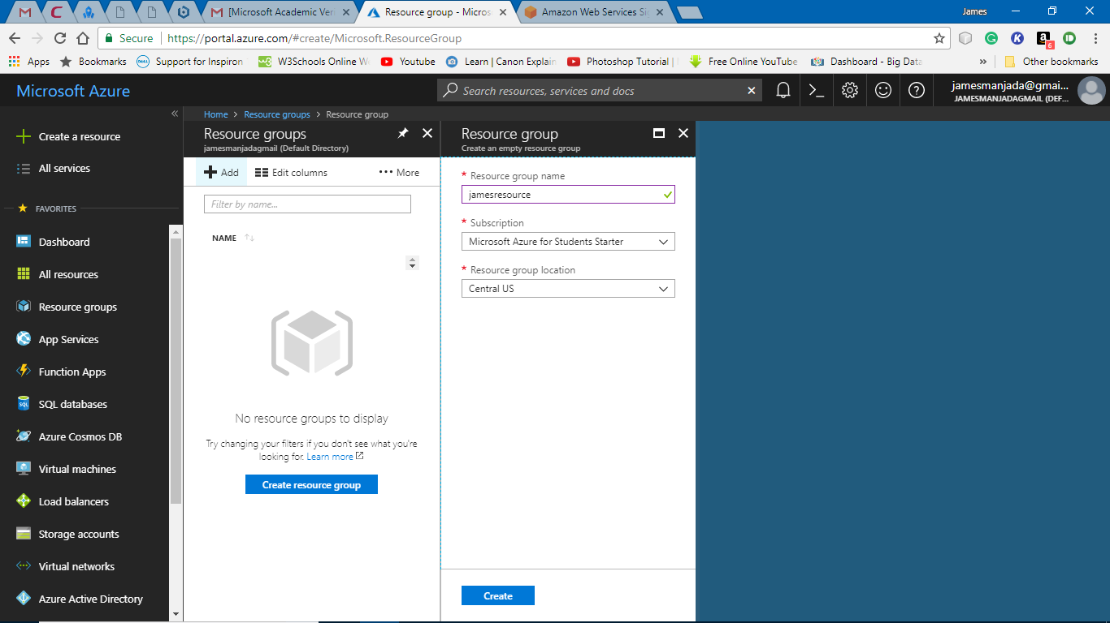

* Once the resource group is created, Create a mobile app. To create Mobile app, specify App name, Subscription of the app, Resource group (Select the resource group which was created earlier)

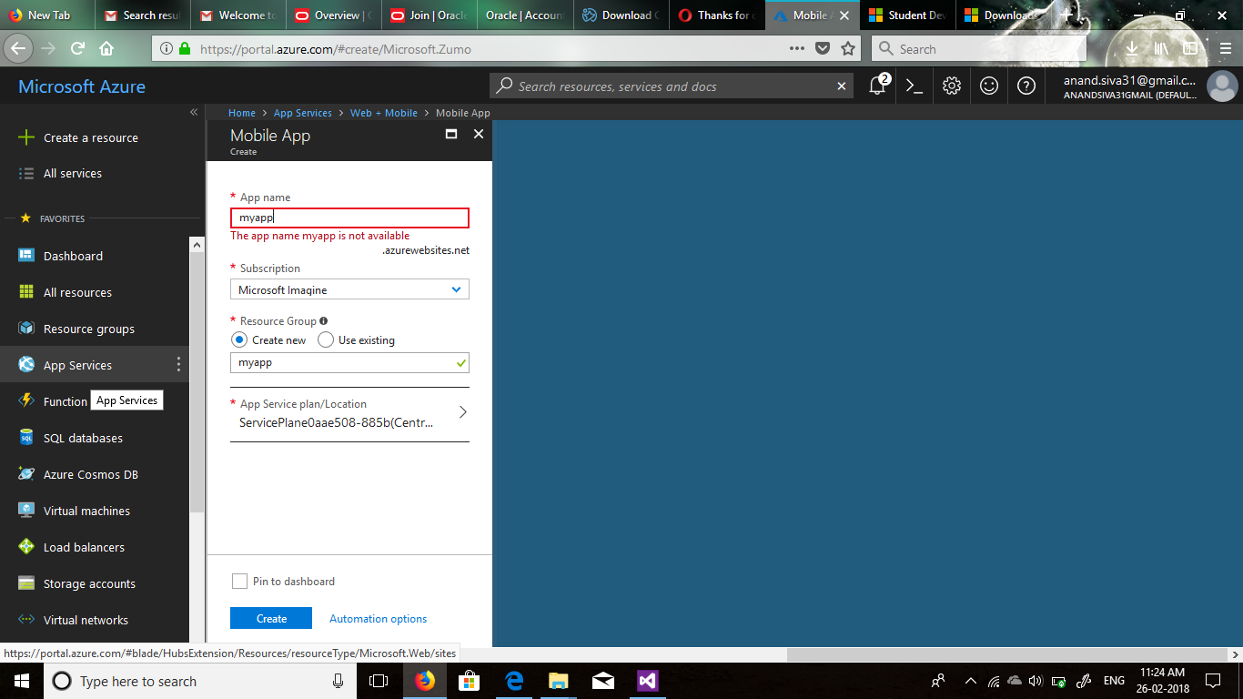

* Then Select the deployment credentials from the let tab. Enter a valid FTP/deployment username, Password, Confirm password

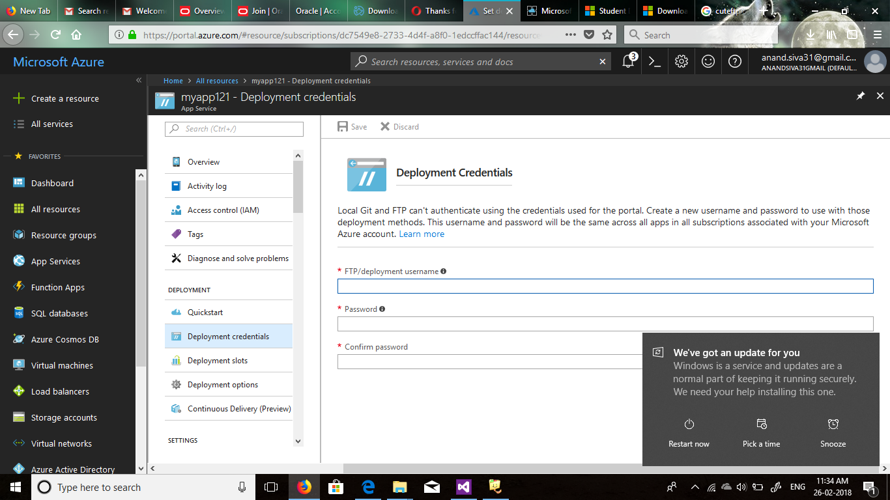

* Once saved the Deployment credentials, go to overview check your URL, App Service, FTP deployment name, FTP hostname, FTPS hostname

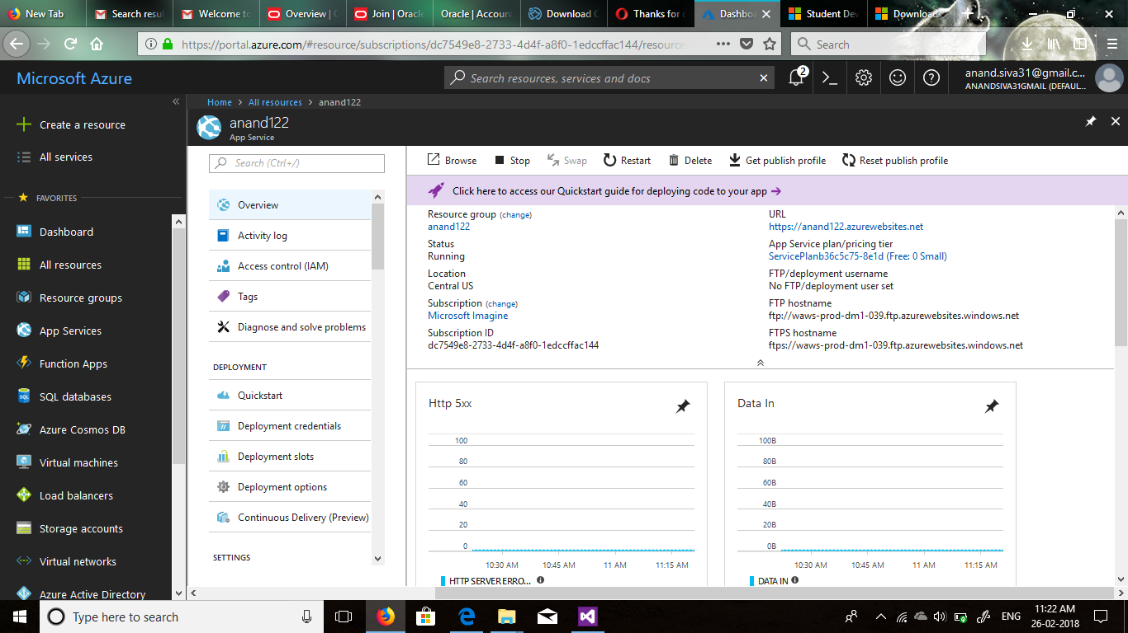

* Copy and paste the FTP Hostname on a web browser and check whether it is showing

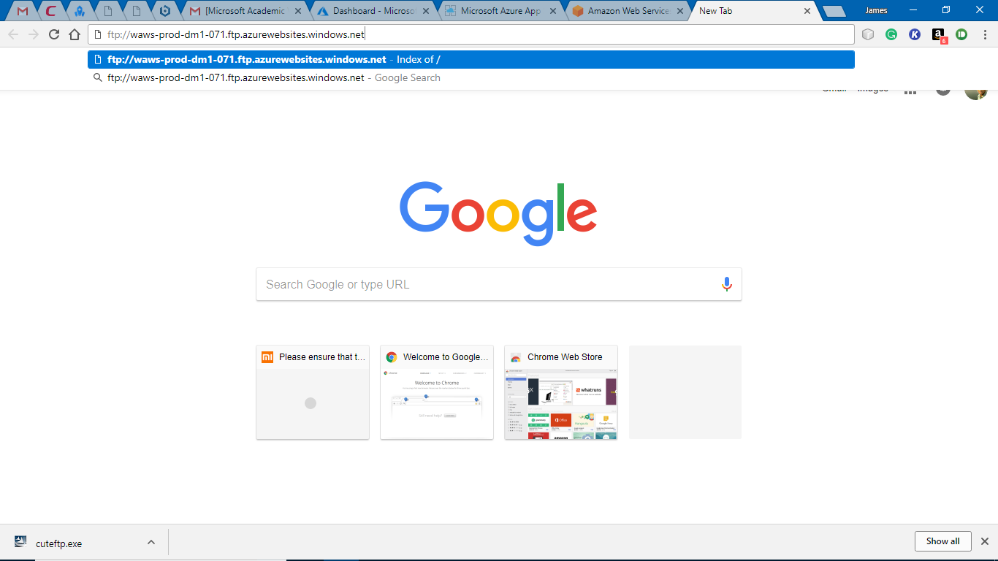

* FTP Hostname shows root directory and files.

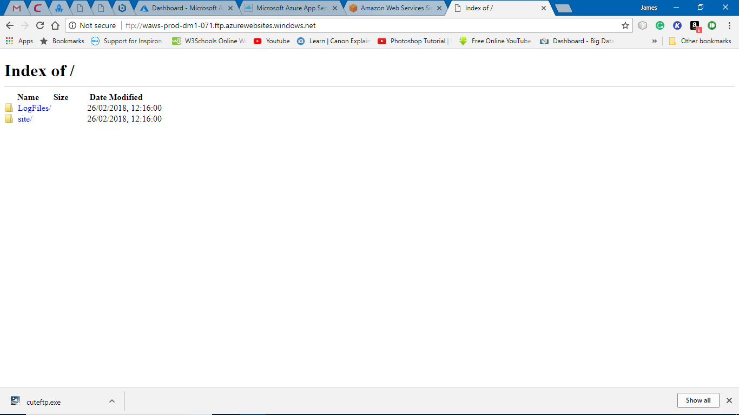

* Download and open cuteFTP. Cute FTP is a File Transfer Protocol (FTP) client used to transfer files between your computer and File Transfer Protocol (FTP) servers.

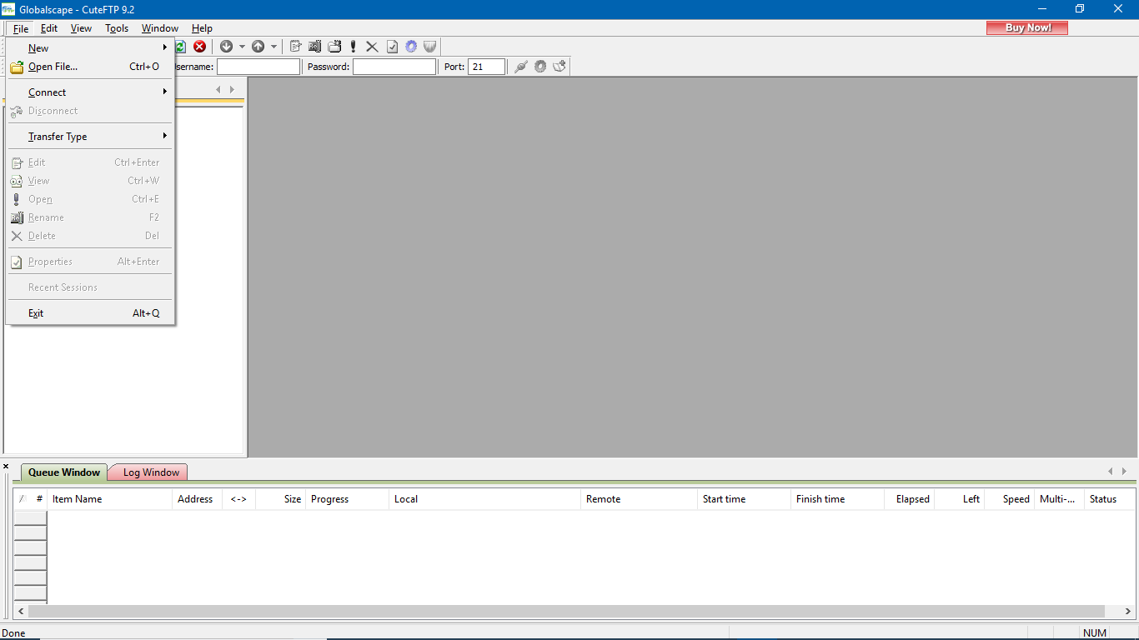

* Create App Service
* Connect to your server using FTP Hostname, Username and password

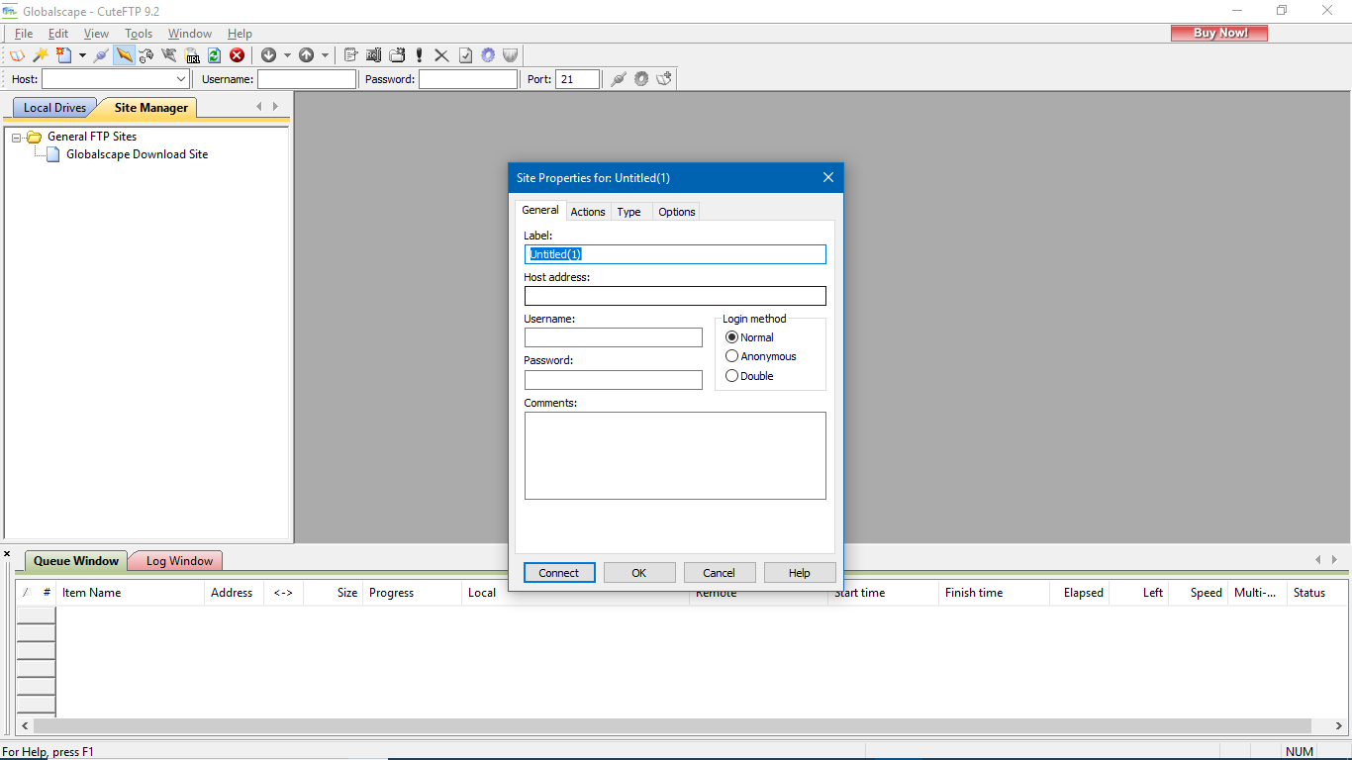

* Once successfully connected, you can access the root directory of the server

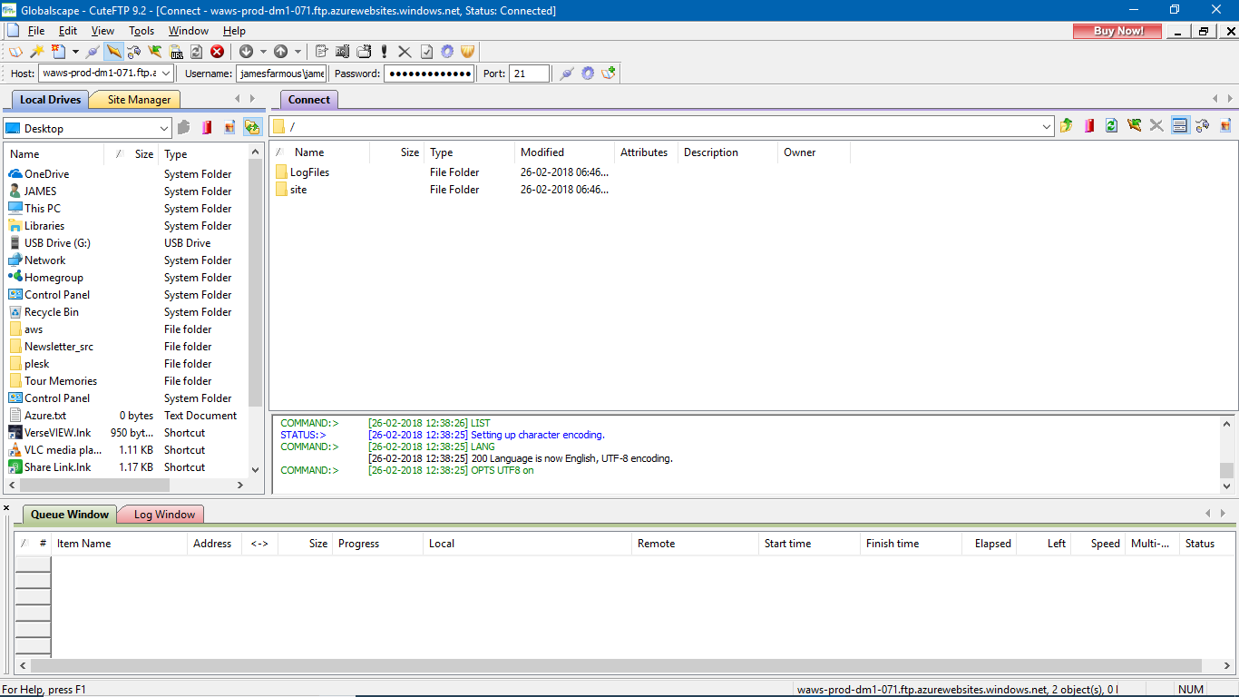

* As default root directory contains Log files and site folder. To upload files just drag and drop to the directory

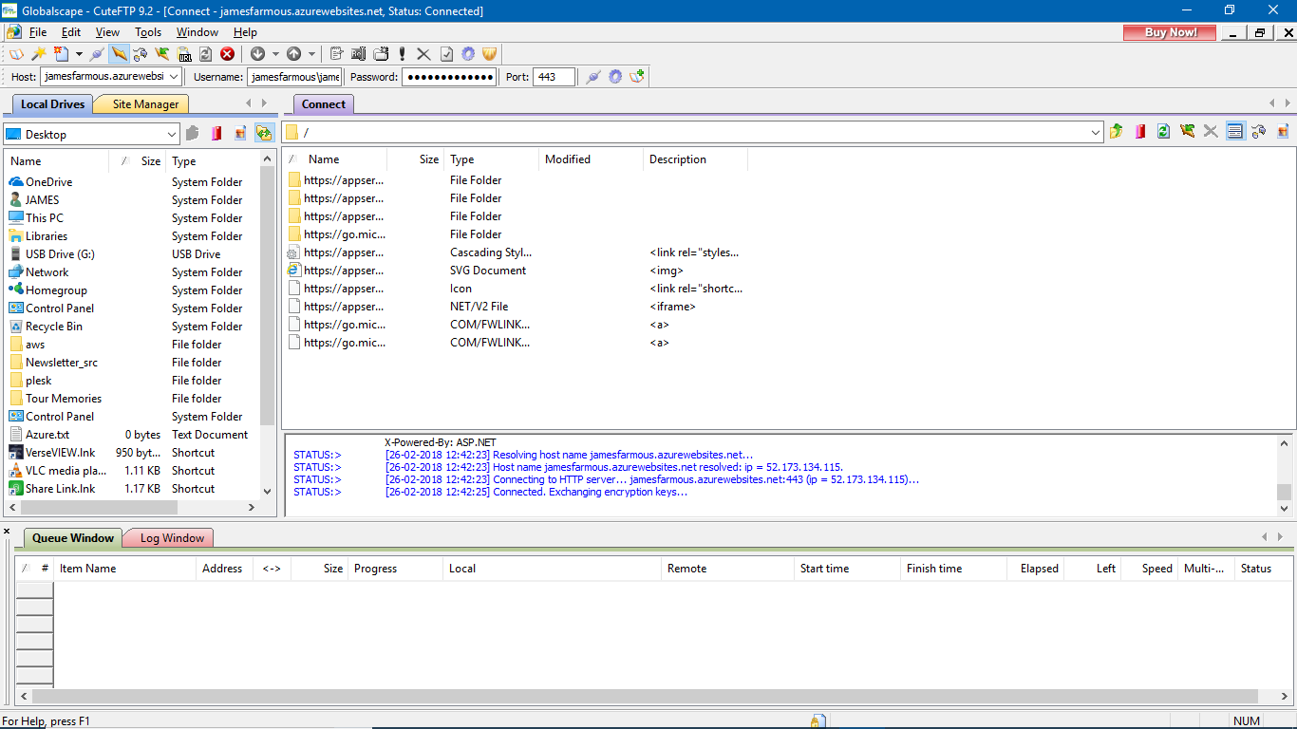

**P1.3.2 Virtual Machines**

It is an operating system or application environment that is installed on software, which reproduces dedicated hardware. The end user has the same experience on a virtual machine as they would have on dedicated hardware. Azure Virtual Machines gives you the flexibility of virtualization for a wide range of computing solutions with support for Linux, Windows Server, SQL Server, Oracle, IBM, SAP, and more. All current generation Virtual Machines include load balancing and auto-scaling, for free. For optimal performance, we recommend pairing your Virtual Machines with [Managed Disks](https://azure.microsoft.com/en-us/pricing/details/managed-disks/). Standard [egress](https://azure.microsoft.com/en-us/pricing/details/bandwidth/) charges apply.

**Benefits**

* Limits cost by reducing the need for physical hardware systems.
* Efficiently use hardware, which lowers the quantities of hardware and associated maintenance costs, and reduces power and cooling demand
* Ease of management because the virtual hardware does not fail.

**Vendors?**

* VMware - mature product portfolio, with many years of use in the IT industry
* Microsoft - a bit of a late player to virtualization, Microsoft is showing considerable progress.

**P1.3.3** Azure Storage Database

**Azure SQL Database is the intelligent, fully-managed relational cloud database service that provides the broadest SQL Server engine compatibility, so you can migrate your SQL Server databases without changing your apps. Accelerate app development and make maintenance easy and productive using the SQL tools you love to use. Take advantage of built-in intelligence that learns app patterns and adapts to maximize performance, reliability and data protection. And it** supports structures such as relational data, JSON, spatial, and XML. SQL Database offers managed [single SQL databases](https://docs.microsoft.com/en-us/azure/sql-database/sql-database-servers-databases), managed SQL databases in an [elastic pool](https://docs.microsoft.com/en-us/azure/sql-database/sql-database-elastic-pool), and managed SQL instances - called [SQL Database Managed Instance](https://docs.microsoft.com/en-us/azure/sql-database/sql-database-managed-instance) (in public preview). It delivers [dynamically scalable performance](https://docs.microsoft.com/en-us/azure/sql-database/sql-database-service-tiers) and provides options such as [column store indexes](https://docs.microsoft.com/sql/relational-databases/indexes/columnstore-indexes-overview) for extreme analytic analysis and reporting and [in-memory OLTP](https://docs.microsoft.com/en-us/azure/sql-database/sql-database-in-memory) for extreme transactional processing. Microsoft handles all patching and updating of the SQL code base seamlessly and abstracts away all management of the underlying infrastructure.

SQL Database shares its code base with the [Microsoft SQL Server database engine](https://docs.microsoft.com/sql/sql-server/sql-server-technical-documentation). With Microsoft's cloud-first strategy, the newest capabilities of SQL Server are released first to SQL Database, and then to SQL Server itself. This approach provides you with the newest SQL Server capabilities with no overhead for patching or upgrading - and with these new features tested across millions of databases

**Implementation**

* Go to Azure Dashboard

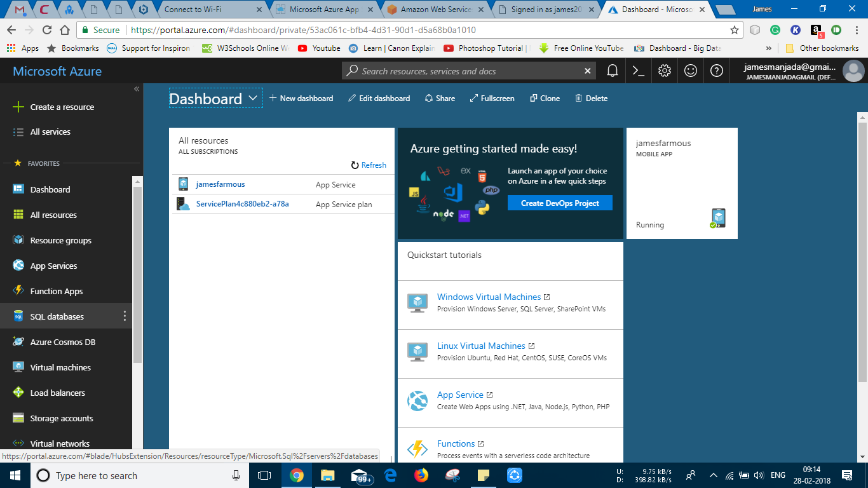

* Select SQL databases from Azure Dashboard.

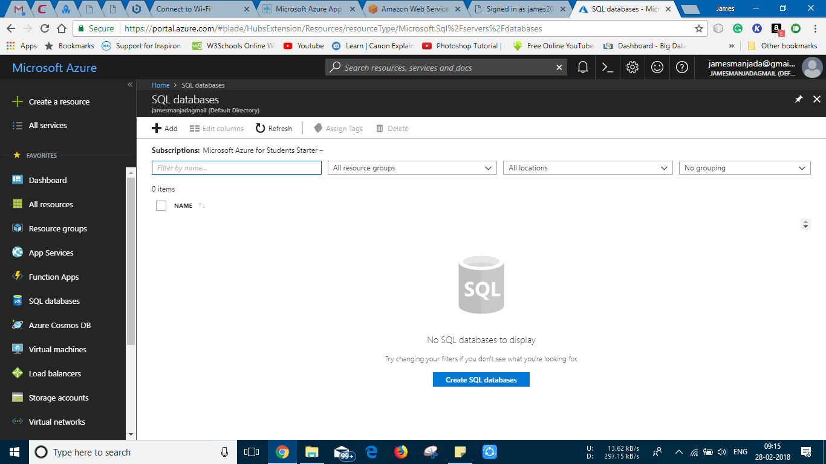

* Add new database. Choose a database name, Subscription, Resource group (Create new or select the existing one), Select resource, Server (You can configure the server), pricing tier (select the basic tier).

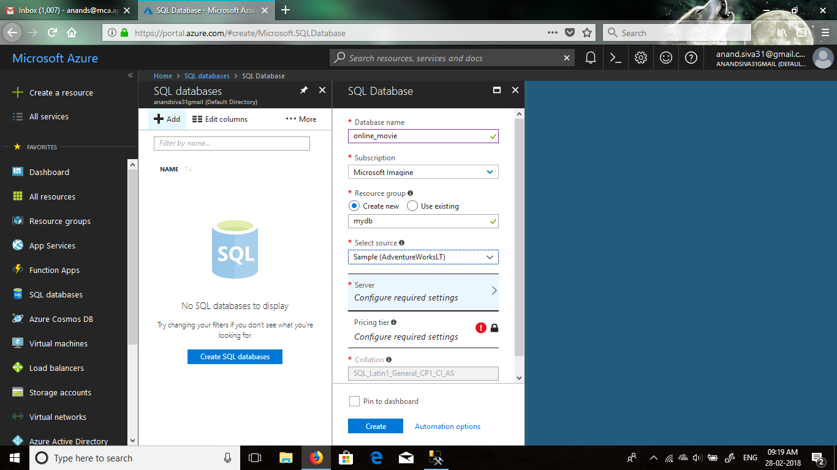

* Server configuration, choose server name, server admin login, password and confirm password and location.

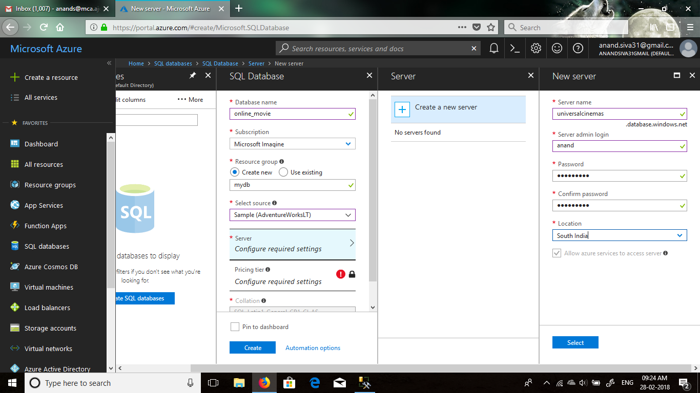

* Once all the configurations are done. Create database.

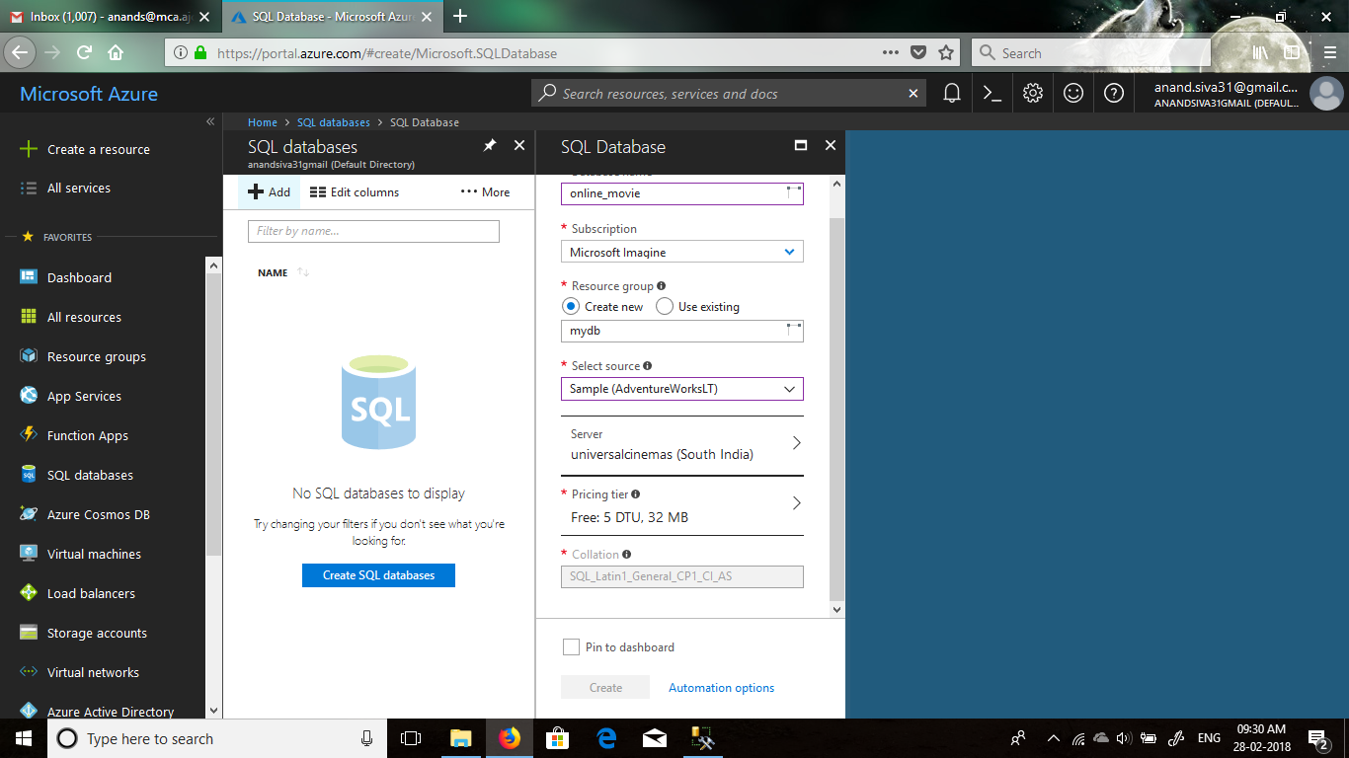

* Go to Overview and verify the database

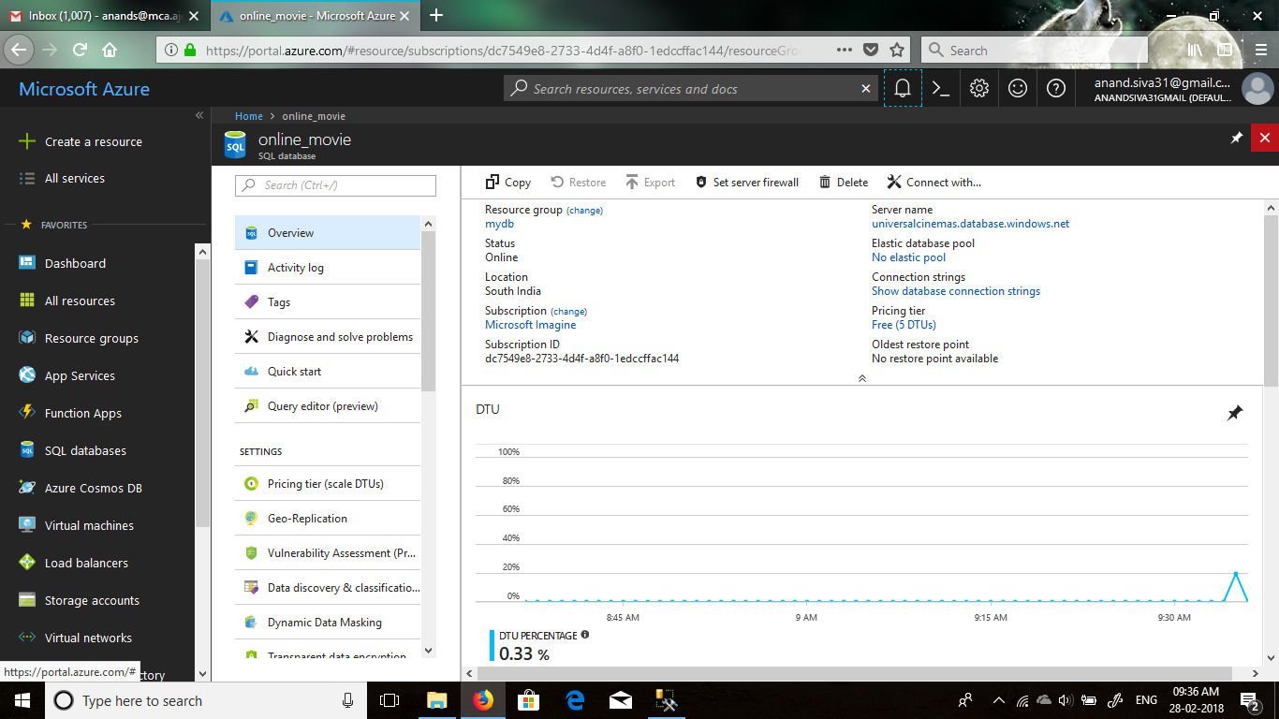

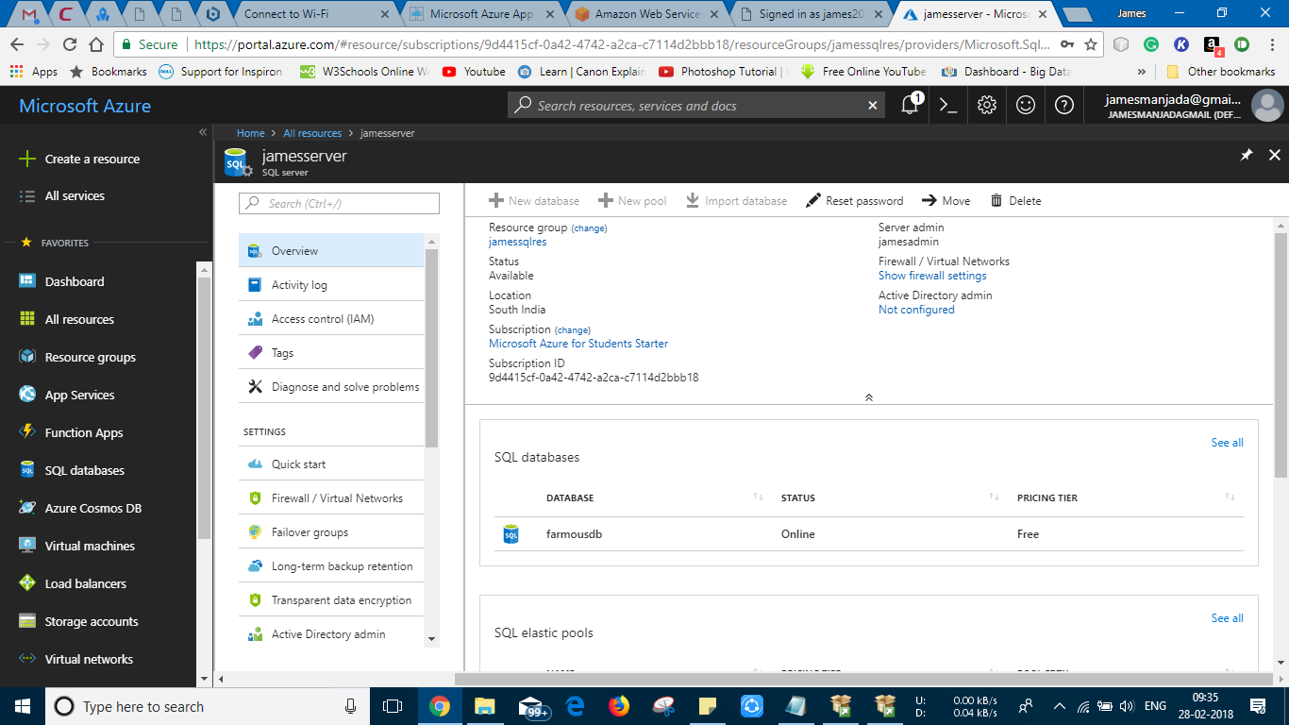

* Set Firewall/Virtual Private network

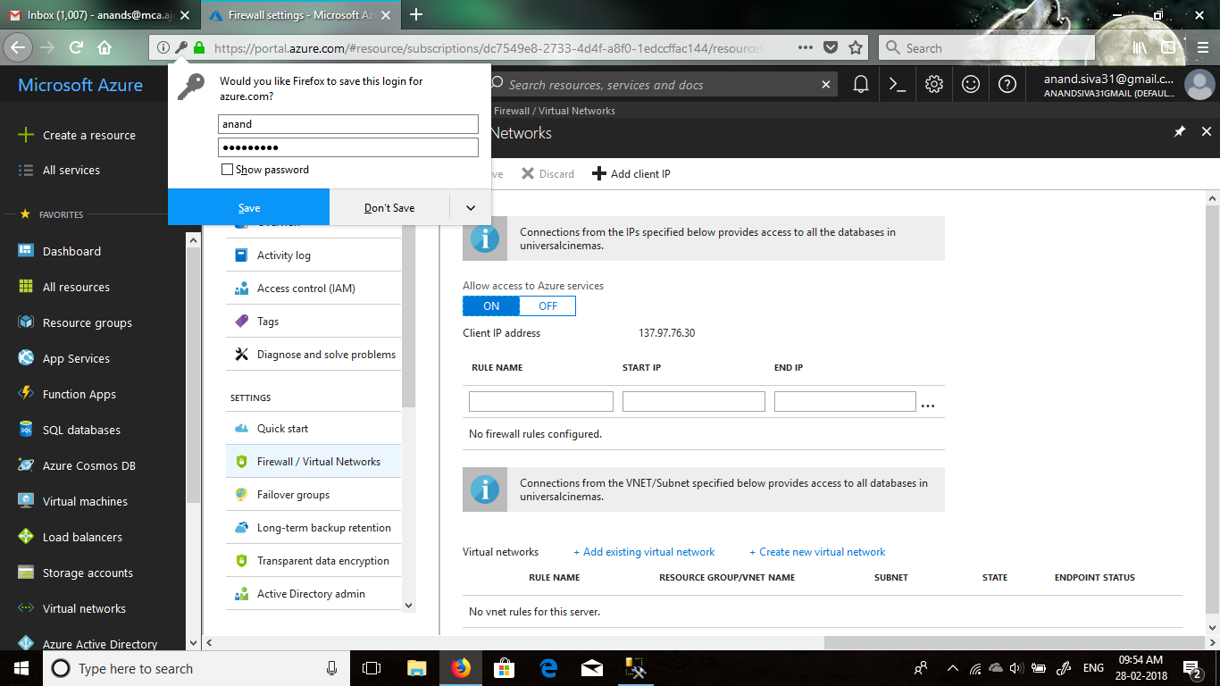

* Allow access to Azure Services, set rule name, start IP and end IP

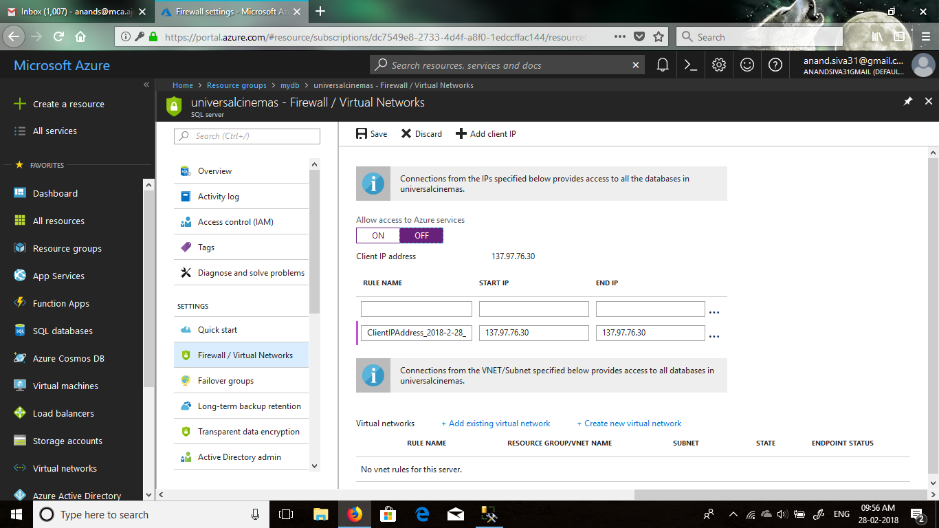

* Use your own key for the encryption

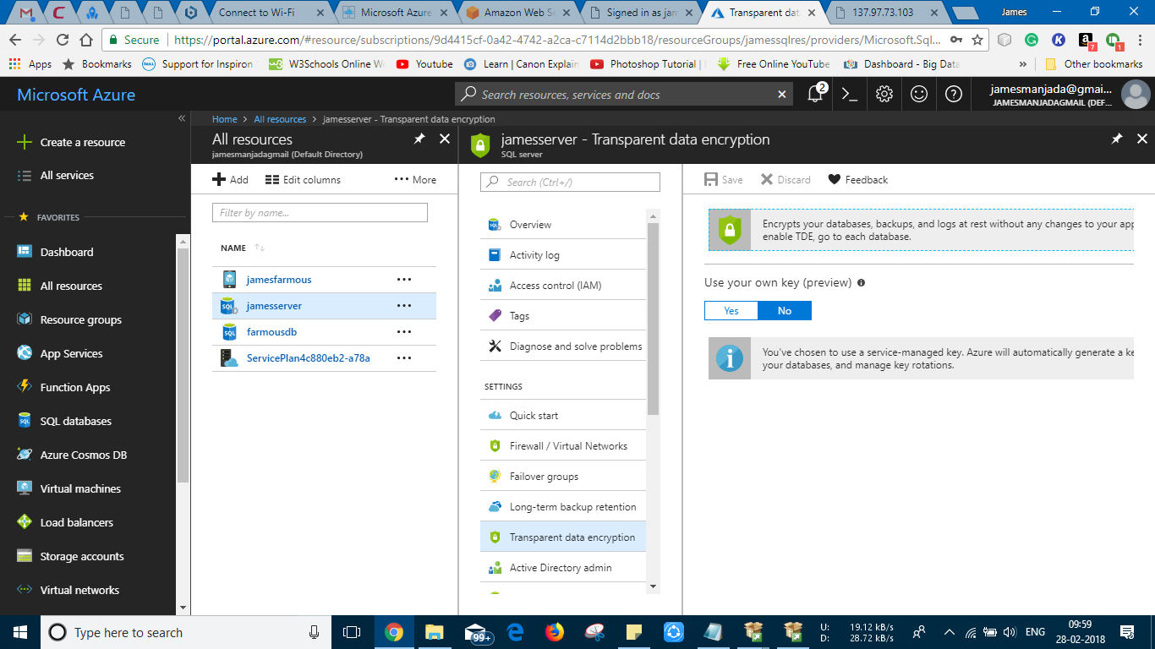

* Once completed save the Firewall rule.

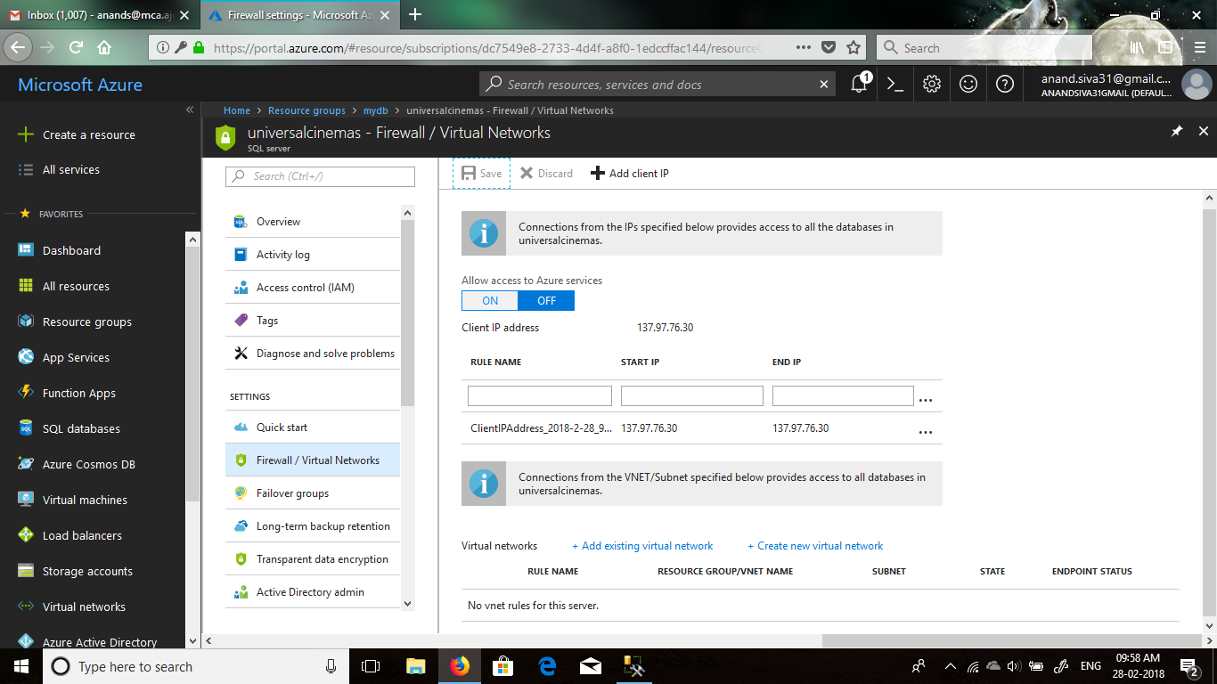

Locate your Geo Replication

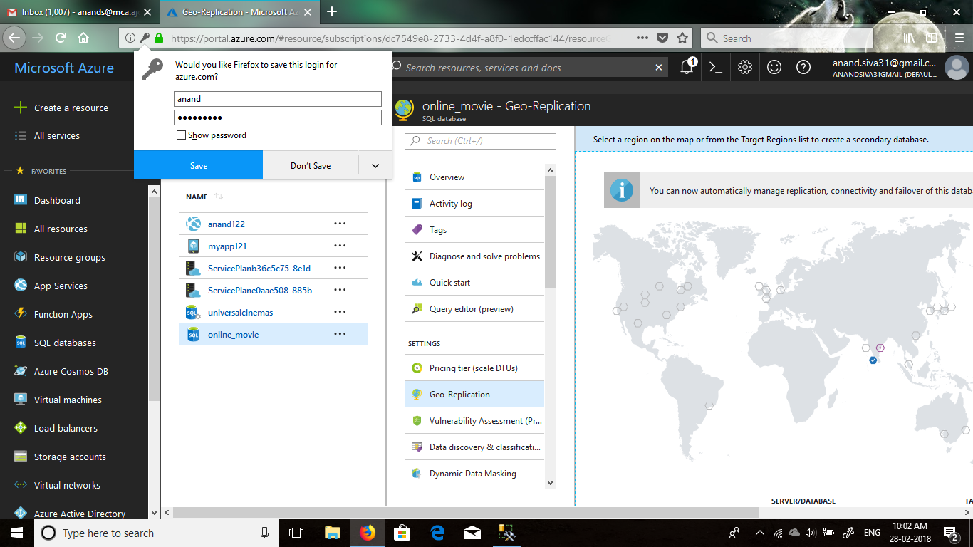

* You can copy the connection string of your database from Dashboard > Connection string which can be used in .NET, JDBC, ODBC, PHP

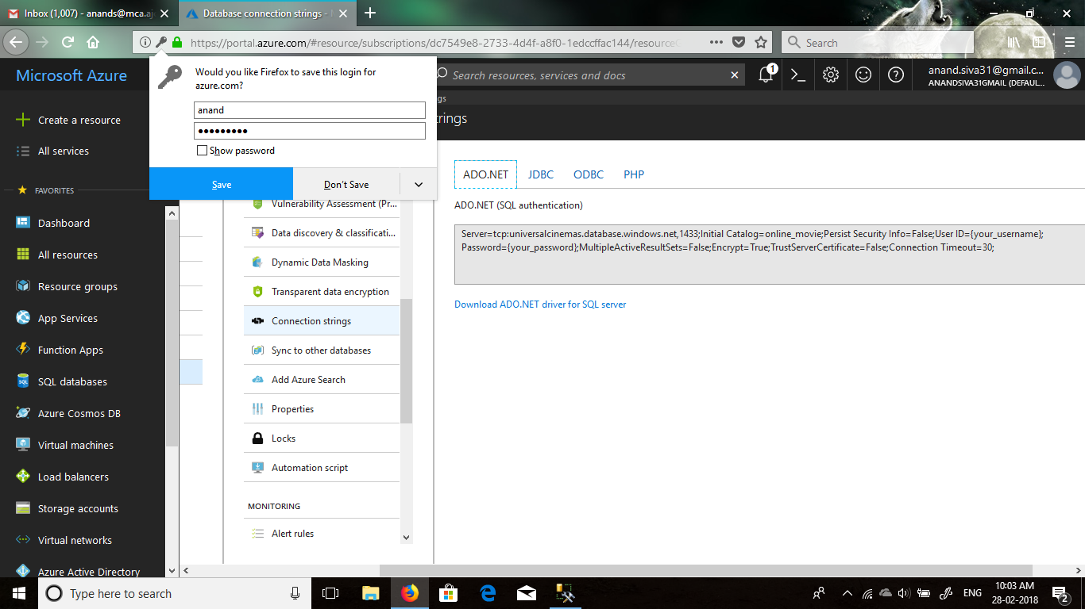

**P1.3.4** DevOps in Azure

In order to release quickly and have stable application environments with minimal errors, it is of vital importance that developers work well with IT operations people and vice versa. To do this, they need to communicate well and sometimes work on the same team.

Ideally, they work in the same environment. Makes sense, right? This is called [DevOps](https://stackify.com/what-is-devops/). DevOps is a hyped-up term, but it comes down to implementing common sense by working better together.

One of the most important goals that DevOps helps to achieve is:

* Faster and more reliable releases of the application through [Continuous Integration (CI)* and Continuous Deployment (CD)](https://stackify.com/fundamentals-of-the-cd-ci-pipeline/)

Microsoft provides some awesome services and features that can help your team to achieve this goal. You’ll learn about them in this article.

* [Continuous Deployment of Azure App Services](https://docs.microsoft.com/azure/app-service/app-service-continuous-deployment)
* [Azure DevOps Projects](https://azure.microsoft.com/features/devops-projects/)
* [Visual Studio Team Services](https://www.visualstudio.com/team-services/)

**Continuous deployment of Azure App Services**

Azure App Services are services that you use to host your web application or API. When you have the source code of your application in source control somewhere, you can easily have it deployed automatically to the App Service, every time you push up a change.

You do this by configuring the Deployment Options feature in App Services. This is really simple to do.

1. In your App Service (like a Web App), go to the Deployment Options blade
2. Here, it asks you to choose a source. So, choose where your source code lives
3. When you’ve chosen your source code repository, you’ll need to authenticate so that Azure can use those credentials to access the source code
4. Next, you can choose the details of your deployment, which can include setting up a performance test as part of the process. In my case, I have chosen GitHub as my source
5. Once this is done, the process starts to run and builds and deploys your source code into the App Service

Once this is configured, every time that you commit changes to the source code repository, it will get built and deployed to the App Service automatically.

You can see the deployments in the Deployment Options blade in the App Service. This is a pretty cool feature and very useful. Especially when you work with a team of developers that are all checking in code to the same repository. However, the Deployment Options feature in App Service is pretty restricted. It is easy to set up, but that also means that you do not have a lot of configuration choices if you need to do more.

**Part 2**

**Using Git as a Version Control System**

**P2.1 Introduction to GitHub**

GitHub is a web-based version-control and collaboration platform for software developers. GitHub, which is delivered through a software-as-a-service ([SaaS](http://searchcloudcomputing.techtarget.com/definition/Software-as-a-Service)) business model, was started in 2008 and was founded on Git, an open source code management system created by [Linus Torvalds](http://whatis.techtarget.com/definition/Linus-Torvalds) to make software builds faster. And it is used to store the source code for a project and track the complete history of all changes to that code. It allows developers to collaborate on a project more effectively by providing tools for managing possibly conflicting changes from multiple developers. GitHub allows developers to change, adapt and improve software from its public repositories for free, but it charges for private repositories, offering various paid plans. Each public or private repository contains all of a project's files, as well as each file's revision history. Repositories can have multiple collaborators and can be either public or private.

GitHub facilitates [social coding](http://whatis.techtarget.com/definition/social-coding) by providing a web interface to the Git [code](http://whatis.techtarget.com/definition/code) [repository](http://searchoracle.techtarget.com/definition/repository) and management tools for collaboration. GitHub can be thought of as a serious [social networking](http://whatis.techtarget.com/definition/social-networking) site for software developers. Members can follow each other, rate each other's work, receive updates for specific projects and communicate publicly or privately.

### **GitHub products and features**

GitHub offers an on-premises version in addition to the well-known SaaS product. GitHub Enterprise supports integrated development environments and continuous integration tool integration, as well as a litany of third-party apps and services. It offers increased security and auditable than the SaaS version.

**P2.2 Working with Git**

* **Sign in to GitHub**

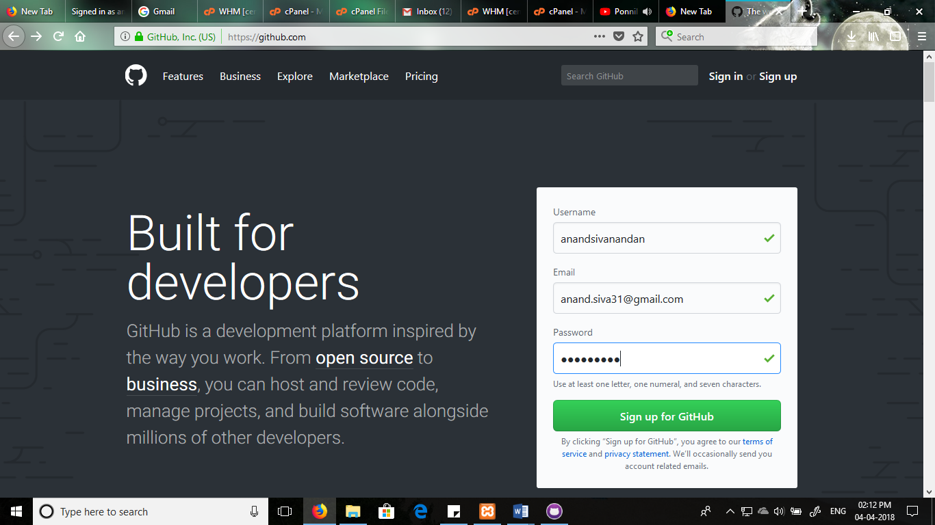

* Once successfully sign in, set up personal account, choose your plan.

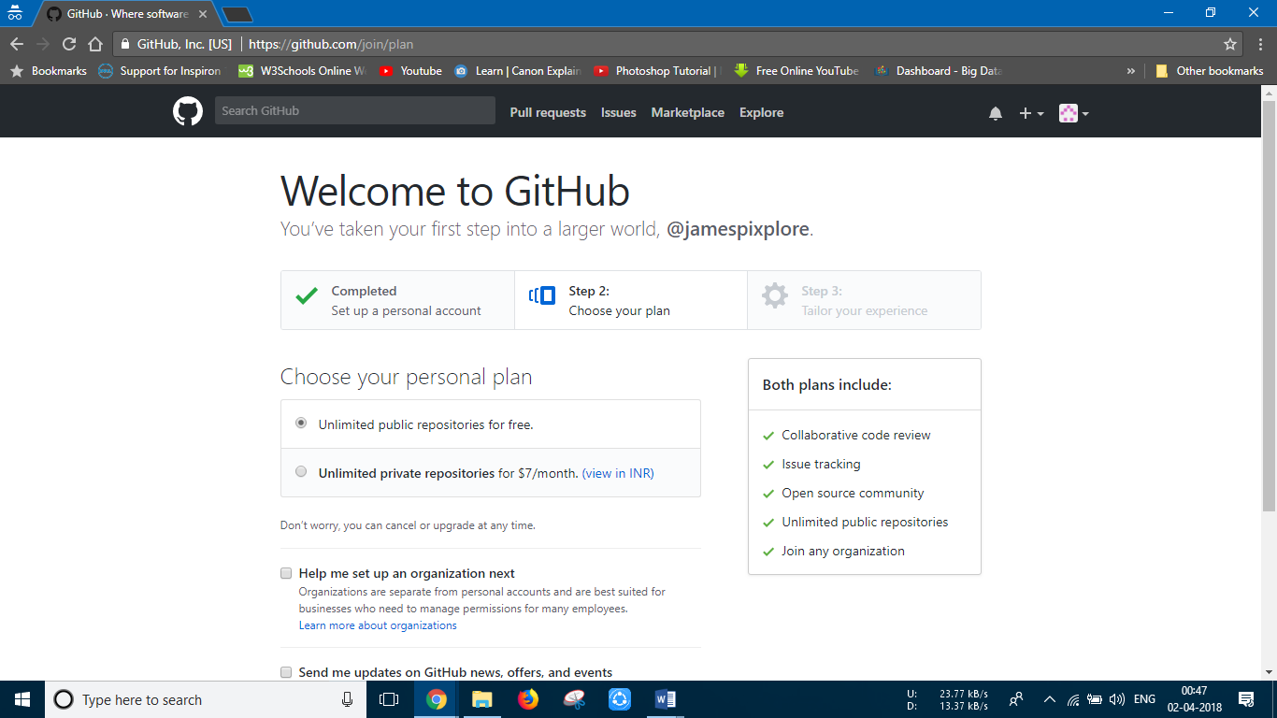

* Tailor your experience.
* Once the account configuration is completed, you can access the home page

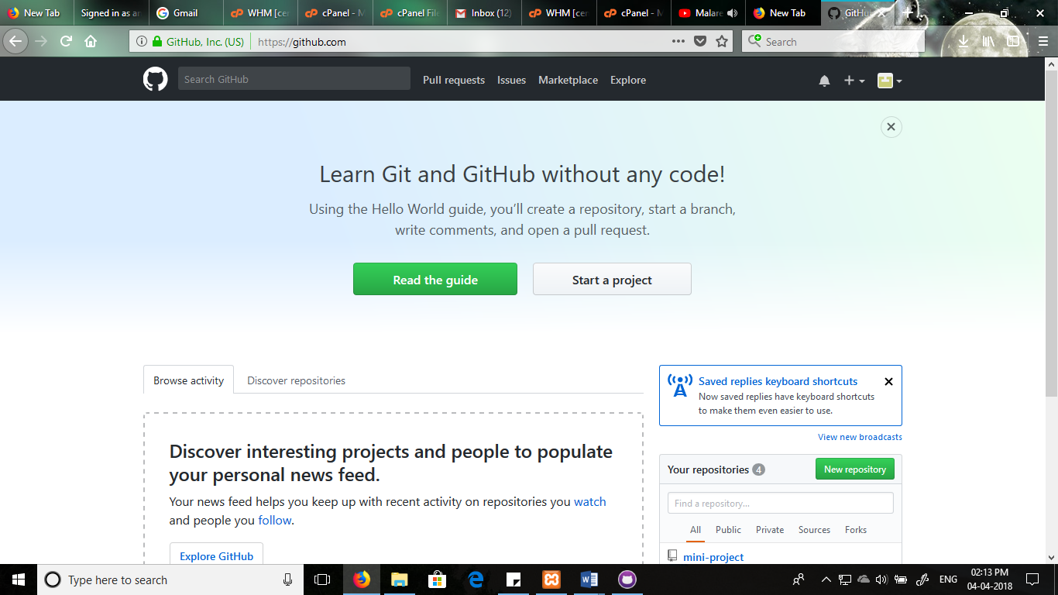

* Create a repository in GitHub

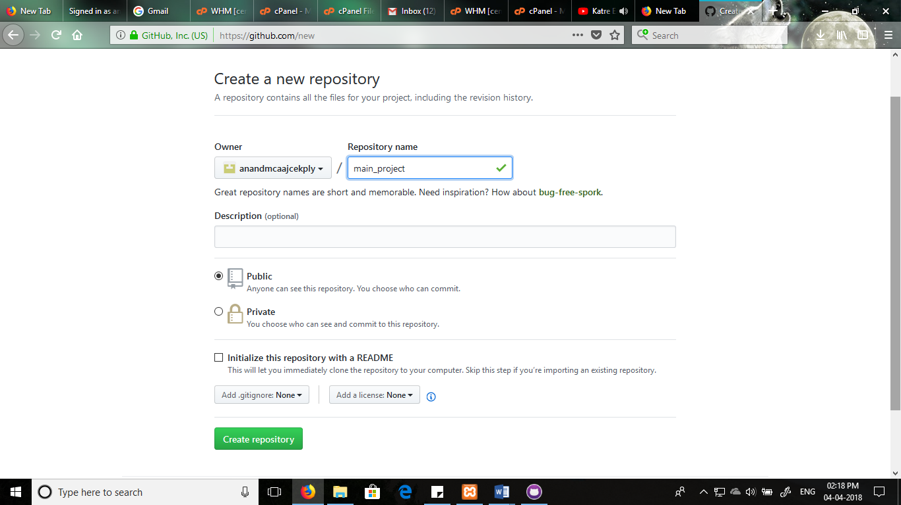

* Once repository is completed, you can setup the repository

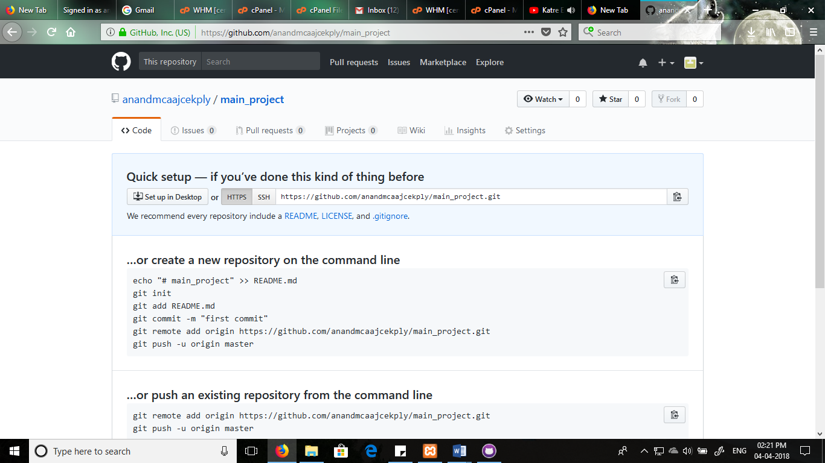

* Download and install GitHub desktop application. Once installed Go to Repository > Clone repository, and select your repository which was created in GitHub.com or Select a local system folder

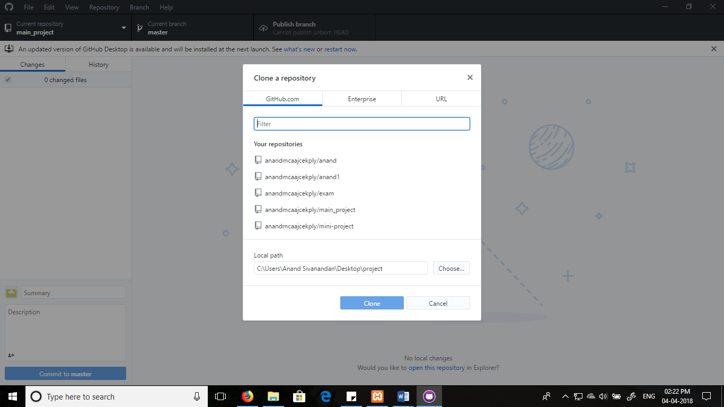

* Add local system folder, then create a local repository with folder name.

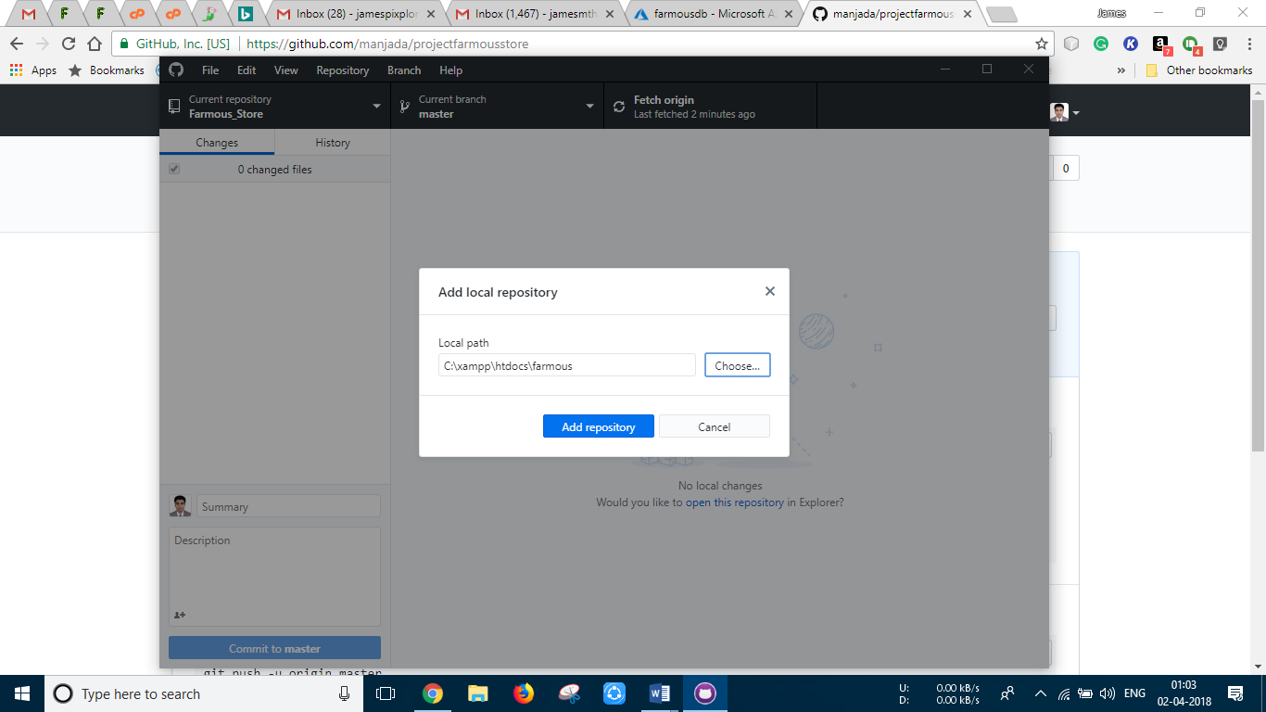

* Once repository is created, make changes on the file which is stored inside the local repository and commit to master.

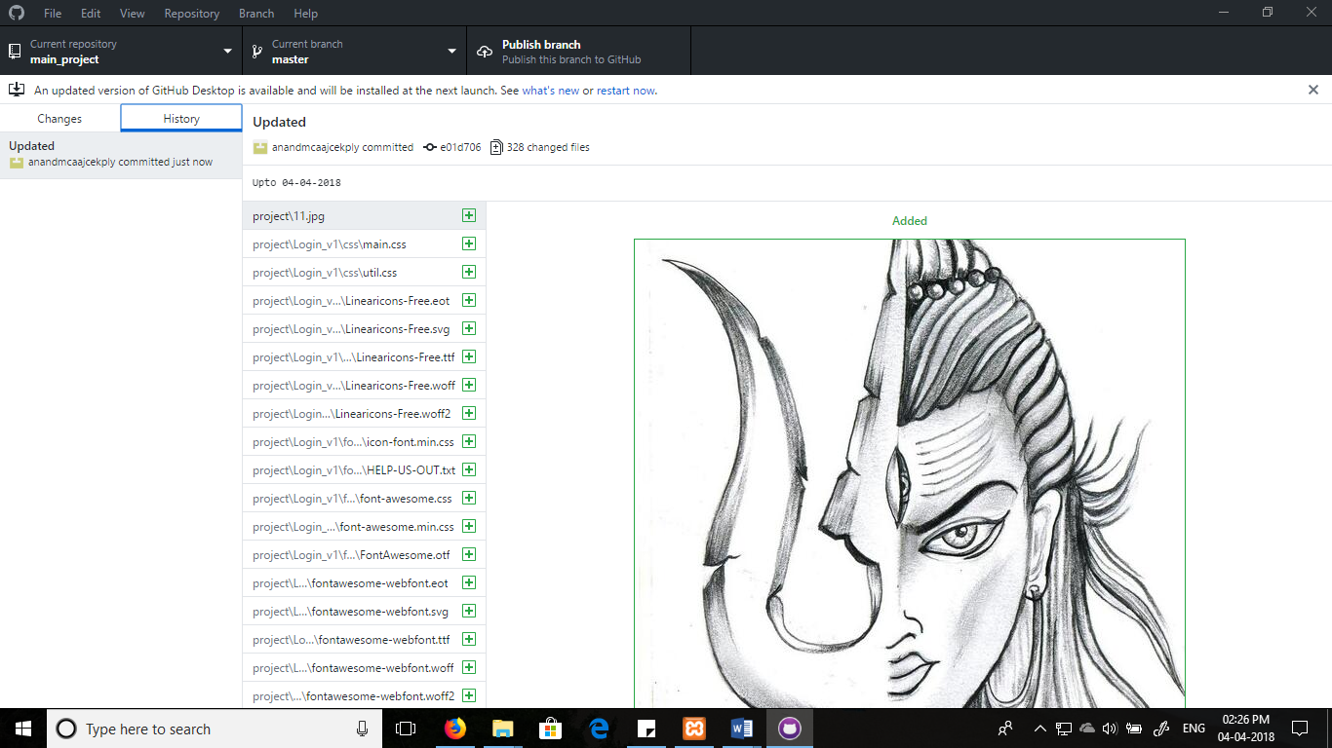

* Push the local repository to orgin

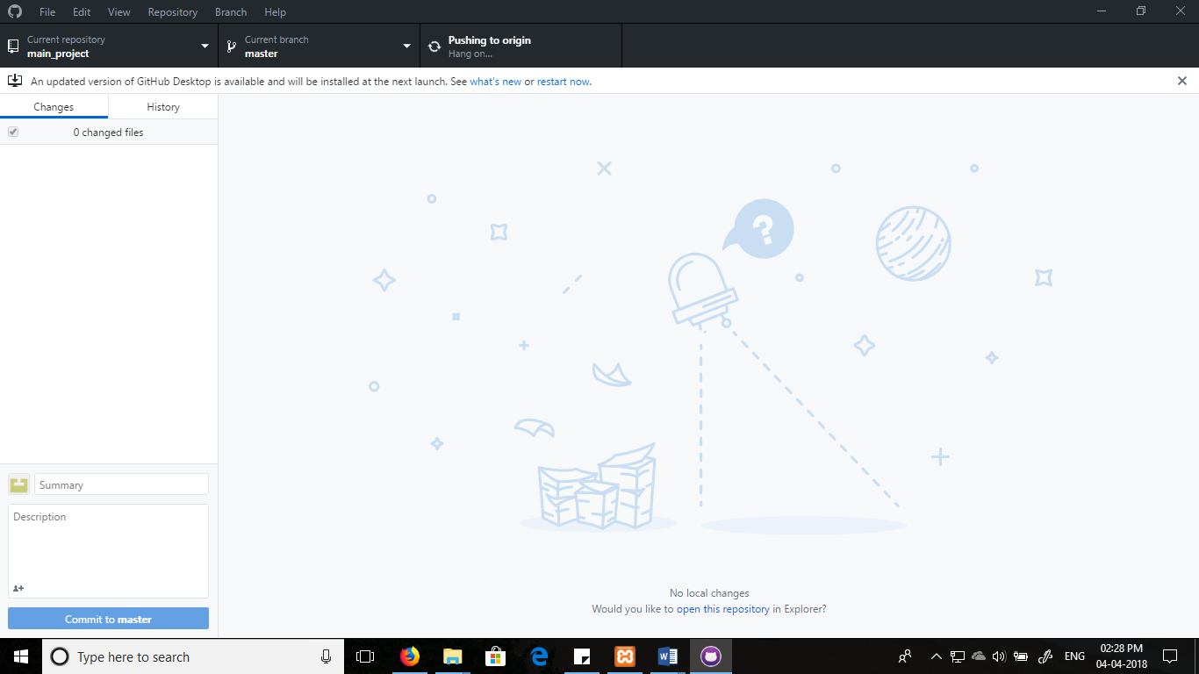

* Refresh GitHub.com repository to fetch commits

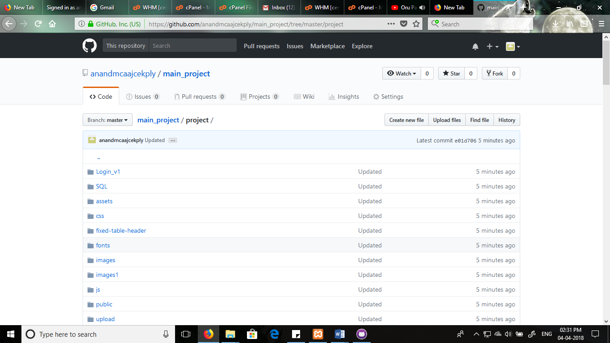

**Part 3**

**Data Design in Novel Technologies**

**P3.1 MongoDB**

**P3.1.1 Introduction to MongoDB**

MongoDB is an [open source](http://whatis.techtarget.com/definition/open-source) database that uses a document-oriented data model. And it is one of several [database](http://searchsqlserver.techtarget.com/definition/database) types to arise in the mid-2000s under the NoSQL banner. Instead of using [tables](http://searchmicroservices.techtarget.com/definition/table) and [rows](http://searchoracle.techtarget.com/definition/row) as in [relational databases](http://searchsqlserver.techtarget.com/definition/relational-database), MongoDB is built on an architecture of collections and documents. Documents comprise sets of [key-value pairs](http://searchenterprisedesktop.techtarget.com/definition/key-value-pair) and are the basic unit of data in MongoDB. Collections contain sets of documents and function as the equivalent of relational database tables. Like other NoSQL databases, MongoDB supports dynamic [schema](http://searchsqlserver.techtarget.com/definition/schema) design, allowing the documents in a collection to have different fields and structures. The database uses a document storage and data interchange format called BSON, which provides a [binary](http://whatis.techtarget.com/definition/binary) representation of [JSON](http://searchwindevelopment.techtarget.com/definition/JSON-Javascript-Object-Notation)-like documents. Automatic [sharding](http://searchcloudcomputing.techtarget.com/definition/sharding) enables data in a collection to be distributed across multiple systems for [horizontal scalability](http://searchcio.techtarget.com/definition/horizontal-scalability) as data [volumes](http://searchstorage.techtarget.com/definition/volume) increase.

MongoDB was created by Dwight Merriman and Eliot Horowitz, who had encountered development and scalability issues with traditional relational database approaches while building [Web applications](http://searchsoftwarequality.techtarget.com/definition/Web-application-Web-app) at DoubleClick, an Internet advertising company that is now owned by Google Inc.

**P3.1.2 Implementation of MongoDB**

1. Download and Install MongoDB server for Windows. https://www.mongodb.com/dr/fastdl.mongodb.org/win32/mongodb-win32-x86_64-2008plusssl-3.6.2-signed.msi/download

2. Download and extract MongoDB PHP driver https://s3.amazonaws.com/drivers.mongodb.org/php/php_mongo-1.6.8.zip

3. Rename any one file (Eg. php_mongo-1.6.8-5.6-vc11.dll) to php_mongo.dll and copy it to Extension directory known as ext directory. XAMPP: xampp\php\ext WAMPP: wamp\bin\php\php\ext

4. Add the following line to your php.ini extension=php_mongo.dll

5. Add Environment variable (Control Panel -> System and Security -> System -> Advanced system settings -> Environment variables) by editing PATH variable. C:\Program Files\MongoDB\Server\3.6\bin C:\xampp\php OR C:\wamp\bin\php

6. Create directory C:\data\db

7. Restart Apache server

8. Open CMD and start MongoDB server by using command Mongod

**Working with MongoDB Server**

* 1. Open the MongoDB Server (MongoDB Compass community: localhost)
  2. Connect to localhost

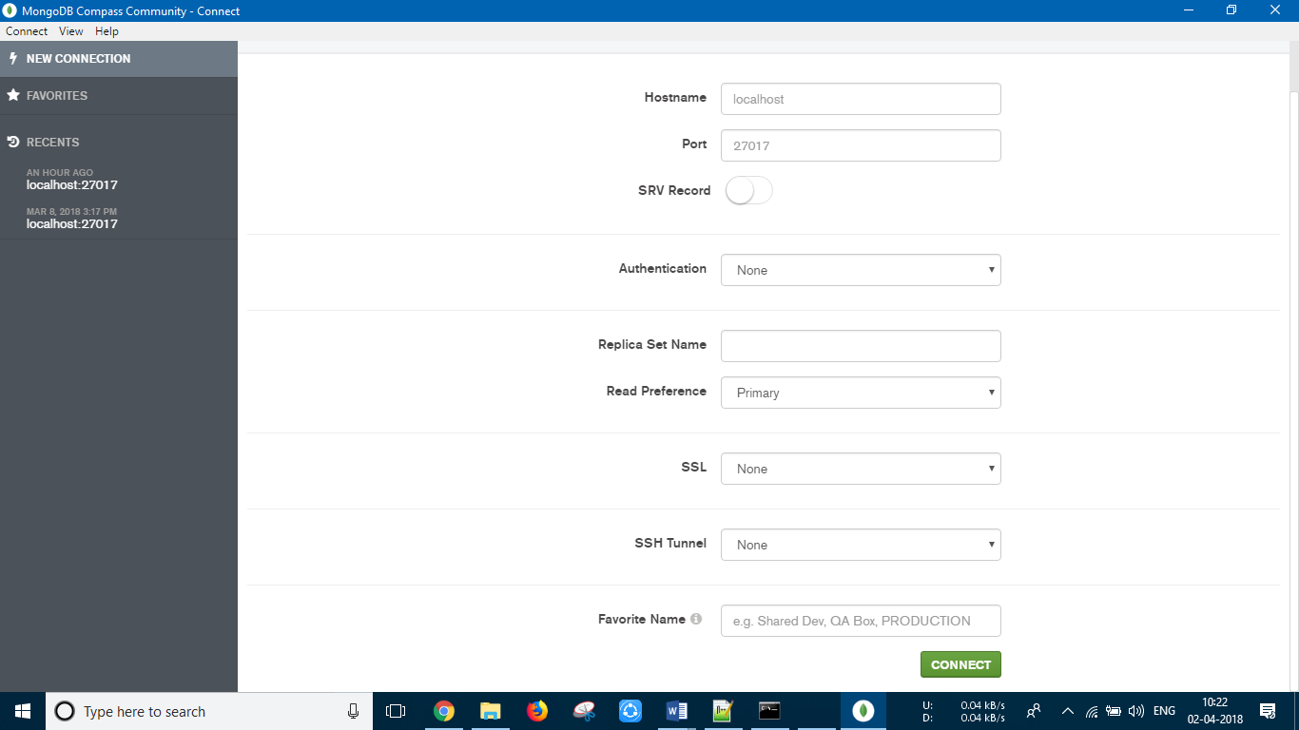

* 1. Once connected to the server, Create a database and collection as well. A collection in MongoDB is equivalent to RDBMS table

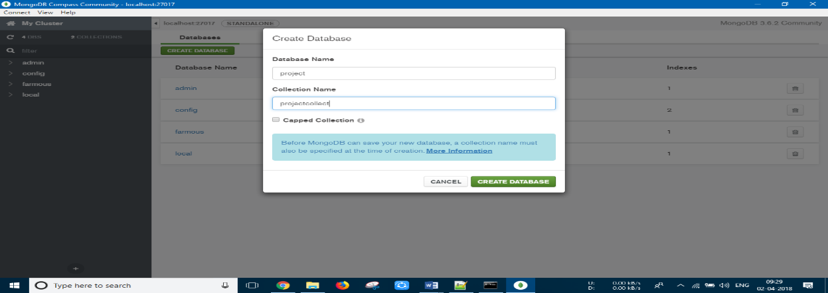

* 1. Once the database and collection are created, insert your documents into the collection. Documents in MongoDB is equivalent to the rows in RDBMS.

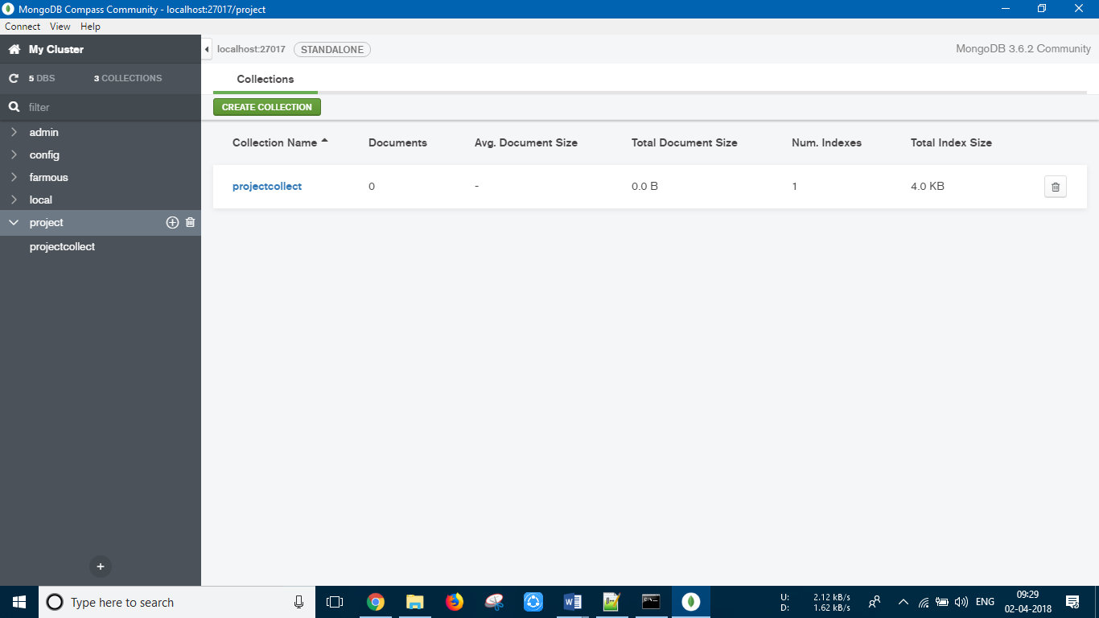

* 1. Document ID is the default and unique value provided by the MongoDB

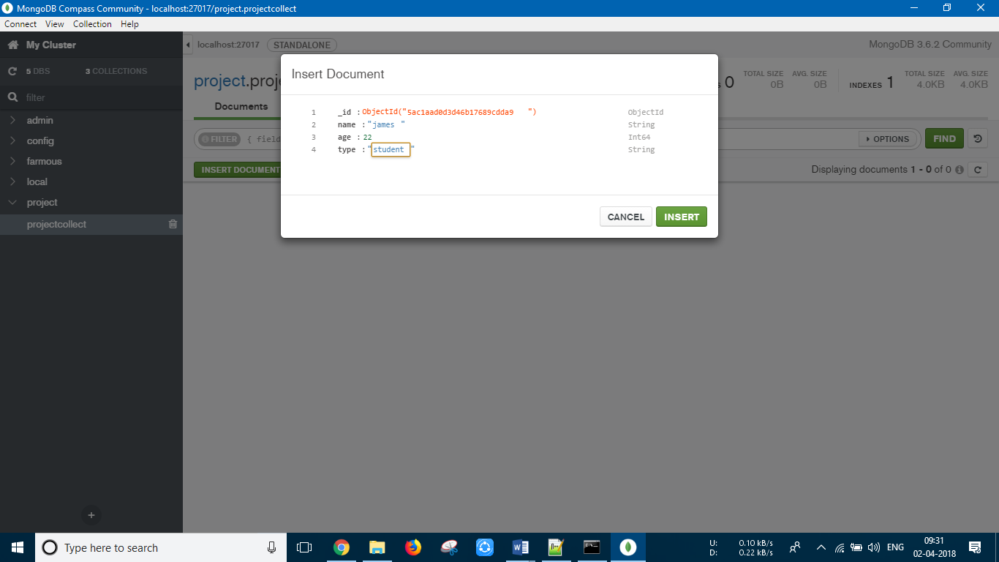

**Basic queries to access your database**

1. MongoDB Connection $con = new MongoClient ();

2. Selection or Creation of Database (MySQL: Database) $db = $con->database_name;

3. Collection Creation (MySQL: Table) $collection = $db->createCollection("collection_name");

4. Document Insertion (MySQL: Insert - Row) $document = array (“key-1" => "value-1", "key-n" => "value-n”); $collection->insert($document);

5. View data (MySQL: Select) $cursor = $collection->find (); foreach ($cursor as $document) {echo $document["key"];}

6. Updating data (MySQL: Update) $collection->update(array("key"=>"old-value"), array('$set'=>array("key"=>"new-value")));

7.Deletion of data (MySQL: Delete) $collection->remove(array("condition-key"=>"condition-value"));

**. php page to with basic queries access MongoDB**

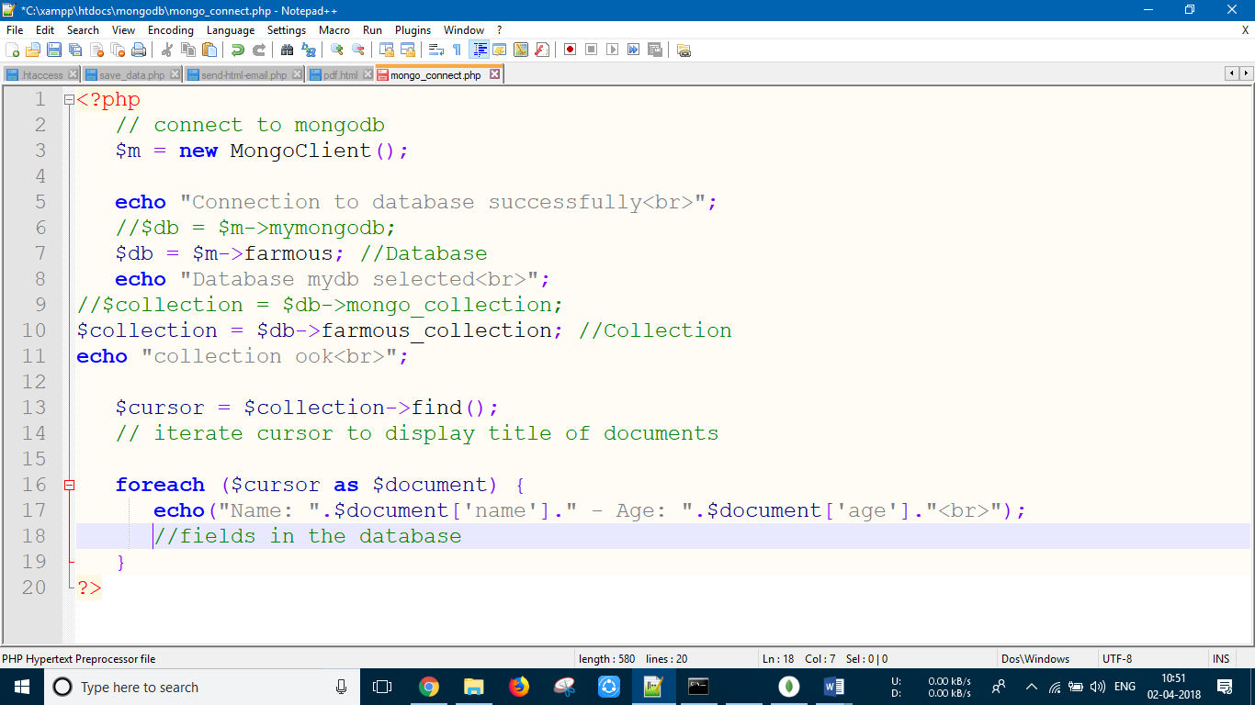

**Output**

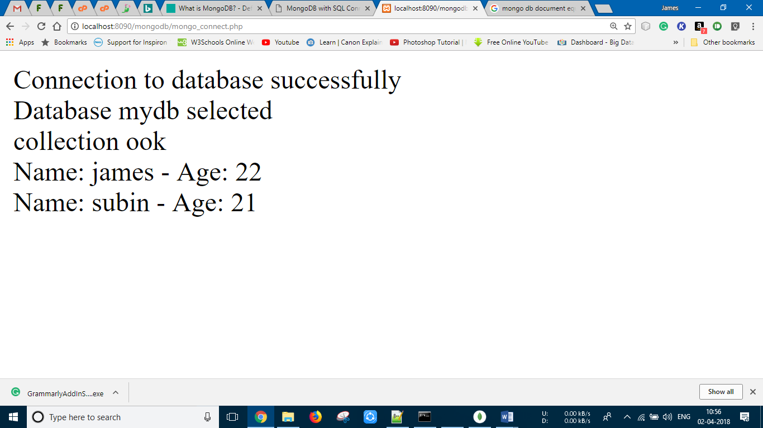

**P3.2 Bigtable in GCP**

**P3.2.1 Introduction to Bigtable**

Google Bigtable is a distributed, column-oriented data store created by Google Inc. to handle very large amounts of structured data associated with the company's Internet search and Web services operations. And it was designed to support applications requiring massive scalability; from its first [iteration](http://searchsoftwarequality.techtarget.com/definition/iteration), the technology was intended to be used with [petabytes](http://searchstorage.techtarget.com/definition/petabyte) of data. The database was designed to be deployed on clustered systems and uses a simple data model that Google has described as "a sparse, distributed, persistent multidimensional sorted map." Data is assembled in order by row key and indexing of the map is arranged according to row, column keys, and timestamps. [Compression](http://searchstorage.techtarget.com/definition/compression) algorithms help achieves high capacity. Google Bigtable serves as the database for applications such as the Google App Engine Datastore, Google Personalized Search, Google Earth and [Google Analytics](http://searchbusinessanalytics.techtarget.com/definition/Google-Analytics). Google has maintained the software as a proprietary, in-house technology. Nevertheless, Bigtable has had a large impact on [NoSQL](http://searchdatamanagement.techtarget.com/definition/NoSQL-Not-Only-SQL) database design. Google software developers publicly disclosed Bigtable details in a technical paper presented at the USENIX Symposium on Operating Systems and Design Implementation in 2006.

Google's thorough description of Bigtable's inner workings has allowed other organizations and open source development teams to create Bigtable derivatives, including the [Apache HBase](http://searchdatamanagement.techtarget.com/definition/Apache-HBase) database, which is built to run on top of the Hadoop Distributed File System (HDFS). Other examples include [Cassandra](http://whatis.techtarget.com/definition/Cassandra-Apache-Cassandra), which originated at Facebook Inc., and Hyper table, an open source technology that is marketed in a commercial version as an alternative to HBase.

**P3.2.2 Implementation of Bigtable**

# Creating a Cloud Bigtable Instance through the [Google Cloud Platform Console](https://console.cloud.google.com/).

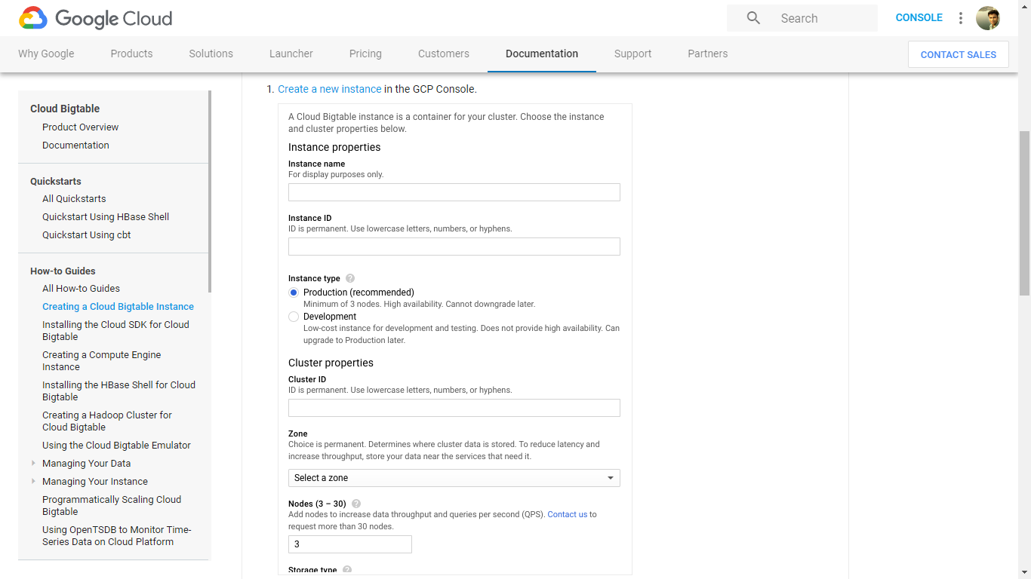

# 2. Installing the Cloud SDK for Cloud Bigtable

gcloud components update beta

gcloud config set project [PROJECT_ID]

gcloud beta Bigtable instances --help  # help for all commands  
gcloud beta bigtable instances create --help  # help for the `create` command

**Part 4**

**Search Engine Optimization**

**Search engine optimization** is a methodology of strategies, techniques, and tactics or it is the process of getting traffic from the free, organic, editorial or natural search results on search engines used to increase the number of visitorsto a [website](https://www.webopedia.com/TERM/W/web_site.html) by obtaining a high-ranking placement in the search results page of a [search engine](https://www.webopedia.com/TERM/S/search_engine.html) ([SERP](https://www.webopedia.com/TERM/S/SERP.html)) — including Google, Bing, Yahoo and other search engines.

**P4.1 Google AdWords**

**P4.1.1 Introduction to Google AdWords**

AdWords (Google AdWords) is an [advertising](http://www.webopedia.com/Internet_and_Online_Services/Electronic_Commerce/Online_Advertising/) service by Google for businesses wanting to display ads on Google and its advertising network. The AdWords program enables businesses to set a budget for advertising and only pay when people click the ads. The ad service is largely focused on [keywords](http://www.webopedia.com/keyword.html).

Businesses that use AdWords can create relevant ads using keywords that people who search the Web using the Google [search engine](http://www.webopedia.com/TERM/S/search_engine.html) would use. The keyword, when searched for triggers your ad to be shown. AdWords at the top ads that appear under the heading "Sponsored Links" found on the right-hand side or above Google search results. If your AdWords ad is clicked on, Google search users are then directed to your [website](http://www.webopedia.com/TERM/W/web_site.html).

When choosing keywords for your AdWords campaigns different matching options are available. The two main keyword match options include the following:

* **Broad Match**: This reaches the most users by showing your ad whenever your keyword is searched for.
* **Negative Match**: This option prevents your ad from showing when a word or phrase you specify is searched for.
* **Phrase Match**: Your ad is shown for searches that match the exact phrase.
* **Exact Match**: Your ad is shown for searches that match the exact phrase exclusively.

When using AdWords keywords are also used to determine your cost of advertising. Each keyword you choose will have a cost per click (CPC) bid amount. The bids specify the maximum amount you're willing to pay each time someone clicks your ad (the maximum [cost-per-click](http://www.webopedia.com/TERM/C/CPC.html)). A higher [CPC](http://www.webopedia.com/TERM/C/CPC.html) bid can allow your ad to show at a higher position on the page.

**P4.1.2 Implementation of Google AdWords**

* 1. **Go to Google AdWords Express and sign into your Google account**

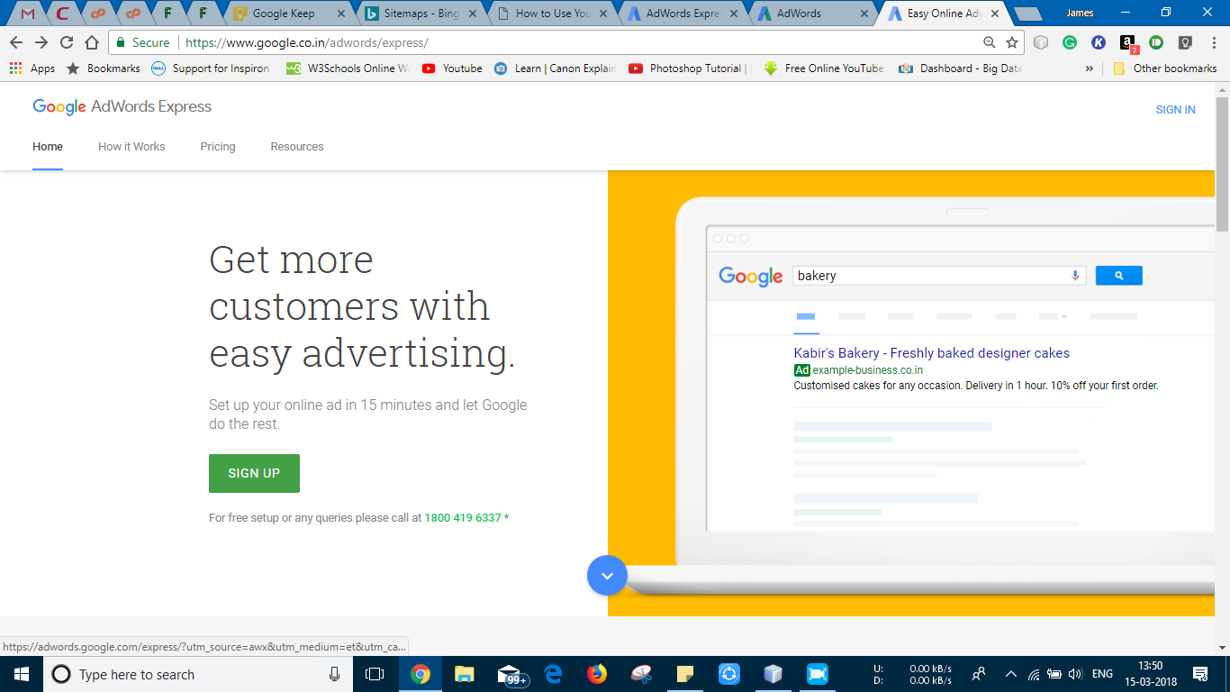

2. Describe your business and website URL

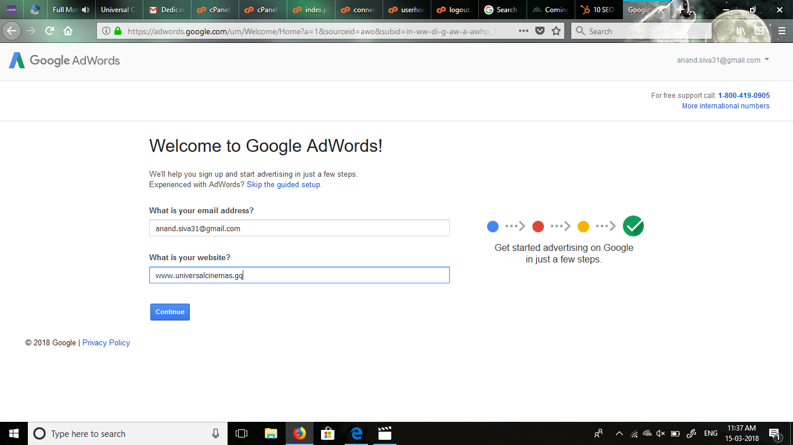

3. Pick a goal for your ad, which means, what action do you most want customers to take?

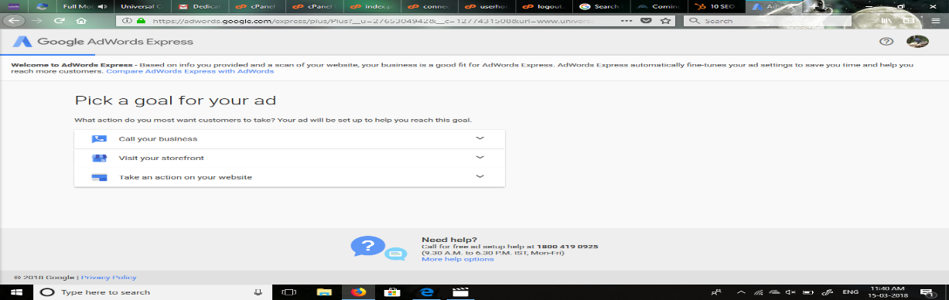

4. Pick an area to show your ad in, Here Google is providing two options, one is Near my business (Which allows you to specify the distance of area from your location) and second is in specific cities, states or countries.

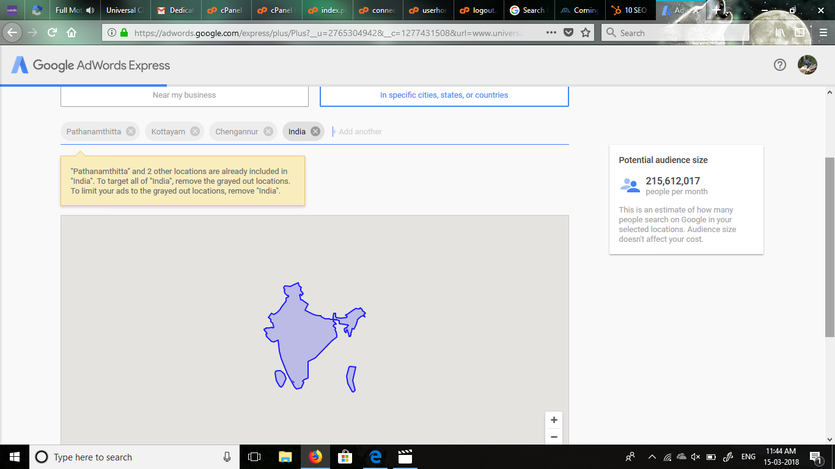

5. Define your products and services. Specifically, it aims for the business category.

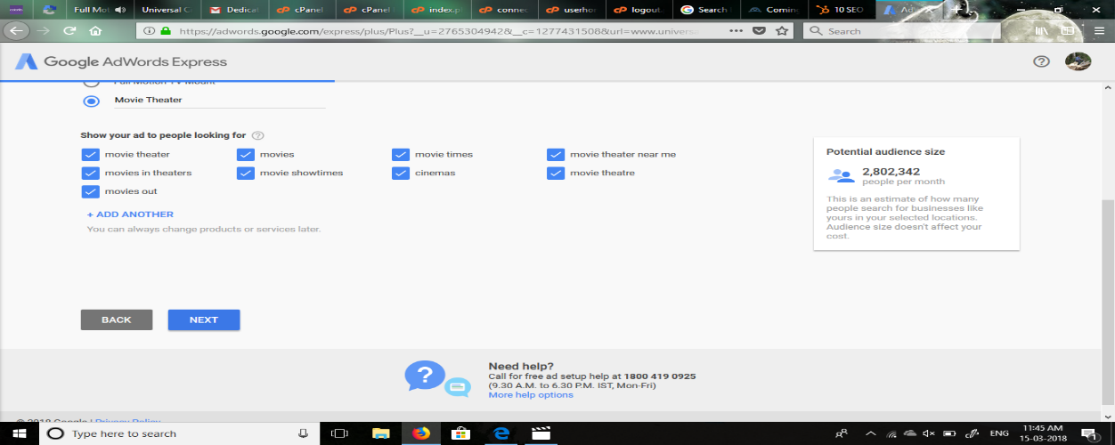

6. Create your Ad preview including Headline, Description, Ad URL.

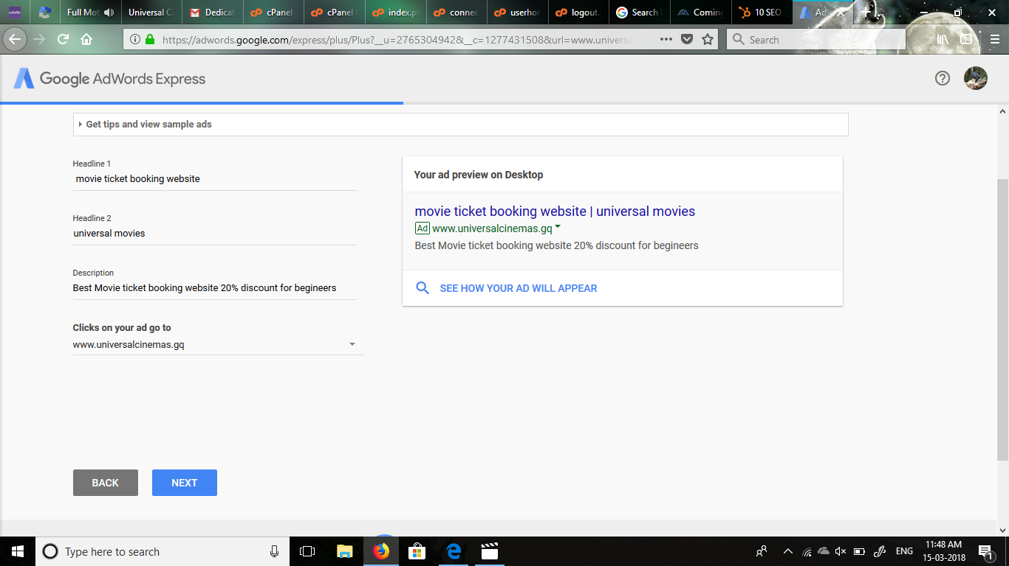

7. Set your budget for peoples click.

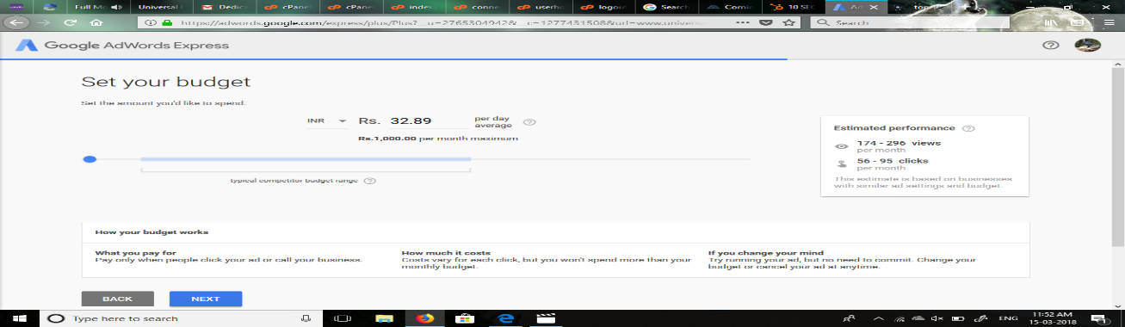

8. Review your Ad and settings.

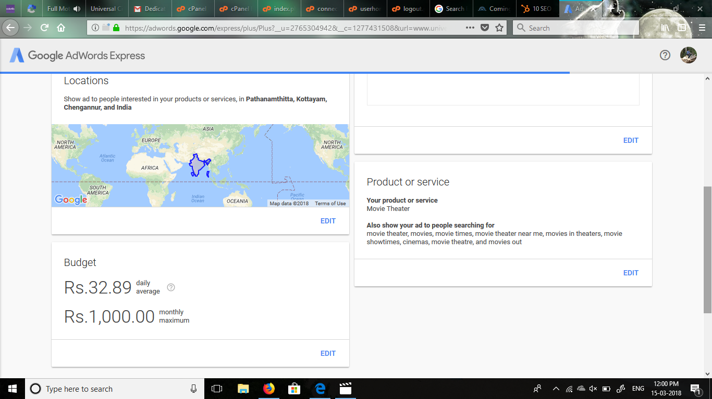

9.Once verified. You can access AdWords dashboard for further process.

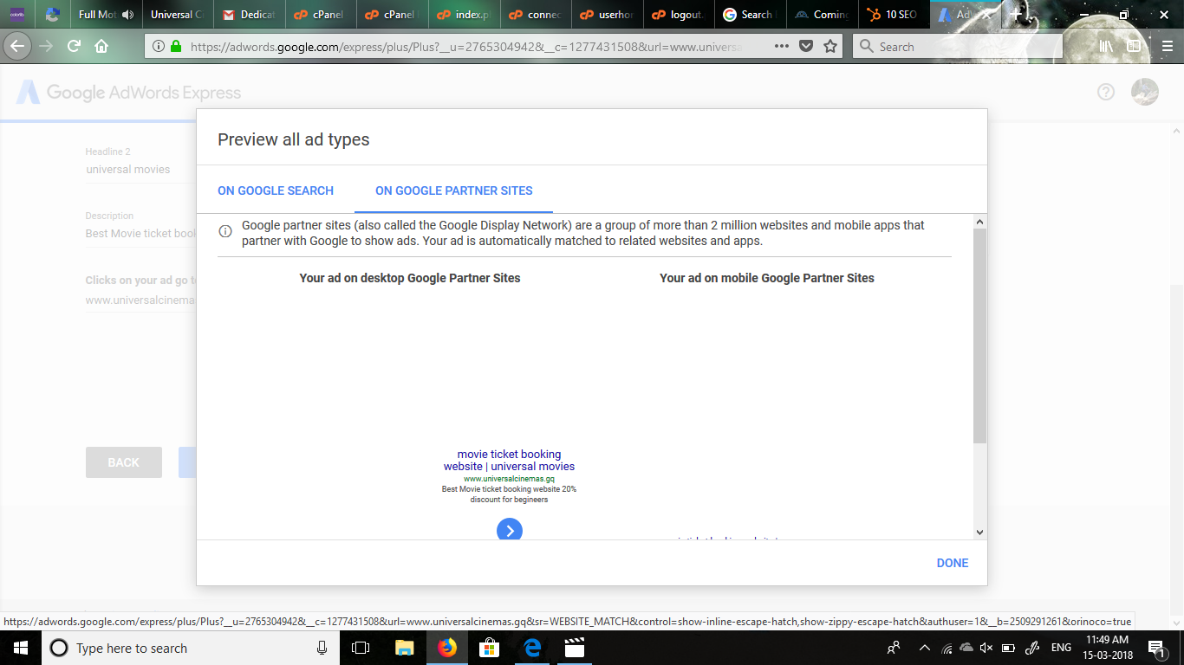

10. The dashboard also allows you to manage created Ads.

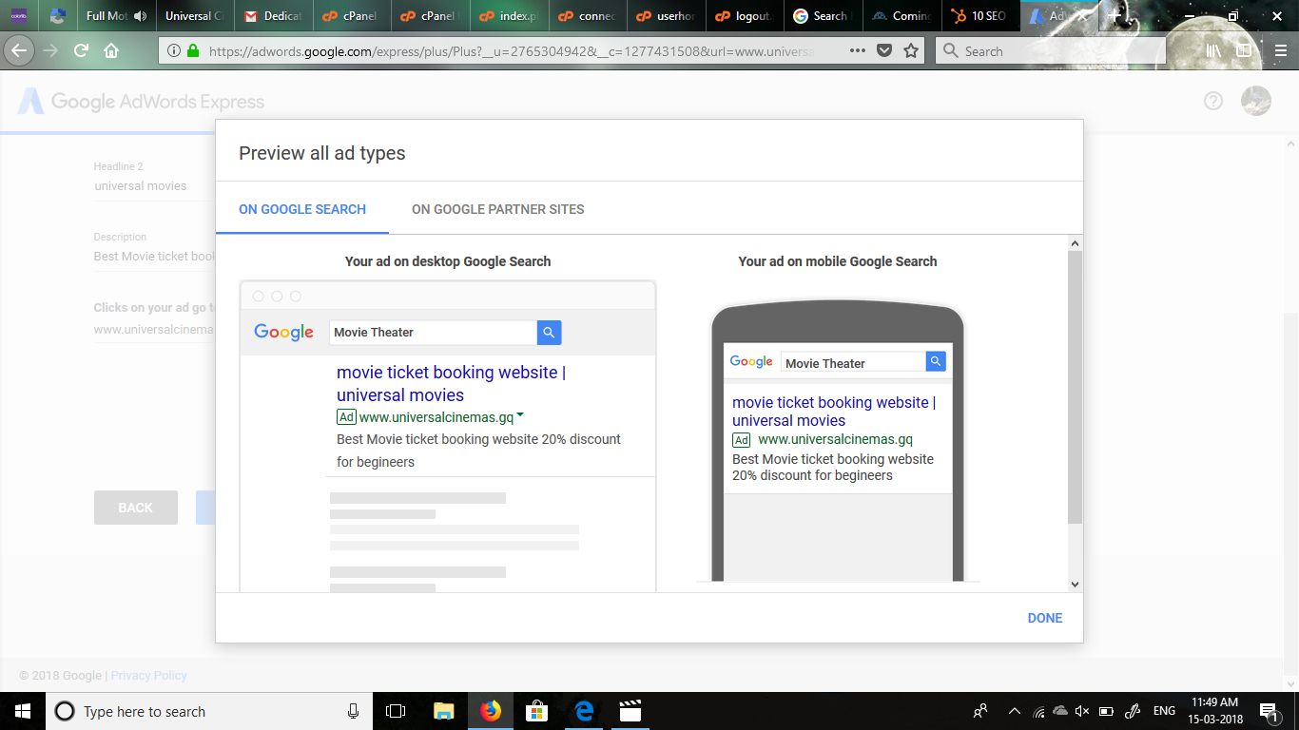

**P4.2 Google AdSense**

**P4.2.1 Introduction to Google AdSense**

AdSense (Google AdSense) is an [advertising](http://www.webopedia.com/Internet_and_Online_Services/Electronic_Commerce/Online_Advertising/) placement service by Google. The program is designed for website publishers who want to display targeted [text](http://www.webopedia.com/TERM/T/text.html), video or [image](http://www.webopedia.com/TERM/I/image.html) advertisements on [website](http://www.webopedia.com/TERM/W/web_site.html) pages and earn money when site visitors view or click the ads. The advertisements are controlled and managed by Google and Web publishers simply need to create a free AdSense account and copy and paste provided code to display the ads. Revenue using AdSense is generated on a per-click or per-[impression](http://www.webopedia.com/TERM/I/impression.html) basis. It is free to become a verified website publisher in the Google AdSense program.

Google currently offers a number of different AdSense programs, depending on the type of content you will place the ads on (e.g. a webpage or RSS feed). Some of the more common programs include:

* AdSense for content: display ads on a website
* AdSense for search: display ads in search results on a website
* AdSense for mobile: display ads on a mobile site
* AdSense for feeds: display ads in RSS feeds
* AdSense for domains: display ads on unused domains

AdSense programs are also available to qualified publishers and developers. Qualified publishers may use AdSense to drive revenues for [iPhone](http://www.webopedia.com/TERM/I/iPhone.html) applications, video or Web [browser](http://www.webopedia.com/TERM/B/browser.html) games.

**Implementation of AdSense**

**1. Go to** [AdSense Custom Search Ads](https://developers.google.com/custom-search-ads/) Generator

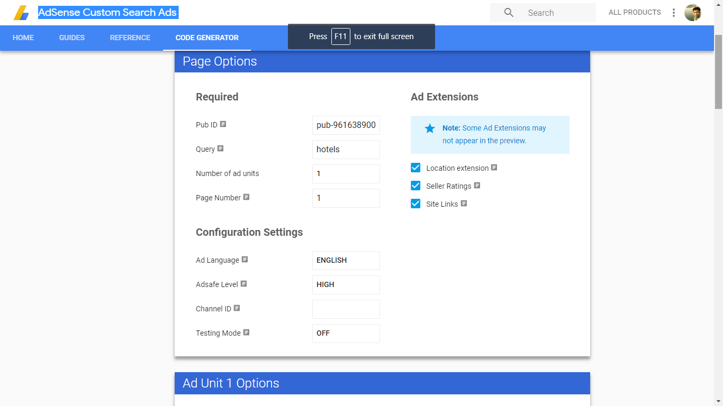

2. Configure page options and page settings, such as Ad query string, no. of ad units, no. of pages, font, and colour etc.

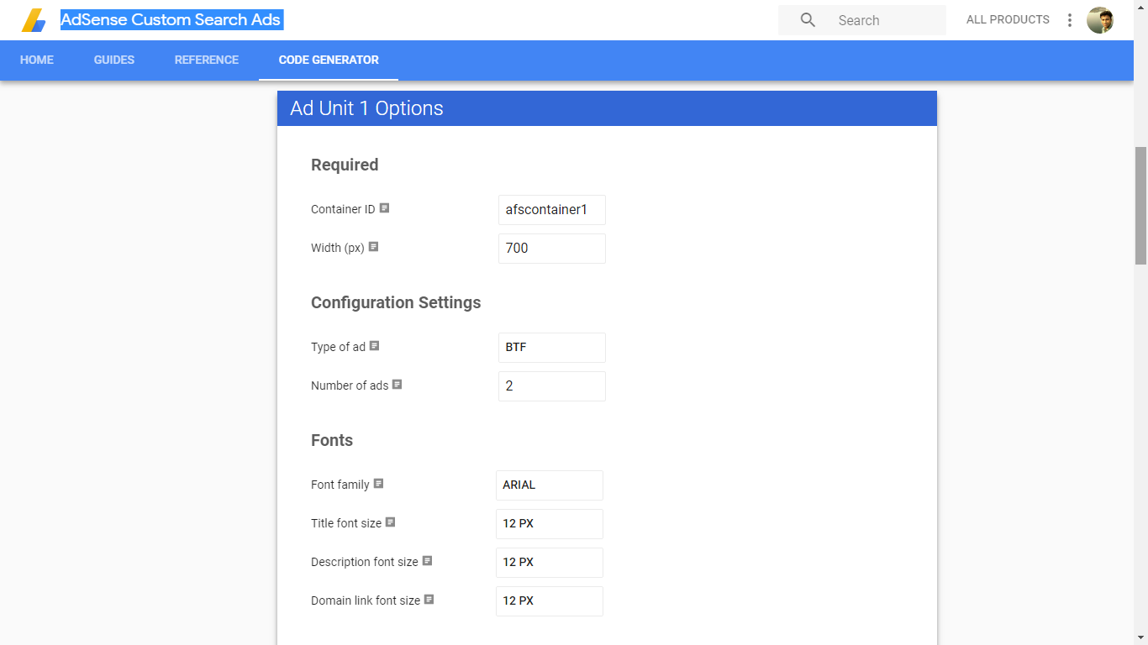

3. Preview your Ad unit.

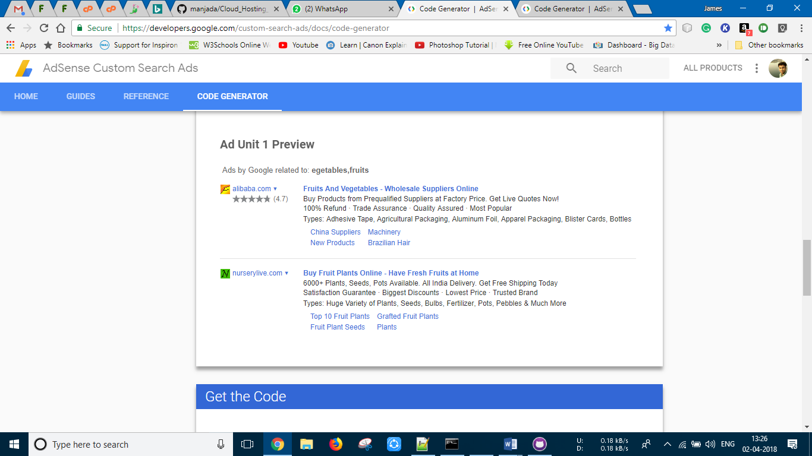

4. Place the JavaScript code in your <head> tag and HTML content in your <body> tag.

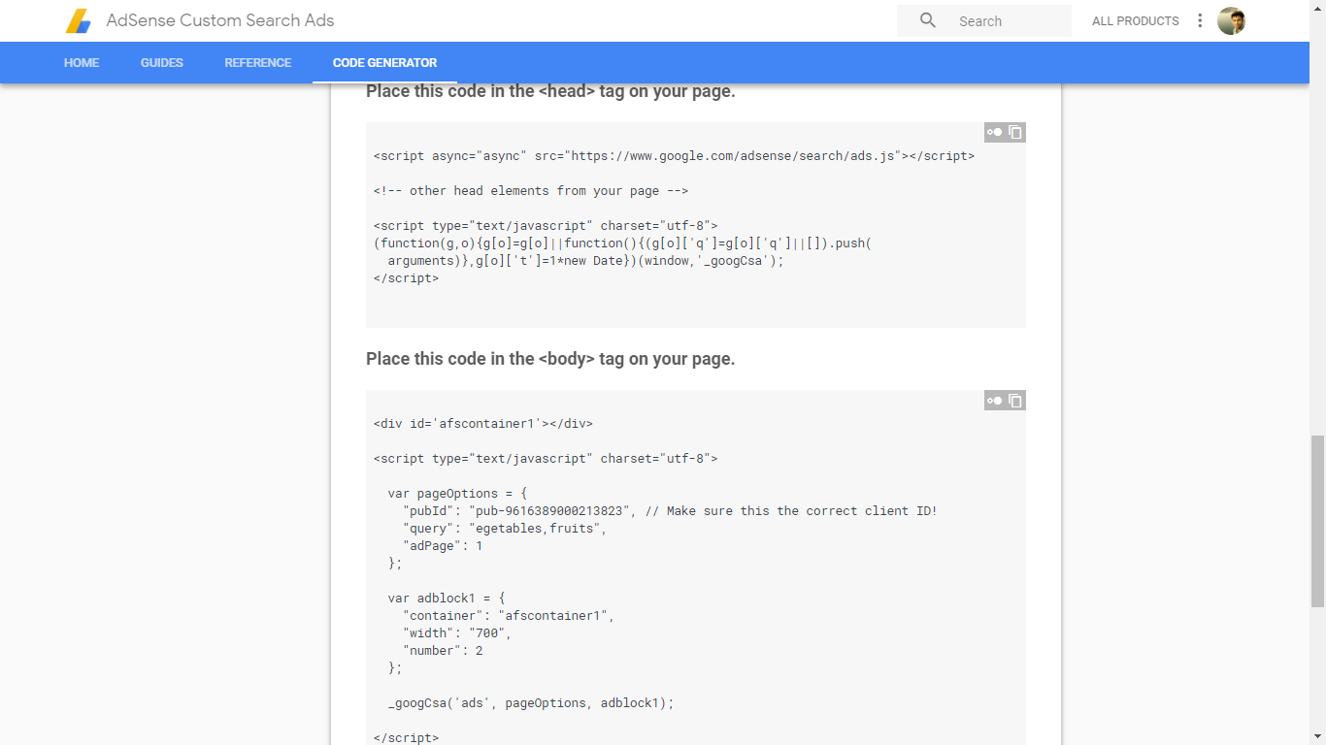

5. Refresh your page to check whether the Ads is working or not.

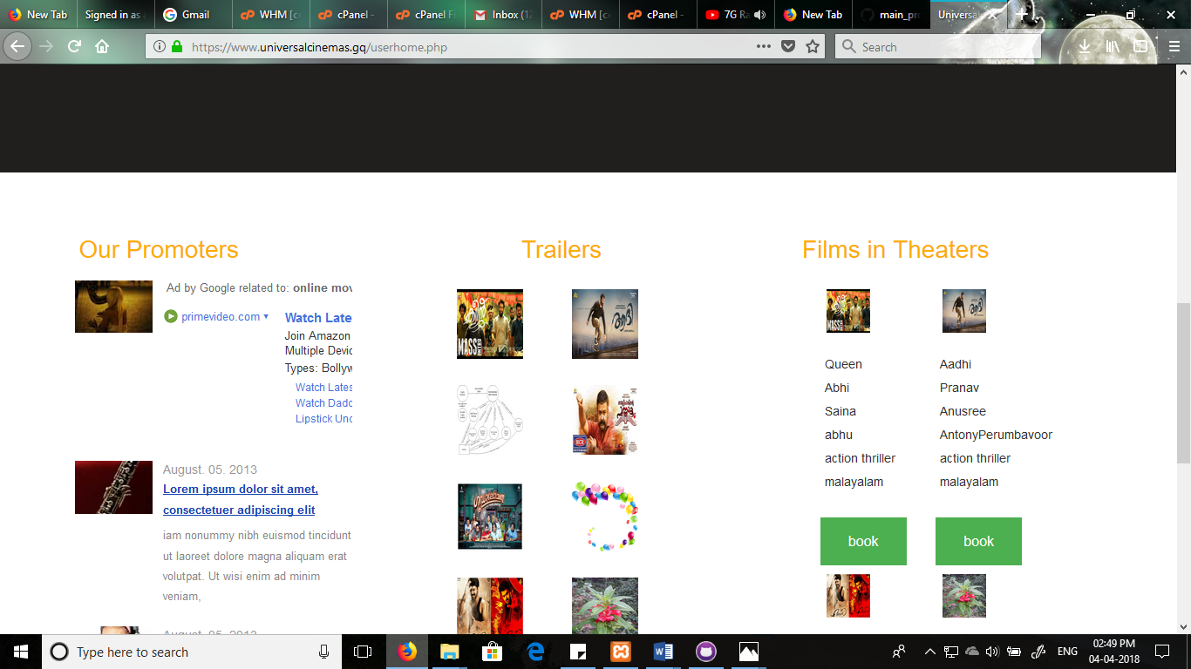

**P4.3 Google Webmasters**

**P4.3.1 Introduction to Google Webmasters**

Google Webmaster Tools (GWT) is the primary mechanism for Google to communicate with webmasters. Google Webmaster Tools helps you to identify issues with your site and can even let you know if it has been infected with malware (not something you ever want to see, but if you haven’t spotted it yourself, or had one of your users tweet at you to let you know, it’s invaluable). And also, GWT let you evaluate and maintain your website's performance in search results Offered as a free service to anyone who owns a website, Google Webmaster Tools (GWT) is a conduit of information from the largest search engine in the world to you, offering insights into how it sees your website and helping you uncover issues that need fixing. You do not need to use GWT for your website to appear in search results, but it can offer you valuable information that can help with your marketing efforts.

#### **How GWT can help monitor your website's performance**

1. It verifies that Google can access the content on your website.  
2. GWT makes it possible to submit new pages and posts for Google to crawl and remove content you don't want search engine users to discover.  
3. It helps you deliver and evaluate content that offers users a more visual experience.  
4. You can maintain your website without disrupting its presence in search results.  
5. It allows you to discover and eliminate malware or spam problems that may not be easily found through other means.

**P4.3.2 Implementation of Sitemap**

A site map is a model of a website's content designed to help both users and search engines navigate the site. A sitemap can be a hierarchical list of pages (with links) organized by topic, an organization chart, or an XML document that provides instructions to search engine crawl bots. The Sitemaps protocol allows a webmaster to inform search engines about URLs on a website that are available for crawling.

1. Generate your website sitemap using an online sitemap generator. Enter your website URL and Start the process

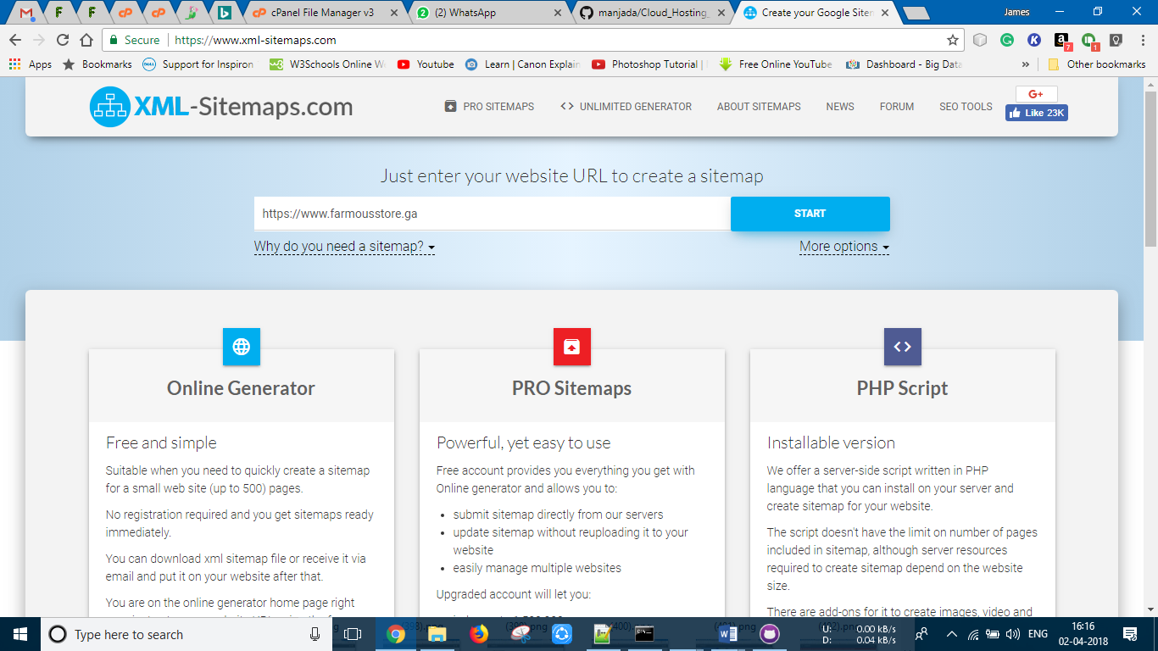

2. Once the process is completed, it will generate a sitemap.xml file.

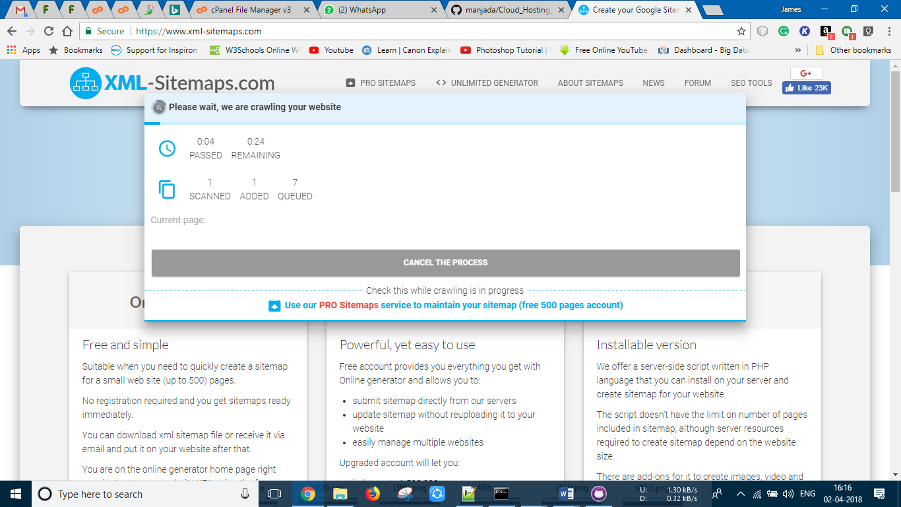

3. Upload the sitemap.xml file to your root directory and enter the path to submit the sitemap

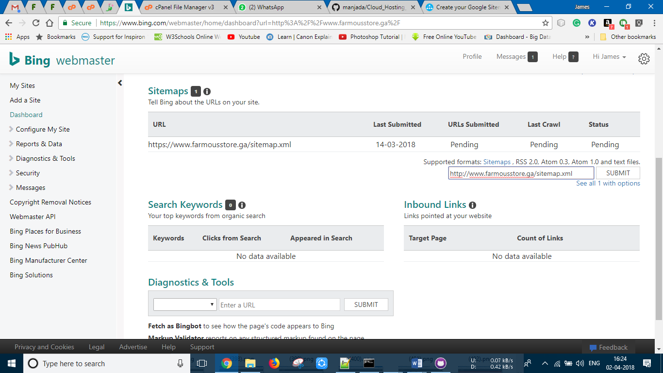

**P4.3.3 Implementation of Robots.txt**

Robots.txt is a text (not html) file you put on your site to tell search robots which pages you would like them not to visit. Robots.txt is by no means mandatory for search engines but generally search engines obey what they are asked not to do. It is important to clarify that robots.txt is not a way from preventing search engines from crawling your site (i.e. it is not a firewall, or a kind of password protection) and the fact that you put a robots.txt file is something like putting a note “Please, do not enter” on an unlocked door – e.g. you cannot prevent thieves from coming in but the good guys will not open to door and enter. That is why we say that if you have really sensitive data, it is too naïve to rely on robots.txt to protect it from being indexed and displayed in search results.

The location of robots.txt is very important. It must be in the main directory because otherwise user agents (search engines) will not be able to find it – they do not search the whole site for a file named robots.txt. Instead, they look first in the main directory (i.e. http://mydomain.com/robots.txt) and if they don't find it there, they simply assume that this site does not have a robots.txt file and therefore they index everything they find along the way.

### **Structure of a Robots.txt File**

The structure of a robots.txt is pretty simple (and barely flexible) – it is an endless list of user agents and disallowed files and directories. Basically, the syntax is as follows:

User-agent:

Disallow:

“*User-agent”* are search engines' crawlers and *disallow:* lists the files and directories to be excluded from indexing. In addition to “user-agent:” and “disallow:” entries, you can include comment lines – just put the # sign at the beginning of the line:

# All user agents are disallowed to see the /temp directory.

User-agent: *

Disallow: /temp/

**P4.4 Bing Webmaster Tool**

**P4.4.1 Introduction to Bing Webmaster Tool**

**Bing Webmaster Tools** (previously the Bing Webmaster Centre) is a free service as part of [Microsoft](https://en.wikipedia.org/wiki/Microsoft)'s [Bing](https://en.wikipedia.org/wiki/Bing_(search_engine)) search engine which allows webmasters to add their websites to the [Bing](https://en.wikipedia.org/wiki/Bing_(search_engine)) index crawler. The service also offers tools for webmasters to troubleshoot the crawling and indexing of their website, Sitemap creation, submission and ping tools, website statistics, consolidation of content submission, and new content and community resources. Bing has generally been great to SEOs and webmasters, and nowhere is this more apparent than with Bing Webmaster Tools. In many ways, Bing Webmaster Tools is actually more advanced — and caters more to SEO professionals — than its Google counterpart, [Google Search Console](https://searchengineland.com/google-webmaster-tools-rebrands-to-google-search-console-221282). For this, I give them a round of applause. I mean, would we have a [Google Disavow Links Tool](https://searchengineland.com/google-launches-disavow-links-tool-136826) if Bing hadn’t [released one first](https://searchengineland.com/bing-launches-way-to-disavow-links-but-why-126262)? Maybe; but I still applaud Bing for catering to SEOs.

**P4.4.2 Implementation of Bing Webmaster Tool**

1. Sign in to Bing webmaster

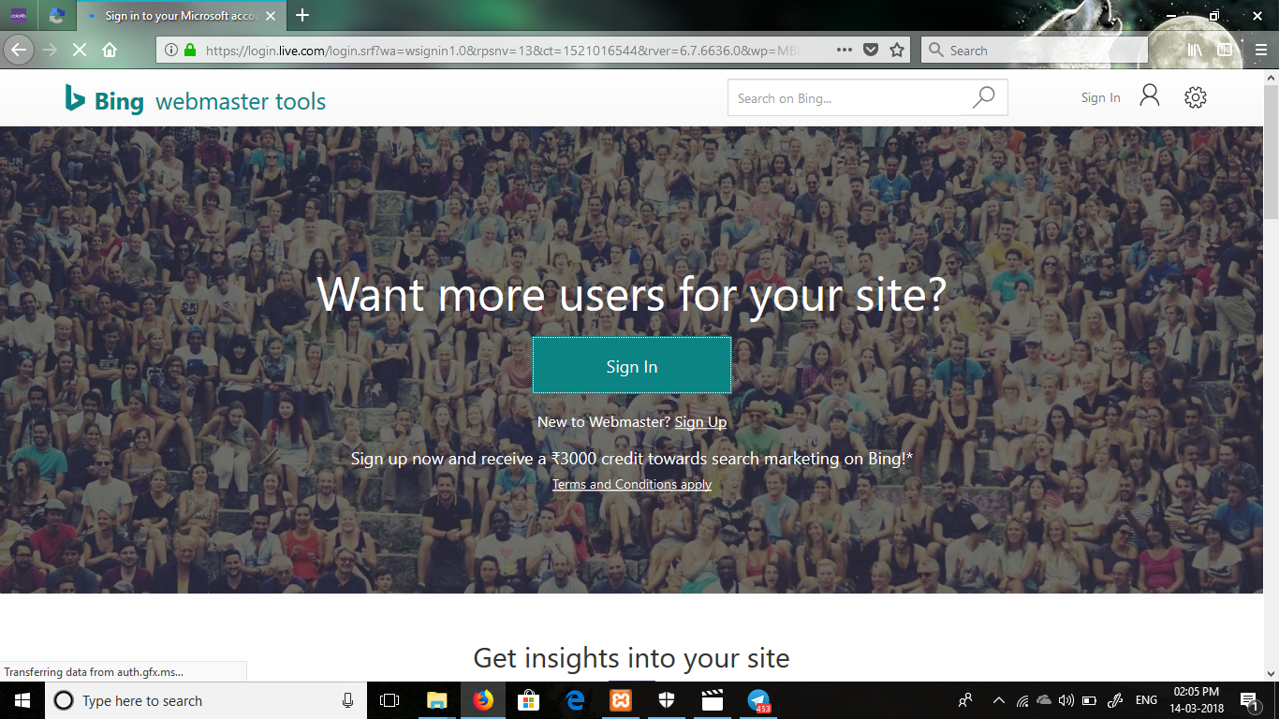

1. Go to My Sites (User-friendly interface to maintain multiple websites from a single account.) and add your website URL

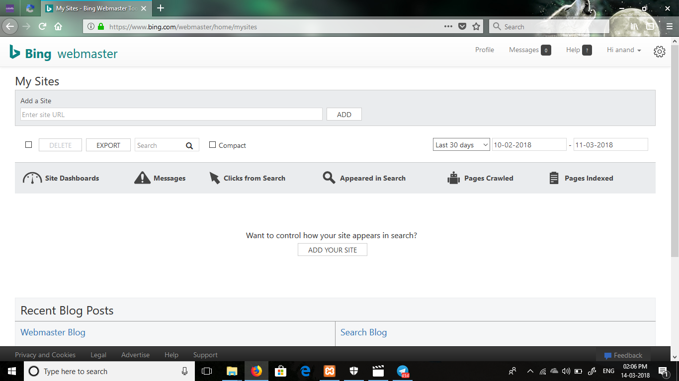

3. Verify ownership of your site.

* Download and Upload BingSiteAuth.xml the file to your root directory.
* Confirm successful upload by visiting your URL/BingSiteAuth.xml in your browser
* Copy and paste a <meta> tag in your default webpage

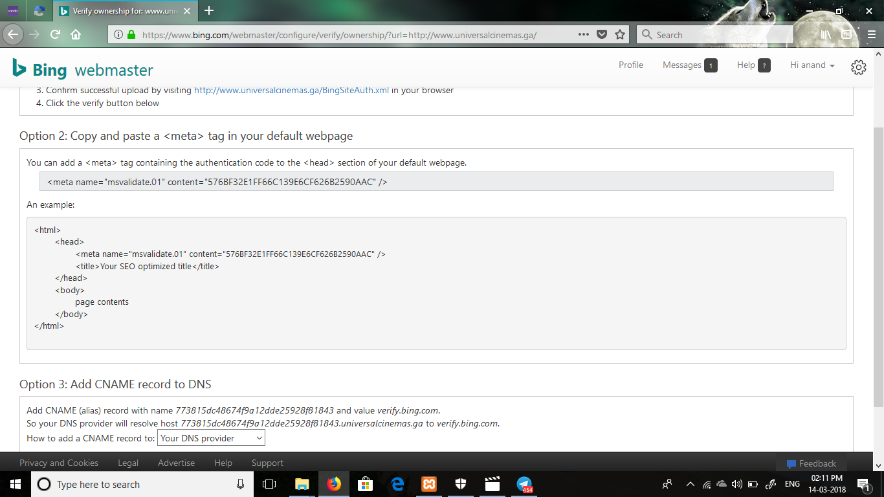

4. Add information about the website and to MySites to complete the process.

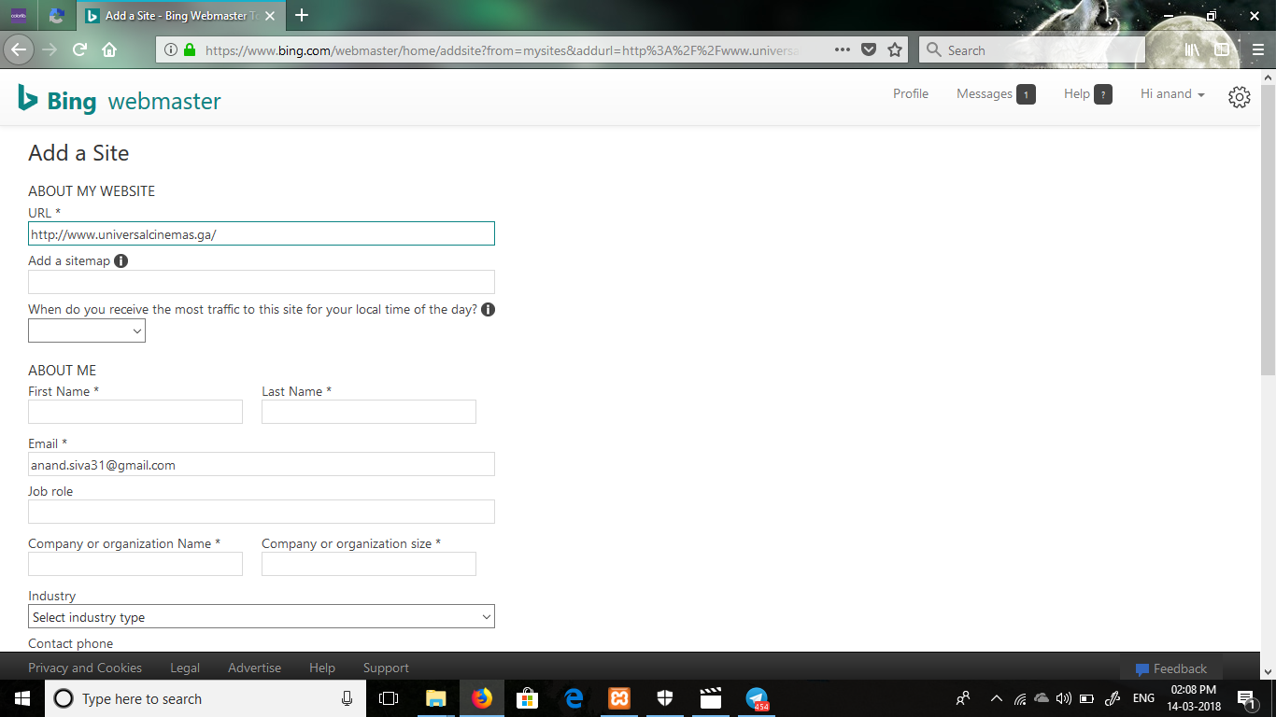

5. Once the given information is saved, you can access the dashboard with your website info.

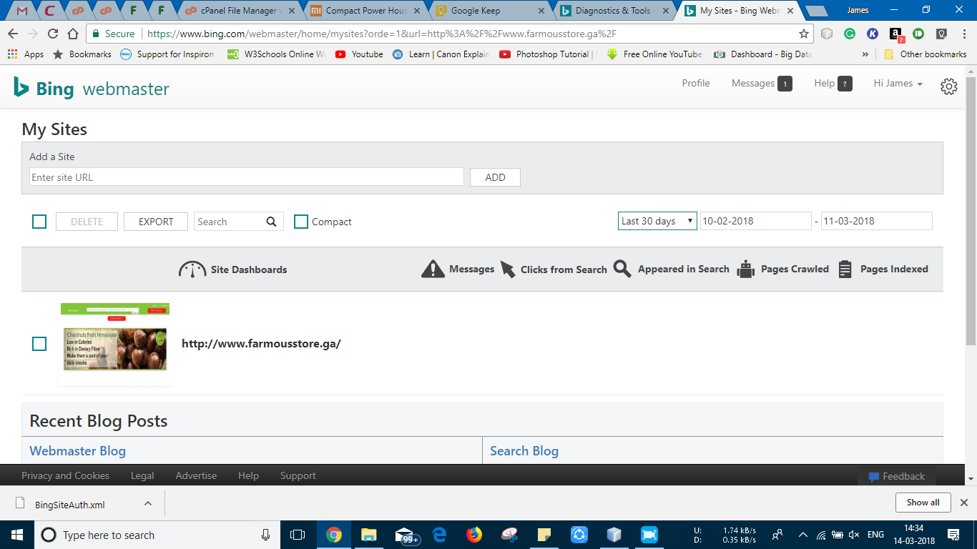

**SEO Analyzer**

SEO analyser tool to give webmasters or bloggers an SEO analysis on a page-by-page basis. This tool analyzes the website social media ranking, site usability, online reputation, meta tags, keywords, and site speed. Examine your webpage and get your analysis report together with your rankings from this SEO tool. Improve your web pages and increase your search engine ranking.

1. Go to Dashboard > Diagnostics & Tools > SEO Analyzer > Enter your Website page URL and Analyse.

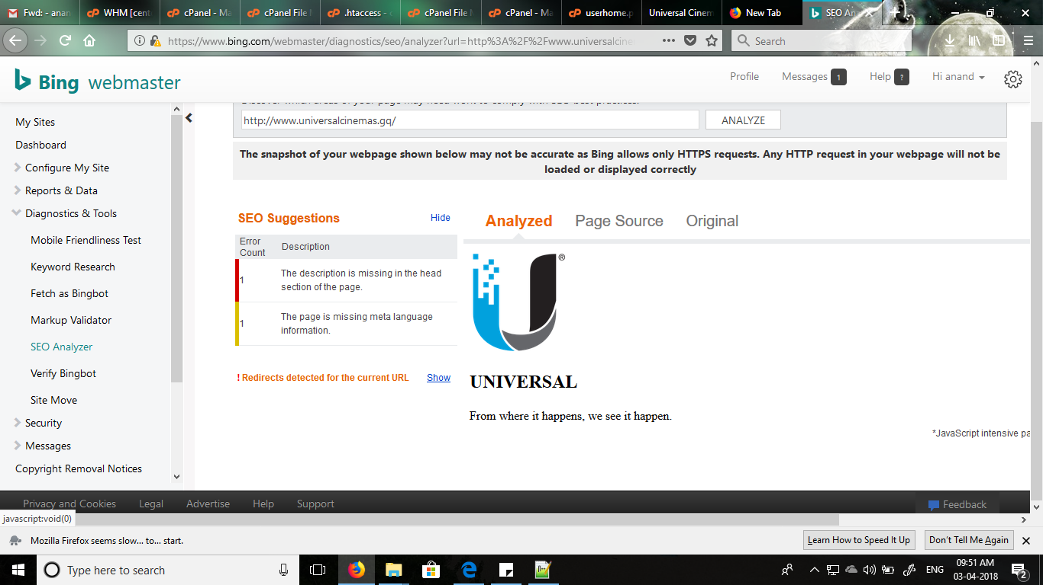

**Fetch as Bingbot**

Bingbot is a web-crawling robot, deployed by Microsoft October 2010 to supply Bing. It collects documents from the web to build a searchable index for the Bing.

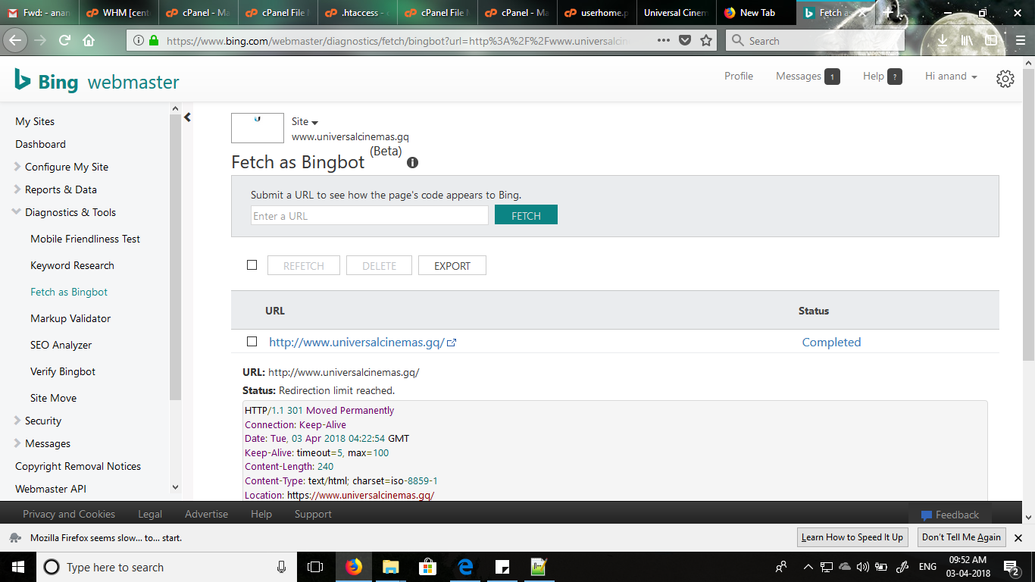

**Part 5**

**Site Security**

**P5.1 SiteLock Security**

SiteLockprovides comprehensive, cloud-based website security solution service that performs daily scans of a website to identify vulnerabilities and protect against threats like viruses, cross-site scripting, SQL injection and even email backlisting’s SiteLock Trust Seal provides customer confidence and increases your sales and conversions. And they are the Global Leader in business website security solutions, is the only web security solution to offer complete, cloud-based website protection. Its 360-degree monitoring finds and fixes threats, prevents future attacks, accelerates website performance and meets PCI compliance standards for businesses of all sizes. Founded in 2008, SiteLock protects over 12 million websites worldwide.

**Key Features**

#### **Website Acceleration**

Improve SEO and reduce bandwidth and server use with SiteLock's Global Content Delivery Network (CDN); ensure a consistent and speedy consumer experience.

#### **DDoS Protection**

Protect websites from all types of DDoS attacks with auto-detection and triggering, and fewer than 0.01% false positives.

#### **Web Application Firewall**

Secure websites from automated and human targeted attacks, prevent scrapers, block backdoor access and sort out bot traffic.

#### **Automatic Detection and Remediation**

Get 360-degree protection from malware and identify vulnerabilities with daily malware detection scans, automatic malware removal, and expert support.

#### **Expert Support 24/7/365**

Connect with SiteLock's specialized security engineers any time of day via email, chat, and phone, and use SiteLock911 for emergency malware removal.

**P5.2 PCI Compliance**

The **Payment Card Industry Data Security Standard** (**PCI DSS**) is an [information security](https://en.wikipedia.org/wiki/Information_security) standard for organizations that handle branded [credit cards](https://en.wikipedia.org/wiki/Credit_card) from the major [card schemes](https://en.wikipedia.org/wiki/Card_scheme). The PCI Standard is mandated by the card brands and administered by the Payment Card Industry Security Standards Council. The standard was created to increase controls around cardholder data to reduce credit card fraud. Validation of compliance is performed annually, either by an external [Qualified Security Assessor](https://en.wikipedia.org/wiki/Qualified_Security_Assessor) (QSA) or by a firm-specific [Draft: Internal Security Assessor (ISA)](https://en.wikipedia.org/wiki/Draft:Internal_Security_Assessor_(ISA)) that creates a Report on Compliance for organizations handling large volumes of transactions, or by Self-Assessment Questionnaire (SAQ) for companies handling smaller volumes.

The PCI Data Security Standard specifies twelve requirements for compliance, organized into six logically related groups called "control objectives." These 6 groups are:

1. Build and Maintain a Secure Network and Systems
2. Protect Cardholder Data
3. Maintain a Vulnerability Management Program
4. Implement Strong Access Control Measures
5. Regularly Monitor and Test Networks
6. Maintain an Information Security Policy

**Goals of PCI Compliance**

1. Building and maintaining a secure network.
2. Protect Cardholder Data.
3. Maintain a Vulnerability Management Program.
4. Implement Strong Access Control Measures.
5. Implement Strong Access Control Measures.
6. Maintain an Information Security Policy.

**Part 6**

**Server Security and Penetration Testing**

**P6.1 Data Security**

Data security refers to protective digital privacy measures that are applied to prevent unauthorized access to computers, databases, and websites. Data security also protects data from corruption. Data security is an essential aspect of IT for organizations of every size and type. Examples of data security technologies include backups, data masking, and data erasure. The core of the data security technology is encryption, where digital data, software/hardware, and hard drives are encrypted and therefore rendered unreadable to unauthorized users and hackers.

**Different Ways to Enhance Data Security**

1.Limit Data Access

2.Identify Sensitive Data

3.Pre-planned Data Security Policy

**P6.2 HTTPS using .htaccess file**

**.htaccess**

.htaccess is a configuration file for use on web servers running the Apache Web Server software. When a .htaccess file is placed in a directory which is in turn 'loaded via the Apache Web Server', then the .htaccess file is detected and executed by the Apache Web Server software. These .htaccess files can be used to alter the configuration of the Apache Web Server software to enable/disable additional functionality and features that the Apache Web Server software has to offer. These facilities include basic redirect functionality, for instance, if a 404 file not found error occurs, or for more advanced functions such as content password protection or image hotlink prevention.

# **How to force HTTPS using a .htaccess file in cPanel**

Once an SSL certificate is installed and a site can be reached via https:// appropriately, visitors should be able to access the whole site or key pages via https:// automatically. In other words, by typing domain.com in a web-browser, a user should be redirected to https://domain.com to access the site securely. To accomplish this, a special set of directives called rewrite rules needs to be added to the website's **.htaccess file**, which can be found in the root folder of a specific site in cPanel (e.g. “public_html”). If the file is not shown, please make sure to click on 'Settings' and tick the option 'Show hidden files'. Also, this file can be created if it cannot be located in any way.

**Redirect Only Specified Domain**

To force a specific domain to use HTTPS, use the following lines of code in the .htaccess file in your website's root folder:

RewriteEngine on

RewriteOptions inherit

RewriteCond %{HTTPS} off

RewriteCond %{REQUEST_URI} !^/[0-9]+\..+\.cpaneldcv$

RewriteCond %{REQUEST_URI} !^/[A-F0-9]{32}\.txt(?:\ Comodo\ DCV)?$

RewriteCond %{REQUEST_URI} !^/\.well-known/pki-validation/[A-F0-9]{32}\.txt(?:\ Comodo\ DCV)?$

RewriteRule ^(.*)$ https://%{HTTP_HOST}%{REQUEST_URI} [L,R=301]

RewriteCond %{REQUEST_FILENAME} !-f

RewriteRule ^([^\.]+)$ $1.php [NC,L]

**P6.3 ModSecurity Tools**

TheModSecurity Toolsinterface allows you to install and manage ModSecurity rules. This interface can be accessed from cPanel & WHM (Home > Security Center > ModSecurity Tools)

**What is ModSecurity and why you need it?**

Mod Security is an open source, embedded web application firewall which protects your website and its applications against various attacks by blocking malicious scripts, programs and injections with the help of regular expressions and set of rules. And It is a module for Apache web servers and checks all HTTP requests that reach Apache and Nginx- supplementary web server of Apache.

**What can Mod Security do to protect your website?**

The Mod Security engine scans all the requests which come to the web server and relative responses which are sent from the server as per its set of rules. If the check succeeds, the HTTP request is passed to the website content but if it fails, then it blocks the request and performs following actions

* Security monitoring and access control
* Virtual Patching
* Full HTTP traffic logging
* Security assessment
* Web application hardening
* Passive security assessment
* Simple request or Regular expression-based Filtering
* URL Encoding Validation
* Auditing
* IP Reputation

**P6.4 OWASP**

The **Open Web Application Security Project** (**OWASP**), an online community, produces freely-available articles, methodologies, documentation, tools, and technologies in the field of web application security. The Open Web Application Security Project (OWASP) is a worldwide not-for-profit charitable organization focused on improving the security of software. **OWASP** Operating as a community of like-minded professionals, OWASP issues software tools and knowledge-based documentation on application security. All of its articles, methodologies, and technologies are made available free of charge to the public.

OWASP seeks to educate developers, designers, architects and business owners about the risks associated with the most common Web application security vulnerabilities. OWASP, which supports both open source and commercial security products, has become known as a forum in which information technology professionals can network and build expertise. The organization publishes a popular Top Ten list that explains the most dangerous Web application security flaws and provides recommendations for dealing with those flaws.

OWASP tools, document and code library projects are organized into three categories, tools and documents that can be used to find security-related design and implementation flaws, tools and documents that can be used to guard against security-related design and implementation flaws and tools and documents that can be used to add security-related activities into the [application  lifecycle management](http://searchsoftwarequality.techtarget.com/definition/application-lifecycle-management-ALM) (ALM).

The Open Web Application Security Protocol team released the top 10 vulnerabilities that are more prevalent on the web in the recent years.

The OWASP Top Ten is a list of the 10 most dangerous current Web application security flaws along with effective methods of dealing with those flaws, which tracks the top software security vulnerabilities

1. Unvalidated input.
2. Broken access control.
3. Broken authentication and session management.
4. Cross-site scripting (XSS) flaws.
5. Buffer overflows.
6. Injection flaws.
7. Improper error handling.
8. Insecure storage.
9. Denial of service (DoS).
10. Insecure configuration management.

**P6.5 Kali Linux Tools**

**P6.5.1 Introduction to Kali Linux Tools**

Kali Linux is the world’s most powerful and popular penetration testing platform, used by security professionals in a wide range of specializations, including penetration testing, forensics, reverse engineering, and vulnerability assessment. It is the culmination of years of refinement and the result of a continuous evolution of the platform, from WHoppiX to WHAX, to BackTrack, and now to a complete penetration testing framework leveraging many features of Debian GNU/Linux and the vibrant open source community worldwide. Kali contains several hundred tools which are geared towards various information security tasks, such as Penetration Testing, Security research, Computer Forensics and Reverse Engineering. Kali Linux was released on the 13th March 2013 as a complete, top-to-bottom rebuild of [Backtrack Linux](http://www.backtrack-linux.org/), adhering completely to [Debian](http://www.debian.org/) development standards.

**Major Kali Linux Penetration Testing tools**

* **Sqlmap**

sqlmap is an open source penetration testing tool that automates the process of detecting and exploiting SQL injection flaws and taking over of database servers. It comes with a powerful detection engine, many niche features for the ultimate penetration tester and a broad range of switches lasting from database fingerprinting, over data fetching from the database.

* **Metasploit Framework**

Metasploit is a penetration testing platform that enables you to find, exploit, and validate vulnerabilities. It provides the infrastructure, content, and tools to perform penetration tests and extensive security auditing and thanks to the open source community and Rapid7’s own hard-working content team, new modules are added on a regular basis.

* **Hashcat**

hashcat is the world’s fastest and most advanced password recovery utility, supporting five unique modes of attack for over 200 highly-optimized hashing algorithms. hashcat currently supports CPUs, GPUs, and other hardware accelerators on Linux, Windows, and OSX, and has facilities to help enable distributed password cracking.

**P6.5.2 Implementation of Kali Linux - Penetration Testing Tools**

**1. Testing with JSQL (JavaScript Query Language)**

JSQL Injection is a Java-based automated SQL injection tool used to find database information from a distant server. Provides a common way of using SQL from within Java to access a database.it is free, open source and cross-platform (Windows, Linux, Mac OS X, Solaris).

* Open the JSQL tool

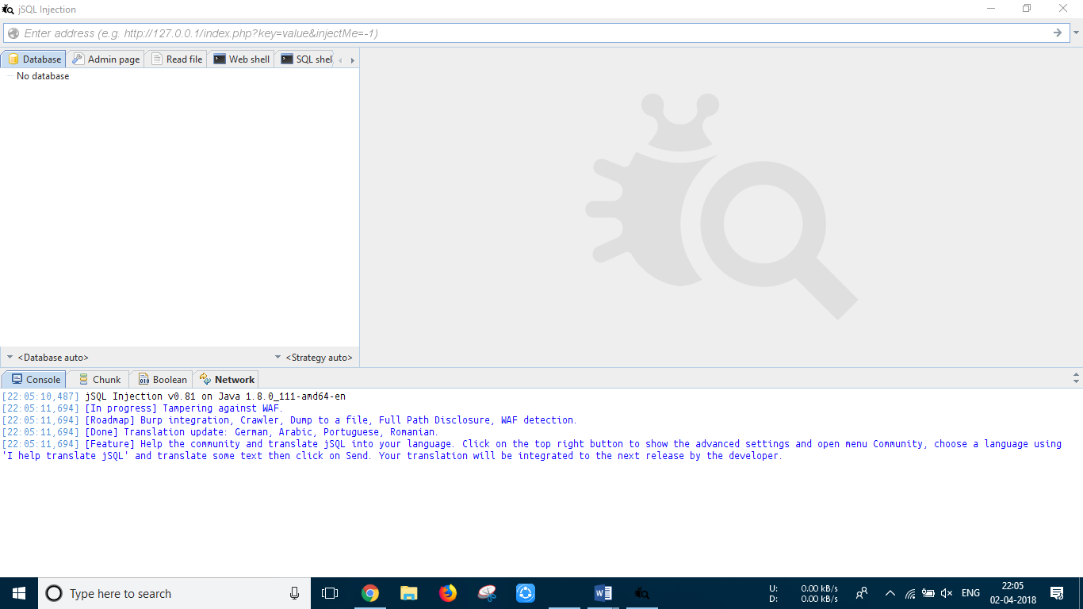

* 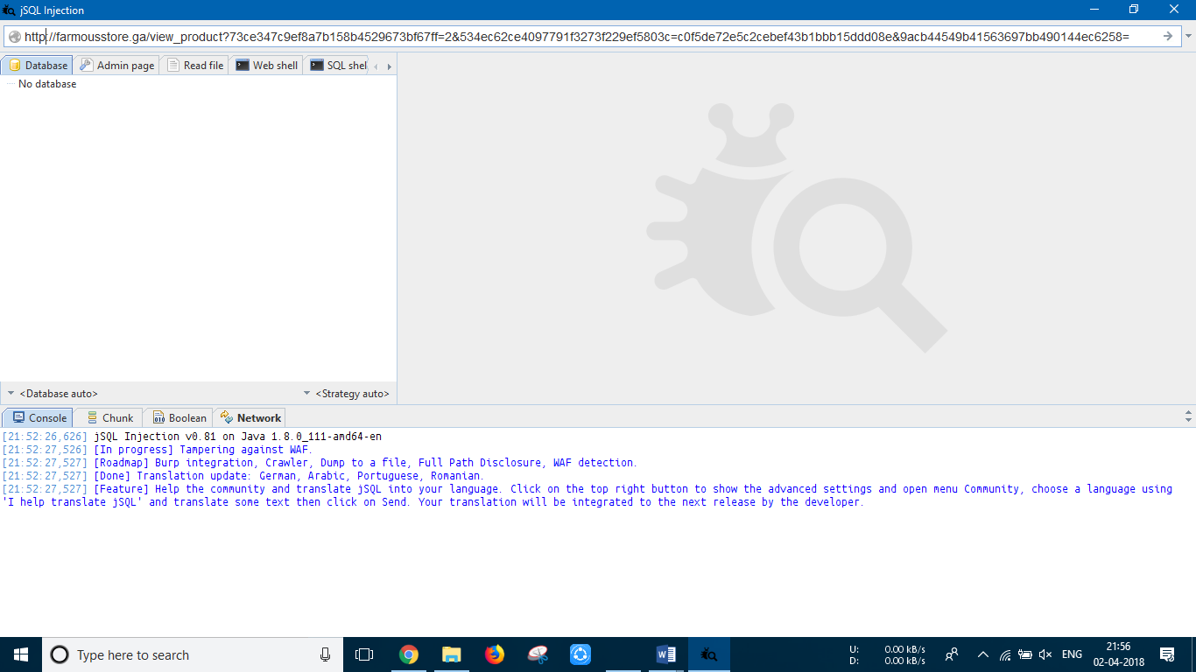Use a valid URL of your website as input to the JSQL tool.
* Start the SQL Injection

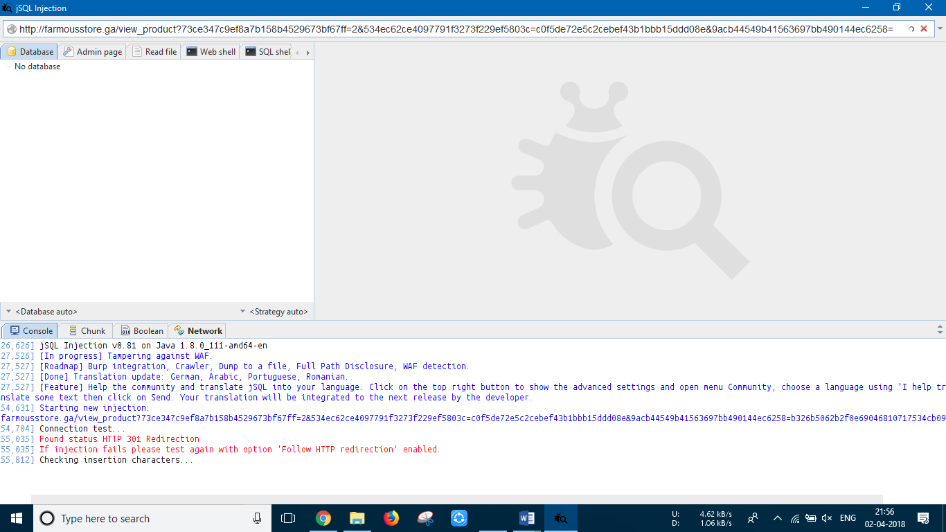

* No SQL Injection found

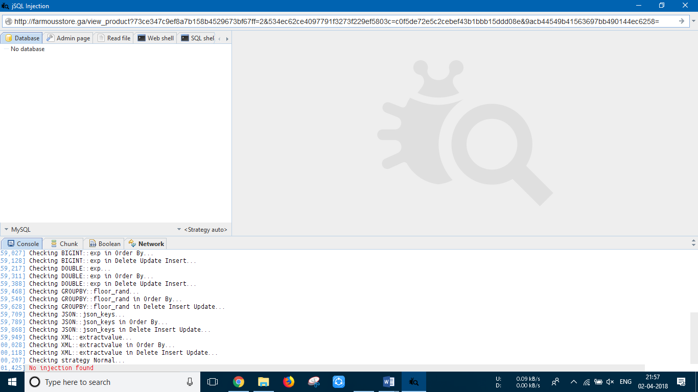

Output:

No SQL Injection Found to exploit

**2. Testing with The Mole**

Mole is a programmed automatic SQL Injection exploitation tool. Just by giving a vulnerable URL and a substantial string on the site it can recognize the injection and exploit it, either by utilizing the union method or a boolean question-based system. The Mole utilizes a command-based interface, permitting the client to show the activity he needs to perform effectively. The CLI likewise gives auto-completion on both commands and command arguments, making the user sort as less as could be expected under the possibilities.

* Download and open themole.exe file
* Once a command-line interface is opened, use the following commands
* url http://www.yourwebsite.com/page.php?id=numeric_value

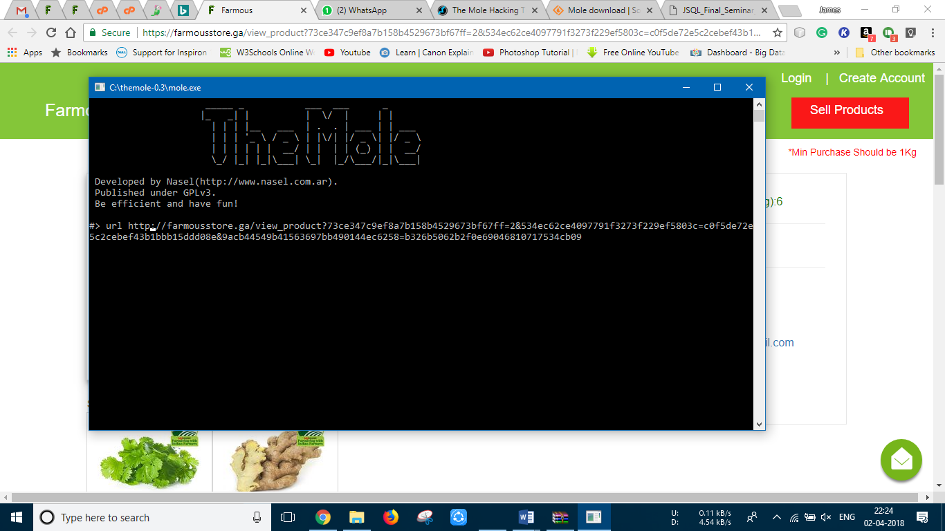

* Now find out any keywords available on the website, it may anything means any word find you on this site, I'm using '**film**'.
* needle vegetable

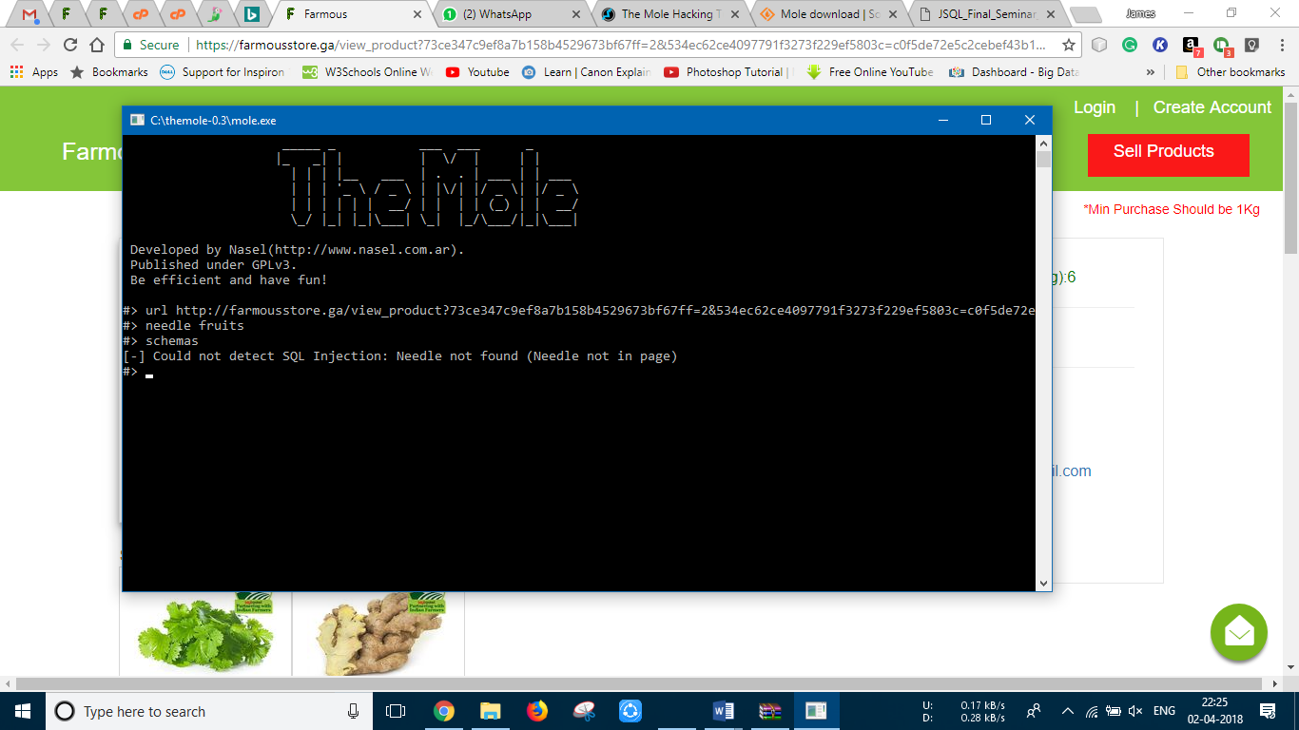

* finally, use command schemas to fetch tables

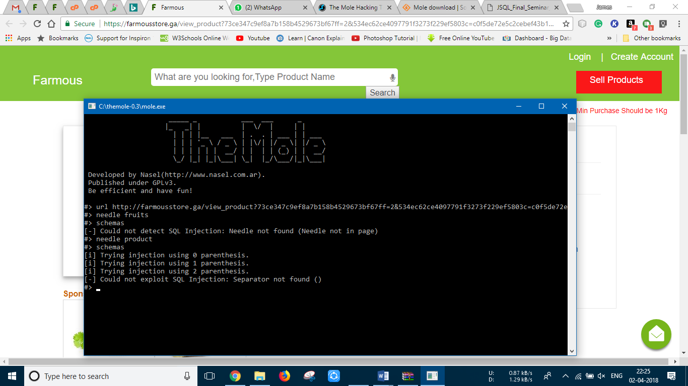

Output:

Could not Exploit SQL Injection

**Part 7**

**Technology Frameworks**

**P7.1 ASP.NET MVC**

**Introduction**

ASP.NET MVC is an open-source software from Microsoft. Its web development framework combines the features of MVC (Model-View-Controller) architecture, the most up-to-date ideas and techniques from Agile development and the best parts of the existing ASP.NET platform. This tutorial provides a complete picture of the MVC framework and teaches you how to build an application using this tool. ASP.NET MVC is basically a web development framework from Microsoft, which combines the features of MVC (Model-View-Controller) architecture, the most up-to-date ideas and techniques from Agile development, and the best parts of the existing ASP.NET platform.

ASP.NET MVC is not something, which is built from ground zero. It is a complete alternative to traditional ASP.NET Web Forms. It is built on the top of ASP.NET, so developers enjoy almost all the ASP.NET features while building the MVC application.

The MVC architectural pattern separates the user interface (UI) of an application into three main parts.

* **The Model** − A set of classes that describes the data you are working with as well as the business logic.
* **The View** − Defines how the application’s UI will be displayed. It is a pure HTML, which decides how the UI is going to look like.
* **The Controller** − A set of classes that handles communication from the user, overall application flow, and application-specific logic.

**Implementation of ASP.Net MVC**

* Download and install Microsoft Visual Studio 2012 and onwards
* Create an ASP.Net MVC Application. Open the Visual Studio. Click File>New > Project menu option. A new Project dialog opens.
* From the left pane, select Templates → Visual C# → Web.
* In the middle pane, select ASP.NET Web Application.
* Enter the project name, MVCApplication2, in the Name field and click ok to continue. You will see the following dialog which asks you to set the initial content for the ASP.NET project.

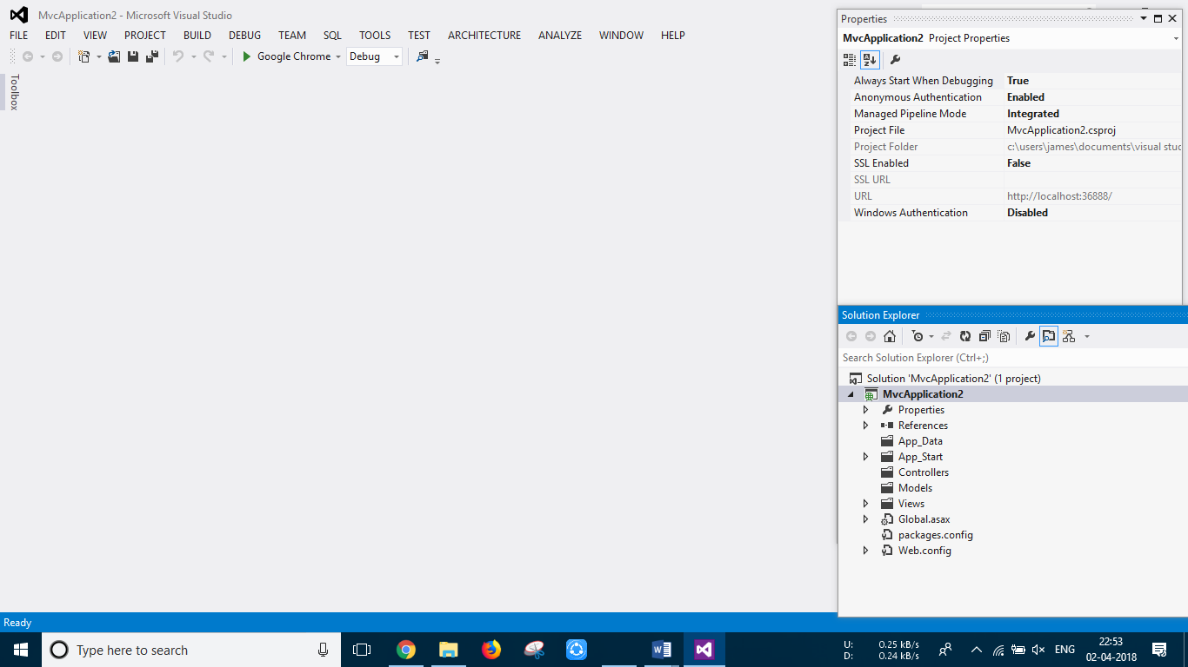

* Run this application from Debug > Start Debugging menu option and you will see a **404 Not Found** Error.

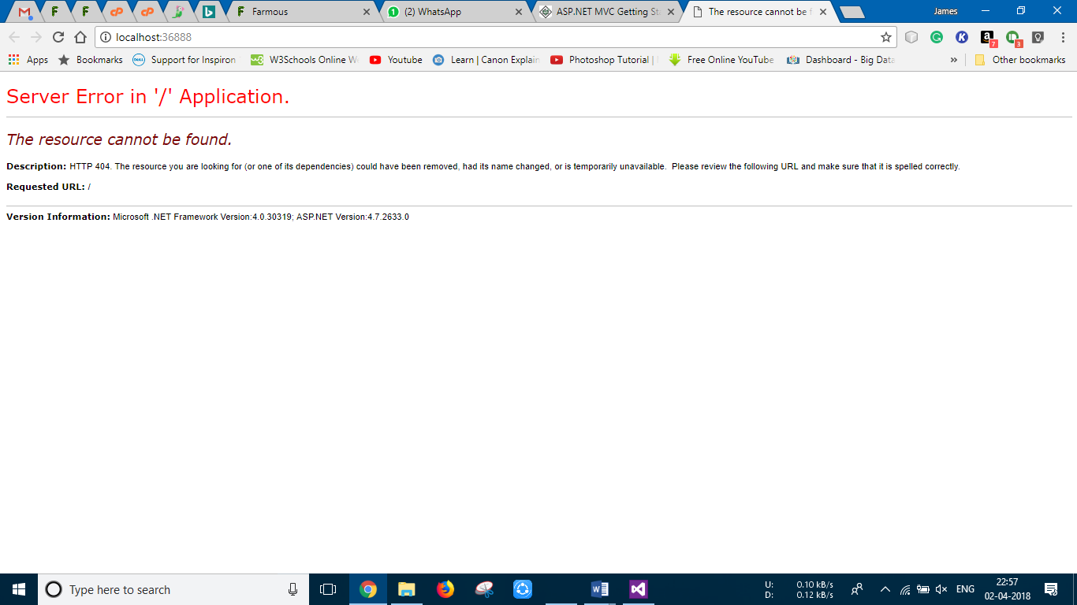

## **Add Controller**

* To remove the 404 Not Found error, we need to add a controller, which handles all the incoming requests.
* To add a controller, right-click on the controller folder in the solution explorer and select Add > Controller.
* Select the MVC 5 Controller – Empty option and click ‘Add’ button. The Add Controller dialog will appear.
* Set a name to Controller and click the Add button.
* To make this a working example, let’s modify the controller class by changing the action method called **Index** using the following code.

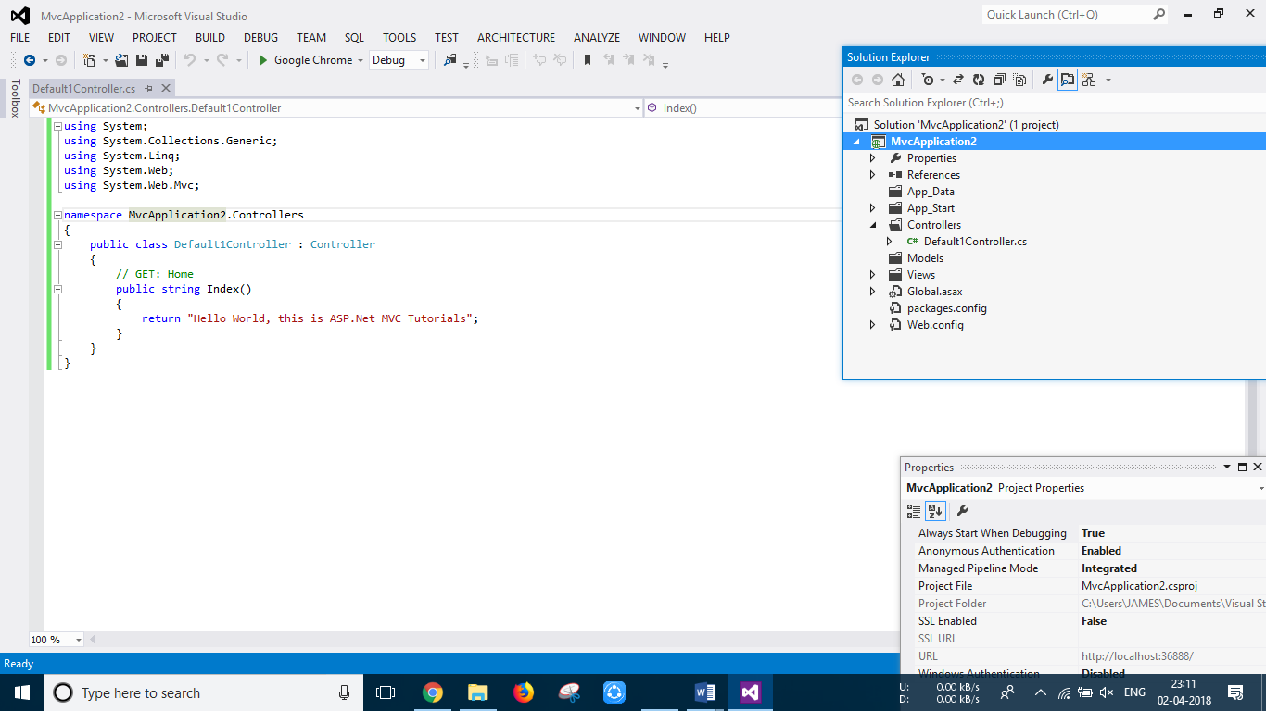

* Run this application from Debug

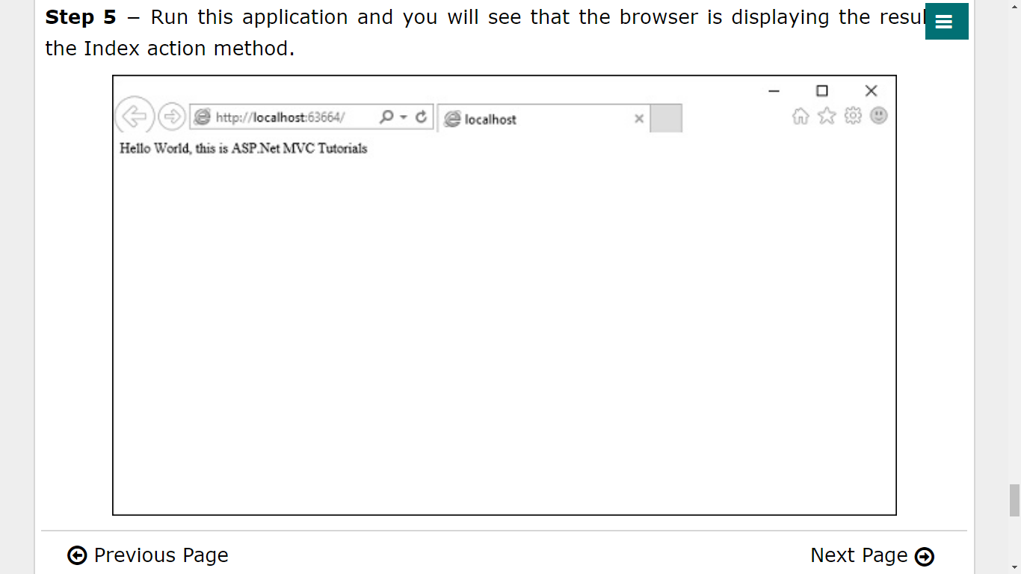

**P7.1 CodeIgniter for PHP**

**Introduction**

CodeIgniter is a powerful PHP framework with a very small footprint, built for developers who need a simple and elegant toolkit to create full-featured web applications. CodeIgniter was created by EllisLab and is now a project of the British Columbia Institute of Technology. And it is an application development framework, which can be used to develop websites, using PHP. It is an Open Source framework. It has a very rich set of functionalities, which will increase the speed of website development work.

If you know PHP well, then CodeIgniter will make your task easier. It has a very rich set of libraries and helpers. By using CodeIgniter, you will save a lot of time, if you are developing a website from scratch. Not only that, a website built in CodeIgniter is secure too, as it has the ability to prevent various attacks that take place through websites.

It is very easy to install CodeIgniter. Just follow the steps given below −

* Download the CodeIgniter

There are two different options legacies and latest. The names itself are self-descriptive. legacy has a version less than 2.x and latest has 3.0 version.

We can also go with GitHub and get all of the latest scripts.

* Unzip the folder.
* Upload all files and folders to your server.
* After uploading all the files to your server, visit the URL of your server, e.g., www.domain-name.com.

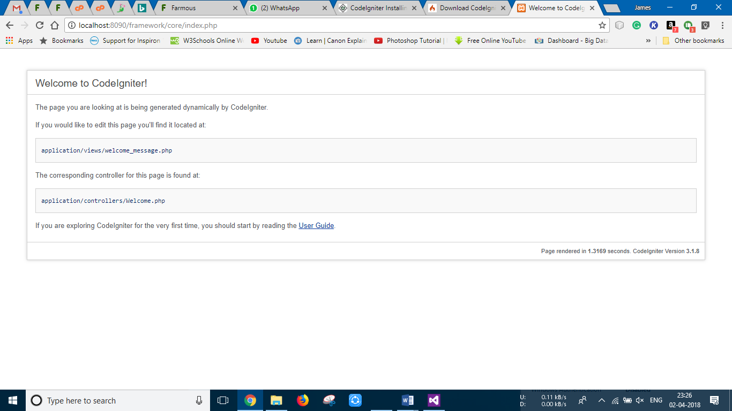

CodeIgniter is based on the **Model-View-Controller (MVC) development pattern**. MVC is a software approach that separates application logic from presentation. In practice, it permits your web pages to contain minimal scripting since the presentation is separate from the PHP scripting.

* The **Model** represents your data structures. Typically, your model classes will contain functions that help you retrieve, insert and update information in your database.
* The **View** is information that is being presented to a user. A View will normally be a web page, but in CodeIgniter, a view can also be a page fragment like a header or footer. It can also be an RSS page or any other type of “page”.
* The **Controller** serves as an intermediary between the Model, the View, and any other resources needed to process the HTTP request and generate a web page.

## **Controllers**

A controller is a simple class file. As the name suggests, it controls the whole application by URI.

### **Creating a Controller**

* First, go to **application/controllers** folder. You will find two files there, **index.html** and **Welcome. Php**. These files come with the CodeIgniter.
* Keep these files as they are. Create a new file under the same path named “**Test.php**”. Write the following code in that file –

<?php

class Test extends CI_Controller

{

public function index()

{

echo "Hello World!";

}

}

?>

### **Calling a Controller**

* The above controller can be called by URI as follows:

http://www.your-domain.com/index.php/test

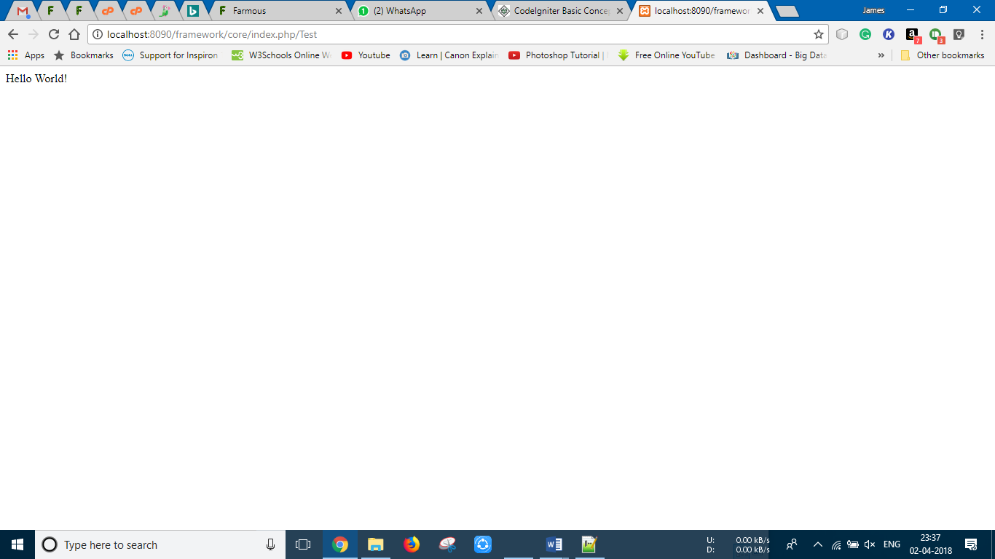

### **Creating & Calling Constructor Method**

Let us modify the above class and create another method named “hello”.

<?php

class Test extends CI_Controller

{

public function index()

{

echo "Hello World!";

}

public function hello()

{

echo "hello function";

}

}

?>

We can execute the above controller in the following three ways −

* <http://www.your-domain.com/index.php/test>
* <http://www.your-domain.com/index.php/test/index>
* <http://www.your-domain.com/index.php/test/hello>

